[Test Plan] Feature Name version xx

Document Status | [DRAFT]
Test Plan Creator | Muhammad Balya Khaidir
Test Plan Reviewr | - M Ridhwan K  - Reviewer_2  - Reviewer_3

Introduction

Overview Feature to be tested
Eg:
The Test Plan has been created to communicate the test approach to team members. It includes the objectives, scope, schedule and approach. This document will clearly identify what the test deliverables will be and what is deemed in and out of scope.
Eg:
This Test Plan is made to ensure that all features on the saucedemo.com website function properly and meet the criteria according to user needs.

Goals and Objective
Eg:
Test Case Tamer is a web-based Test Management tool used to create and store tests as well as the results of running those tests. This tool is a new product written with Ruby on Rails using a ‘mysql’ database. The test team is responsible for testing the product and ensuring it meets their needs. The test team is both the customer and the tester in this project.

Phase 1 of the project will deliver TCT (Test Case Tamer) with functionality to create and store manual tests. This will allow the test team to start transferring tests over to the new system. Must have functionality is considered more important than the delivery date in this project.

Eg:

The saucedemo.com website is a website that simulates a simple online store (e-comerce) that has features such as a login page, product list dashboard, shopping cart, and checout. The stages of testing the features carried out by manual testing (Manual Test) are as follows:

- Testing the Login page features aims to ensure users do not experience problems when performing the login and logout process. The test scenario is to use a valid username, invalid, stable connection and unstable connection.
- Sort
- Sort price low to high
- Sort price high to low
- Sort product name A to Z
- Sort product name Z to A
- Logout function, whether the feature work properly and test after user logout, whether user can still return to the previous page or not.

Test Item
List of test items (feature / product)

No | Feature | Test Item
#1 | Login | - Login with valid username  - Login with invalid username  - Login with valid password  - Login without username  - Login without password  - Login without input username and password  - Login without internet connection
#2 | Sort | - Sort price High to Low  - Sort price Low to High  - Sort product name A to Z  - Sort product name Z to A
#3 | Logout | - Function logout work properly  - Web can go back to previous page after logout

In Scope Testing
List of in feature to be tested

No | Feature | Requirement / Design specifications
#1 | Login | 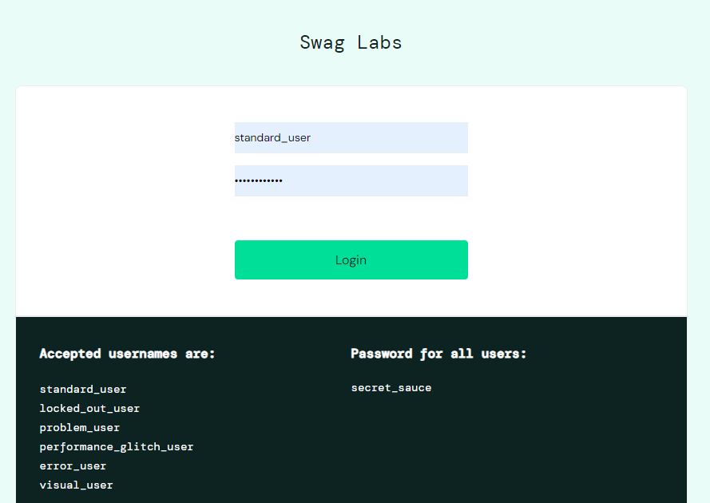
#2 | Sort | 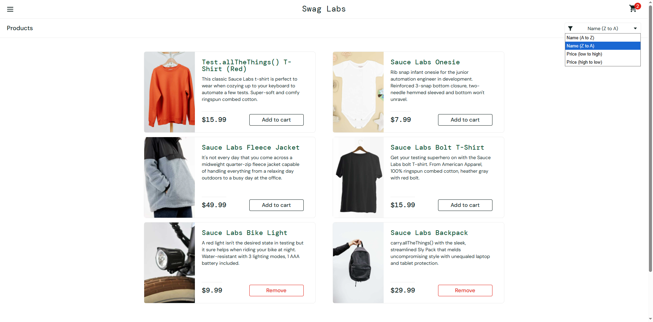
#3 | Logout | 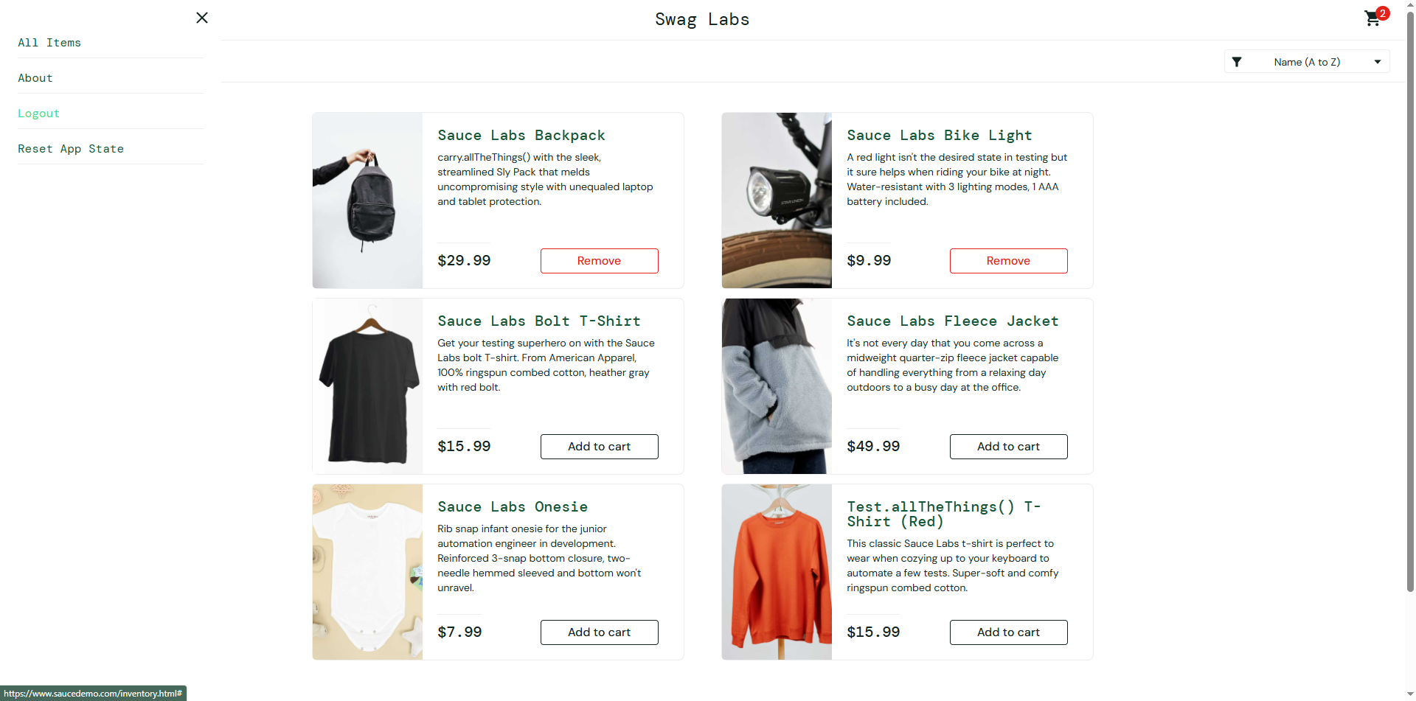

Out of Scope Testing
List the features of the software / product which will not be tested.

No | Feature | Reasons
#1 | Cart | This testing phase will be focus to test login, sorting and logout feature

Testing Approach
Summary of testing approach that will be implemented during testing phase

Eg:
The project is using an agile approach, with weekly iterations. At the end of each week the requirements identified for that iteration will be delivered to the team and will be tested.

Exploratory testing will play a large part of the testing as the team has never used this type of tool and will be learning as they go. Tests for planned functionality will be created and added to TCT as we get iterations of the product.

Eg:
The testing process uses Exploratory testing type because the tester does not know from the beginning the process of making the saucedemo.com website. So that the tester explores the website to test whether the website is suitable and can be used by users without any problems.

Test Environment
Information about testing environment that will be used during testing phase e.g URL, and version of App
- Website: https://www.saucedemo.com/
- Android version: v13
- Env: Production
- Browser: Edge & Chrome

Test Deliverables
- Test Plan (this document itself): [link]
- Test Case: [link]
- Test Script (if any): [link]
- Test data (if any): [link]
- Defect Report: [link]
- Test Report: [link]

Testing Timeline

No | Task | Estimation Time |  | Actual Time
 |  | Start Date | Finish Date | Start Date | Finish Date
#1 | Develop Test Planning | 02 Okt 2025 | 08 Okt 2025 | 06 Okt 2025 | 06 Okt 2025
#2 | Develop Test Case | 02 Okt 2025 | 08 Okt 2025 | 06 Okt 2025 | 07 Okt 2025
#3 | Test Case Review | 09 Okt 2025 | 09 Okt 2025
#4 | Execute Test | 09 Okt 2025 | 10 Okt 2025 | 10 Okt 2025 | 10 Okt 2025

References
List of related documents e.g PRD, Figma design, API Contract, Copy document etc

