**PF-LAB PROJECT**

Mubahil Ahmed

Syed Ali Zain

Shahrukh Khan

Ahsan Ahmad

Students Management System

**INTRODUCTION:**

The following C++ program is a Students Information Management System which is used for education establishments to manage student data and manage many other student-related data needs in a school. In this Student Information Management System project, the user can create, display, modify and delete the student data. Such programs are required by the schools and colleges to get rid of the conventional File Management System and get the access of data in no time, this saves them a lot of time and storage and the integrity of the data is maintained.

**FUNCTIONS:**

This program has the following functionalities: -

* Create student records.
* Modify/Update student records.
* Delete student records.

Moreover, the program has input validation involved inside so that only valid data gets into the database. For example, you can only use an 11-Digit phone number, or the length of roll number can only be 6-digits.

**CODE:**

#include<iostream>

#include <string>

using namespace std;

string names[20], rollNumbers[20], course[20], semester[20], contact[20];

int total=0;

void dataEntery()

{

int students=0;

cout<<"How many students do you want to enroll?"<<endl;

cin>>students;

cout<<"----------------------------------------"<<endl;

if(total==0)

{

int count=0;

total=students+total;

for(int i=0; i<students; i++)

{

cout<<"\nEnter the following data of student: "<<i+1<<endl<<endl;

cout<<"Enter Name of student: ";

cin.ignore();

getline(cin, names[i]);

cout<<"Enter Roll Number: ";

cin>>rollNumbers[i];

while (rollNumbers[i].length() != 6)

{

cout<<"Kindly enter a valid Roll Number (6-Digit): ";

cin>>rollNumbers[i];

}

cout<<"Enter Course: ";

cin.ignore();

getline(cin, course[i]);

cout<<"Enter Semester: ";

cin>>semester[i];

cout<<"Enter Contact Number: ";

cin>>contact[i];

while (contact[i].length() != 11)

{

cout<<"Kindly enter a valid Number (11-Digit): ";

cin>>contact[i];

}

cout<<"----------------------------------------"<<endl;

}

}

else

{

for(int i=total;i<students+total;i++)

{

cout<<"Enter the Data of student "<<i+1<<endl<<endl;

cout<<"Enter Name: ";

cin.ignore();

getline(cin, names[i]);

cout<<"Enter Roll Number: ";

cin>>rollNumbers[i];

while (rollNumbers[i].length() != 6)

{

cout<<"Kindly enter a valid Roll Number (6-Digit): ";

cin>>rollNumbers[i];

}

cout<<"Enter Course: ";

cin.ignore();

getline(cin, course[i]);

cout<<"Enter Semester: ";

cin>>semester[i];

cout<<"Enter Contact Number: ";

cin>>contact[i];

while (contact[i].length() != 11)

{

cout<<"Kindly enter a valid Number (11-Digit): ";

cin>>contact[i];

}

cout<<"----------------------------------------"<<endl;

}

total=students+total;

}

}

void showRecord()

{

if(total==0)

{

cout<<"No data available..."<<endl;

cout<<"----------------------------------------"<<endl;

}

else

{

for(int i=0;i<total;i++)

{

cout<<"Data of Student "<<i+1<<": "<<endl<<endl;

cout<<"Name: "<<names[i]<<endl;

cout<<"Roll Number: "<<rollNumbers[i]<<endl;

cout<<"Course: "<<course[i]<<endl;

cout<<"Semester: "<<semester[i]<<endl;

cout<<"Contact Number: "<<contact[i]<<endl;

cout<<"----------------------------------------"<<endl;

}

}

}

void searchRecord()

{

if(total==0)

{

cout<<"No data available..."<<endl;

cout<<"----------------------------------------"<<endl;

}

else

{

string rollNum;

cout<<"Enter the roll number of student"<<endl;

cin>>rollNum;

while (rollNum.length() != 6)

{

cout<<"Kindly enter a valid Roll Number (6-Digit): ";

cin>>rollNum;

}

for(int i=0;i<total;i++)

{

if(rollNum==rollNumbers[i])

{

cout<<"Name: "<<names[i]<<endl;

cout<<"Roll Number: "<<rollNumbers[i]<<endl;

cout<<"Course: "<<course[i]<<endl;

cout<<"Semester: "<<semester[i]<<endl;

cout<<"Contact Number: "<<contact[i]<<endl;

cout<<"----------------------------------------"<<endl;

}

}

}

}

void updateRecord()

{

if(total==0)

{

cout<<"No data available..."<<endl;

cout<<"----------------------------------------"<<endl;

}

else

{

string rollNum;

cout<<"Enter the Roll Number of student which you want to update: ";

cin>>rollNum;

while (rollNum.length() != 6)

{

cout<<"Kindly enter a valid Roll Number (6-Digit): ";

cin>>rollNum;

}

for(int i=0;i<total;i++)

{

if(rollNum==rollNumbers[i])

{

cout<<"\nPrevious data"<<endl<<endl;

cout<<"Data of Student "<<i+1<<endl;

cout<<"Name: "<<names[i]<<endl;

cout<<"Roll Number: "<<rollNumbers[i]<<endl;

cout<<"Course "<<course[i]<<endl;

cout<<"Semester "<<semester[i]<<endl;

cout<<"Contact Number: "<<contact[i]<<endl<<endl;

cout<<"----------------------------------------"<<endl;

cout<<"\nEnter new data"<<endl<<endl;

cout<<"Enter Name: ";

cin.ignore();

getline(cin, names[i]);

cout<<"Enter Roll Number: ";

cin>>rollNumbers[i];

while (rollNumbers[i].length() != 6)

{

cout<<"Kindly enter a valid Roll Number (6-Digit): ";

cin>>rollNumbers[i];

}

cout<<"Enter Course: ";

cin.ignore();

getline(cin, course[i]);

cout<<"Enter Semester: ";

cin>>semester[i];

cout<<"Enter Contact: ";

cin>>contact[i];

while (contact[i].length() != 11)

{

cout<<"Kindly enter a valid Number (11-Digit): ";

cin>>contact[i];

}

cout<<"----------------------------------------"<<endl;

}

else

{

cout<<"\nNo data found...";

cout<<"----------------------------------------"<<endl;

}

}

}

}

void deleteRecord()

{

if(total==0)

{

cout<<"No data available..."<<endl;

cout<<"----------------------------------------"<<endl;

}

else

{

int a;

cout<<"Press 1 to delete all record"<<endl;

cout<<"Press 2 to delete specific record"<<endl;

cin>>a;

cout<<"----------------------------------------"<<endl;

if(a==1)

{

total=0;

cout<<"All record is deleted..!!"<<endl;

cout<<"----------------------------------------"<<endl;

}

else if(a==2)

{

string rollNum;

cout<<"Enter the Roll Number of student which you want to delete"<<endl;

cin>>rollNum;

while (rollNum.length() != 6)

{

cout<<"Kindly enter a valid Roll Number (6-Digit): ";

cin>>rollNum;

}

cout<<"----------------------------------------"<<endl;

for(int i=0;i<total;i++)

{

if(rollNum==rollNumbers[i])

{

for(int j=i;j<total;j++)

{

names[j] = names[j+1];

rollNumbers[j] = rollNumbers[j+1];

course[j] = course[j+1];

semester[j] = semester[j+1];

contact[j] = contact[j+1];

}

total--;

cout<<"Your required record is deleted..."<<endl;

cout<<"----------------------------------------"<<endl;

}

}

}

else

{

cout<<"Invalid input";

cout<<"----------------------------------------"<<endl;

}

}

}

int main()

{

int value;

cout<<" -----------------------------------"<<endl;

cout<<"\tSTUDENT MANAGEMENT SYSTEM\t"<<endl;

cout<<" -----------------------------------"<<endl;

while(true)

{

cout<<endl;

cout<<"\t***********************\n";

cout<<"\t***********************\n";

cout<<"\tPress 1 to Enter Data"<<endl<<endl;

cout<<"\tPress 2 to Show Data"<<endl<<endl;

cout<<"\tPress 3 to Search Data"<<endl<<endl;

cout<<"\tPress 4 to Update Data"<<endl<<endl;

cout<<"\tPress 5 to Delete Data"<<endl<<endl;

cout<<"\tPress 6 to Exit"<<endl<<endl;

cout<<"\t***********************\n";

cout<<"\t***********************\n";

cout<<"\t";

cin>>value;

cout<<"----------------------------------------"<<endl;

switch(value)

{

case 1:

dataEntery();

break;

case 2:

showRecord();

break;

case 3:

searchRecord();

break;

case 4:

updateRecord();

break;

case 5:

deleteRecord();

break;

case 6:

exit(0);

break;

default:

cout<<"Invalid input"<<endl;

break;

}

}

}

**SCREENSHOTS:**

# Creating

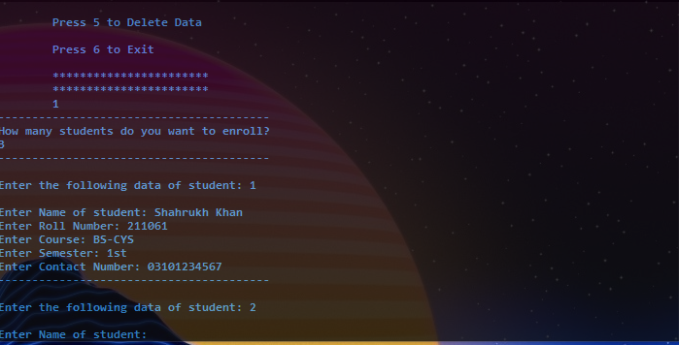

# Displaying

# 

# Searching

# 

# Updating

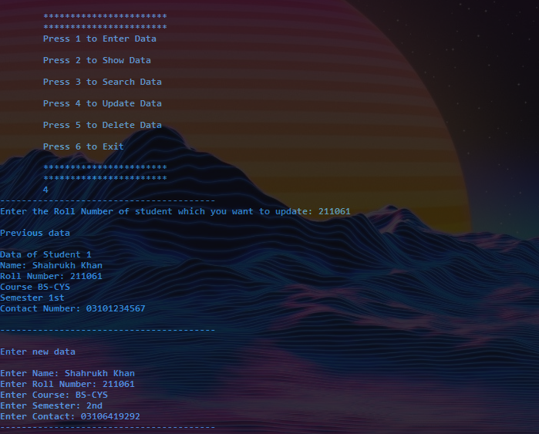

# Deleting

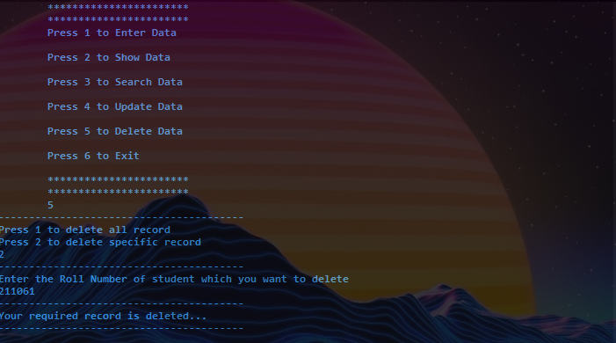

# **THANK YOU**