**Assignment**

* **Code for generating random numbers**

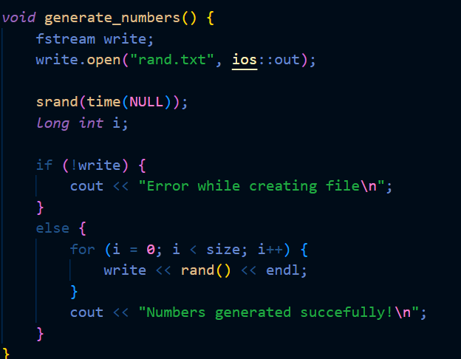

* **Code for writing numbers on file**

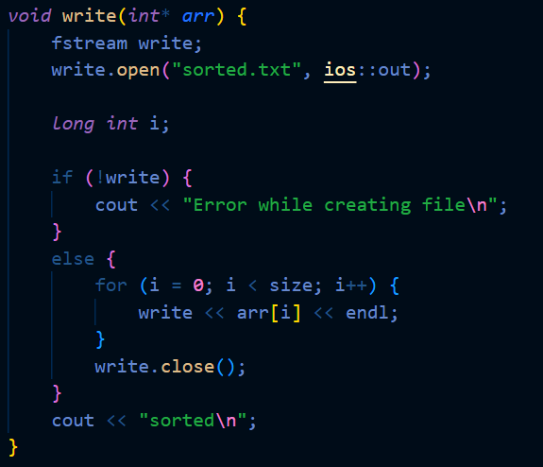

* **Code for reading and storing numbers in an array**

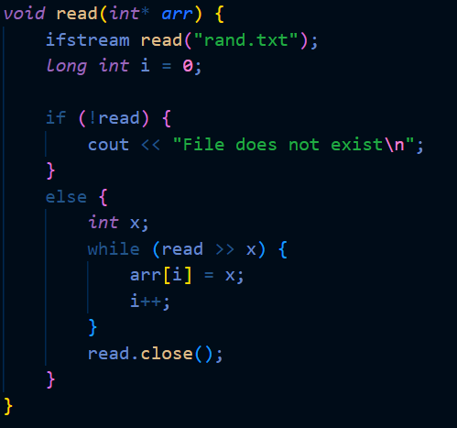

* **To calculate time, I have used “chrono” library**

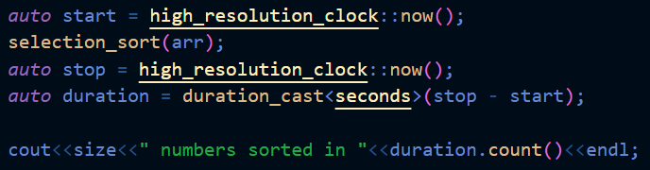

* **To check time taken for different amount of numbers, just change the size and you will get the amount of time taken by sorting function.**

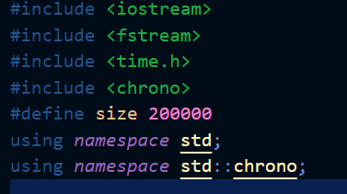

# Selection Sort

* **Code**

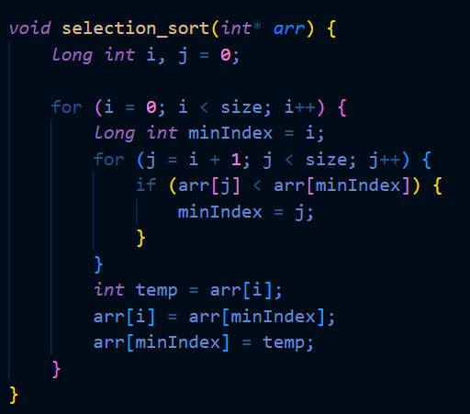

* **Main function**

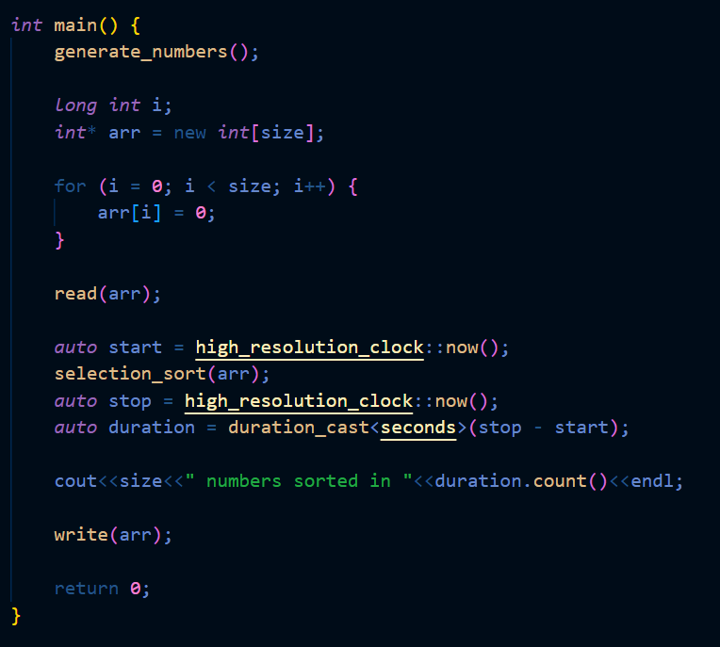

# Merge Sort

* **Code**

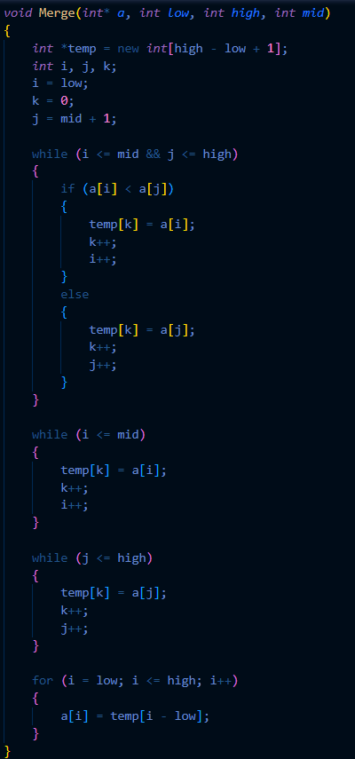

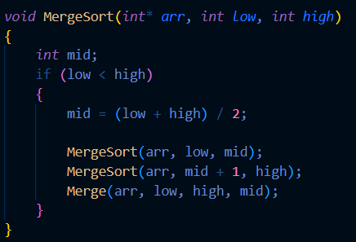

* **Main function**

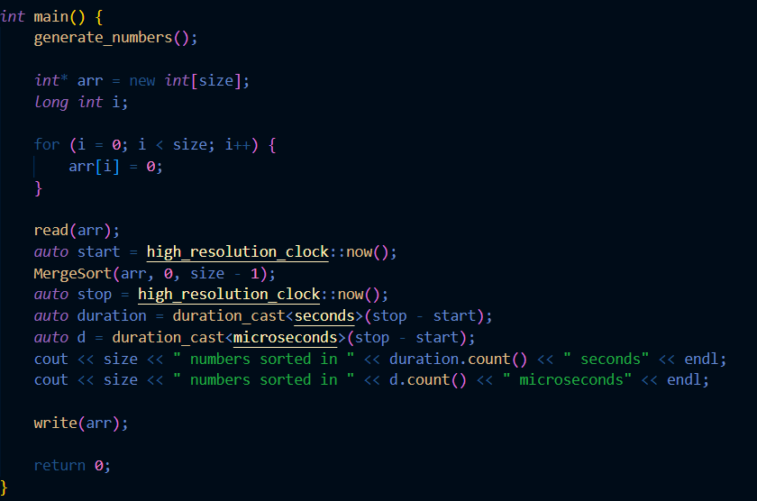

# Results

* **Selection Sort**

Time complexity: O(n*n)

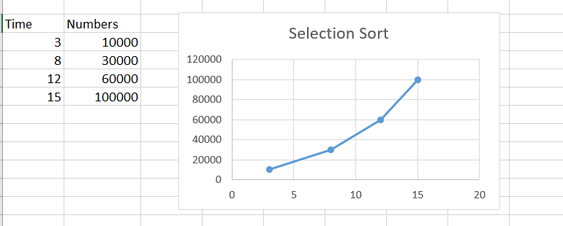

* **Merge Sort**

