**KEYAZ CONSULTANCY**

**MIDTERM II EXAMINATION 2023**

**Age Group (4 – 5 years): MIDDLE CLASS**

**Learning Area 5: Reading**

My name is ______________________________________________

**School: _____________________________________________________**

1. **Circle the correct sound for the pictures.**

|  |  |
| --- | --- |
|  | l p f |
| https://encrypted-tbn2.gstatic.com/images?q=tbn:ANd9GcQDERX1c1ILjZgz3FpQaUcqi_C5Mv00xtjV5h0bzc0IlKuC3SOT | n o t |
|  | p i z |
|  | k s e |
|  | o r g |
|  | u c b |

1. **Match the same syllable and write.**

ha

ba ha __________

ca ga __________

da fa __________

fa ba __________

ga ca ___________

ha da ___________

1. **Read and draw.**

bed

hen

pen

leg

ten

1. **Fill in the missing vowels.**

a, _______, i ______, u

1. **Fill in sound ‘o” and read.**

b ____ y t ___p

d ____ll p ___t

h ___t b ___x

1. **Draw pictures for the syllable.**

ba ma

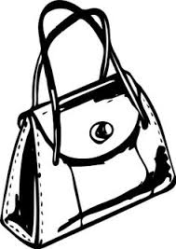

ca

ra

ya

1. **Copy and write.**

**J j J j J j J j**

________________________________________________________________________________________________________________________________________________________________________________________________________________________________________________________________________________________________

**jug jump jim**

________________________________________________________________________________________________________________________________________________________________________________________________________________________________________________________________________________________________

**Where is the jug?**

________________________________________________________________________________________________________________________________________________________________________________________________________________________________________________________________________________________

**END**