**KEYAZ CONSULTANCY**

**MIDTERM II EXAMINATION 2023**

**Age Group (4 – 5 years): MIDDLE CLASS**

**Learning Area 4: Mathematical Concepts**

My name is ______________________________________________

**School: _____________________________________________________**

1. **Count and write.**

A set of __________ chairs.

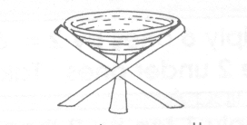 A set of __________ stools.

A set of ________ flowers.

A set of _______ tins.

A set of _______ pot.

1. **Draw for the number.**

**5**

**1**

**4**

**3**

**0**

1. **Write the number between**

0 _____ 2

3 ____ 5

6 _____ 8

9 _____ 11

1. **Write the number before.**

____ 1

____ 2

____ 4

____ 6

____ 8

1. **Write number words.**

5 _____________ 1 ____________

4 ____________ 2 ____________

3 _____________

(one, four, two, five)

1. **Colour the smaller.**

**END**