**KEYAZ CONSULTANCY**

**MIDTERM II EXAMINATION 2023**

**Age Group (4 – 5 years): MIDDLE CLASS**

**Learning Area 3: Health Habits**

My name is ______________________________________________

**School: _____________________________________________________**

1. **Match the same fruits and draw.**

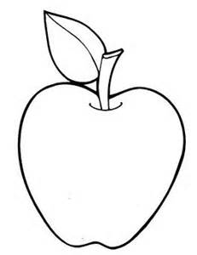 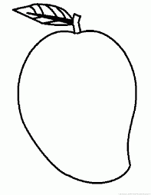 

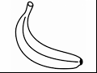 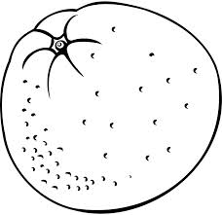

 

 

1. **Fill in the missing letter.**

|  |  |  |
| --- | --- | --- |
| flower | D:\DESKTOP BACKUP\assesst\SAM PICTURES\SAM PICTURES2\home tools products outline\comb.png comb | water |
| flo____er | c___m___ | wat___r |
| D:\DESKTOP BACKUP\assesst\SAM PICTURES\SAM PICTURES2\Human body parts\head.png  head | [http://t0.gstatic.com/images?q=tbn:ANd9GcSuy8S_Lzt-68Wd6soOdMJe2TeVREoDQDpkHYVPdopIBbUZl7UTzjA4jZCGUA](http://www.google.co.ug/imgres?imgurl=http://etc.usf.edu/clipart/19100/19127/soap_19127_lg.gif&imgrefurl=http://etc.usf.edu/clipart/19100/19127/soap_19127.htm&usg=__X2zEXi_NshsM831SBoX1qtRosa4=&h=663&w=700&sz=48&hl=en&start=20&zoom=1&tbnid=kjnNfH9gkO-xyM:&tbnh=133&tbnw=140&ei=HJa2TbyWB8ftOaXSwP4O&prev=/search?q=soap&hl=en&sa=N&gbv=2&tbm=isch&itbs=1) soap | tin |
| h__ad | s___ap | t___n |

1. **Read and draw.**

|  |  |  |  |
| --- | --- | --- | --- |
| fish | cat | sun | ball |
|  |  |  |  |

1. **Match body parts to senses.**

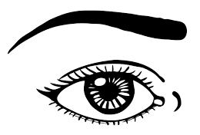

walking

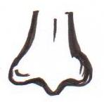

hearing

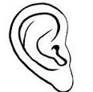

seeing

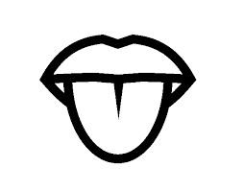

smelling

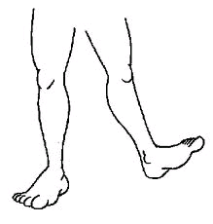

tasting

1. **Complete the sentences.**

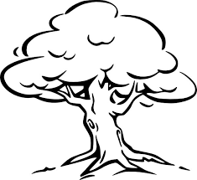

This is a tree.

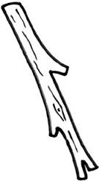

This is a ____________

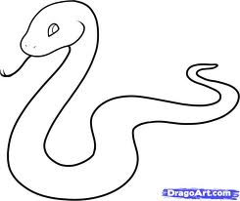

This is a ____________

This is a ____________

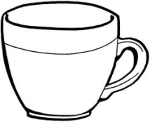

This is a ____________

(snake, cup, stick, pencil)

**END**