**KEYAZ CONSULTANCY**

**MIDTERM II EXAMINATION 2023**

**Age Group (4 – 5 years): MIDDLE CLASS**

**Learning Area 2: English**

My name is ______________________________________________

**School: _____________________________________________________**

1. **Match to the belonging.**

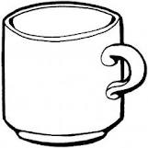

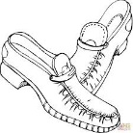

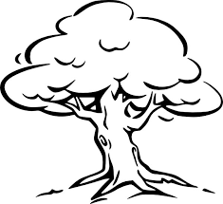

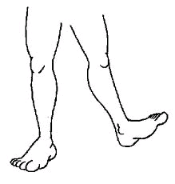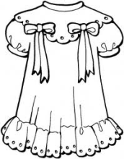

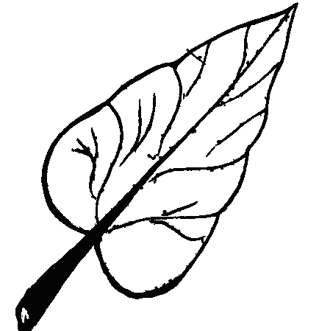

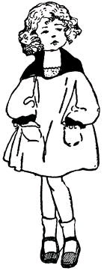

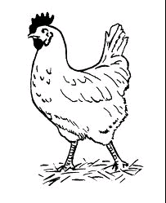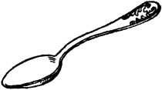

1. **Read and draw these people.**

children teacher

gate keeper school nurse

cook cleaner

school driver

1. **Name these animals.**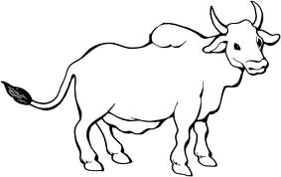

____________

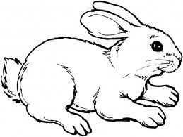

____________

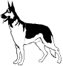

____________

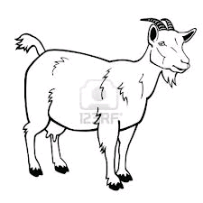

____________

____________

1. **Fill in the missing letters.**

s ___ake z___bra r __t el___p___ant

1. **Match capital to small lettered words and draw.**

A hut ________

B girl ________

C fish ________

E book ________

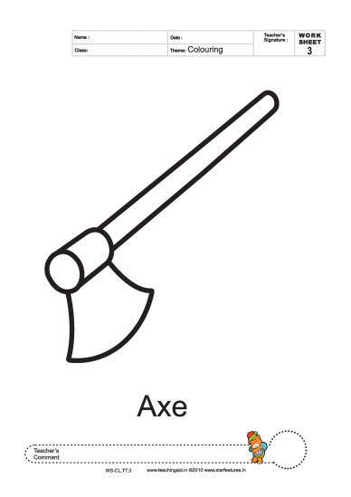

F axe _______

G egg _______

H cup ________

**END**