**LOHANA SCHOOLS**

**BABY CLASS WORK TWO (ACTIVITY FOUR) 2020**

**Name: ……………………………………………………..Stream:…………**

Developing and using my language appropriately.

1. Read colour and copy.

|  |  |  |  |
| --- | --- | --- | --- |
|  | s |  |  |
|  |  |  |
|  |  |  |
|  |  |  |
|  | c |  |  |
|  |  |  |
|  |  |  |
|  |  |  |

1. Match the same letters and copy.

a f ___________

b e ___________

c a ___________

d b ___________

e c ___________

1. Put the missing parts.
2. Match the same pictures

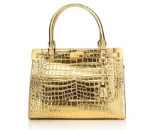 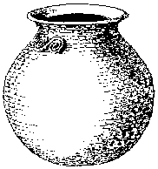

 

 





1. Copy these letters.

|  |  |  |  |  |  |
| --- | --- | --- | --- | --- | --- |
| b | c | a | d | f | e |
|  |  |  |  |  |  |

1. Sound and write.

|  |  |  |  |  |
| --- | --- | --- | --- | --- |
|  |  |  |  |  |
|  |  |  |  |  |
|  |  |  |  |  |

1. Sound and write.

a + i p

a

1. Circle the same.

S + S

i i n

p o p

1. Match the same.

S i a n

t s

p a

n t

i p

1. Circle the same pictures.

  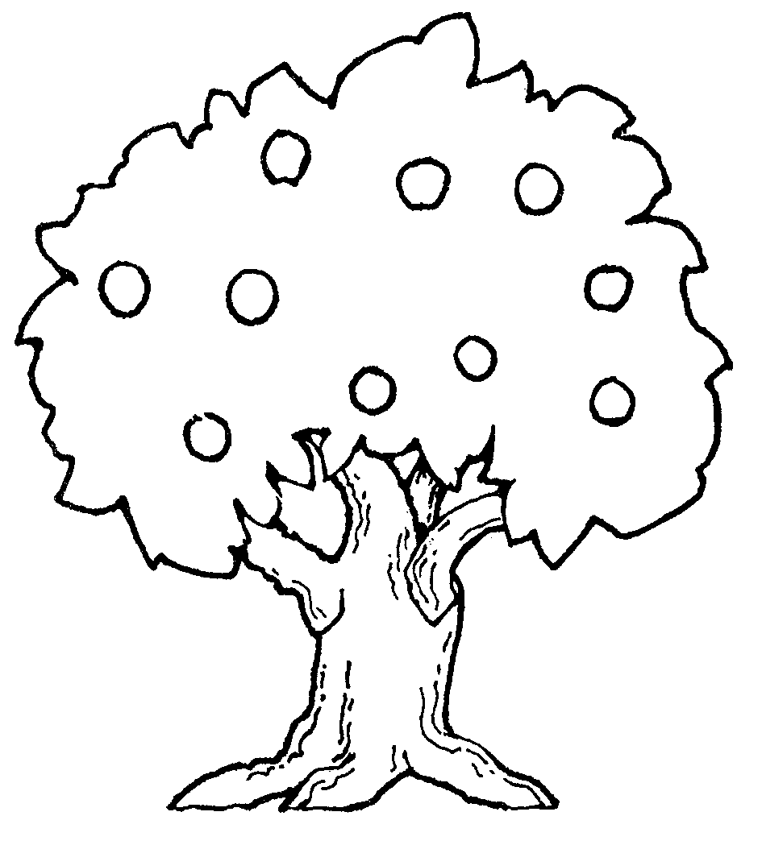

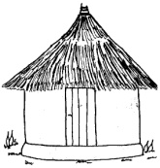  

[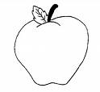](http://images.google.co.ug/imgres?imgurl=http://clear.msu.edu/dennie/clipart/apple.gif&imgrefurl=http://clear.msu.edu/dennie/clipart/&usg=__zaO4hKg4thqaN1PPKE-yW5TvFkg=&h=368&w=400&sz=3&hl=en&start=5&um=1&itbs=1&tbnid=mTx1QthmAz42JM:&tbnh=114&tbnw=124&prev=/images?q=clipart+apple&tbnid=y6sWcICiB7tbwM:&tbnh=0&tbnw=0&um=1&hl=en&rlz=1T4GZEZ_en-GBIL287IL288&tbs=isch:1)

1. Copy and learn.

_________________________________________________

_________________________________________________

_________________________________________________

_________________________________________________

_________________________________________________

_________________________________________________

________________________________________________

Copy and learn.

_________________________________________________

_________________________________________________

_________________________________________________

_________________________________________________

_________________________________________________

_________________________________________________

_________________________________________________

_________________________________________________

Copy and learn.

____ _____ ______ _____

1. Developing and using mathematical concept in my day to day experience.

Shade the shapes.

1. Count and write.

0 1 2 3

4 5

1. Match the same shapes.
2. Match the same numbers and copy.
3. 5
4. 4
5. 1
6. 2
7. 3
8. Circle the same numbers.

2 3

0 2 3 9

1 5

6 7

6 0 8 2

4 7

1. Interacting with Exploring knowing and using my environment.

Shade a cup.



Draw a cup.

1. Colour a pot.

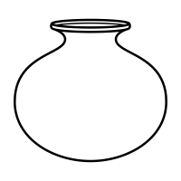

Draw a pot

1. Match things at home.

[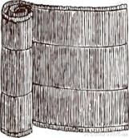](http://thumbs.dreamstime.com/z/rolled-mat-28272238.jpg) [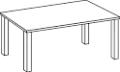](http://www.google.co.ug/url?url=http://www.clker.com/clipart-table-line-art.html&rct=j&frm=1&q=&esrc=s&sa=U&ved=0CBcQwW4wAWoVChMI2qTfjqD5xwIVhb8UCh0sYQ1q&sig2=3nvz0tM1XDN3YNhZvCl77A&usg=AFQjCNFZeU6GBseckyDQWi4P3LIYffBTQw)

 





[](http://www.google.co.ug/url?url=http://www.clker.com/clipart-table-line-art.html&rct=j&frm=1&q=&esrc=s&sa=U&ved=0CBcQwW4wAWoVChMI2qTfjqD5xwIVhb8UCh0sYQ1q&sig2=3nvz0tM1XDN3YNhZvCl77A&usg=AFQjCNFZeU6GBseckyDQWi4P3LIYffBTQw) [](http://thumbs.dreamstime.com/z/rolled-mat-28272238.jpg)

Shade a cat.

