**KEYAZ CONSULTANCY**

**MIDTERM II EXAMINATION 2023**

**Age Group (3 – 4 years): BABY CLASS**

**Learning Area 4: Mathematical Concepts**

My name is __________________________________________

1. **Match the same and write.**

0 4 4

3 2 ______

1 5 ______

4 3 ______

5 0 ______

2 1 _______

1. **Copy and write.**

|  |  |  |  |  |
| --- | --- | --- | --- | --- |
| **6** | **7** | **8** | **9** | **10** |
|  |  |  |  |  |
|  |  |  |  |  |
|  |  |  |  |  |
|  |  |  |  |  |

1. **Circle the correct number.**

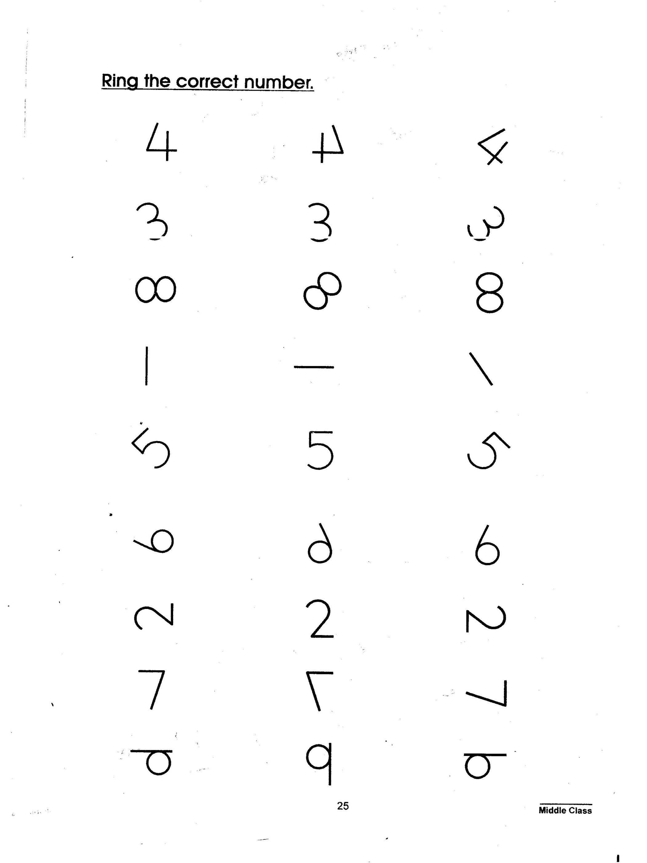

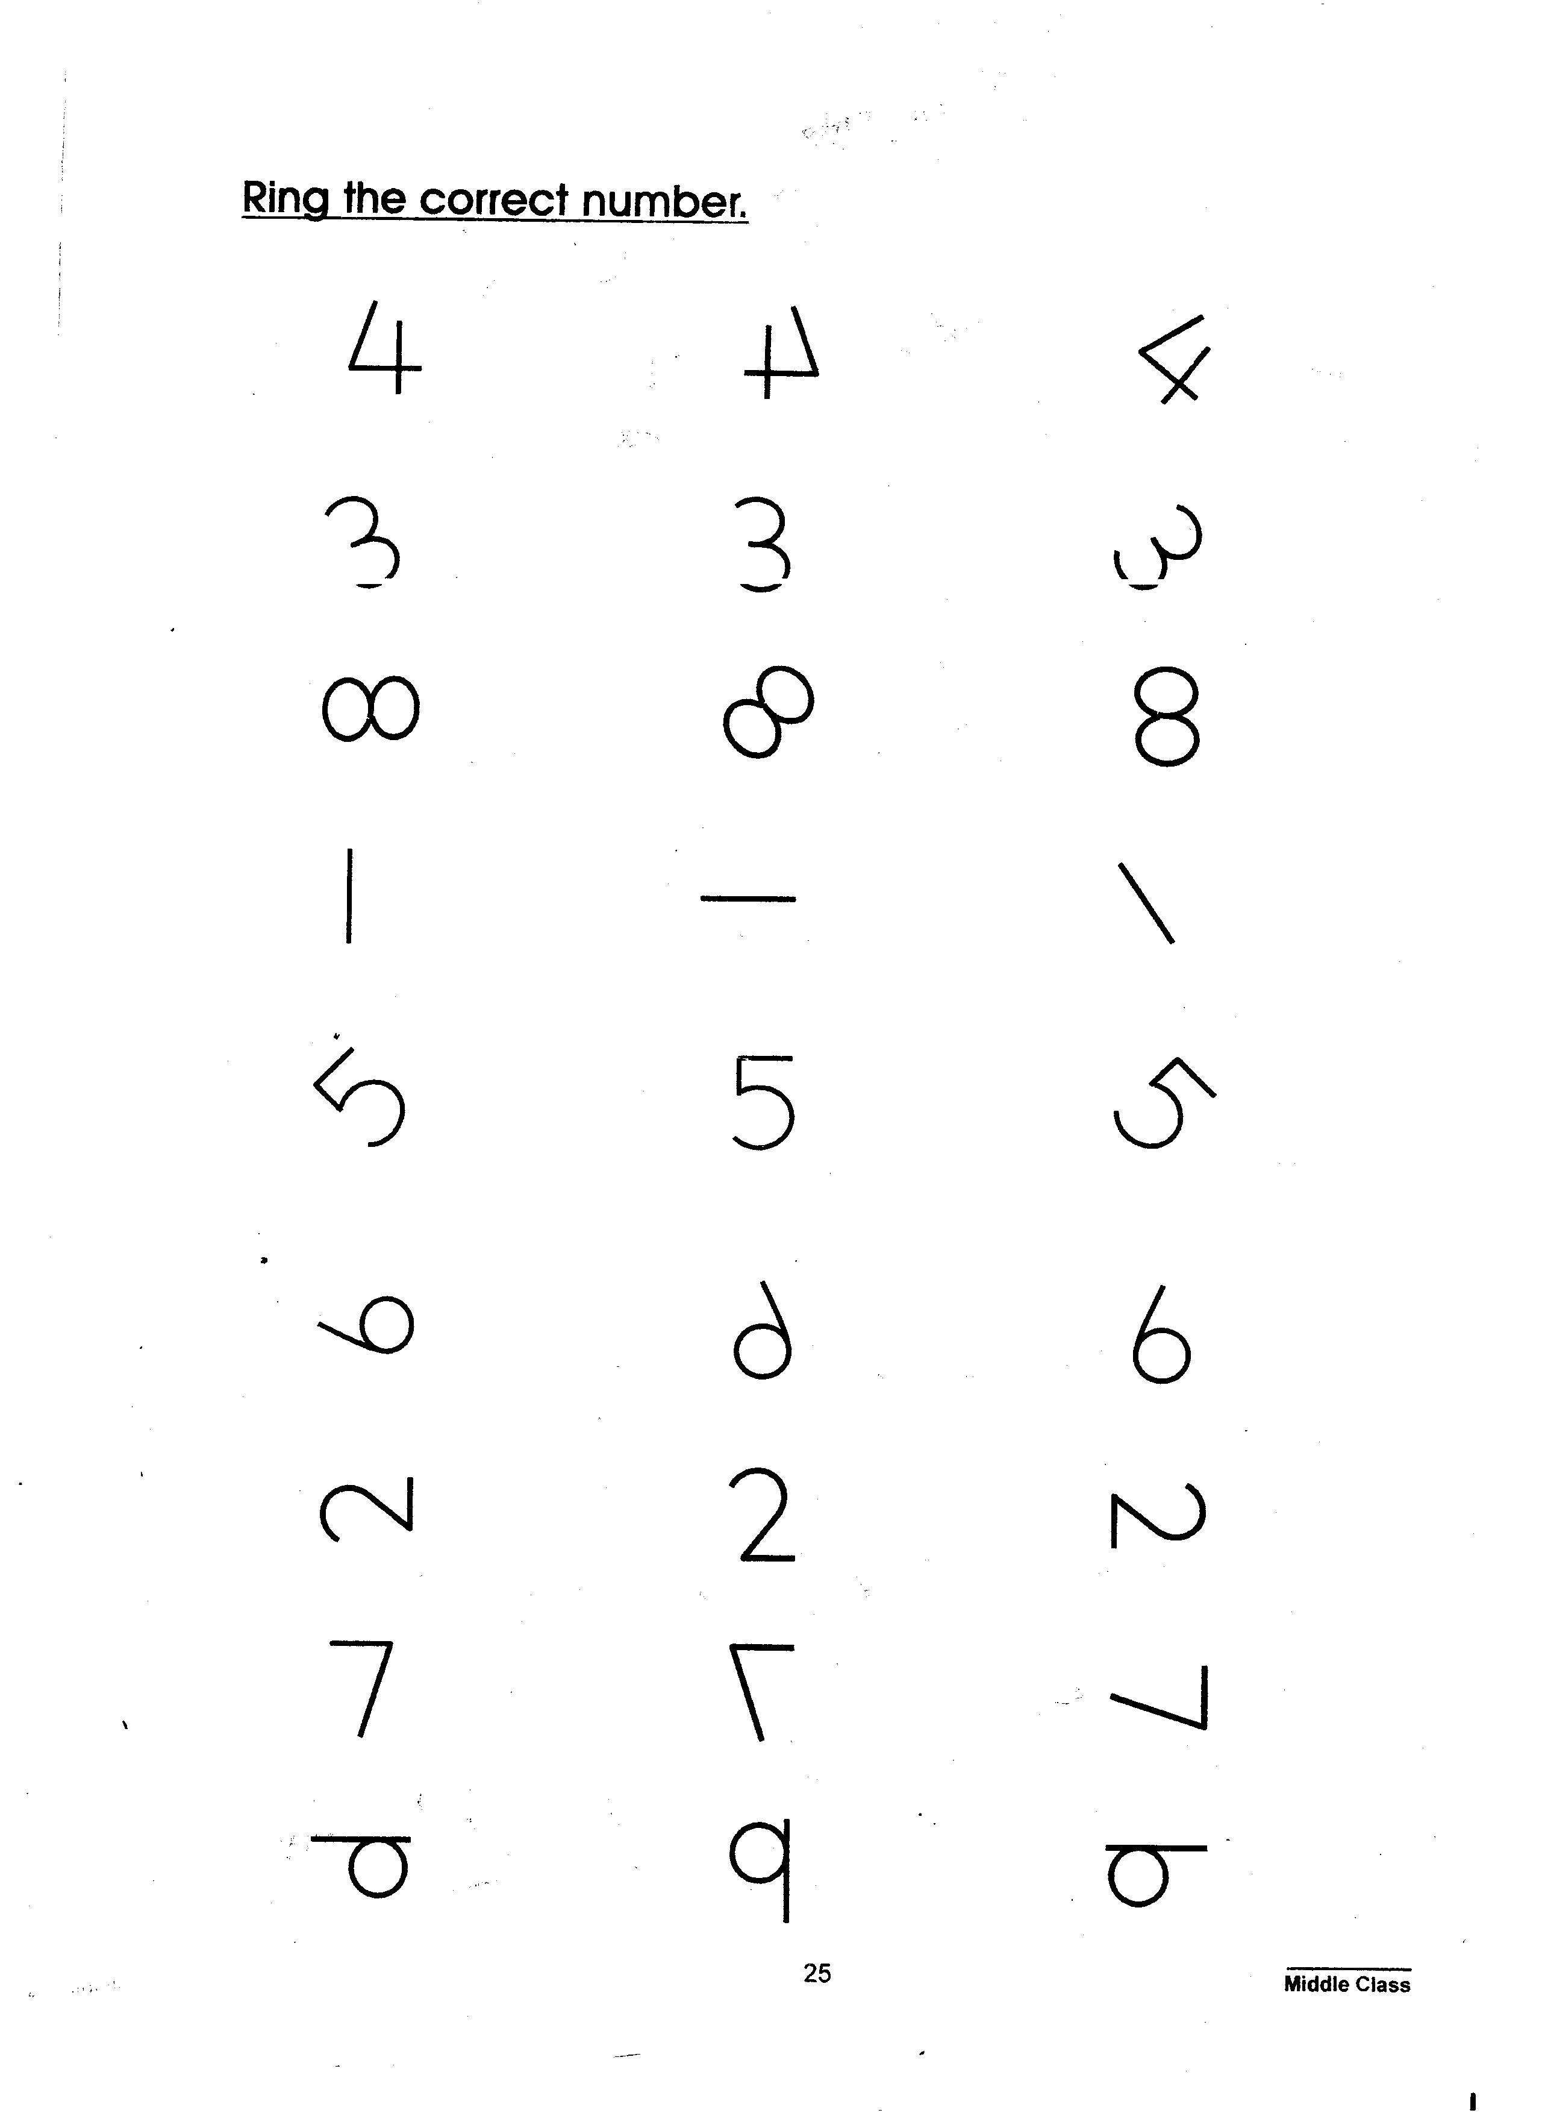







1. **Count and match.**

4

3

6

1. **Count and write.**

= _____________

= ______________

= ______________

**End**