**KEYAZ CONSULTANCY**

**MIDTERM II EXAMINATION 2023**

**Age Group (3 – 4 years): BABY CLASS**

**Learning Area 2: English**

My name is __________________________________________

1. **Copy and draw.**

|  |  |  |  |
| --- | --- | --- | --- |
| https://encrypted-tbn3.gstatic.com/images?q=tbn:ANd9GcSpoWpwb-eqqPRCRUsOMsISBCh6cMOiElbbKI_79KmEcR5N6-99 |  | E:\EXAMS\oasis\OBAMA\egg.png |  |
|  |  |  |  |

1. **Match the same.**

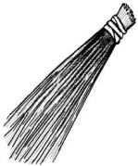 [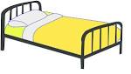](http://www.google.co.ug/imgres?imgurl=http://upload.wikimedia.org/wikipedia/commons/b/ba/Steel_bed.svg&imgrefurl=http://commons.wikimedia.org/wiki/File:Steel_bed.svg&usg=__mdgvI0X7DyZueT0pmxXyBI5Pu6A=&h=686&w=1208&sz=7&hl=en&start=4&zoom=1&tbnid=sL4q61u3ytIKMM:&tbnh=85&tbnw=150&ei=c3x-UYCjBa3n4QT5tYFQ&prev=/search?q=bed&hl=en-UG&gbv=2&tbm=isch&itbs=1&sa=X&ved=0CDAQrQMwAw)

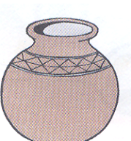 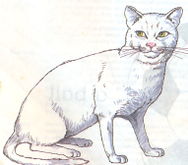

[](http://www.google.co.ug/imgres?imgurl=http://upload.wikimedia.org/wikipedia/commons/b/ba/Steel_bed.svg&imgrefurl=http://commons.wikimedia.org/wiki/File:Steel_bed.svg&usg=__mdgvI0X7DyZueT0pmxXyBI5Pu6A=&h=686&w=1208&sz=7&hl=en&start=4&zoom=1&tbnid=sL4q61u3ytIKMM:&tbnh=85&tbnw=150&ei=c3x-UYCjBa3n4QT5tYFQ&prev=/search?q=bed&hl=en-UG&gbv=2&tbm=isch&itbs=1&sa=X&ved=0CDAQrQMwAw) 

 

1. **Cross the odd man out.**

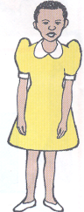 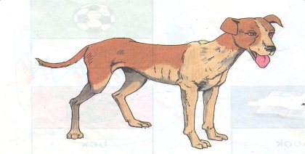 

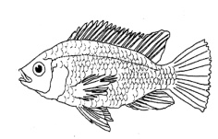

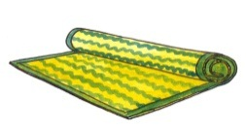  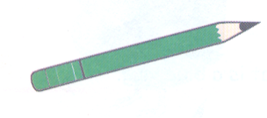

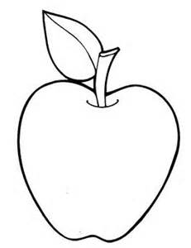

1. **Match letters to words.**

a mat

b pot

c table

m cat

p axe

t box

**End**