

Top class: **Holiday Work**

**Name**: ____________________________________________________

1. **Read, match and copy these action words**

walk write ________________________

eat speak _______________________

read come ________________________

write jump ________________________

stand walk ________________________

dance sweep ________________________

come eat ________________________

speak greet ________________________

jump read ________________________

sweep stand ________________________

laugh wash ________________________

kneel cook ________________________

greet laugh ________________________

cook kneel ________________________

wash dance _________________________

1. **Match sounds to words and write.**

ie toy____________

ng cream_________

ai spoon___________

ch pie______________

ck swing___________

sm air______________

ay chin____________

gi deck___________

sp smile___________

cr pay____________

ay glimp___________

1. **Name the source of sound**

baa:___________________

sss:____________________

quack:_________________

woof:___________________

aaa:____________________

zzz:_____________________

1. **Make sentences using “and”.**

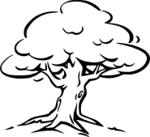 **a tree and a stone**

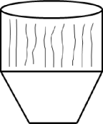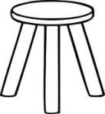 **____________________________________________**

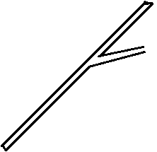 **____________________________________________**

****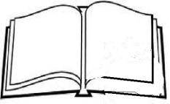**_________________________________________**

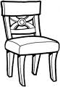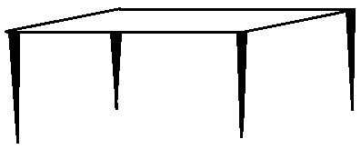**_______________________________________**

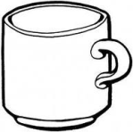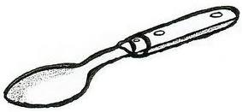**______________________________________**

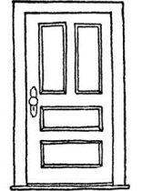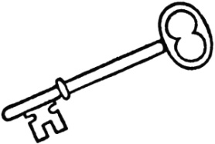**______________________________________**

1. **Draw these fruits**

|  |  |  |  |  |
| --- | --- | --- | --- | --- |
| Pineapple | Watermelon | banana | mango | Orange |
|  |  |  |  |  |

1. **Make sentences using the given words**
2. annoy: ______________________________
3. coin: ________________________________
4. spoil: ________________________________
5. how: ______________________________
6. flower pot: _________________________
7. now: _______________________________
8. loud: _______________________________
9. mouth: ______________________________
10. our: ________________________________
11. enjoy: _______________________________
12. **Make sentences using the table**

|  |  |  |  |
| --- | --- | --- | --- |
| I  They  She | can | write  dance | well  happily  nicely |

______________________________________________

_______________________________________________

_______________________________________________

_______________________________________________

________________________________________________

1. **Match the word to its starting sound**

black gr

frost sw

brush bl

grant kn

strain tr

swift sl

spoil br

wrong str

kneel dr

treat fr

drink wr

slumber sp

1. **Name these shapes**

|  |  |  |  |
| --- | --- | --- | --- |
|  |  |  |  |
|  |  |  |  |

1. **Write the next number**

0 __________ 6 _________ 3 __________

8 __________ 5 _________ 8 __________

11 __________ 9 _________ 14 _________

13 __________ 2 _________ 7 __________

1 ___________ 10 ________ 4 __________

18 __________ 12 ________ 15 _________

1. _________ 17 ________ 19 _________
2. **Name these pictures**

Broom, rake, mop slasher

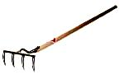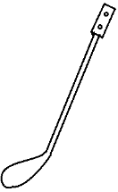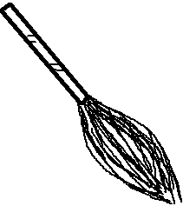

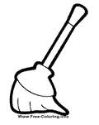

1. **Read and draw dangerous this**

fire

stone

needle

pin

razorblade

Safety pin

nail

stick

1. **Read the story and answer questions**

One day, **Pocha** went to his **farm**. It had very many animals such as **Cows, Goats, sheep and rabbits**.

As he was moving around the farm, he saw a **big** **snake** near the rabbits. Pocha was so scared thinking that the snake might bite his rabbits. So he ran very fast with a **big stick** and killed it

**Answer questions about the story**

1. What is the name of the man in the story?

_____________________________________

1. Write four animals found at pocha’s farm.
2. _______________ (ii) ____________
3. ________________ (iv)____________
4. As pocha was moving he saw a __________
5. What did he use to kill the snake?

Pocha used _____________________

1. Draw and name any dangerous animal you know
2. **Make sentences from the given table**

|  |  |  |
| --- | --- | --- |
| She  He | is | running  playing  carrying  sleeping  sitting |
| They | are |

She ___________________________________

_______________________________________

_______________________________________

_______________________________________

­­­­­­­­­­­­­­­­_______________________________________

He ______________________________________

________________________________________

________________________________________

________________________________________

________________________________________

They _____________________________________

________________________________________

________________________________________

________________________________________

­­­­­­­­­________________________________________

1. **Add these numbers**

6 3 = 5 5 =

7 1 = 3 2 =

2 2 = 9 1 =

1 1 = 3 3 =

9 0 = 6 4 =

4 4 = 8 1 =

6 1 = 7 3 =

1. **Read and match these**

20 twenty nine

21 thirty

26 twenty

29 twenty six

30 twenty one

19 twenty seven

3 fifteen

27 thirteen

15 three

13 nineteen

1. **Write numbers (1-30)**

|  |  |  |  |  |  |  |  |  |  |
| --- | --- | --- | --- | --- | --- | --- | --- | --- | --- |
| 1 |  |  |  |  |  |  |  |  |  |
|  |  |  |  |  |  |  |  |  |  |
|  |  |  |  |  |  |  |  |  |  |

* **END -**