

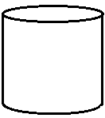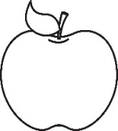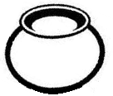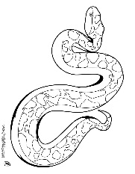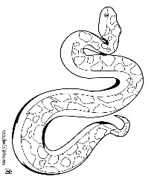**BABY CLASS: HOLIDAY WORK**

1. **Match the same pictures**

1. **Colour**

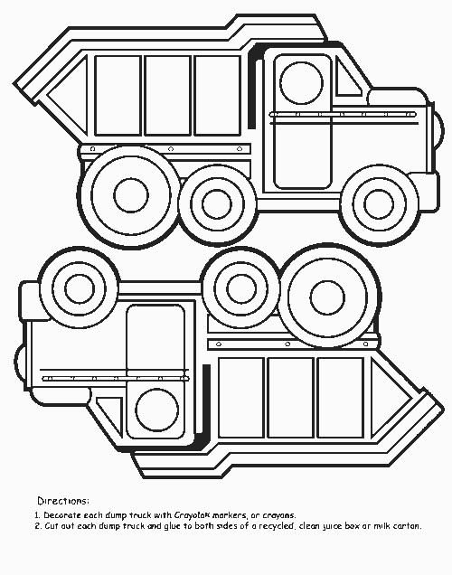

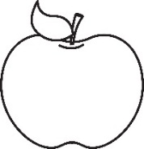

1. **Write over**

s n

a p

t i

i t

p a

n s

1. Count number orally

|  |  |  |  |  |
| --- | --- | --- | --- | --- |
| 1 | 2 | 3 | 4 | 5 |

1. Colour
2. Write over the shapes
3. Shading is fun

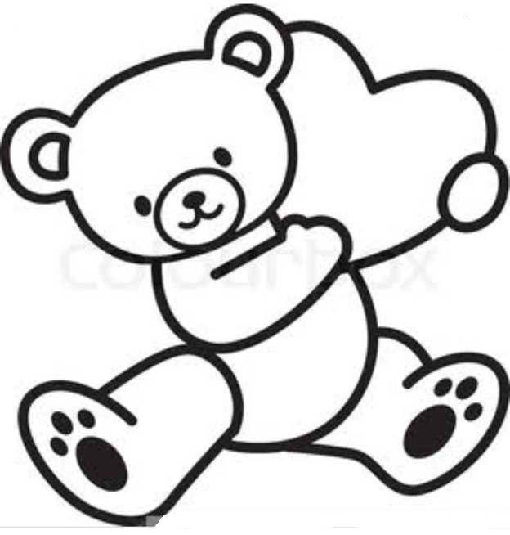

1. Copy the same

|  |  |  |  |  |  |  |  |
| --- | --- | --- | --- | --- | --- | --- | --- |
| 0 | 1 | 0 | 1 | 0 | 1 | 0 | 1 |
|  |  |  |  |  |  |  |  |
|  |  |  |  |  |  |  |  |
|  |  |  |  |  |  |  |  |
|  |  |  |  |  |  |  |  |
| a | t | a | t | a | t | a | t |
|  |  |  |  |  |  |  |  |
|  |  |  |  |  |  |  |  |
|  |  |  |  |  |  |  |  |
|  |  |  |  |  |  |  |  |

1. Colour the birthday gift

1. Copy and write

|  |  |  |  |  |  |
| --- | --- | --- | --- | --- | --- |
|  |  |  |  |  |  |
|  |  |  |  |  |  |
|  |  |  |  |  |  |
|  |  |  |  |  |  |
|  |  |  |  |  |  |
|  |  |  |  |  |  |
|  |  |  |  |  |  |
|  |  |  |  |  |  |
| 2 | 2 | 2 | 2 | 2 | 2 |
|  |  |  |  |  |  |
|  |  |  |  |  |  |
|  |  |  |  |  |  |
|  |  |  |  |  |  |
|  |  |  |  |  |  |
|  |  |  |  |  |  |
|  |  |  |  |  |  |
|  |  |  |  |  |  |
|  |  |  |  |  |  |
|  |  |  |  |  |  |
|  |  |  |  |  |  |

-End-