

**MIDDLE CLASS : HOLIDAY WORK**

**Name: ……………………………………………………………**

1. **Copy and read these sounds.**

g p oo n st ai

___ ___ ___ ___ ____ ____

___ ____ ____ ____ ____

ch v m qu ee

**yo**

**pr**

**z**

**sh**

**y**

**oo**

**st**

**oo**

**tr**

**sh**

**pr**

**z**

**x**

**w**

**ee**

**ee**

**ee**

**oo**

**oo**

**oo**

**sh**

**sh**

**sh**

**sh**

1. **Sound, read and match.**

cat 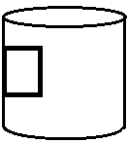

mat 

tin 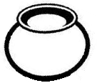

sun 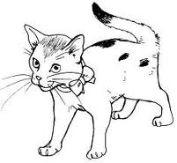

pot 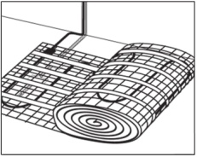

1. **Write 5 sounds you know.**

  

1. **Copy and write.**

|  |  |  |  |  |  |  |  |  |  |
| --- | --- | --- | --- | --- | --- | --- | --- | --- | --- |
| 00 0 | 1 | 2 | 3 | 4 | 5 | 6 | 7 | 8 | 9 |
|  |  |  |  |  |  |  |  |  |  |

|  |  |  |  |  |  |  |  |  |  |
| --- | --- | --- | --- | --- | --- | --- | --- | --- | --- |
| 00 10 | 11 | 12 | 13 | 14 | 15 | 16 | 17 | 18 | 19 |
|  |  |  |  |  |  |  |  |  |  |

1. **Count and match.**

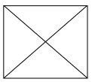 **6**

** 8**

** 5**

** 3**

** 7**

** 4**

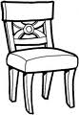 **2**

** 1**

1. **Copy and read sentences.**

It is a book.

__________________________________________

It is a pot.

_________________________________________

It is a bed.

_________________________________________

It is a roof.

________________________________________

This is a cup.

________________________________________

It is a mat.

_________________________________________

1. **Write numbers 0 – 13.**



0

0

1. **Match sound to a word and write.**

sh clock_______

oo tree_______

s pot_______

th book______

p set________

ee short_______

ck tooth______

1. **Count and write.**

**= = = = =**

1. **Read the sounds.**

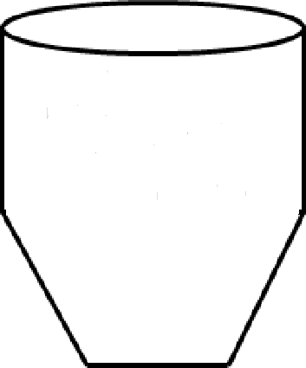

s a t I p n ck e h r m d g o u l f b j oa z w v th y ee x qu ch oo sh ck

1. **Fill in sound “oo” and read.**

b ___ ___ k r ___ ___ t l ___ ___ k

g ___ ___ d t ___ ___ f ___ ___ t

s ___ ___ n st ___ ___ l z ___ ___

1. 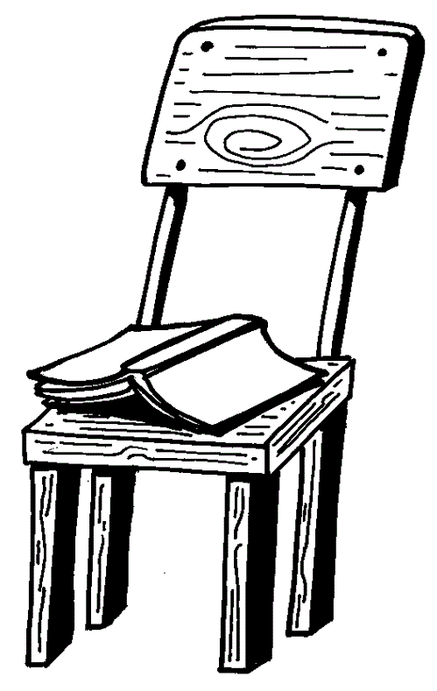**Write the correct preposition.**

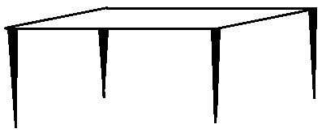



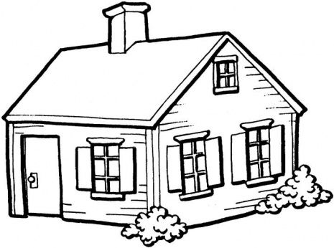

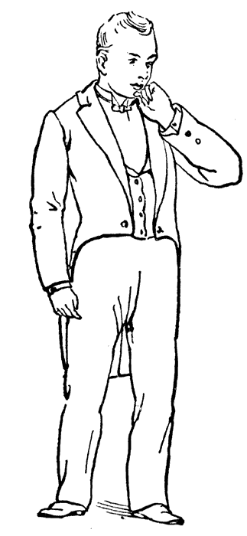

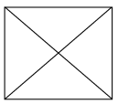



**(near, between, in, under, on)**

1. **Match the same and name**

 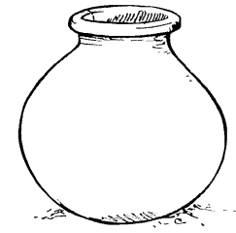________

 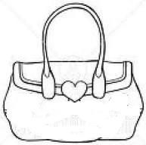_______

 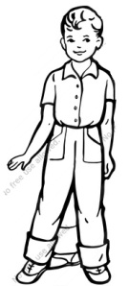 _________

 __________

 ________

**(sun, pot, tree, boy, bag)**

1. **Copy the numbers.**

**man**

0 1 2 3 4 5 6 7 8 9

11 12 13 14 15 16 17 18 19 20

1. **Count and write.**









**-End-**