**ITEM ONE**

**Section A**

1. Name the element of a map that enables a person to locate a place.

2. How can crop farming be encouraged in Kotido District?

3. Give one problem caused by strong winds to the community.

4. What is the major cause of land conflicts in Uganda?

5. Mention the traditional cash crop that grows well in Kalangala District.

6. State the main human activity which reduces the number of animals in game parks in East Africa.

7. What are wetlands?

8. Why is Fort Patiko important in the history of Uganda?

9. Explain why there were fewer rebellions in Uganda compared to the other countries in East Africa.

10. Give one reason why colonialists introduced the growing of cash crops in Africa.

11. Why is Paul Mukasa remembered in the history of Uganda?

12. In which one way is budgeting important to a school?

13. Explain one economic factor that made the Africans to demand for their independence.

14. How is a national identity card helpful to a citizen of Uganda?

15. State one importance of Port Dar-Es- Salaam to the people of Tanzania?

16. Give one reason why some parts of the Nile river are navigable.

17. How is uncontrolled lumbering dangerous to the environment?

18. Why areas around the Kenya Highlands suitable for dairy farming?

19. Mention the main reason why the government of Uganda is discouraging her population from settling around highlands.

20. Which discovery marked the end of the stone age period?

21. State one problem caused by over population in Kabale District.

22. In which was the German colonial rule made unpopular in Tanganyika?

23. Explain the main contribution of Sir Walter Cotts as a British governor in Uganda.

24. How will the construction of the Great North Road help the people of Uganda and South Sudan?

25. What is a continent?

26. How is the Akasombo dam important to the people of Ghana?

27. Why do people living in and around the Sahara Desert put on light clothes?

28. State one difference between the tropic of cancer and the tropic of Capricorn in terms of location.

29. Name the tropical grassland of South Africa.

30. How are the Ngoni and the Chagga of Tanzania similar in terms of tribal grouping?

31. In which one way did the triangular trade affect the people of West Africa?

32. Name any one commission under the former OAU.

33. Why are radios more widely used than televisions in Uganda?

34. Name the ministry in the government of Uganda that handles refugee problems.

35. Under what type of weather will a traveller sit under a tree for protection?

**For each of the questions 36 – 40, answer either Christianity or Islamic questions but not both. No marks will be awarded to a candidate who attempts both alternatives in a number.**

36. **Either:** According to the Old Testament, who was the first murderer on earth?

**Or:** According to the Islamic faith, which animal is forbidden to be eaten by Muslims?

37. **Either:** Why is respect very important among Christian communities?

**Or:** Why is respect very important among Muslim communities?

38. **Either:** Mention the name given to the first five books of the Old Testament.

**Or:** Mention the prophet in Islam to whom Allah revealed the book of Tauret.

39. **Either:** Why is circumcision very important among Muslims in Uganda today?

**Or:** Why is circumcision very important to Muslims?

40. **Either:** State one reason why Jesus was considered a saviour by Christians.

**Or:** Why do Muslims make a pilgrim to Mecca?

**Section B**

41(a) Write short notes about the following:

(i) bank .................

(ii) fake currency ..............

(b) Why should the government of Uganda fight against the circulation of fake currency?

(c) Which bank in Uganda is responsible for producing new currency?

42(a) State the term used to refer to the extraction of fish from water bodies.

(b) Suggest any two measure the government of Uganda has put in place to control the catching of young fish from lakes in Uganda.

(c) In which are the fish caught helpful to the people of Uganda?

43. **The diagram below shows a farming practice.**

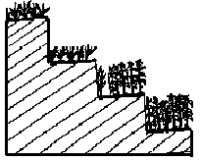

(a) Name the farming practice shown in the diagram above.

(b) Identify one area in Uganda where the practice is carried out.

(c) Give a reason why it is necessary for people living in that area to carry out the practice.

44(a) Write OAU in full.

(b) Which organisation has replaced OAU?

(c) Give any one reason why the OAU was formed.

(d) In which one way are annual meetings of the African Union benefiting the member states?

45(a) Define the term independence.

(b) State any two advantages African states enjoyed after getting independence.

(c) Identify the new form of colonialism being used on Africa by developed countries.

46(a) What is a ranch?

(b) State one activity that can be carried out on a ranch.

c) Give one reason why veterinary assistants are needed on a ranch.

(d) Identify one product got from a ranch.

47(a) Define the word tax.

(b) Mention one type of tax collected in Uganda.

(c) How does the government use the money collected from taxes?

(d) How does the smuggling of goods from and into the country affect its economy?

48(a) What is a weather station?

(b) Mention any two elements of weather.

(c) In which are the spaces left in a Stevenson screen important?

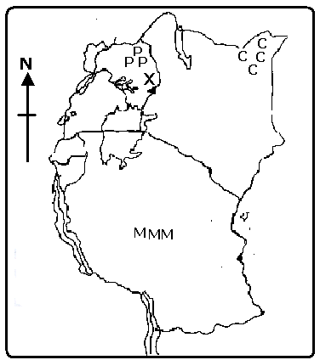49. **Use the map below to answer the questions that follow.**

(a) Give the main economic activity carried out in the area marked C C C.

(b) State any one reason why area marked P P P is sparsely populated.

(c) How was mountain marked X formed?

(d) Why is area marked M M M not able to support animal rearing?

50. **The table below shows the amount of rainfall and temperature for the city of Durban. Use it to answer the questions that follow.**

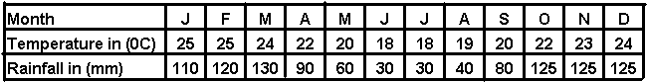

(a) What was the highest temperature recorded in Durban during that period?

(b) In which month did Durban receive the lowest amount of rainfall?

(c) Why is not good for residents living in Durban to plant crops in the month of May?

(d) Calculate the average amount of rainfall Durban received that year.

**For each of the questions 51 – 54, answer either Christianity or Islamic questions but not both. No marks will be awarded to a candidate who attempts both alternatives in a number.**

51. **Either:** (a) In which two way does Christianity help to solve the body needs of its followers?

(b) State any one way a Christian can help to people in need.

(c) Which parable did Jesus use to show that neighbours should help their friends in need?

**Or:** (a) What is zakat?

b) Give two ways zakat is given in Islam.

(c) Mention benefit Muslims get from paying zakat.

52. **Either:** (a) In which did God destroy sinners in Noah’s time?

(b) Mention two of Noah’s children.

(c) How did Noah and his family escape God’s punishment?

**Or:** (a) How did Allah punish sinners during prophet Nuhu’s time?

(b) Mention two of prophet Nuhu’s children.

(c) How did prophet Nuhu escape Allah’s punishment?

53. **Either:** “It was written that you should not tempt your God.”

(a) Who said the above words?

(b) Where was he when he said those words?

(c) To whom did he say those words?

(d) What lesson does a Christian learn from that experience?

**Or:** (a) What is Hadith?

(b) Why did prophet Muhammad pronounce Hadiths?

(c) Give two examples of Hadiths prophet Muhammad pronounced.

54. **Either:** (a) Define the word church.

(b) Why are the following people remembered in Christianity?

(i) St. Peter

(ii) St. Stephen

(b) Give one problem faced by Jesus’ followers in the early church.

**Or:** (a) What is Jihad.

(b) Why are the following people remembered in Islam?

(i) Abu Baker

(ii) prophet Ibrahim

(b) Give one problem early converts of Islam faced.

5. **Either:** (a) What is pass-over?

(b) Why did Moses order Israelites to stain their doorposts with blood on the night of the pass-over?

(c) What punishment did the Egyptians get on the night of the pass-over?

(d) Why didn’t Moses reach the Promised Land?

**Or:** (a) Define the word Nikkah.

(b) Mention two things that can nullify marriage in Islam.

(c) Give one requirement that should fulfilled before marriage takes place in Islam.

**END**

**ITEM TWO**

**SECTION A (40 MARKS)**

1. Name the water body which separates Africa from Europe.

2. Give the school symbol where the distance to the school is written.

3. What causes land forms in an area?

4. Name the place where District head offices are found.

5. Which element of a map helps to interpret symbols?

6. How can the government of Uganda help people affected by landslides?

7. Why are most African countries depending on developed countries?

8. Name the local raw material used in making mats.

9. Name the common fish caught from East African lakes.

10. Give one reason why markets are important to farmers.

11. What was the cause of the Great Trek in South Africa?

12. Name any one subject that helps children develop their talents.

13. How can farming be possible in the drier parts of Uganda?

14. Why did the Africans want to rule their own countries?

15. Name any one material on which trade was developed during Pre-colonial Uganda.

16. Name any one country through which the Trans Africa High way passes.

17. How did the coming of Europeans interfere with the African culture?

18. Why are children encouraged to greet elders?

19. Give one reason why people save money.

20. Write ECOMOG in full.

21. How can a community help to care for a nearby church?

22. Give one way how child labour affects the progress of education in Uganda.

23. Which type of family consists of father, mother and their biological children?

24. Why are game rangers important in Game parks?

25. What is population?

26. How did the introduction of cash crops improve the life of Ugandans?

27. Give one importance of Jos plateau to the people of Nigeria.

28. How does the availability of Employment in a country promote development?

29. Write down any one role of local leaders towards education?

30. Name any one raw material for pottery industry.

31. In which one way is planted vegetation helping people to develop economically in Uganda?

32. Why is mining in East Africa not fully developed?

33. State one advantage of Multi – party system of governance.

34. Write one way the government of Uganda is ensuring proper health among children.

35. A part from Mass media, state one other way the government programmes are passed on to people.

**For question 37 – 40, answer either Christianity or Islam but not BOTH in a number.**

36. **Either**: How many Apostles did Jesus have?

**Or:** How many prophets did Allah have?

37. **Either**: Who preached about hope in troubled times?

**Or:** Name the first born child of Ibrahim.

38. **Either**: Why did God send his only son Jesus Christ to die for our sins?

**Or:** Why did Allah send Prophet Muhammad to suffer for the Muslims.

39. **Either**: What does the Bible teach us about marriage?

**Or:** What does the Quran teach us about Marriage?

40. **Either**: State one reason why Saul was rejected by God as a King of Israel.

**Or:** State one reason why Muslim woman dress themselves in Hajib?

**SECTION B (60 MARKS)**

41.a). Mention any two ways of managing wastes in the community

b). Name any two bodies in East Africa that are protecting the Environment.

42. **Study the map of Africa below and answer questions that follow.**

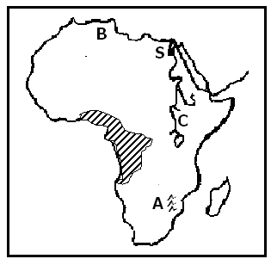

(a) Name the city marked S.

(b) Name mountain ranges marked A.

(c) Why does river marked C flow northwards?

(d) Why are forests in area shaded ever green?

43.a). A part from Zambabwe, name any other two countries in the Southern hemisphere where white settlers took over land.

b). State any two ways how the Africans were treated in Zimbabwe.

44. a). Write any two causes of famine in our community.

b). Give two ways in which illiteracy may lead to poor farming methods.

45.a). Give two ways in which people benefit from rainfall.

b). How does the rainy season determined people’s way of dressing?

c). Mention one way in which too much rainfall is dangerous to people’s health.

46.a). What does each of the following mean?

i). Scramble for Africa: __________

ii). Partition of Africa? ______

b). Mention one reason for the Scramble and Partition of Africa.

47.a). State any two reasons why democracy is important in a country.

b). Write any two ways democracy promotes development in a country.

48.a).What is environment?

b). Write down any two ways in which the environment of Uganda has been destroyed?

c). What should the government of Uganda do to protect the environment?

49.a). Name any two private companies that offer similar services like the post office.

b). Give any two ways how Uganda Post Bank has promoted development in Uganda.

50.a). What do the following terms mean?

i). Direct rule: _______

ii). Indirect rule: _______

b). In which two ways did the two systems of administration affect Africans?

**For each of the questions 51to 55, answer Either Christian or Islam but not BOTH.**

51. Either: a). Who said these words “Love one another just as I love you?”

b). Which group of people did he tell these words

c). Give two reasons why Christians are advised to love one another.

Or: a). Who said these words “Never drink hurriedly like a camel?”

b). Which group of people were told these words?

c). Give two reasons why Muslims are advised to love one another.

52. Either: a). Why was Jesus given that name?

b). What sign enabled the wise men to know that Jesus had been born?

c). Mention two reasons why wise men wanted to see Jesus.

Or: a). What is Salat Al – Juma’at?

b). Give two ways salat Al- Juma’ at benefit the Muslims.

c). How do Muslims tell the time for prayer?

53. **For Both:** a).In which two ways can we create peace and harmony in Society?

b). Mention two situations that can arise due to lack of peace in the society?

54. **For Both**: a). Why are people advised to be patient by Allah / God.

b). Give any two ways God / Allah rewards those who are patient.

55. **For Both:** a).Mention two ways giving can bring happiness among Christians/ Muslims.

b). In which two ways can parents fulfill the act of giving in order to create happiness?

**END**

**ITEM THREE**

**SECTION A**

1. Name the organization similar to the East African Community during the colonial days.

2. Name the four cardinal points of a compass.

3. Give one reason why people in Uganda build houses with slanting roofs.

4. State the prevailing winds which bring rain to East Africa.

5. Suggest one reason why a map without a boundary is not a good map.

6. In which one way are livestock farmers avoid leaving the soil bare?

7. Give one cause of soil erosion.

8. Mention any way a farmer can protect his crops from wind.

9. How did native African living along the coast contribute to the existence of the Swahili culture?

10. What event marked the beginning of colonial rule in Uganda?

11. Why is a drum a common symbol for most tribes in Uganda?

12. Suggest any one problem experienced in a society without laws.

13. How did the kingdom of Buganda become a part of the British colonies?

14. How do levels of education affect industrial growth?

15. State one way Uganda wildlife has been abused.

16. Give one reason why the colonialists did not take any interest in Karamoja.

17. What Verse of the National Anthem shows that Uganda is a God fearing nation?

18. State how rural electrification is likely to change people’s lives.

19. Why did the colonial government in Kenya restrict the movement of Africans during the Mau-Mau rebellion?

20. Give the role played by the secretary for defense on a Local Council I.

21. Identify one characteristic of a lake with rivers flowing out it.

22. Why are written sources of history more widely used by learners than oral sources of history?

23. How is a head teacher important to the learning of children in a primary school?

24. Identify any one economic activity carried out on lake Volta.

25. Why did Alexander Mackay decide to bring the first printing press to Uganda?

26. Give one characteristic of mountain vegetation.

27. Which education policy was introduced in some African countries to reduce illiteracy?

28. Why should Ugandan farmers be provided with improved seeds?

29. How did slave trade cause famine in Africa?

30. What contributes to a high population density around oasis?

31. Give the major reason why ranching is not common in Uganda.

32. How did the protectorate law unite Ugandans?

33. Suggest one reason why very many children were not attending school before the introduction of UPE in Uganda.

34. What was the major aim of opening up missionary stations by the early missionaries?

35. In which do feeder roads help people in meeting their needs?

36. Why do some parts of a river have rapids?

**In questions 37 to 40, answer either Christian or Islamic questions but not both.**

37. **Either:** Who was the youngest Uganda Martyr?

**Or:** Who is considered as the first prophet in Islam?

38. **Either:** Give one way a God fearing pupil is supposed to behave at school.

**Or:** According to Islam, point out one characteristic of hypocrisy in actions and deeds.

39. **Either:** How is a God-parent important in the sacrament of Baptism?

**Or:** Who carries out circumcision in the Islamic faith?

40. **Either:** State one way you can use the fruit of love at school.

**Or:**  When can ones living be accounted with gains according to the Koran?

**SECTION B**

41(a) Give the major characteristic of convectional rainfall.

(b) Why was the Wild Education Centre set up by the Uganda government?

(c) Why is it difficult to make a living in the dry savannah regions?

(d) Give one way warm currents influence the economic actives along the coastal areas of East Africa.

42(a) Suggest one reason why Uganda is rich in culture.

(b) Why do some tribes in Uganda have similar customs?

(c) Give two ways Arabs helped the kingdom of Buganda to became stronger.

43(a) Apart from helping in locating places, give any other use of latitudes.

(b) Why is important for explorers to move with a compass?

(c) How is Uganda and the Democratic Republic of Congo similar in terms of location?

(d) What major factor influences the climate of Democratic Republic of Congo?

44(a) What is plantation farming?

(b) Why did Ugandans grow crops on small farms during colonial times?

(c) How is subsistence farming a disadvantage to farmers?

(d) Suggest one way the government of Uganda can help subsistence farmers to improve on their income.

45(a) What is a political party?

(b) State any reason why the British colonialists encouraged the formation of political parties in East Africa.

(c) Suggest two ways a country like Uganda can promote Human Rights.

46(a) Give two factors that affect the prices of agricultural produce on the market.

(b) How can the government help to improve on produce prices in rural areas?

(c) State one way low produce prices is affecting farming in rural areas.

47. Compare Uganda with the Republic of Nigeria in terms of:

(i) Geographical location

(ii) Regional grouping

(iii) economy

(iv) climate

48(a) Why do countries such as Uganda need to trade with other countries?

(b) Describe any two ways Kenya benefits economically from Uganda.

(c) How does Uganda depend on Kenya economically?

49(a) State any reasons why the youth move from rural areas to urban areas.

(b) Apart from knowing the number of people in a country, why else does the government carry out a population census?

50(a) Apart from hosting the Common Wealth Heads of Government Meeting (CHOGM0 in 2007, what other factor shows that Uganda is a member of the Common Wealth?

(b) Write down two benefits Uganda enjoys as a member of the Common Wealth.

(c) Give one way in which a High Commissioner is different from an ambassador.

51(a) Name two products obtained from palm oil.

(b) Give one disadvantage of obtaining oil locally.

(c) Which district in Uganda is known for growing oil palms?

52(a) Why are most African countries having problems with foreign exchange?

(b) Give one problem faced by governments with limited foreign exchange.

(c) Suggest two ways the government of Uganda gets foreign exchange.

**For questions 51 – 55 answer either Christianity or Islam but not both**

53 (a) Who was the twin brother of Jacob?

(b) Why was Jacob sent to his uncle Laban?

(c) How did Esau solve his problem with his brother?

(d) What lesson do you learn from the story of Jacob and his twin brother?

**Or:** (a) Under what circumstances is a Muslims exempted from daily prayers?

(b) Give any two reasons why Muslims pray to Allah to protect them during prayer.

(c) Why does a Muslim seek refugee after death?

54. **Either:** According to the Bible, which martyr was stoned to death?

(b) How did John the Baptist die?

(c) Give two reasons why king Mwanga ordered the killing of the Uganda martyrs.

**Or:** (a) Identify four groups of people exempted from fasting during the month of Ramadhan.

55. **Either:** (a) Where were the apostles on the day of Pentecost?

(b) How did the apostles behave after receiving the holy spirit?

(c) Suggest two ways pupils use the gifts of the Holy Spirit at school.

**Or:** (a) In which two ways is prayer important to a Muslim?

(b) Why was it easier for prophet Muhammad to convert the following to Islam?

(i) Khadijah

(ii) Abubaker

**END**

**ITEM FOUR**

**SECTION A**

1. Give one reason why people keep animals in their homes.

2. What name is given to the imaginary lines on the globe that run from east to west?

3. State one way trees help in improving people’s health.

4. What is the biggest local government unit in Uganda?

5. Suggest one way in which the knowledge about climate of an area can be helpful to a farmer.

6. How can a P. 7 pupil contribute to the security of a community?

7. How are tse-tse flies dangerous to cattle farmers?

8. Give one factor that led to the establishment of the East African Community.

9. Give one traditional industry common in East Africa.

10. Give the major role of a speaker in parliament.

11. Mention one problem a government can prevent by carrying building and maintaining hospitals and dispensaries.

12. How have valley dams helped in reducing nomadic pastoralism in Uganda?

13. Why do people take it to be safe to settle on slopes of mountains with extinct volcanoes?

14. How did Sir Albert Cook as a Christian missionaries show God’s love to the people of Uganda?

15. Give one reason why trees in desert regions have thick bark and thin leaves.

16. Compare Uganda and Libya in terms of location.

17. State any one importance of democracy.

18. Identify one way the government can control population growth.

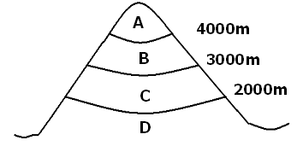19. State one way in which child abuse can be controlled in your sub-county.

20. Which area is most suitable for pastoralism base on its temperature and vegetation?

21. Why does part A develop an ice cap?

22. Compare part C and part B in terms of vegetation.

23. Why is area A cooler than area D?

24. How is an ox-bow lake formed?

25. How does the United Nations tried to keep peace in the world?

26. State one problem Africans faced in their struggle for independence.

27. Explain why the Bantu people formed settlements around lake and river regions.

28. State one method used by colonialists to administer colonies in Africa.

29. How is industrialization a threat to wild life?

30. Give one way governments in African countries promote good governance.

31. Why is important for a school to have a name?

32. Suggest one danger caused by keeping animals in or near a school compound.

33. State one way the high rate of unemployment can be reduced in Uganda.

34. Which political party led Rwanda to independence?

35. Apart from expecting guns, state any other reason why King Muteesa I invited missionaries to Uganda.

**In questions 36 to 40, answer either Christian or Islamic questions but not both.**

36. **Either:** According the Christian principles, how should we treat our enemies?

**Or:** How did prophet Muhammad treat his enemies when he required Mekkha?

37. **Either:** What miracle did Jesus perform at the wedding at Cana?

**Or:** What role did prophet Muhammad play in starting Islam?

38. **Either:** Why was David able to defeat Goliath?

**Or:** Why is prophet Musa remembered in Islam?

39. **Either:** Why is the cross an important symbol in Christianity?

**Or:** Why is the moon an important symbol in Islam?

40. **Either:** Which word do Christians use to end any prayer?

**Or:**  What doe the word ibadat mean in Islam?

**SECTION B**

41. A farmer was rearing 1000 heads of cattle on a farm of 15 hectares.

(a) What is the average of cattle per hectare?

(b) Give one way in which those cows are likely to affect the environment.

(c) State two ways in which the farm is likely to benefit from the community.

42. The graph below shows the change s in a school enrollment from 1996 – 2000.

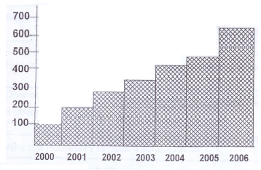

(a) What change took place in the enrollment from 2000 to 2006?

(b) Suggest any two possible causes of the change in the enrollment.

(c) Name one school resource that is likely to be affected by the change in enrollment as shown above.

43(a) Give one type of communication.

(b) Suggest one advantage of modern communication in Uganda today.

(c) Give one way uncontrolled use of mobile phones can promote insecurity.

(d) What makes a radio a cheaper medium of communication than newspapers?

44(a) State one source of income for the Uganda government.

(b) Mention two items on which revenue collected in Uganda is spent.

(c) Give one factor that make a government collect less revenue than expected.

45(a) Briefly explain the word decentralization.

(b) Give any two advantages of decentralization.

(c) Under what arm of government are cabinet ministers?

46(a) State one factor that influences the climate of Africa.

(b) Give two ways of conserving the environment.

(c) Suggest one way deforestation affects the environment.

47(a) Name two natural disasters that can occur in mountainous areas.

(b) Give one way natural disasters affect people in areas where they take place.

(c) Which ministry in the government of Uganda is responsible to handle natural disasters?

48(a) Give one factor for setting up an industry in an area.

(b) Give any two benefits of an industry in an area.

(c) State one possible advantage of having an industry near a city.

49(a) Define the word culture.

(b) Give any two importance of culture in our community.

(d) Suggest any one way intermarriages affect cultures.

50. Why are the following personalities remembered in the history of their countries?

(a) Gregory Kayibanda

(b) Julius Nyerere

(c) Dr. Apollo Milton Obote

(d) Nelson Mandela

**For questions 51 – 55 answer either Christianity or Islam but not both**

51. **Either:** (a) What does the word church mean in Christianity?

(b) How do Christians benefit from being members of the church?

(c) Why is prayer important in the life of a Christian?

(d) Which prayer did Jesus teach his disciples?

**Or:** (a) What is zakat?

(b) Identify one person who qualifies to get zakat.

(c) Give any two things that can be given as zakat.

52. **Either:**(a) Give the two greatest commandments as summarized by Jesus.

(b) Why are commandments important in a Christian’s life?

(c) What can be compared to Ten Commandments in a school?

**Or:** (a) Write two reasons why every Muslim should make a holy journey to Mekkha.

(b) Why are these places important in the Islamic faith?

(i) Mekkha

(ii) Medina

53 (a) What is sin?

(b) Give any to effects of Adam’s sinning to mankind.

(c) Suggest the plan God put in place to save man from the original sin.

**Or:** (a) Give any two daily prayers a Muslim recites.

(b) Why do Muslims pray five times a day?

54. **Either:** (a) How has Jesus kept his presence among Christians today?

(b) How did the Holy Spirit appear to the apostles on the Pentecost day?

(c) How did the Holy Spirit help the apostles as they preached the word of God?

**Or:** (a) What should a Muslim do when she / he misses a prayer?

(b) Write two conditions that can make a Muslim miss prayer.

(c) What is the role of a muezzin in the Islamic community?

55. **For both:** (a) Give three common beliefs in both Christianity and Islam.

(b) State any one difference in beliefs between Islam and Christianity.

**END**

**ITEM FIVE**

**SECTION A**

1. Why are symbols instead of real objects used in maps?

2. Which type of transport is commonly used in Uganda today to travel to and from Kalangala District?

3. State one reason which kept the interior of Africa to be unknown to Europeans in the early days.

4. What was the work of the Legislative Council (LEGCO) during colonial days?

5. Which is the major factor of weather that influences population distribution?

6. How are the Drakensberg Mountains similar to the mountain Kilimanjaro in terms of formation?

7. Give one reason why Ugandans should stand up when singing the national anthem.

8. Name the East African country which was ruled by Germany and Britain.

9. Why does Uganda use English as her national language?

10. State the role of political parties in Uganda before 1962.

11. Which type of vegetation favours the establishment of national game parks in Africa.

12. What causes wind?

13. How were Bushmen in Southern Africa affected by the early settlers?

14. Give one contribution of Asia to the economic development of Uganda.

15. How did river Nile influence the coming of the early European explorers to Africa?

16. Why are PIASCY messages displayed in most school compounds?

17. State one way the British colonialists helped to improve the way of living of the people in East Africa.

18. How is Fort Jesus important to the government of Kenya.

19. Why is the road network in the Democratic Republic of Congo underdeveloped?

20. Mention one method Europeans used to acquire colonies in Africa.

21. How is the duty of the police similar to that of a prefect in a school?

22. What is Customs Duty?

23. Name the map symbol given below.

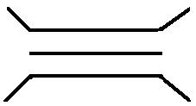

24. Suggest one reason why African natural resources have not been fully utilized.

25. Which international organization was replaced by the United Nations? (U.N.)

26. How are the Fulani of Nigeria similar to the Turkana of Kenya?

27. Who is the current Speaker of the East African Legislative Assembly (EALA)?

28. State the rebellion that resulted into the forced registration of guns in Uganda.

29. How did the Christian missionaries benefit from the presence of IBEACo.?

30. State one reason why terrace farming is recommended to be used by farmers in mountainous areas.

31. Which irrigation scheme in Sudan is famous for sugarcane growing?

32. Give one way in which the 1900 Buganda Agreement affected the Kabaka.

33. What were the Bantustans in South Africa?

34. State one function of the Central Bank.

35. Identify any one process involved in the formation of rainfall.

**In questions 36 to 40, answer either Christian or Islamic questions but not both.**

36. **Either:** Why did God send away Adam and Eve from the garden of Eden?

**Or:** Why did Allah send away Adam and Hawa from paradise?

37. **Either:** Who is a martyr?

**Or:** What is Jihad?

38. **Either:** How do Christians benefit from reading the Bible?

**Or:** How Muslims benefit from reading the Koran?

39. **Either:** Why did Simon Peter deny Jesus Christ?

**Or:** On which mountain did prophet Muhammad receive the first revelation?

40. **Either:** Why do Christians receive the Holy Communion?

**Or:**  How does a Muslim get the title of Haji or Hajat?

**SECTION B**

41. Study the table below and answer the questions that follow.

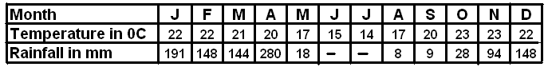

(a) Find the temperature range.

(b) State the highest amount of rainfall recorded on the table.

(c) Name the type of climate shown on the table above.

(d) What is the relationship between temperature and rainfall?

42(a) Write NEMA in full.

(b) Mention any one duty of NEMA.

(c) Write down any two human activities that lead to environmental degradation.

43(a) Which type of administration did the British colonialists use in Uganda?

(b) Give two reasons why the British colonialists used the type of administration mentioned in (a) above.

(c) How was Semei Kakungulu useful to the British colonialists in Uganda?

44(a) Name the organization in Africa that was formed to replace the Organisation of African Unity (OAU).

(b) Give two reasons why the organization given in (a) above was formed.

(c) Mention one problem facing the organization you have mentioned in (a) above.

45. **Use the diagram to answer the questions that follow.**

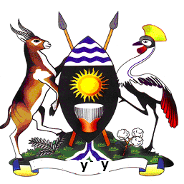

(a) Name the attribute shown above.

(b) What crops are represented on the above attribute?

(c) Name the part of the attribute marked Y.

(d) Who designed the above attribute?

46(a) Where are the headquarters of the East African Community?

(b) Suggest two reasons why the East African Community has been revived.

(c) Which organ of the East African Community is responsible for making laws?

47(a) Name the organization responsible for controlling oil production and prices in Africa.

(b) State one reason why northern Libya is more populated than the south.

(c) State one way the people of Libya benefit from the great man made river.

(d) Compare Libya and Uganda in terms of location.

48(a) What is population distribution?

(b) State two factors that influence population distribution in East Africa.

(c) Mention one problem facing people living in mountainous areas.

49(a) Who is the founder of the Bunyoro-Kitara Empire?

(b) State two contributions the Bachwezi made to the modern economy of Uganda.

(c) Give one reason why the Chwezi Empire declined.

50. **Study the map of East Africa below and answer the questions that follow**.

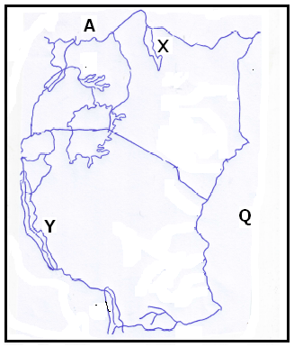

(a) Name the country marked A.

(b) How is Lake X similar to Lake Y in terms of formation?

(c) Name the water body marked Q.

(d) How is port Mombasa useful to a country like Uganda in terms of trade?

**For questions 51 – 55 answer either Christianity or Islam but not both**

51. **Either:** (a) On which mountain did Moses receive the ten commandments?

(b) Give one way in which the Ten Commandments are important to school children.

(c) Identify the commandment broken in each of the following:

(i) having many wives

(ii) engaging in corruption

**Or:** (a) There are five Arkans on which Islam stands. State any two Arkans.

(b) State any two a Muslim should fulfill before undertaking the Haji.

52 **Either:** (a) Mention two gospel writers.

(b) How did the Holy Spirit help the gospel writers to carry out their work?

(c) Which book of the Bible was written by St. Paul?

**Or:** (a) Who is a Caliph?

(b) Name any two Caliphs you know.

(c) What was the work of Caliphs?

53 **Either:** (a) Where did Jesus perform his first miracle?

(b) Mention any two miracles Jesus performed.

(c) Why did Jesus Christ perform miracles?

**Or:** (a) Name any two Holy books in Islam.

(b) Identify the prophets to whom the books you have mentioned in (a) above were revealed.

54. **Either:** (a) What is prayer?

(b) Suggest any three importance of praying together.

**Or:** (a) What is salat?

(b) Mention any three things a Muslim should do before performing salat

55. **Either:** (a) Why is the 3rd of June celebrated in Uganda?

(b) Which religioud leader was killed on the orders of kabaka Mwanga at Luba palace in Busoga?

(c) Suggest any two lessons learnt from the Uganda matyrs.

**Or:** (a) Why was prophet Muhammad unable to see his father?

(b) Name the foster mother of Prophet Muhammad.

(c) Identify two towns in Saudi Arabia related to Prophet Muhammad.

**END**

**ITEM SIX**

**SECTION A (40 MARKS)**

1. Name the instrument that a pilot uses to show direction.

2. Give the title of the officer who accounts for all government money in the district.

3. What method did the Banyoro use to show that they hated the Baganda chiefs?

4. State any one reason why people of the community should follow rules and regulations.

5. Give any one way Uganda benefits from the East African Development Bank.

6. Mention any one result of the Great Trek in South Africa.

7. Name the first railway line to be built in East Africa.

8. State any one way heavy rainfall can lead to food shortage.

9. Give any one way heavy rainfall can lead to food shortage.

10. Mention any one way a high population affects the vegetation of an area.

11. State any one reason why the British used indirect rule.

12. Name the biggest island country of Africa.

13. Give any one benefit of the Bantu migration to East Africa.

14. State any one cause of insecurity in the School.

15. Why is Jomo Kenyatta remembered in the history of Kenya?

16. Mention any one importance of participating in National elections in Uganda.

17. What term is given to power that is produced from running water.

18. Give any one way landslides affect people’s way of life.

19. Why should school children be taught road safety rules?

20. State any one way early marriages lead to child abuse.

21. Name the dry winds that blow across the Sahara desert.

22. Mention any one way the coming of Nilotes to East Africa affected the natives.

23. State any one importance of a magistrate in the community.

24. Mention any one way UPC helped to promote peace in Uganda.

25. Give any one use of a multipurpose river project t industries.

26. Mention any one reason for the formation of the UNO.

27. State any one way Ugandans benefited from the LEGCo after 1945.

28. State any one way in which good roads promote tourism in a country.

29. Give any one reason why symbols are used on a map.

30. Name any one physical feature that forms a natural boundary between Uganda and DRC.

31. Give any one way forests promote the activities of a carpenter.

32. Give any one way the people of Kenya benefited from the coming of the white settlers.

33. Name the method that is used to mine crude oil.

34. Mention any one duty of the local council I Committee.

35. Name the social service people get from the place shown.

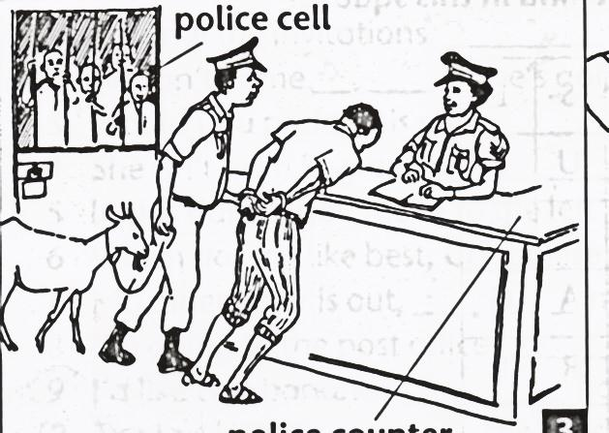

**In questions 36 – 40, answer either Christianity or Islam but not both.**

36. Either: Who was the earthly father of Jesus?

Or: Who was the earthly father of Prophet Mohammad?

37. Either: What is lent?

Or: What is Saum?

38. Either: How is the church house important in prayer?

Or: How is a mosque important in prayer in Islam?

39. Either: Name any one apostle of Jesus who was found of fishing.

Or: Name the first Caliph of Prophet Mohammad (PBUH)

40. Either: State any one way of spoiling prayer in Christianity.

Or: State any one way of spoiling prayer in Islam.

**SECTION B**

41. a) Name one country in the central region of Africa where

equatorial rainforests are found.

b) Give one problem the country named above experiences as a

result of thick forests

c) State any two ways the country named benefits from the

presence of thick forests.

42. a) Name the official who;

i) Designed the Uganda National flag

ii) Composed the Uganda National Anthem

b) State any one reason why Uganda does not have a national

language.

c) State any one benefit of a national language to a country.

43. Study the diagram below and use it to answer questions that follow.

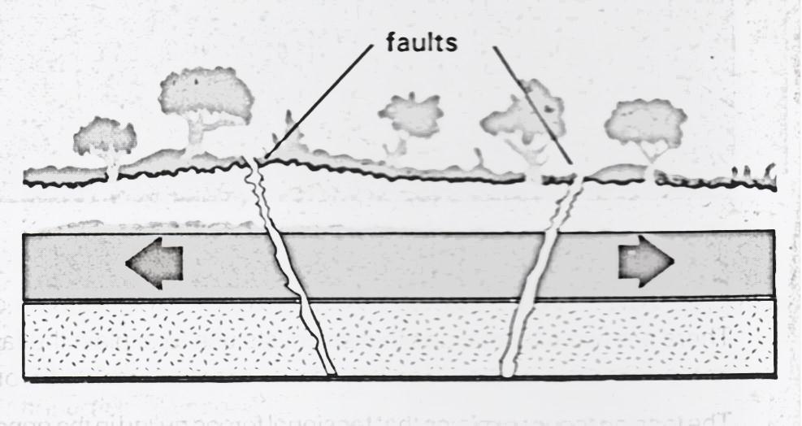

a) Name the forces labelled X.

b) What process is shown in the diagram?

c) Give any two examples of mountains formed by the process above.

44. a) Name the first Portuguese explorers to come to the coast of

East Africa.

b) State any two positive results of the Portuguese settlement at the coast.

c) Give any one problem of the Portuguese faced at the coast.

45. a) Name any one river that ends in a form of a delta in West

Africa.

b) Mention any two uses of the delta mentioned above.

c) State any one problem that can be caused by the river mentioned above.

46. a) Which country neighbours Uganda to the South West?

b) Give any two problems faced by the above country due to her

location.

c) State any one way Uganda benefits from the above country.

47. a) Name the major mineral mined in Zambia.

b) State any one method of mining the above mineral.

c) Give two problems faced during the mining of the above mineral.

48. a) Which group of people introduced the idea of iron smelting

in Uganda?

b) Who was the last ruler of the above group?

c) Apart from iron smelting, state any two other contribution of the above group.

49. a) What term is used to refer to the way people are spread in an

area?

b) Give any two problems caused by high population in urban

areas.

c) State any one way the government can encourage people to live in rural areas.

50. Match accordingly.

A B

Benedicto Kiwanuka UNC

IK Musaazi UPC

Dr. HM Obote KY

Muteesa II DP

i) Benedicto Kiwanuka _____

ii) IK Musaazi ____

1. Dr. HM Obote _________
2. Muteesa II _

**For numbers 51 – 55, answer either Christianity or Islam but not both.**

Either:

51. a) Name the last book in the Bible.

b) What helps Christians to understand the Bible well?

c) State any two ways of misusing the Bible.

Or:

a) Name the last Surat in the Qur’an.

b) What helped Moslems to interpret the Qur’an well?

c) State any two ways of misusing the Qur’an.

52. Either:

a) Name the Prophet in the Old Testament who foretold the coming of the messiah

b) Why was the birth of the messiah foretold?

c) Give any two ways the birth of the messiah was different from that of any ordinary child.

Or:

a) Name the Prophet in Islam who did not see his father in his life time.

b) Why didn’t the above named Prophet see his father?

c) Mention two ways the Prophet above helped his uncle who brought him up.

53. Either:

a) Which group of people continued with Jesus’ work when he ascended into heaven?

b) Give any two reasons why Jesus promised to send a helper to the group mentioned above.

c) What is the work of the Holy Spirit among modern Christians?

Or:

1. What title is given to the immediate successors of

Muhammad?

1. How did the successors named above strengthen Islam?
2. Mention two reasons why Prophet Mohammad needed friends.

54. Either:

a) According to Christianity, why are the following factors considered before choosing a marriage partner?

i) Health

ii) Religion

b) Why should a mature Christian marry?

c) State any one challenge married couples always face in their marriages.

Or:

a) According to Moslems, why are the following factors considered before choosing a marriage partner?

i) Health

ii) Religion

b) Why should a mature Moslem marry?

c) State any one challenge married couples face in their marriages.

55. Either:

a) Apart from Christianity, mention any other two world religions.

b) Give one reason why Christians should show respect to believers of other religions.

c) Why is it bad for Christians not to respect believers of other religions?

Or: a) Apart from Islam, mention any other two world religions.

b) Give one reason why Moslems should show respect to believers of other religions.

c) Why is it bad for Moslems not to respect believers of other religions?

**END**

**ITEM SEVEN**

SECTION A:

1. Kato was going to school early in the morning and he saw his shadow in front of him. In which direction was the school?

2. Which neighbouring country lies to the north east of Kenya?

3. Identify any one weather instrument which is not kept in a Stevenson screen.

4. Why should the government encourage the community to plant more trees?

5. How has the NAADS programme improved the livelihood of rural farmers in Uganda?

6. Give one reason why river Congo pours the greatest volume of water into the Atlantic Ocean.

7. Why is the Ugandan flag sometimes flown on half-mast?

8. For what reason is the cement factory located in Tororo other than Mukono town?

9. What is the importance of carrying out rural electrification in Uganda?

10. State one reason why Fort Jesus was built by the Portuguese.

11. How was the LEGCO of the colonial period similar to the present day parliament of Uganda?

12. Name the agent in Uganda who was appointed to assist in establishing the British colonial rule.

13. How are the Fulani of Nigeria similar to the Karimajong of Uganda in terms of their occupation?

14. Give one role of a good citizen.

15. How was the Mau Mau rebellion similar to the Maj Maji rebellion?

16. In which way was the formation of mountain Rwenzori different from that of mountain Kilimanjaro?

17. Identify one country in Africa which was not colonized by foreigners.

18. Which type of climate is described as hot and dry throughout the year?

19. Which name was given to the long journey made by Boars from the Cape Colony to the new found states?

20. Why was Ghana referred to as the Gold Coast by Europeans?

21. What is the importance of budgeting to your school?

22. Why is Dr. Leakey remembered in the history of East Africa?

23. State one reason why Uganda has sent her troops (soldiers) to Somalia.

24. Mention the country where the 2010 World Cup tournament took place.

25. Define the term “National Constitution”.

26. Why is Nkwame Nkurumah remembered in the history of Africa?

27. State one reason why the highlands and lake regions of East Africa are densely populated.

28. Name the major cash crop grown on the Gezira irrigation scheme in Sudan.

29. Mention one cause of refugees in Africa.

30. State one problem faced by people living in mountainous areas.

31. How has the creation of more districts in Uganda benefited the people living there?

32. State one reason why slave trade took long to end in Africa.

33. Mention the reason why the railway line was extended from Kampala to Kasese.

34. State one way children are being abused in Uganda.

35. Why should PIASCY be taught in schools of Uganda?

**For questions 36 – 40, answer either Christianity or Islam but not both.**

36. **Either:** Name the mountain where Noah’s Ark rested.

**Or:** Name the mountain where Nuhu’s ship rested.

37. **Either:** Who led the Israelites to the Promised Land?

**Or:** Which prophet is remembered for his patience and endurance?

38. **Either:** Which angel delivered God’s message to Mary?

**Or:** Which angel used to deliver Allah’s messages to prophet Muhammad?

39. **Either:** State one way lent is important in the Christian faith.

**Or:** State the importance of Rhamadhan to Muslims.

40. **Either:** Name the disciple who doubted the resurrection of Jesus.

**Or:** Why did prophet Muhammad move from Mecca to Medina?

**SECTION B**

41(a) Differentiate between weather and climate.

(b) State two elements of climate.

(c) Why are weather forecasts important to a farmer?

42(a) Suggest a reason why tourism is considered an industry.

(b) Write three importance of the tourism industry.

43(a) What is population density?

(b) Suggest two reasons why population census is carried out in a country.

(c) Mention one negative effect of having a high population.

44(a) Mention the new name of the Organization of African Unity.

(b) Name the current Chair Person of the commission of the body you have mentioned in (a) above.

(c) Suggest two reasons why the above organization was formed.

45(a) What is a national budget?

(b) Mention any two parts of a budget.

(c) Which ministry is in charge of the national budget?

46(a) Name the body responsible for organizing elections in Uganda.

(b) State any two functions of the body you have mentioned in (a) above.

(c) State one reasons why by-elections may be held.

47(a) State two reasons why the Portuguese were interested in East Africa.

(b) Mention one problem faced by the Portuguese at the East African coast.

(c) How has Fort Jesus remained important to the people of Kenya today?

48(a) How is cocoa growing important to the economic development of Ghana?

(b) Mention any one problem faced by cocoa farmer in Ghana.

(c) How is the harvesting of cocoa different from that of coffee?

49. **Study the map of East Africa and answer the questions about it.**

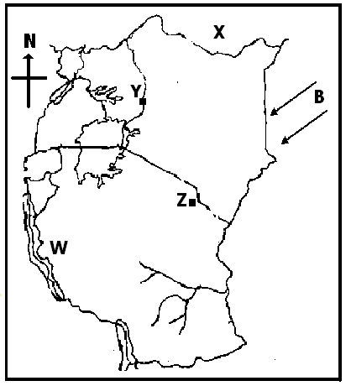

(a) What is the relationship between people who live on the slopes of mountain Y and Z in terms of economic activities?

(b) Name the country marked X.

(c) Give the effect brought by the winds marked B.

(d) In winch arm of the rift valley is lake W located?

50(a) State any two contributions of the Bachwezi.

(b) How did the size of Bunyoro Kitara contribute to its downfall?

(c) Who was the last ruler of the Bachwezi?

51. (a) How is cocoa growing important to the economic development of Ghana?

(b) Mention any one problem faced by cocoa farmer in Ghana.

(c) How is the harvesting of cocoa different from that of coffee?

52(a) Name one multi-purpose river project in Africa.

(b) Write down any two reasons why the multi-purpose river project is important.

(c) Suggest any one problem faced by government when getting up the multi-purpose river project.

**For 53 – 55, answer either Christianity or Islam but not both.**

53. **Either:**

(a) What work was Moses doing before he was called by God.

(b) Name one event that took place on Mt. Sinai.

(c) Mention any two miracles Moses performed before Pharaoh in Egypt.

**Or:**

(a) Write down any two pillars of Islam.

(b) Name the first and last prophets in Islam.

(i) First prophet____________

(ii) Last prophet_____________

54. **Either:**

(a) What is a parable?

(b) Why did Jesus use parables in most of his teachings?

(c) What lessons do we learn from the following parables?

(i) the prodigal son

(ii) the Good Samaritan

**Or:**

(a) Why are the following people important in the Islamic faith?

(i) Imam

(ii) Muazzin

(b) Mention any two of the daily prayers offered by Muslims.

55. **For both Christians and Muslims**

Mention any four common beliefs between Christians and Muslims.

**END**

**ITEM EIGHT**

**SECTION A**

1. Name one product got from palm leaves.

2. Mention any one role played by the World Health Organization.

3. What type of transport is used to transport perishable goods from Entebbe to Kampala**?**

4. How did the coming of the Arab traders affect the life of the people in East Africa?

5. Give the importance of recreation activities in our community.

6. What is this tool used for at school?



7.What is the main role of the clerk to parliament**?**

8. Apart from inheritance, state any one other way of getting leaders in our community.

9. Why do we turn off lights when not in use.

**The diagram below shows a rain gauge. Use it to answer the questions that follow.**

**X**

10. Give the reason why the above drawn instrument of weather is placed in an open place.

11. How did the early Europeans to Africa solve the problem of language difficulty**?**

12. How is a nursery bed important in the school**?**

13. What led to the industrial development of South Africa**?**

14. Why is land regarded as a resource**?**

15. Give one reason why some rivers in Uganda pour their water into L. Victoria.

16. What was the major cause of the Nyangire rebellion in Uganda**?**

17. Who is a leader**?**

18. State one factor that can lead to child abuse.

19. In which way does the AU promote development in Africa**?**

20. Which British official established the Imperial British East Africa Company**?**

21. State any one condition that may lead to a by-election in an area.

22. How do prefects promote order in the school**?**

23. What was the cause of the Sudanese mutiny in Uganda**?**

24. How did the early man get his food**?**

25. What is the similarity between the Fulani of Nigeria and the Karimojong of Uganda in term of economic activities**?**

26. Name any type of culture.

27. In which one way did Muteesa1 contribute to the introductionof western education in Uganda**?**

28. Give any one role played by a clan head**.**

29. Under which arm of the government are the teachers**?**

30. State any one reason why candidates should have watches.

31. How did the 1900 Buganda agreement affect the powers of the Kabaka**?**

32. Give one way in which telephone is important in a school.

33. Give the reason why some families cannot produce enough food for their children.

34. State the reason why some Africans participated in the Second World War.

35. Which crop is grown in Kirombero Valley irrigation scheme**.**

**For questions 36 – 40, answer either Christianity or Islam but not both.**

36. **Either:** Which act brought suffering in the world?

**Or**: Which act brought suffering in the world?

37. **Either:** Write down any one piece of good advice in Christianity.

**Or:** Write down any one good advice in Islam.

38. **Either:** Mention the father of Joseph who was sold to Egypt according to the Bible.

**Or:** Who was the father of Prophet Yusuf

39. **Either:** What is Holy Matrimony?

**Or:** What is Nikah in Islam?

40. **Either:** Write any one Christian organization operating in Uganda.

Or: Write any one Islamic organization operating in Uganda today.

**SECTION B**

41. a) What is population distribution.

b) Give any two factors that influence population distribution.

c) How does climate affect the population of an area.

42. a) What is a national budget**?**

b) Give any one reason why a pupil should make a budget.

c) Which type of budget is shown above**?**

d) Why is the above budget not good for a school**?**

43. a) What is an ethnic group**?**

b) Which ethnic group is associated with the legend of the spear and the bead**?**

c) State any two reasons why Nilotics changed from nomadic pastoralism to mixed farming when they reached Uganda.

44. a) What is basic technology**?**

b) Give any two importance of basic technology.

c) State any one product got from basic technology**.**

45. a) Who is a citizen of Uganda by birth**?**

b) Mention any two responsibilities of a citizen in Uganda.

c) How can a citizen help the police to keep law and order**?**

46. a) Give any two factors that influence climate.

b) Why should an airport have a weather station**?**

c) How is weather forecasting important to traders**?**

47. Study the diagram below and answer questions that follow.

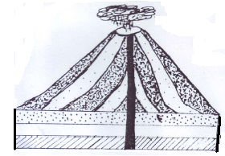

**C**

**K**

**Earth’s**

**crust**

**Y**

a) What name is given to the process shown above**?**

b) Why does Arabica coffee grow well on the above physical feature**?**

c) Name the part marked C in the diagram drawn above.

d) Give the type of lake formed on the above feature.

48. **(a) Study the pictures below and answer the questions that follow.**

|  |  |
| --- | --- |
| **(A)** | **C:\Users\pc\Desktop\images\stock-vector-boy-writing-a-letter-80451595.jpg(B)** |
| **(C)** | **C:\Users\pc\Desktop\images\download.png**  **(D)** |

1. Which modern means of communication is shown in picture marked;

**A** ____

**C** ___

(b) Why is the communication means shown in picture marked “**D**” used by most people in your community today?

(C) Which group of people introduced the means of communication in B

49. a) What is the difference between natural and planted vegetation?

b) Give two reasons why people destroy vegetation today.

c) Which type of vegetation zone is commonly found on the shores of

L. kyoga?

50. **Study the Uganda National Flag and answer the questions that follow.**

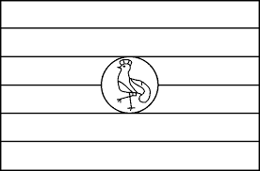

**B**

**Y**

**R**

**B**

**Y**

**R**

a) What name is given to the bird drawn above**?**

b) Why is above bird chosen to be Uganda’s national emblem**?**

c) Which colour on the Uganda national flag shows the colour of Africans**?**

d) Write the date when the above flag was flown officially for the first time in Uganda.

**For questions 51 – 54 answer Either Christianity Or Islam BUT NOT BOTH.**

**EITHER:**

51. (a) What do we call the fasting period of Christians?

(b) Why do Christians fast and pray?

(c) What do we remember on the following days?

(i) Christmas day _______

(ii) Easter Sunday ________

**OR:**

1. What do we call the fasting period for Moslems?
2. Why do Moslems fast and pray?

(c) Write any **two** groups of people exempted from fasting.

**EITHER:**

52. (a) In which book do we find the story of creation?

(b) Give **two** reasons why God created man.

(c) How did man disobey God?

**OR:**

1. What did Allah create on the first day?
2. Give **two** reasons why Allah created Adam.
3. How did Adam disobey Allah?

53. **EITHER:**

(a) What is a sin?

(b) Write any **two** examples of sin in your community

(c) How can a Christian avoid sin?

**OR:**

1. What is a sin?
2. Write any **two** examples of sin in Islam.

(c) How can a Moslem avoid sin?

54. **EITHER:**

(a) Write any **two** miracles Jesus performed.

(b) What helped Jesus to perform miracles?

(c) Why did Jesus perform miracles?

**OR:**

1. Write any **two** miracles performed by prophet Abraham.

(b) What enabled Prophet Muhammad to perform miracles?

1. Why did Abraham perform the above miracles?

55. **FOR BOTH**: (a) Write any **two** qualities of a God fearing person.

(b) Write any **two** similarities between Christians and Moslems.

**END**

**ITEM NINE**

**SECTION A**

1. Mention any one social activity through which culture is promoted in your community.

2. Name the United Nations agency that deals with the protection of the natural environment.

3. Apart from Margherita, name any other snow-capped mountain peak in East Africa.

4. How did the discovery of fire improve the early man’s way of life?

5. Name the country in West Africa that was referred to as the home of freed slaves.

6. Why is lumbering difficult in equatorial rain forests of the Democratic Republic of Congo?

7. State any one way in which colonial rule weakened African traditional culture.

8. Draw a map symbol of a bridge in the space provided below.

9. State any one way Ludwig Krapf contributed to the spread of Christianity in East Africa.

10. Why is the 9th October declared a public holiday in Uganda every year?

11. Mention any one benefit of a large population to the trade industry.

12. Abiya was going to school in the morning when she saw her shadow on her right hand side. To which direction was Abiya going?

13. Give one reason why the government of Uganda is improving on the feeder road network.

14. Mention any one special group of people represented in the Parliament of Uganda.

15. Give one reason why Nelson Mandela fought against minority White rule in South Africa.

16. What evidence proves that the Portuguese once lived on the coast of East Africa?

17. How does climate influence the style of building houses in desert areas?

18. Which body of the former East African Community was replaced by the Uganda National Examinations Board?

19. Give any one factor that can cause a deficit budget to a country like Uganda.

20. Name the organ of a democratic government responsible for interpreting laws.

21. Why was the west Nile region transferred from Belgian Congo to Uganda during the evolution of boundaries in 1914?

22. Mention any one way people in a community become leaders.

23. State any one way Uganda and South Sudan depend on each other.

24. What is the effect of the rotation of the earth on its axis?

25. Name the nationalist who led DR Congo to independence.

26. Why did the people of Tanganyika rebel against the Germans?

27. Name the place in South Africa famous for gold mining.

28. Give one duty of responsible citizens of a country like Uganda.

29. Mention any one cause of the long distance trade in East Africa.

30. State one factor that kept the interior of Africa unknown to the Europeans for a very long time.

31. What problem is a candidate likely to face when reading a map without a key?

32. State the way Sir Andrew Cohen caused political instability in Buganda in 1953.

33. Why are most rift valley lakes in East Africa salty?

34. Give the traditional occupation of most of the Fulani.

35. State any one way in which communication is important to traders.

**For questions 37- 40, answer either Christianity or Islam but not both:**

36. **Either:** Give the importance of the sacrament of Baptism in Christianity.

**Or:** Mention the pillar of Islam that promotes charity.

37. **Either:** According to the Holy Bible, how was Aaron helpful to Moses?

**Or:** How did Allah punish the sinners during prophet Nuhu’s time?

38. **Either:** State one way Christians use their talents to glorify God.

**Or:** Mention any one Islam is different from other religions.

39. **Either:** How was the resurrection of Jesus Christ from the dead helpful to the apostles?

**Or:** How did prophet Muhammad escape being killed by the people of Makkah who were against his teachings?

40. **Either:** What was the first sin according to the Holy Bible?

**Or:** Why is it necessary for every Muslim to have ablution before performing prayer?

**SECTION B**

41(a) Give any two roles played by the African Union.

(b) State two challenges facing the African Union.

42. Match the irrigation schemes in A with the crops grown in list B correctly.

|  |  |
| --- | --- |
| **List A** | **List B** |
| Doho Irrigation scheme | Ground nuts |
| Gezira Irrigation Scheme | Rice |
| Richard Toll Irrigation Scheme | Sugar cane |
| Kilombero valley irrigation scheme | cotton |

(a) Doho Irrigation scheme __________

(b) Gezira Irrigation Scheme _____________

(c) Richard Toll Irrigation Scheme _______

(d) Kilombero valley irrigation scheme _____

43. Why did European countries organise the Berlin Conference in 1884?

(b) State one outcome of the Berlin Conference.

(c) Why were European countries eager to acquire colonies in Africa?

(d) Name one European country that had colonies in Africa at the time of the Berlin conference.

44 (a) What is subsistence farming?

(b) Give two reasons why most farmers in Uganda practice subsistence farming.

(c) State one reason why most farmers in Uganda prefer growing traditional cash crops to non-traditional ones.

45(a) Why is it not suitable to build a fish factory in Karamoja?

(b) State any two problems facing the fishing industry in Uganda.

(c) Give one way the government of Uganda can improve her fishing industry.

46(a) State two ways in which a good road network is important to the development of a country like Uganda.

(b) Give one advantage of railway transport over road transport.

(c) Mention one reason that led to the decline of railway transport in East Africa.

**Study the map below and answer question 47.**

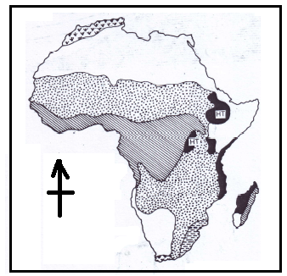

47(a) Give one characteristic of vegetation shaded .

(b) Why is the region shaded sparsely populated?



(c) What type of climate is experienced in areas shaded ?

(d) Using letter D, show the Mediterranean sea on the map above.

48(a) Name the physical feature that influenced the coming of European explorers to East Africa.

(b) Give two results of the exploration of Africa.

(c) State one problem explorers faced when they came to Africa.

49(a) Give two reasons why the Bantu migrated from their cradle to East Africa.

(b) State two ways the settlement of the Bantu in East Africa affected the people who were already living there.

50(a) Which regional body unites most of the countries in West Africa?

(b) Mention any two reasons why the regional body named in (a) above was formed.

(c) Give one challenged faced by the regional body named in (a) above.

**For questions 51 – 55 answer either Christianity or Islam but not both.**

51 **Either:** Jesus said to them,” **Come with me, and I teach you to catch people**”. (Matthew 4:19)

(a) Name the two people whom Jesus Christ told the above words.

(b) What were the two people doing at the time they were called?

(c) What lesson do you learn from the action that was taken by the two people after Jesus Christ had told them the above words?

**Or:** And when it is said to them, “**Come, so that the messenger of Allah may ask forgiveness from Allah for you,**” they twist their heads, and you would see them turning away their faces in pride.

(a) According to the Qur’an, which people did Allah refer to in the above words?

(b) Mention any two characteristics of such people referred to above.

(c) Which chapter in the Qur’an condemns the actions of such people?

52. **Either:** (a) What are sexual deviations?

(b) What sexual deviation can be committed by a close relative?

(c) State two dangers of sexual deviations.

**Or:** What are sexual deviations?

(b) What sexual deviation can be committed by a close relative?

(c) State two dangers of sexual deviations.

53. **Either:** (a) What are parables?

(b) Mention two parables Jesus used in His ministry.

(c) State one reason why Jesus used parables in His teaching.

**Or:** (a) What is Hajj?

(b) Mention two conditions a Muslim is required to fulfill before performing Hajj.

(c) Give any one benefit of performing hajj.

54. **Either:** (a) What is success?

(b) State any two things a Christian should do to succeed.

(c) State one reason why people at school fail in their work.

**Or:** (a) What is success?

(b) State any two things a Muslim should do to succeed.

(c) State one reason why people at school fail in their work.

55. **Either:** (a) Write A.T.R in full.

(b) State any two differences between A.T.R and Christianity.

(c) State any one reason why some Christians don’t fear death.

**Or:** (a) Write A.T.R in full.

(b) State any two differences between A.T.R and Islam.

(c) State any one reason why some Muslims don’t fear death.

**END**

**ITEM TEN**

**SECTION A**

1. Why are traffic signs put on roads in Uganda?

2. How does the district Education Officer come into power?

3. What title is given to the leader of the central bank in Uganda?

4. Name the group of people who founded the Bunyoro Kitala Empire?

5. How does Uganda suffer for being a land locked country?

6. State one objective of the East African Community.

7. What is the relationship between Bigobyamugenyi and the Bachwezi?

8. Which social service is provided by hospitals in Uganda?

9. Draw a symbol of a swamp in the space provided below.

10. Why are contours constructed around mountains?

11. State one way peace can be promoted in a home.

12. Name one inland port on Lake Victoria in Tanzania.

13. How was the tool below useful to early man?

14. Give one reason why John Speke was sent to Uganda by the Royal Geographical Society.

15. Name one physical feature that forms a natural boundary between Uganda and Rwanda.

16. How are hot springs economically important to the people?

17. Give the difference between a river source and a river mouth.

18. In which month does a financial year begin in Uganda?

19. How are forests important to the wild animals?

20. Mention one Lake in Uganda crossed by the Equator?

21. Which type of vegetation provides the best wood for making boats and ships?

22. Which physical feature is shared by all members of the East African Community?

23. Why are Indians remembered in the history of East Africa?

24. How do Can crops benefit from animals on a farm?

25. How was the formation of Mt. Rwenzori similar to that of the Great Rift Valley?

26. State any one cause of a by – election in Uganda.

27. What element of weather is measured by a hygrometer.

28. Identify one common disaster in mountainous areas.

29. State one situation that may lead to the Uganda national flag to be treated like this.

30. Give one way in which radio stations can promote trade.

31. What lesson do you learn from the story of the spear and the bead?

32. State one cause of rural urban migration.

33. Give one reason why criminals are sentenced.

34. What is mass media communication?

35. How did Bachwezi contribute to the economic development of East Africa?

**FOR NUMBERS 36 – 40, ANSWER EITHER CHRISTIANITY OR ISLAM**

**BUT NOT BOTH**

36. Either: How is Lent period important to a Christian?

Or: How is Saum important to a Muslim?

37. Either: How can Christians use their eyes to glorify God?

Or: How can Muslims use their eyes to glorify God?

38. Either: Name the Angel who brought to the Virgin Mary the message for the birth of Jesus.

Or: Name the Angel who brought to Mariam the message for the birth of Prophet Isa.

39. Either: State one way Christians respect the churches a place of worship.

Or: State one way Muslims respect the mosque as a plce of worship?

40. Either: Name the group of people who brought Christianity to Uganda.

Or: Name the group of people who brought Islam to Uganda?

**SECTION B**

41. a) What title is given to the person heading bank of Uganda?

b) Give two ways through which commercial banks are important

to people.

c) Which group of people started the banking system in Uganda?

42. a) Why was early man known as the Stone Age man?

b) State two ways through which early man obtained his food.

c) How is Bigobyamugenyi economically important to our country?

43. a) Name the last member country to join the East African

Community.

b) Why was the East African Community revived?

c) Why is Tanzania not a member of common market for Eastern

and Southern Africa (COMESA)

44. a) Mention two ways through which the government of Uganda

gets income

b) Give two social services on which the government of Uganda

spends her revenue.

45. Study the map of Uganda and answer the questions that follow.

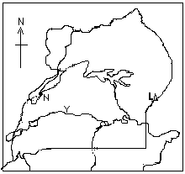

B

M

C

a) How is formation of Lake N different from Lake C?

b) State the main crop grown in the shaded area.

c) Which ethnic group entered Uganda using route marked B?

d) Why is water transport difficult I area marked M?

46. a)What was LEGCo in full.

b) Why was LEGCo formed?

c) Write down any first two Ugandans to be nominated /appointed

on LEGCo in 1945.

47. Use the diagram below to answer the questions that follow.

D

E

Health & moor land

B

A

Bamboo

a) Why is area A suitable for animal grazing?

b) Which type of vegetation is formed in area B?

c) How does vegetation B promote Lumbering?

d) Why is human settlement difficult in area D?

48. a) What is subsistence farming?

b) Give two reasons why most farmers in East Africa practice

Subsistence farming.

c) State one disadvantage of subsistence farming.

49. a) Who is a missionary?

b) How did missionaries contribute towards the education sector in

Uganda?

c) Which missionary helped to control sleeping sickness on the

shores of Lake Victoria?

50. Use the map below to answer questions that follow.

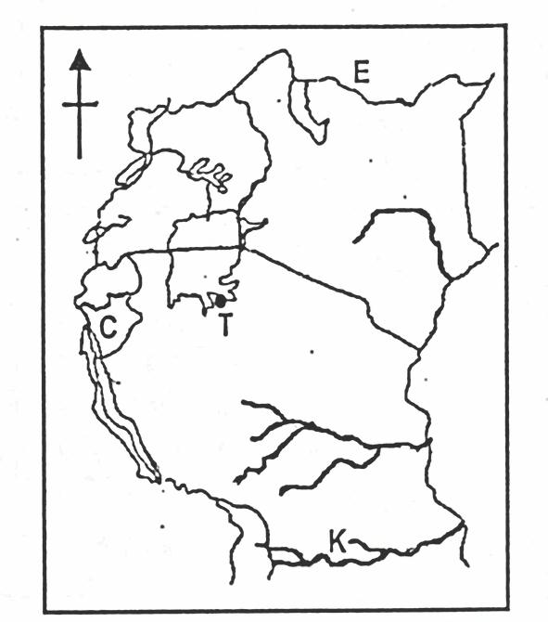

**Z**

**M**

**R**

a) Which group of people live on the slopes of mountain Z?

b) How is country E similar to country M in terms of location?

c) Write down any one port found on Lake marked R.

d) How is river K politically important to Tanzania and

Mozambique?

**For questions 51 – 55, Answer Either Christianity or Islam but not both.**

51. Either:

a) What is suffering?

b) How did Jesus suffer before He met His death?

c) State one way in which a Christian suffers physically.

d) How did Jesus help people who were in need?

Or:

a) What is suffering?

b) How did Prophet Muhammad suffer before He met His death?

c) State one way in which a Muslim suffers physically.

d) How did Prophet Muhammad (PBUH) help people who were in

need?

52. Either:

a) According to the Bible, who is regarded as the ancestor of

many nations?

b) Give any one name among the children of the ancestor

of many nations mentioned above.

c) State two ways in which the ancestor of many nations

showed great faith to God.

Or:

1. Which Prophet is regarded as the grandfather of believers

according to Islam?

1. Give one name among the children of the grandfather

mentioned above.

1. Mention any two ways in which the grandfather of the nations

showed His faith to Allah.

53. Either:

a) What is Lent?

b) Give one reason why Christians observe lent.

c) Mention any two things a Christian should observe during lent

period

Or:

a) What is Saum?

b) Write down any two groups of people exempted from fasting.

c) Write down any one reason why Muslims observe Saum.

54. Either:

a) What is a Parable?

b) Mention two parables Jesus used in His ministry.

c) State any one reason why Jesus used parables in His teaching.

Or:

a) What is Hijja?

b) Mention two conditions a Muslim should fulfill before performing

Hijja.

1. Give any one benefit of performing Hijja.

55. Either:

Jesus said to them, “Come with me and I teach you to catch people.” (Mathew 4:19)

a) Name the two people whom Jesus Christ told the above word.

b) What were the two people doing at the time they were called?

c) State one lesson learnt from the action that was taken by the

two people after Jesus called them.

Or:

a) Name the companion that Allah gave to Prophet Adam.

b) According to the Qu’ran, where did Allah get Adam’s

companion?

c) Give any two things a woman can do to please her husband in

marriage.

**END**

**ITEM ELEVEN**

**SECTION A (40 marks)**

1. Of what use is a compass to a pilot?
2. Why is a P.7 pupil not allowed to participate in National elections?
3. Name the type of house shown in the diagram below.

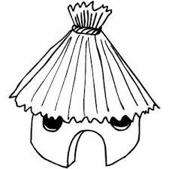

1. State one duty of prefects in a school.
2. Suggest any one way people can conserve the forests in our community.
3. Mention any one type of volcanic mountain in E. Africa.
4. Give any one process involved in the textiles industry.
5. Suggest one way farmers in Uganda can improve on their activity.
6. Why was the Uganda flag raised to replace the Union jack?
7. Which relief feature occupies most parts of Uganda?
8. Suggest one way how rivers can be dangerous to people around.
9. Apart from smoking, give one other way people in Uganda preserve fish.
10. Why are slopes of mountains highly populated?
11. What is poaching?
12. Why is rainfall measured in millimetres?
13. State the importance of feeder roads towards farmers in Uganda.
14. Which arm of the East African Rift Valley does Lake Turkana belong?

**Use the diagram below to answer questions 18 and 19.**

1. Which symbol of Uganda is represented by the above diagram?
2. Why is the above symbol drawn standing on one leg?
3. Under which ethnic group do the Lugbara belong?
4. How is money an important aspect in trade?
5. Name the Kabaka of Buganda who welcomed the earliest missionaries to Uganda.
6. Write **N.F.A** in full.
7. State one role played by the judiciary in Uganda.
8. **UPE** schools are learning institutions funded by government. Outline any one challenge faced by **UPE** schools.
9. Give one weather change that can affect farmers’ activities.
10. Which **E.A.C** service has its headquarters in Uganda?
11. Apart from being the capital city, mention one other function of Kampala to Ugandans.
12. How did the Arabs contribute to the development of E. Africa?
13. Land is one of the important natural resources in E. Africa. Give one way people can be encouraged to conserve it.
14. **Draw a map symbol for a factory in the space provided.**
15. Why should the government encourage urban-rural migration among people in Uganda?
16. Give any one reason why terrace farming is not commonly practised in Buganda region in Uganda.
17. Apart from animal pests and diseases, give one other problem affecting the pastoralists in E. Africa.

How was Fort Jesus helpful to the Portuguese on the E. African coast?

**RELIGIOUS EDUCATION**

**(For questions 36-40, answer either Christianity or Islam but not both in a number)**

1. **Either:** Give one reason why Christians remember John the Baptist.

**Or:** Give one reason why Muslims remember Adam.

1. **Either:** What is repentance?

**Or:** When does a Muslim seek for repentance?

1. **Either:** What name is given to the fasting period for Christians?

**Or:** What term is used to describe the fasting period for the Muslim

community?

1. **Either:** Give any one temptation Jesus got in the wilderness.

**Or:** Give any one way a Muslim can avoid temptation.

1. **Either:** Name the sacrament in Christianity that strengthens one in Christianity.

**Or :** Name the pillar of Islam that strengthens a Muslim in Allah.

**SECTION B (60 marks)**

1. a) What are non-traditional cash crops?

b) Mention any two examples of cash crops grown as beverages in E. Africa.

c) Why does the government encourage the growing on non-traditional cash

crops in Uganda?

1. a) What is ‘**Tourism’**?

b) Which tourist attractionis famous for each national game park below;

i) **Bwindi national park?**

ii) **L. Nakuru national park?**

c) Give one problem faced by wild animals in national parks of E. Africa.

1. a) Which countries share common border with Uganda in the following directions;
2. North _____
3. West ____

b) Why does Uganda need to cooperate with her neighbours?

c) What term is used to refer to lines parallel to the Equator?

1. a) What is population?

b) Suggest any two factors that can determine a rise in population.

1. Why is it necessary for the government to encourage people to practise family planning methods?

45. a) Write the following in full.

i) **LEGCO**______

ii) **C.M.S** _________

b) Why was **LEGCO** formed in 1920s?

c) State any one contribution of Albert Cook towards Uganda’s development.

**46. a) Match the following correctly:**

**A B**

**Escarpments** hole formed at the top of an extinct volcano.

**Horst** highest point of a mountain

**Crater** steep sides of a rift valley

**Peak** a mountain formed as a result of faulting.

i) **Escarpments** ___________

ii) **Horst** __________

iii) **Crater** _________

iv) **Peak**  _______

**Study the map of E. Africa below and answer questions that follow;**

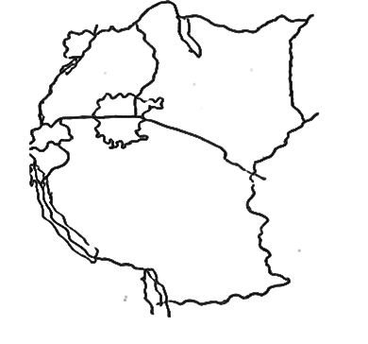

**1**

**A**

**C**

**B**

46. a) Give any one difference between countries marked **A** and **B**.

1. How is country marked **C** economically important to country marked **A**?
2. Name one waterfall located along river marked **1**.
3. Using letter **Y,** show the location of Zanzibar Island.
4. a) What is a **wetland**?

b) Which body in Uganda is responsible for the conservation of wetlands?

c) Why is it dangerous to clear wetlands?

d) Give any one way in which wetlands are important.

1. a) What are Stone Age sites?

b) Give any one importance of Stone Age site to people around it.

c) In which Stone Age period did early man discover fire?

d) In which one way is Nyero Stone Age site different from other Stone Age sites?

1. a) What is transport?
2. How does a good road network promote development in a country?
3. Why is air transport considered as the most suitable type for perishable goods in overseas trade?
4. Which body in Uganda is responsible for repairing and construction of roads?

**RELIGIOUS EDUCATION**

**(For questions 51-55, answer either Christianity or Islam but not both in a number)**

1. **Either:**

a) Who were the **disciples** according to the Bible teaching?

b) Which disciple is remembered for;

i) doubting Jesus’ resurrection?

ii) being most loved by Jesus?

c) Why did Jesus call the disciples?

**Or:**

1. Who were the **caliphs** according to Islamic history?
2. Which caliph is remembered as;
3. the immediate successor of Prophet Muhammad?
4. the cousin of Prophet Muhammad?
5. Why did Prophet Muhammad migrate from Mecca to Medina?
6. **Either:**
7. What event took place at each of the following places?
8. **Galilee**  __________
9. **Golgotha** ____________
10. Which group of people were the first to visit baby Jesus?

c) Why was Jesus taken to Egypt?

**Or:**

1. What event took place at each of the following places?
2. **Badri**
3. **Mt. Hira**
4. Why did the Arabs (meccans) hate Prophet Muhammad’s teachings?
5. Where was Prophet Muhammad buried?
6. **Either:**
7. What is a **covenant**?
8. Which covenant did God make with the following people?
9. **Noah**
10. **Abraham**
11. Why did God instruct Noah to build an Ark?

**Or: a)** What is **Zakat?**

1. Mention any two groups of people (Muslims) entitled to get Zakat.
2. How is **Zakat** different from **Sadaq**?
3. **Either: a)** What is a **sin**?
4. Give any two examples of sinful acts according to Christian teaching.
5. Why did Jesus love sinners?

**Or: a)** What is a **sin**?

Mention any two examples of sinful acts according to Islamic teaching?

1. Give one way through which a Muslim can guard against sin.
2. **Match the following correctly;**

**Job** most loved by Jesus.

**John the Baptist** prophet famous for his endurance and perseverance.

**Joshua**  last prophet according to the Bible.

**John**  delivered Israelites to the Promised Land.

1. **Job** __
2. **John the Baptist** __
3. **Joshua**  __
4. **John** __

Or

**Abu Talib**  African slave who converted to Islam.

**Abdallah**  built the holy Kaaba.

**Bilal**  uncle to Prophet Muhammad.

**Ibrahim**  father of Prophet Muhammad.

1. **Abu Talib**  ____
2. **Abdallah**  ___
3. **Bilal**  ____
4. **Ibrahim** __

**END**

**ITEM TWELVE**

**SECTION A**

1. Name the element of a map that helps to measure the actual ground distance between places.

2. How is a nuclear family different from an extended family?

3. What role do citizens play in maintaining peace and security in their areas?

4. How can parents help to control the rate of child abuse in Uganda?

5. Why do areas near the equator have higher temperatures in March and September?

6. How does the temperature vegetation zone favour the dairy farming in south Africa?

7. Mention any one way the collapse of the East African Community in 1977

negatively affected member states.

8. How does the International Labour Organization (ILO) work for the welfare of workers?

9. Mention one factor that made MAU-MAU rebellion to last for long in Kenya.

10. Which type of education was introduced by Christian missionaries in Uganda?

11. Why are mineral resources not fully exploited in East Africa?

12. What role do veterinary doctors play in our community?

13. Apart from mediating peace talks, how else do religious leaders promote peace in a country?

14. What title is given to a diplomat from a common wealth country to another common wealth nation?

15. Why is it shorter to use air transport from Entebbe to Arua than Road transport?

16. Name one voluntary organization operating in Uganda.

17. Why is Africa related to the origin of mankind?

18. How were ox-bow lakes formed?

19. How did the 1900 Buganda agreement lead to the loss of land of the Kingdom?

20. Draw a diagram showing a deficit in the space below.

21. Which colour of the Uganda National Flag symbolizes brotherhood?

22. Mention the only depression lake in Kenya.

23. Why does west Africa have many lagoons?

24. What is meant by excise duty?

25. Write FRELIMO in full

26. How did the colonialists benefit from indirect rule?

27. Which element of weather helps farmers to winnow their harvested crops?

28. State one factor that promotes trade in an area.

29. Why did the British colonialists introduce taxes in Uganda?

30. Give one way forests promote fish.

31. Why are coastal areas warmer than the interior?

32. How does African Union promote human rights?

33. How does the world bank contribute to Uganda’s budget?

34. State one role of ECOMOG to its member states.

35. Why is terracing not a common practice in central region of Uganda?

**For questions 36 – 40, answer either Christianity or Islam but not both.**

36. Either: What sacrament makes one to join God’s family?

Or: What pillar make one to join Islam?

37. Either: How did God show love to Noah and his family?

Or: How did Allah show love to Nuuhu and his family?

38. Either: What lesson do you learn from the resurrection of Jesus Christ?

Or: What lesson do you learn from the acts of Prophet Muhammad?

39. Either: Why did God create man in his image?

Or: Why did Allah create man in his image?

40. Either: Mention one way you as a Christian child should relate with others?

Or: Mention one way you as a moslem child should relate with others?

**SECTION B**

41. a) Name the first European explorer to cross through the Masai land.

b) Write down any two problems faced by European explorers in East Africa.

c) How did exploration work speed up the colonialization process of East

African states.

42. a) Use the map below and answer questions that follow.

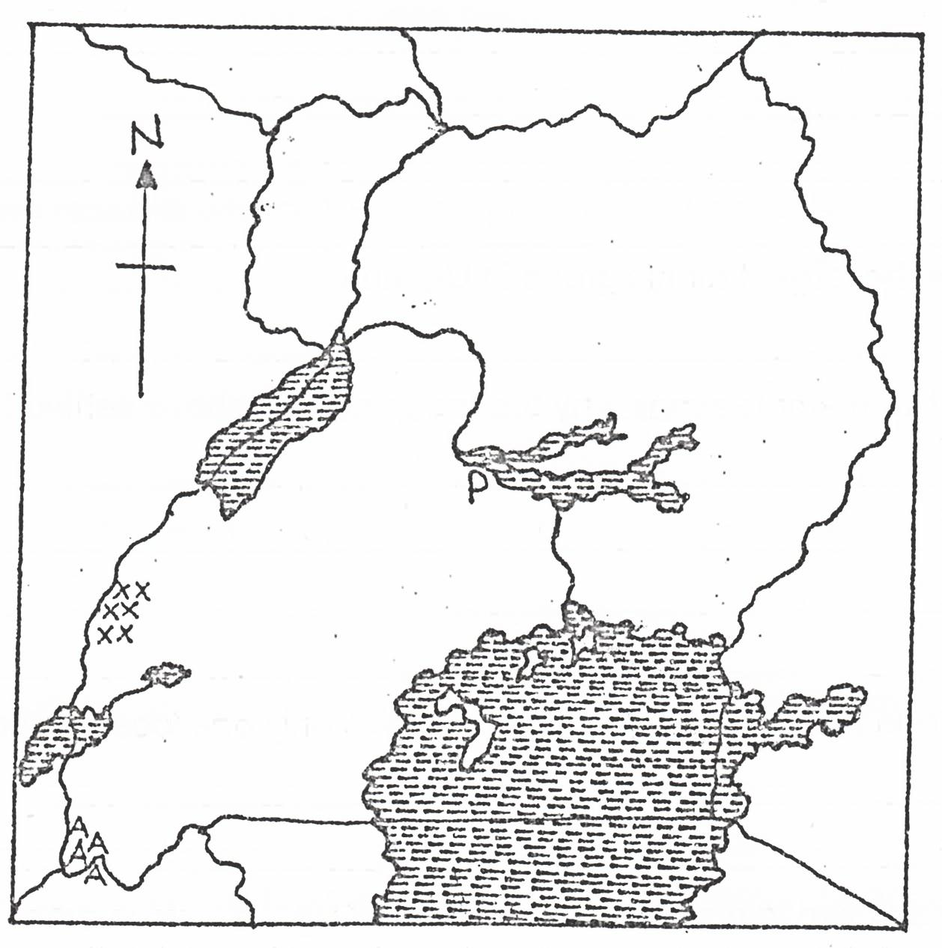

a

N

Z

a) Name the river marked a on the map.

b) State two economic activities done in a place marked Z on a map.

c) Why is water transport on the part of the river marked N difficult?

43. a) Name any one first Ugandan to join the legislative council (LEGCO) in

1945

b) Mention two functions of the legislative council (LEGCO) to the colonial

government.

c) How did the people of Uganda join LEGCO?

d) Why did the people of Uganda demand representation in the LEGCO?

44. a) Apart from taxes, give any two other ways government gets income.

b) Mention any one challenge the government faces in collection of taxes.

c) How does government ensure proper spending of its income?

45. a) Name any one commonest cash crop grown by countries of the Nile basin.

b) Write down any two factors that have promoted the growing of the

cash crop mentioned above.

c) Why has the growing of the above crop declined in Uganda?

46. a) Name any two African countries that remained free from colonialism.

b) State any two reasons why any of the countries above remained free from

colonialism.

47. a) What term is used to mean the increase in the number of people living in

an area?

b) State any two factors that can cause population to increase in a country.

c) If county R has a population of 6000 people in 20km. calculate its

population density.

48. Match minerals in list A with places where they mined in list B.

**List A List B**

Cobalt Kabale

Salt Kasese

Wolfram Tororo

Phosphate Lake Katwe

Cobalt ____

Salt ____

Wolfram ____

Phosphate ___

49. The diagram below shows things used at a polling station. Study it and answer

questions that follow.

P

Q

a) Name the items marked P and Q

b) State two different people responsible for managing a polling station during elections.

50. The table below shows temperature and rainfall recorded in a certain region.

Study it and answer questions that follow.

|  |  |  |  |  |  |  |  |  |  |  |  |  |
| --- | --- | --- | --- | --- | --- | --- | --- | --- | --- | --- | --- | --- |
| Months | J | F | M | A | M | J | J | A | S | O | N | D |
| Temp. (0C) | 21 | 24 | 28 | 31 | 37 | 28 | 36 | 25 | 26 | 27 | 24 | 22 |
| R/fall(mm) | 0 | 0 | 3 | 11 | 69 | 117 | 206 | 310 | 142 | 13 | 0 | 0 |

a) Name one month where rainfall was received heaviest?

b) In which month was the highest amount of rainfall received?

c) What type of climate is shown on the table above?

d) Calculate the rainfall range basing on the above graph.

***For questions 51 – 55, answer only Christianity or Islam. But Not Both.***

51. Either:

a) Apart from worshipping the devil, mention any one way Jesus was

tempted while in the wilderness.

b) What name was given to the meal that Jesus had with His disciples before

He died on the cross?

c) How is fasting important to a Christian.

d) Who prepared the last supper for Jesus?

Or:

1. What name is given to the early morning meal for Muslims during

Ramadhan?

b) What name is given to the night prayers during the fasting period for

Muslims?

c) Mention any two ways fasting is important to a Muslim.

52. Either:

a) Name the special book Christians use to preach the word of God.

b) State two factors that make the above book unique.

c) How do pupils benefit from the above mentioned special book?

Or:

a) Name the special book Muslims use to preach the word of Allah.

1. State any two factors that make the above book unique.
2. How do pupils benefit from the above mentioned special book?

53. Either:

a) Who led Jesus to the wilderness?

b) Why did Jesus go the wilderness?

c) Why did the devil tempt Jesus in the wilderness?

1. How do Christians overcome temptation?

Or:

a) Who escorted Prophet Muhammad to Taif?

b) Why did Prophet Muhammad go to the Taif?

c) How did the people of Taif receive Him?

d) How do Muslims overcome temptations?

54. Either:

a) What term is used to mean the short stories with hidden spiritual meaning as taught by Jesus?

b) Mention any two reasons why Jesus used the above stories.

c) What do Christians learn from the story of the ten virgin girls.

Or:

1. What term is used to mean the traditions, deeds and words of Prophet

Muhammad?

b) Mention any two reasons why Muslims follow the traditions above.

c) What lesson do Muslims learn from the acts of Prophet Muhammad?

55. Either:

a) “It is not good for a man to live alone, I will make a suitable companion for

him”. (Genesis: 2:18)

a) Who said the above words?

1. Why were the above words said?

c) Where did God put the above named person?

d) Why did the above person disobey God?

Or:

“I know what you do not know, go and collect the soil from earth (Surat Imran”

a) Who said the above words?

b) To whom were the above words said?

c) Where did Allah put the person he created?

d) Why did the above person disobey Allah?

**END**

**ITEM THIRTEEN**

**SECTION A (40 Marks)**

1. James was travelling to the Eastern direction and turned 900 clockwise. What was his new direction?
2. Name the country that neighbours Uganda in the South West.
3. Write C.M.S in full.
4. Why was Sir Samuel Baker liked by the people of Acholi?
5. State any one problem faced by crop farmers in Uganda.
6. How did Uganda Chiefs and Kings benefit from slave trade?
7. What is farming?
8. Which official represents the central government in a district?
9. Why is Lake Kyoga a swampy lake?
10. Name the map symbol shown below.
11. In which wayare lines of latitude and longitude similar?
12. Name the physical feature which covers most parts of Uganda?
13. State the major reason why farmers in mountainous areas terrace their land?
14. Name the biggest national referral hospital in Uganda.
15. What was the major cause of the Lamogi rebellion in Uganda between 1911-1912?
16. Where do we find the headquarters of the East African community?
17. How is Lake Katwe economically important to Uganda?
18. Which type of coffee is commonly grown on the slopes of Mt. Elgon?
19. Why is water transport (navigation) difficult on some parts of river Nile?
20. What name do we give to the people who were hired to come and build the Uganda railway?
21. Suggest any one reason why Kingdoms are important to a country.
22. State any one reason why it is not available to settle on the slopes of an active volcano.
23. Write COMESA in full.
24. Why is mixed farming not commonly practiced in Uganda?
25. Who is a ‘child’ according to the constitution of Uganda?
26. Which mineral is mined in Tororo district?
27. What is communication?
28. Why were political parties formed in Uganda in 1950s?
29. How can people protect themselves from harsh sunny weather?
30. Name the line of longitude that determines date and time.
31. What title is given to a person who heads the police in Uganda?
32. Name the largest natural forest in Uganda.
33. Why is it difficult to read a map without a key?
34. What do we call the plant cover of an area that grows on its own?
35. Give the compass direction of Kenya from Uganda.

**For questions 36-40, answer Either Christianity or Islam but not both in a number.**

1. Either: Explain the term ‘Lent.’

Or: What name is given to the fasting period for Muslims?

1. Either: Why did Simon Peter deny Jesus three times?

Or: Why did Prophet Muhammad leave Mecca to Medina?

1. Either: What sin did Adam and Eva commit?

Or: Explain the term ‘Caliph’ according to Islam.

1. Either: Mention the first apostle to be called by Jesus Christ.

Or: Who was the first wife of Prophet Muhammad?

1. Either: Write any form of suffering experienced by Christians.

Or: Write U.M.S.C in full.

**SECTION B**

1. **Study the map of East Africa below and answer questions from it.**



**Y**

**X**

**L**

1. Name the country marked X.
2. Which major cash crop is grown on Island Y?
3. Name the Capital City of country L.
4. How is port Mombasa important to the economy of Uganda
5. EAC stands for East African Community.

a). Name the last country to become a member state of the EAC.

b). Why isn’t Nigeria a member country of the EAC.

c). Mention one non-land locked country of the EAC.

d). How is Arusha related to the general duties of the EAC?

1. a) How is Muteesa I related to the Missionary work in Uganda?

b). Write down two positive contributions of the Missionary work in Uganda?

c). Which local religion existed in Uganda before the coming of the Missionaries?

1. A democratic government has three organs.

a). Which organ punishes law breakers?

b). What is the main duty of the legislature?

c). Who heads the executive arm?

d). What role does the speaker play in the parliament.

1. **Complete the table below.**

|  |  |
| --- | --- |
| **Raw material** | **Finished product** |
| a). Limestone | **______________________** |
| b). _________________________ | Shoes / bags/belts |
| c). Wood | **______________________** |
| d). ______________________ | Cigarettes |

1. a) Mention two factors one has to consider before setting up a crop farm in a school.

b). How do school children benefit from a school garden?

c). Why do most schools in Urban areas lack school farms and gardens?

1. Why is tourism important in a country?
2. Write URA in full.

b). Give one duty of the URA.

c). Write down one source of government’s revenue.

d). How does the government spend her revenue?

1. **Study the diagram below and answer the questions correctly.**

k

23½0N

23½0N

z

0o

0o

s

0o

a). Name the line of longitude marked S.

b). Line of latitude marked Z is the equator, name any one East African country it crosses.

c). What name is given to the line of latitude marked K?

d). Mention one month of the year when the sun is overhead line marked Z.

1. Mining is the extraction of minerals from underground.

a). **Mention the minerals obtained from these lakes.**

1. Lake Katwe ______
2. Lake Magadi ___
3. Lake Albert __

b). Which mineral led to the extension of the Uganda railway to Kasese?

***In questions 51-55, answer Either Christianity or Islam BUT not both on the same number.***

1. **Either:**

a). What is a talent?

b). Mention any two examples of talents given to a person by God.

c). Give one way how people mis use their talents.

**Or:**

a). What is a talent?

b). Mention any two examples of talents given to a person by Allah.

c). Give one way how people mis use their talents.

1. **Either:**

a). State any two reasons why Christians pray as soon as they wake up in the morning.

b). Give any two symbols of a Christian.

**Or:**State any two reasons why Moslems pray.

b). Mention any two prayers said by Moslems.

1. **Either:**

a). Why is baptism important in Christianity?

b). Who baptized Jesus Christ?

c). Name the river where Jesus was baptized from.

d). Name one religious leader who baptizes in Christianity.

**Or:**

a). What is circumcision?

b). Give one reason why Moslems undergo into circumcision.

**For both**

54a) Why do religious people encourage people to work?

b). What was the work of Zachaeus?

c). Give two reasons why some people fail to work.

1. Either :

a). Name one quality of leadership Jesus had.

b). Apart from Jesus, name one leader talked about in the Bible.

c). Write down one bad characteristic of the leader of today.

d). How can one become a school prefect?

**Or:**

a). Give one quality of leadership Mohammad had.

b). Apart from Mohammad, name one leader talked about in the Quran.

c). Write down one bad characteristic of the leader of today.

d). How can one become a school prefect?

**END**

**ITEM FOURTEEN**

**SECTION A**

1. Which imaginary lines on the globe are also called meridians?
2. Name the relief feature that covers the largest part of Africa.
3. In which way do lakes and rivers modify climate?
4. Why is a museum important to a country?
5. Name the local council committee member in charge of security.
6. What was indirect rule as used by the British in Uganda?
7. How is Kampala related to East African development Bank?
8. Write down one activity people should do to maintain good climate conditions of an area.
9. Why is it important for children to attend social functions in your community?
10. Why do different animals live in different vegetation zones?
11. State one danger of high smuggling of goods into the country.
12. Why is it necessary for farmers to know the rainy and dry seasons?
13. Give any one effect of slave trade in East Africa.
14. Why is tourism considered to be an invisible form of trade?
15. Which organization is responsible for elections in Uganda?
16. Give any one tourist attraction on River Zambezi.
17. Write down one way in which a country can control its population growth.
18. In which region of Africa is Eritrea found?
19. Why is Milton Obote remembered in the political history of Uganda?
20. State one way of acquiring basic needs.
21. How does wind influence the climate of an area?
22. Give one reason why Europeans were interested in finding a sea-route to India.
23. What is the opposite direction North West?
24. What is the multi-party system of government?
25. Which body promotes trade among the countries of Southern Africa?
26. State the duty of UPDF in Uganda.
27. Give any one challenge facing African Union today.
28. In which way are traffic rules and signs important to man?
29. Write down any one advantage of irrigation farming.
30. Give one reason why Democratic Republic of Congo is famous for lumbering.
31. What happens to a law breaker after the court has proved him or her guilty?
32. Why is it important for Uganda to have national symbols?
33. State any one reason why the Pan-African movement was formed.
34. Write down any one weather disaster.
35. What was the system of trade used in the long distance trade?

**For each of the questions 36 to 40, Answer Either Christian Or Islamic question but not both.**

1. **Either**:- Why do Christians close eyes when praying?

**Or**:- Why do men sit separately from women praying?

1. **Either**:- State the work of the Holy Spirit in the church today.

**Or**:- How were the Caliphs important to Prophet Muhammad?

1. **Either:**- Name the town where Jesus Christ grow up from.

**Or:**- In which town was prophet Muhammad born?

1. **Either**:- How can Christians follow Jesus Christ’s example?

**Or**:- How can Moslems follow Muhammad’s example?

1. **Either:**- Write in full U.J.C.C.

**Or**:- Write U.M.S.C in full.

**SECTION B.**

1. (a) Name two places where people get their needs from.

(b) Give two problems met by people when trying to get their needs.

1. (a) Why was LEGCO formed in 1921 in Uganda?

(b) Name the first two Ugandans to be nominated in LEGCO.

(c) How did LEGCO help in the struggle for independence in Uganda?

1. (a) Which organ of the East African Community does the same work as the Uganda Parliament?

(b) In which year did Rwanda and Burundi join the East African

Community?

(c) Give any two problems affecting the current East African

Community.

1. (a) Write IBEACO in full.

(b) Why was IBEACO formed in 1887 in East Africa?

(c) Write down two reasons why IBEACO ran bankrupt.

1. (a) What is mining?

(b) Give any one method of mining used in East Africa.

(c) State any two economic values of mining to the people of East Africa.

1. (a) Name the body in Uganda responsible for conservation of forests.

(b) Why are Equatorial rain forests also called tropical rain forests?

(c) State any two reasons why people carry out deforestation.

1. (a) Which organization was replaced by African Union?

(b) In which city are the headquarters of African Union?

(c) Give any two reasons why African Union was formed.

1. (a) What is an ethnic group?

(b) Give two major ethnic groups of people in Africa.

(c) State one reason for the migration of ethnic groups in Africa.

1. **Study the map of Uganda below and use it to answer the questions that follow.**

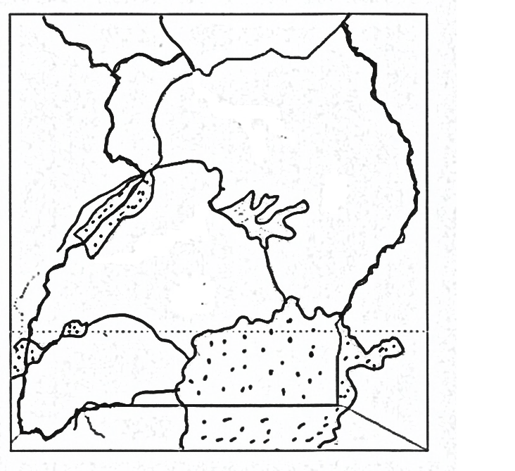

**F**

**P**

**x**

**x**

**x**

**x**

**x**

**x**

**N**

**S**

1. Name the river marked with letter **P**.
2. Which rebellion was staged in the country marked **F**?
3. What is the major economic activity of the people who live in the Island marked **S**?
4. Which part of Nile is marked **xxx**?
5. (a) Which type of climate experiences hot and dry summers, warm and

wet winters?

(b) Name any two countries in Africa which experience the type of

climate named above.

(c) Which winds bring rainfall to the above named climate in 50(a) ?

**For each of the question 51 to 55, answer Either Christian Or Islamic questions but not both.**

1. **Either**: (a) Why did Jesus Christ perform miracles?

(b) State any two ways how Jesus Christ took care of His people’s need.

(c) Give any one benefit of the Holy Spirit to any Christian believer.

**Or**:- (a) Give any two conditions a Moslem must consider before performing Salat.

(b) State any two things a faithful Muslim is not supposed to do during fasting.

1. **Either**: (a) What do you understand by the word “church”?

(b) What name is given to the followers of Jesus Christ?

(c) Name two branches of the church.

**Or**: (a) What do you understand by the word “Mosque”?

(b) What name is given to the followers of Mohammad?

(c) Name two branches of Islam.

1. **Either**:- (a) How is Mt. Sinai important in Christianity ?

(b) Which commandment makes us contented with what we have?

(c) In which two ways are the ten commandments of great value to Christians today?

**Or**:- (a) How is Mt. Hira important in Islam?

(b) Which pillar urges Muslims to help others?

(c) In which two ways are the pillars of Islam are of great value to Moslems today?

1. **Either**: (a) What are voluntary organizations?

(b) Give any three voluntary organizations operating in Uganda.

**Or**: (a) What are voluntary organizations ?

(b) Give any **three** voluntary organizations operating in Uganda.

1. **Either: Match the following correctly.**

**A B**

(i) Judas Iscariot buried the body of Jesus

(ii)Simon of Cyrene first to baptize people.

(iii)John the Baptist betrayed Jesus.

1. Joseph of Arimathea helped Jesus to carry the cross.
2. Judas Iscariot ……………
3. Simon of Cyrene …………
4. John the Baptist ………
5. Joseph of Arimathea ……

**Or:- Match the information in list A with that in list B.**

**A B**

(i) Adam become the mother of prophet Isa

(ii) Nuuh first person to be created

1. Musa built Ark.
2. Mariam delivered Allah’s people from slavery
3. Adam …………
4. Nuuh ……………
5. Musa ………………
6. Mariam ………………

**END**

**ITEM FIFTEEN**

**SECTION A.**

1. Which East African country is referred to as the “pearl of Africa”?
2. Why are people discouraged from settling in swamps?
3. Give **one** reason why Rwanda and Uganda do not have the same time yet they are neighbours.
4. How does overgrazing affect the environment?
5. Apart from Mt. Rwenzori, write down any other block mountain in Africa.
6. Why do rivers flow from a higher altitude to a lower altitude?
7. How do winds influence the climate of an area?
8. In which way are planted forests different from natural forests?
9. Give **one** disadvantage of having an extended family.
10. How does poaching affect game parks?
11. How does tourism promote Art and craft industry in Uganda?
12. How does good medical service contribute to population growth?
13. Why is Pubungu remembered in the ethnic migration into Uganda?
14. How did the discovery of iron help to improve the life of the early man?
15. Why did the Arabs come to settle at the coast of E.Africa?
16. In which way does a deficit budget bring misery in the family?
17. State the major cause of insecurity in a family.
18. What is the difference between customs tax and excise duty?
19. What helps a camel to adapt the desert conditions?
20. Give **one** reason why railway transport is not used by many people in Uganda.
21. What is mass media?
22. Why is electricity important for economic development of a country?
23. On which African river was Kainji project set up?
24. Why was Africa referred to as a white man’s grave?
25. How did Mutesa I contribute to the coming of missionaries to Uganda?
26. How did Semei Kakungulu help the British to establish their rule in Uganda?
27. Give **one** advantage Kenya has over Uganda during international trade.
28. How do African landlocked countries solve the problems of transport?
29. Why do we stand up when singing the national anthem?
30. Apart from making laws, mention any other **one** functions of a legislature.
31. How is democracy promoted in schools?
32. How did the formation of LEGCO help Africans to fight for independence?
33. Which political party led Kenya to independence?
34. Give the importance of Arusha to E.Africa.
35. Why is it difficult to have a national language in Uganda?

**Answer Either Christianity or Islam**

1. **Either:**- How did the teaching of John the Baptist ease the work of

Jesus Christ?

**Or**:- How did Prophet Muhammad’s marriage to Khadijah ease his work

of spreading Islam?

**Either:**- What is sin according to Christianity?

**Or**:- What is sin according to Islam?

1. **Either**:- What is fear in Christianity?

**Or**:- What is fear in Islam?

1. **Either:**- Who was the father of Joseph according to the Bible?

**Or**:- Who was the father of prophet Yusuf according to the Quran?

1. **For Both**.

Give **one** cause of divorce among married couples today.

**SECTION B.**

1. (a) Give **one** way a national budget helps a country to develop economically.

(b) Apart from taxes, give any other **two** ways the government gets income.

(c) Give **one** challenge the government faces when collecting taxes.

1. (a) What is Burundi’s neighbouring country to the East?

(b) Why should Burundi promote good relationship with its neighbours?

(c) Give any **two** ways in which the above named country benefits from Burundi.

1. (a) Give any **one** way slave traders got slaves.

(b) Give **two** reasons why slave trade was carried out.

(c) Mention **one** Island in the Indian Ocean where slaves from East Africa were taken.

1. **Study the map below and answer the questions that follow**.

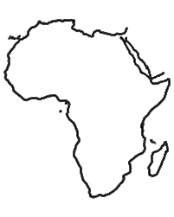

**R**

**R**

**R**

**R**

**M**

**M**

**M**

**M**

**M**

**R**

**R**

**R**

**M**

1. Draw and indicate the degrees for the Prime Meridian on the map for Africa above.
2. Name the climatic regions of Africa marked;
3. **RRR** ______
4. **MMM** _____
5. How do ocean currents marked R affect the climate of the areas if flows to?
6. (a) Name any **one** river that ends in form of a delta in West Africa.

(b) Mention **two** uses of the delta mentioned above.

(c) State any problem that can be caused by the river mentioned

above.

1. (a) State any **one** role played by each of the following service providers below.
2. Uganda People’s defence force (UPDF)
3. Uganda Prisons.

(b) State any **one** challenge faced by the Uganda Police as they carry out their duty.

1. (a) Mention any **two** tribes that belong to the Plain Nilotes in Uganda.

(b) Why didn’t the pastoral tribes form kingdoms?

(c) State **one** importance of studying the settlement patterns of

people.

1. (a) What are multipurpose river projects?

(b) Name the cash crop grown on Gezira irrigation scheme.

(c) Why is canal irrigation method commonly used in Gezira?

1. What are the benefits of Gezira to the people?
2. (a) Name the political party that led Rwanda to independence.

(b) Why were foreign laws hated by the people of East Africa?

(c) How did the formation of political parties speed up the demand

for independence?

(d) Why did Tanganyika get independence before other countries of

East Africa?

1. (a) State any **two** ways road users observe traffic rules.

(b) Give the importance of lollipop men to school children.

(c) What is the meaning of orange colour of the traffic lights?

**For questions 51 – 55 answer Either Christianity or Islamic but not both.**

1. **Either**:- (a) What does the lent period remind Christians?

(b) Give **two** ways Christians observe lent.

(c) What does fasting mean to a Christian?

**Or**:- (a) What does fasting mean to a Moslem?

(b) State **two** ways Moslems observe fasting.

(c) What does fasting mean to a Moslem?

1. **Either**:- (a) Name any **two** free services you as a Christian can offer to

your church.

(b) Give any **two** ways the church gives free services to the people in

a community.

**Or**:- (a) Name any **two** free services you as a Christian can offer to

your mosque.

(b) Give any **two** ways Moslems give free services to people in the

community.

1. **Either:- “I will ask the Father and he will give you another helper, who will stay with you forever (John 14:16 – 26)”**
2. Who said the above words?
3. Name the promised helper according to the statement above.
4. State any **two** ways in which the helper guides Christians today.

**Or**:- (a) Name the first caliph of prophet Mohammad.

(b) In which **two** ways were caliphs helpful in Islam?

1. Give **one** lesson a Muslim can learn from the work of the caliphs.
2. **Either**: (a) Name **two** church founded organizations which provide

councelling services to married couples.

(b) State any **two** challenges faced by the organizations you have

mentioned in (a) above.

**Or**:- (a) Name any **one** Islamic founded organization that promotes youth activities in Uganda.

(b) State any **two** challenges faced by the organization you have

mentioned above.

(c) Mention any **one** way the above organization have socially

contributed towards the development of Uganda.

1. **For Both**.
2. In which **two** ways have Christianity and Islamic religions promoted development in Uganda.
3. State **two** challenges the above religiou s face as they try to promote development in Uganda.

55a. either: **Match list A to B correctly**

**List A List B**

Ash Wednesday Jesus performs the first

Holy Thursday Holy Communion

Ascension Day Christians begin fasting

Pentecost day disciples received the Holy Spirit

Jesus ascended to heaven

***0r***: 55a. Either: match list A to B correctly

**List A List B**

IddI-Adhuwa holy journey of Muslims to Mecca

Iddi el- fitri prophet Mohammed’s journey from Mecca to medina

Hijja festival that marks end of Ramadhan

Hejira festival for Muslims to remember prophet Ibrahim’s sacrifice to Allah

**END**