JIM PREPARATORY NURSERY & PRIMARY SCHOOL

IKI-IKI

MOTTO: OUR GOD IS ABLE

**TERM TWO ASSEAAMENT EXAMS SET V 2023**

**PRIMARY SEVEN**

**INTEGRATED SCIENCE**

**DURATION: 2HRS 15 MIN**

NAME: ..................................................................................

STREAM: ..............................................................................

|  |
| --- |
| **FOR EXAMINERS’ USE ONLY** |
|  |

|  |  |  |
| --- | --- | --- |
| **FOR EXAMINERS’ USE ONLY** | | |
| **Qn. No.** | **MARKS** | **EXR’S NO.** |
| **1 – 10** |  |  |
| **11 – 20** |  |  |
| **21 – 30** |  |  |
| **31 – 40** |  |  |
| **41 – 43** |  |  |
| **44 - 46** |  |  |
| **47 - 49** |  |  |
| **50 - 52** |  |  |
| **53 - 55** |  |  |
| **TOTAL** |  |  |

**Read the following instructions carefully.**

1. This paper has two sections: **A** and **B.**
2. Section **A** has **40**questions (40 marks)
3. Section **B** has **15** questions (60marks)
4. Answer **all** questions. All answers to both sections **A** and **B** must be written in spaces provided.
5. All answers must be clearly written using **blue** or **black** ball point pen or ink.
6. Unnecessary changes of work may lead to loss of marks.
7. Any handwriting that cannot be easily read, may lead to loss of marks.
8. Do **not** fill anything in the boxes indicated for official use only.

**Section A : (40Marks)**

1. Mention the process by which nimbus clouds are formed.

………………………………………………………………………………….

2. Write one energy resource from water.

………………………………………………………………………………….

3. Give one way in which some bacteria are useful to people.

………………………………………………………………………………….

4. What name is given to the non metallic conductor of electricity

in a dry cell?

………………………………………………………………………………….

5. Give one way of storing fish at home safe without getting

spoiled.

………………………………………………………………………………….

6. State one cause of soil erosion.

………………………………………………………………………………….

7. How does proper cooking of meat help to protect people from

getting tapeworms?

………………………………………………………………………………….

8. State the importance of the pigment found in plants.

………………………………………………………………………………….

**The diagram below shows a banana plant. Use it to answer questions 9 and 10.**

**X**

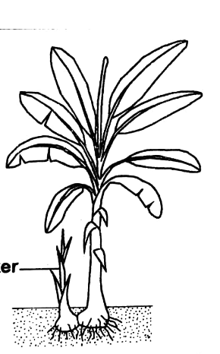

**Y**

9. Name part marked **X**.

………………………………………………………………………………….

10. State one advantage part **Y** has as it grows.

.……………………………………………………………………………….

11. Mention one form of energy produced by a ball when it is

kicked.

.……………………………………………………………………………….

12. Give one way of maintaining the hygiene of utensils at home.

.……………………………………………………………………………….

13. Why is carbondioxide used to preserve drinks?

.……………………………………………………………………………….

14. State one similarity between a sugarcane and irish potato in

the way they store their food.

.……………………………………………………………………………….

15. Give one effect of smoking to the lungs.

.……………………………………………………………………………….

16. Mention one importance of radiation to people.

.……………………………………………………………………………….

17. Write one example of a flat bone.

.……………………………………………………………………………….

18. What immediate advice can you give to a fellow pupil who has

poured hot porridge on her hand?

.……………………………………………………………………………….

**The diagram below shows a musical instrument. Use it to answer questions 19 and 20.**

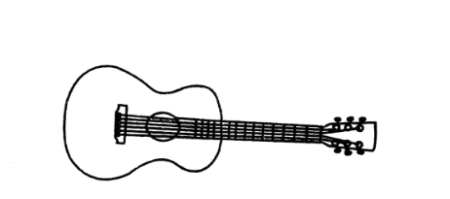

19. Name the musical instrument above.

.……………………………………………………………………………….

20. How is the musical instrument above played?

.……………………………………………………………………………….

21. Give one tool used in the stocking of bee hives.

.……………………………………………………………………………….

22. State one danger of failure to keep latrines clean.

.……………………………………………………………………………….

23. How do most fungi reproduce?

.……………………………………………………………………………….

24. Give one danger of polythene bags on the soil.

.……………………………………………………………………………….

25. How does slashing tall grass around homes help to control

the spread of malaria?

.……………………………………………………………………………….

26. Name the viral disease that causes swelling of glands in the

neck and face.

.……………………………………………………………………………….

**The diagram below shows an instrument used to measure weight. Use it to answer questions 27 and 28.**

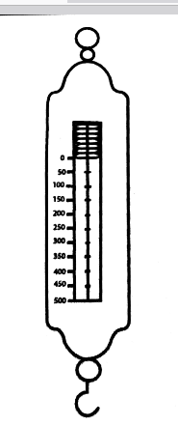

27. Name the instrument in the diagram.

.……………………………………………………………………………….

28. Why does the instrument above give its measurement in

Newtons?

.……………………………………………………………………………….

29. Why is the floor of a pigsty constructed in a slanting way?

.……………………………………………………………………………….

30. Mention one proper storage of garden tools.

.……………………………………………………………………………….

31. Give one factor considered by animals as they choose a place

where to reproduce from.

.……………………………………………………………………………….

32. State one advantage of row planting.

.……………………………………………………………………………….

33. Which part of legumes makes them different from other

dicots?

.……………………………………………………………………………….

34. Mention the quantity of sugar needed to make ORS locally

using one litre of water.

.……………………………………………………………………………….

35. Name one breed of chickens reared by people.

.……………………………………………………………………………….

**The diagram below shows a method of grazing goats. Use it to answer questions 36 and 37.**

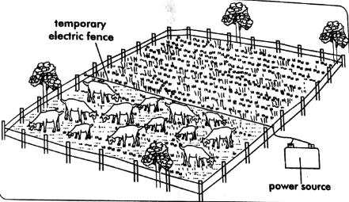

36. Name the method shown above.

.……………………………………………………………………………….

37. State one advantage of using the method shown above.

.……………………………………………………………………………….

38. State one use of magnets to people.

.……………………………………………………………………………….

39. Which practice can be done regularly to strengthen muscles?

.……………………………………………………………………………….

40. Mention the waste product excreted by the skin.

.……………………………………………………………………………….

**SECTION B ( 60 MARKS)**

41(a) Mention the method of feeding highly recommended for

babies between 0 and 6 months.

.……………………………………………………………………………….

(b) State two advantages of the method mentioned in a) above to

babies.

i)…………..…………………………………………………………………

ii)……………………………………………………...…………………….

(c) Why is proper hygiene important when feeding babies?

.……………………………………………………………………………….

42(a) Mention one class of cold blooded vertebrates.

.……………………………………………………………………………….

(b) How do cold blooded vertebrates reproduce?

……………………………………………..…………..…………………….

(c) Apart from reproduction, mention two other factors used to

group animals together.

i).…………………………………………..…………………………………

ii)……………………………………………………………………………..

43(a) In a statement, write the meaning of essential drugs.

………………………………………………………………………………

(b) State two importance of essential drugs to people.

i)……………………………………………………………….……………

ii) …………………………………………………………………………..

(c) Give one proper storage of essential drugs.

….……………………………………………………………………………

44. **The diagram below shows a joint in the human body. Use**

**it to answer questions that follow.**

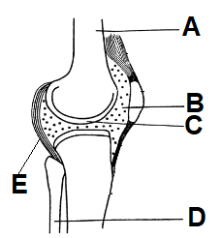

(a) Name parts marked **A** and **D**.

i) A………………………………… ii) D…………………………….

(b) State the importance of part marked **E**.

..………………………………………..…………..…………………….

(c) How is the function of part **B** similar to that of **C**?

.……………………………………………………………………………

45(a) Mention the component of soil formed by;

i) weathering ……………………………………….…………………….

ii) rotting ………………………………………………………………….

(b) State two importance of the component formed by rotting in

the soil.

i) ……………………………………………………………………………

ii)……………………………………………….…………..……………….

46(a) State the meaning of harvesting as used in crop husbandry.

…………………………………………….…………………….………….

(b) Mention any two methods used to harvest crops.

i)………………………………………..….………..……………………..

ii)……………………………………………………………………………

(c) Why should harvested crops be dried well before storage?

………………………………………………………………………………

47(a) Give two diary breeds of cattle.

i) ……………………………..…… ii)…...………………………..….

(b) State two ways of making dairy cattle produce more milk.

i)………………………………………..…………..……………………..

ii)………………………………………………………………………….

48. **Use the illustration about the number of teeth in human**

**beings to answer questions that follow.**

4I C P

- upper jaw

- lower jaw

4

4

2

2

4

(a) Identify the set of teeth shown above.

………………………………………………………………………………

(b) Which type of teeth misses in the set of teeth above?

…………………………………………..…………..……………………..

(c) Why is the above set of teeth called a deciduous set?

………………………………………………………………………………

(b) How can teeth be protected from dental carries?

…………………………………………..…………..……………………..

49(a) Mention two chemical changes that produce energy.

i) ……………………………..……. ii)…………………………………

(b) Give one similarity between chemical and biological changes.

…………………………………………..…………..……………………..

(c) State one importance of chemical changes in the

environment.

………………………………………………………………………………

50. **The diagram below shows the life cycle of an insect. Use it**

**to answer questions that follow**

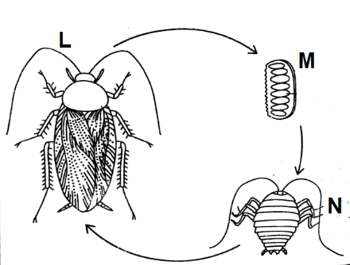

(a) Identify the insect shown in the diagram.

………………………………………………………………………………

(b) Name stage marked **N**.

………………………………………………………………………………

(c) State two ways of controlling the insect at stage **M**.

i).……………………………………………………………………………

ii) ……………………………………………………………………………

51(a) Mention two weather instruments that show the direction of

wind.

i).…………………………..……… ii)………….……………..………

(b) Give two uses if wind to people.

i)…………………………………………………………….………………

ii)….…………………………………………………………….………….

52. **Match the elements of PHC in list A with activities done to**

**promote them in list B correctly.**

**List A** **List B**

Health education Washing hands after using a toilet

Water and sanitation Immunisation with tetanus toxoid

vaccine

Maternal and Removing broken containers from

child health care the compound

Control of Displaying messages on posters

Communicable

diseases

i) Health education ….………………………………………………

……………………………………………………………………………..

ii) Water and sanitation …………………………………………………

……………………………………………………………………………..

iii) Maternal and child health care ……………………………………

…………………………………………………………………………….

iv) Control of communicable diseases………………………………..

…………………………………………………………………………….

53(a) Mention two materials used to produce biogas.

i)..…………………………………… ii)..………………………………

(b) State the role of bacteria in the production of biogas.

....…………………………………………..………………………………

(c) How does the use of biogas help to conserve the

environment?

..…………….………………………………………………………………

54(a) Mention the method used to make water pure.

……………………………………………….………………………………

(b) State two properties of pure water.

i)..……………………………………………………..……………………

ii)..……………………………………………………………………..……

(c) Give one use of pure water to people.

……………………………………………………………………………..

55. **Arrange the components of an electric circuit below to**

**form a complete circuit.**

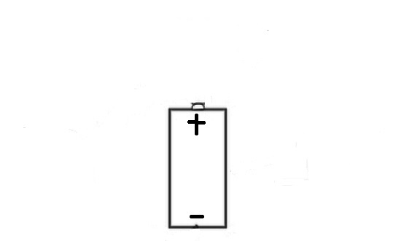  

**End**