JIM PREPARATORY NURSERY & PRIMARY SCHOOL

IKI-IKI

MOTTO: OUR GOD IS ABLE

**TERM TWO ASSEAAMENT EXAMS SET V 2023**

**PRIMARY SIX**

**SOCIAL STUDIES WITH RELIGIOUS EDUCATION**

**DURATION: 2HRS 15 MIN**

NAME: ..................................................................................

STREAM: ..............................................................................

**DO NOT OPEN THIS BOOKLET UNTIL YOU ARE TOLD TO DO SO**

|  |  |  |  |  |
| --- | --- | --- | --- | --- |
| **FOR EXAMINERS’ USE ONLY** | | | | |
| **QN. NO.** | | **MARK** | | **SIGN** |
| **1-10** | |  | |  |
| **11-20** | |  | |  |
| **21-30** | |  | |  |
| **31-40** | |  | |  |
| **41-43** | |  | |  |
| **44-46** | |  | |  |
| **47-49** |  | |  | |
| **50-52** |  | |  | |
| **53-55** |  | |  | |
| **TOTAL** |  | |  | |

***Read the following instructions carefully:***

1. This paper has **two** Sections: **A** and **B**.
2. Section **A**, has **40** questions (40 marks)
3. Section **B** has **15** questions (60 marks).
4. Answer **ALL** questions: All answers to both Sections **A** and **B** must be written in spaces provided in full sentences.
5. All answers must be written using a blue or black ballpoint pen or ink but not pencil. All work done in pencil except diagrams will **NOT** be marked.
6. Unnecessary alteration of work will lead to loss of marks.
7. Any handwriting that cannot be easily read, may lead to loss marks.

**SECTION : A (40 MARKS)**

1. Name any one drainage feature found on Uganda’s plateau.

………………………………………………………………………………….……

2. State a reason why a map should have a heading.

…………………………………………………………………………………....…

3. Mention the type of climate which is very hot with scanty rainfall.

…………………………………………….…………………………………………

4. State any one effect of swamp drainage to aquatic life.

…………………………………………….…………………………………………

5. Why are crop farmers advised to stay on the wind ward side of the

mountain?

……………………………………………………………………………………….

6. Mention any one factor that influenced human settlement in

ancient times.

……………………………………………….……………………………………..

7. How are block mountains and the rift valley similar in terms of

their formation?

………………………………………………………………………………………..

8. Give any one responsibility of clan heads in the community.

……………………………………………………………..…………………………

9. Which imaginary lines are drawn on maps from North pole to South

pole?

……………………………………………………………………………………….

10. Why is the Ugandan government encouraging foreign investors to

come and set up industries?

………………………………………………………………………………………

11. In which way do children lead to the abuse of their rights?

………………………………………………………………………………………

12. Why is transport important in setting up an industry?

………………………………………………………………………………………

13. Why did Germany lose all of her nations after World War I?

………………………………………………………………………………………

14. State one effect of the rotation of the earth on its axis to people.

………………………………………………………………………………………

15. Who was the first executive Prime Minister of independent Uganda

in 1962?

………………………………………………………………………………………

16. Write down any one method used in locating places on a map.

……………………………………………………………………………………..

17. Mention one factor that favours large scale fishing in Kalangala

district.

………………………………………………………………………………………

18. Mention any one human activity that helps to conserve forests in

Uganda.

……………………………………………………………………………………….

19. Name any one tribe in Uganda that belongs to the River-lake

Nilotes.

………………………………………………………………………………………

20. Name any one country in East Africa that is crossed by the

Equator.

.………………………………………………..……………………………………

21. Mention any one economic activity carried out in Port Bell.

………………………………………………………………………………………

22. Draw the road sign meaning children crossing the road.

23. Why did King Kabalega and Mwanga resist colonial rule in

Uganda?

………………………………………………………………………………………

24. Which feature on the Uganda coat of Arms represents the rich

culture of Uganda?

………………………………………………………………………………………

25. Mention one group of people who form part of the Legislature in a

democratic government.

………………………………………………………………………………………

26. Name the nationalist who composed the Uganda National Anthem.

………………………………………………………………………………………

27. Give any one factor that attracts more people to urban areas than

to other areas.

.……………………………………………………..………………………………

28. Give one climatic advantage Uganda has because of its location

along the Equator.

……………………………………………………………………….……………..

29. What is the value of a librarian in the school community?

…………………………………………………..…………………………………

30. It is 7:00am at Accra, what time will it be at a place **X** which is

45° East?

31. Why is barter trade not used in Uganda today?

…………………………………………….…………………………

32. Give any one way of increasing food production in a country like

Uganda.

………………………………………………………………………………………

33. What was the cause of the Kabaka crisis in Buganda in 1953?

……………………………………………………………………………………….

34. How does altitude determine the flow of a river?

………………………………………………………………………………………

35. Give any one way road safety education is important to road users.

………………………………………………………………………………………

**For questions 36 – 40 answer either Christianity or Islam BUT NOT BOTH in a number.**

36. **Either**: Mention the role Peter played in promoting the church

today.

……………………………………………………………………………

**Or**: Give one role caliph Abubaker played in promoting Islamic

faith.

……………………..……………………………………………………

37. **Either**: What is a parable?

…………………………...………………………………………………

**Or**: What is hadith in Islam?

……………………………………………………………………………

38. **Either**: Give any one reason why Christians are encouraged to

repent after sinning.

.……………………………………………………………………………

**Or**: Give any one reason why Muslims are encouraged to repent

after sinning.

……………………………………………………………………………

39. **Either**: Name any one of the two people who committed the

original sin according to the Bible.

.……………………………………………………………………………

**Or**: Name any one of the two people who committed the original

sin according to the Quran.

………………………………………………….…………………………

40. **Either**: Why is baptism important to Christians?

………………….…………………………………………………………

**Or**: Why do Muslims circumcise their new made converts and

newly born baby boys?

….……………..……………………………………………………………..

**SECTION B : (60 MARKS)**

41(a) State any two ways in which rainfall is useful to people.

i)…………………………………………………………………………………

ii)………………………………………………………………………………...

(b) Mention any two ways too much rainfall may be harmful to

people.

i)…………………………………………………………………………………

ii)………………………………………………………………………………...

42. Match the leaders in list A to their ways of acquiring their

leadership correctly.

**A**

Omukama of Bunyoro

Mayor

Chief Administrative officer

Scouts and Girl guides

**B**

Appointment

Elections

Volunteering

Inheritance

(a) Omukama of Bunyoro ……………………..………………………………

(b) Chief Administrative officer ………………………………………………..

(c) Mayor ……………………………………………………………………………

(d) Scouts and Girl guides ………………………………………………………

43(a) Which group of foreigners introduced rupees as a form of money?

……………………………………………….…………………………………..

(b) Mention any one place where national money is controlled in a

country.

…………………………………………………………………………………..

(c) Mention any two dangers one may face for keeping a lot of money

at home.

i)…………………………………………………..……………………………..

ii)…………………………………………………………………………………

44. **Use the map of Uganda below to answer the questions that**

**follow.**

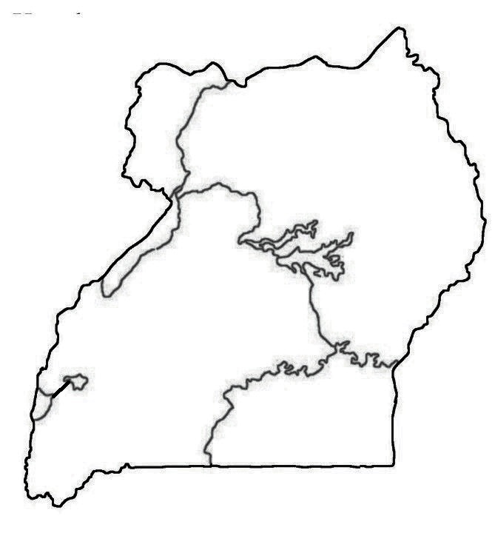

(a) Name the tributary of R. Nile marked **X**.

………………………………………………………………………………….

(b) Why are areas around feature marked **W** densely populated?

..………………………………....………..…………………………………….

(c) Why is water transport at place marked with letter **Z** difficult?

.………………………………………………………………………………....

(d) Of what formation is mountain marked **R**?

….………………………………………………………………………………..

45(a) Mention any one social value of game parks to a country.

…………………………………………………………………………………….

(b) State any two ways tourism industry can be developed in Uganda.

i)…………………………………………………………………………………..

ii)………………………………………………………………………………….

(c) Mention any one problem facing game parks in East Africa.

…………………………………………………………………………………….

46(a) Name the ministry under which the Police belongs.

……………………………………………….…………………..………………

(b) How does the Police help to keep law and order in a country?

…………………………………………………………………………..………

(c) Mention the Police department charged with the following duties;

i) extinguishing by big fires

……………………………………………………………………………………

ii) controlling traffic flow on roads

……………………………………………………………………………………

47(a) Give any two ways land is important to people as a resource.

i)…………………………………………………………………………………..

ii)………………………………………………………………………………….

(b) In which two ways do people misuse land.

i)…………………………………………………………………………………..

ii) …………………………………………………………………………………

48(a) State any two examples of social services provided to the people

by the government and non government organisations.

i)…………………………………………………………………………………

ii) ………………………………………………………………………………..

(b) Give any one reason why the government provides social services

to the people.

……………………………………………………………………………………

(c) State any one challenge the government faces in providing social

services to the people.

……………………………………………………………………………………

49. Study the budget below and answer questions that follows.

**Budget A Budget B**

**Expenditure**

(a) Which of the above budget will promote savings in a country?

…………………………………………………………………………………….

(b) Apart from the above budgets, name any other one type of

budget.

…………………………………………………………………………………

(c) Give any one way the government gets money for providing social

services.

……………………………………………………………………………………

(d) Give a reason why a family needs to make a budget.

……………………………………………………………………………………

50(a) Why is rice mostly grown in swampy areas?

..………………………………………………………………………………….

(b) Give any two reasons why it is not advisable to settle in swampy

areas.

i)…………………………………………………..………………………….….

ii)…………………………………………………………………………………

(c) Give a reason why lake Kyoga is a shallow lake?

……………………………………………………………….………………….

**For questions 51 – 55, answer Either Christian Or Islamic questions BUT NOT BOTH in a number.**

51. **Either** :

(a) Write any two ways Christians show obedience to God.

(i)………………………………………………………………………………...

(ii)………………………………………………………………………………..

(b) Mention any two results of disobedience in the Christian faith.

i)……………………………………………………………………………….

ii) ……………………………………………………………………………..

**Or:**

(a) Write any two ways Muslims show obedience to Allah.

(i)………………………………………………………………………………...

(ii)………………………………………………………………………………..

(b) Mention any two results of disobedience in the Islamic faith.

i)……………………………………………………………………………….

ii) ……………………………………………………………………………..

52. **Either** :

(a) Name the period when Christians fast.

…………………………………………………………………………………...

(b) State any two ways Christians benefit from fasting.

i)………………………………………………………………………………….

ii)………………………………………………………………………………….

(c) What good practise should Christians do to promote faith during

fasting?

…………………………………………………..………………………………

**Or:**

(a) Name the period when Muslims fast.

..………………………………………………………………………………...

(b) State any two ways Muslims benefit from fasting.

i)………………………………………………………………………………...

ii)………………………………………………………………………………….

(c) What good practice should, Muslims do to promote faith during

fasting?

……………………………………………….………….……………………….

53. **Either** :

(a) Give any two duties of angels in Christianity.

i)…………………………………………………………………………………

ii)………………………………………………………………………………….

(b) Mention any two examples God’s angels in Christianity.

(i)………………………………… (ii)……………………………………….

**Or:**

(a) Give any two duties of angels in Islam.

i)……………………………………………………………………………....

ii) ……………………………………………………………………………..

(b) Mention any two examples of Allah’s angels in Islam.

i)………………………………… (ii)…………………………………....

54. **Either** :

(a) State the meaning of honesty in Christianity.

…………………………………………………………………………………

(b) Give any one way of being honest to others.

……………………………………………..………….………………………

(c) Mention any two benefits of being honest to others.

i)………………………..……………………………………………………

ii)…………………………………………………………………………….

**Or**:

(a) State the meaning of honesty in Islam.

…………….………………………………………………………………….

(b) Give one way of being honest to others.

…………………………………………….….……………………………….

(c) Mention any two benefits of being honest to others.

i)…………………………..…………………………………………………..

ii)………………………………………………………………………………

55. **Either:**

(a) Name the mountain on which the ten commandments were

received.

………………………………………………………………………………..

(b) Why did God give the ten commandments to Moses?

…..……………………………………………………………………………..

(c) Write any two of God’s commandments.

i)………………………………………………………………………………….

ii)………………………………………………………………………………….

**Or:**

(a) Name the mountain on which Musa received the Tauret.

…………………………………………………………………………………..

(b) Why did Allah give Prophet Musa the book of Tauret?

.…..……………………………………………………………………………..

(c) Write any two pillars of faith in Islam.

i)…………………………………………………………………………………

ii)………………………………………………………………………………..

=====**End**=====