JIM PREPARATORY NURSERY & PRIMARY SCHOOL

IKI-IKI

MOTTO: OUR GOD IS ABLE

**TERM TWO ASSEAAMENT EXAMS SET V 2023**

**PRIMARY ONE**

**ENGLISH LANGUAGE**

**DURATION: 2HRS 15 MIN**

NAME: ..................................................................................

STREAM:..............................................................................

**INSTRUCTIONS:**

1. Read well and answer all questions.

2. You must write well.

3. Write correct spellings.

**SECTION A**

**Fill in the missing letter .**

1. te__cher

2. e__rs

3. docto__

**Write the words in brackets correctly.**

4. That _____________ is big . (manwo)

5. I can not see my __________ . (bkoo)

6. This is a ________ . (tma)

7. My _________ is short . (cilpen)

**Give the plural .**

**one**  **many**

8. boy ___________

9. bag ___________

10. goat ___________

**Write a small word .**

11. classroom ________

12. near ________

**Write in** ABC **order .**

13. e, d, f

_______________

14. duster, book, father

______________________________

15. matron, baby, cook

______________________________

**Circle the correct word.**

16. father, fahter, fathar

17. bleta, table, lebta

**Use the given words to complete the sentences.**

**(** are,is,an, am **)**

18. I ______ a good girl .

19. Tom has ________ orange .

20. These _______ pens .

**Fill in the gaps with a correct word.**

21. I sit ______ a chair .

22. Tom is pointing _______ the sun .

23. I am _______ Primary One class .

24. Sarah has a book ________ a pencil.

**Study the pictures and complete the sentences correctly.**

25. [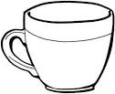](http://www.google.co.ug/url?q=https://www.pinterest.com/crpitt/tea-time/&sa=U&ved=0ahUKEwj6rYSqh6TWAhXnJsAKHWrLDT0QwW4IGzAD&usg=AFQjCNH7ou0F_URSR06EpODBMQ3bQ8ej6Q) [](http://www.google.co.ug/url?q=https://www.pinterest.com/crpitt/tea-time/&sa=U&ved=0ahUKEwj6rYSqh6TWAhXnJsAKHWrLDT0QwW4IGzAD&usg=AFQjCNH7ou0F_URSR06EpODBMQ3bQ8ej6Q)

These are _________ .

26. 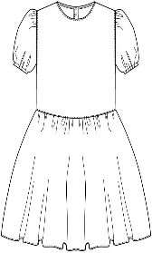 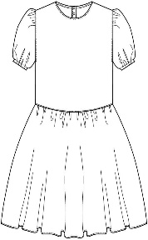 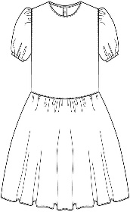

I can see three _________ .

27. 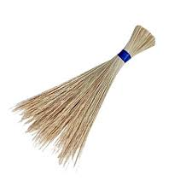

They are big _________ .

28. **[](http://www.google.co.ug/url?q=https://drawinghowtos.com/open-book-17703/&sa=U&ved=2ahUKEwj0h6Lf1tb0AhXLi1wKHWfzAgcQqoUBegQIDxAB&usg=AOvVaw0Y_mj-YuBFhzKwYZDhvZkb)** **[](http://www.google.co.ug/url?q=https://drawinghowtos.com/open-book-17703/&sa=U&ved=2ahUKEwj0h6Lf1tb0AhXLi1wKHWfzAgcQqoUBegQIDxAB&usg=AOvVaw0Y_mj-YuBFhzKwYZDhvZkb)** These are two __________ .

**Arrange the words to make a correct sentence .**

29. boy is a He .

____________________________

30. eating food I am .

____________________________

**Give the opposite .**

31. small ______________

32. good ______________

33. mother ______________

**Write the number in words.**

34. Tom has _________ books . 2

35. I saw _______ chairs . 6

36. There are _________ pencils in the tin . 4

37. A week has _________ days . 7

**Match and make a correct word** .

38. class board _______________

39. chalk keeper _______________

40. shop room _______________

**Answer**  Yes, it is . **or**  No, it is not .

41. Is this a chair ?

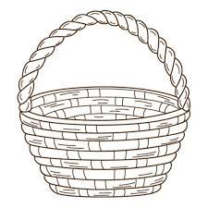 _______________

42. Is this a cup ?

[](http://www.google.co.ug/url?q=https://www.pinterest.com/crpitt/tea-time/&sa=U&ved=0ahUKEwj6rYSqh6TWAhXnJsAKHWrLDT0QwW4IGzAD&usg=AFQjCNH7ou0F_URSR06EpODBMQ3bQ8ej6Q) _______________

43. Is this a dog ?

[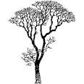](http://www.google.co.ug/url?q=https://www.polyvore.com/one_colored_trees/collection?id=1603270&sa=U&ved=0ahUKEwji4_2lgdrZAhVE0lMKHeiiBTwQwW4IITAG&usg=AOvVaw0cMISn0fQLlyHoJBAecTfI) ______________

44. Is this a pot ?

_______________

45. Is this a house ?

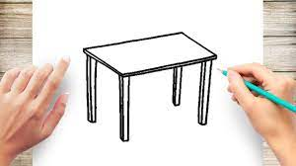 ______________

**Write one word for many** .

( **colours, numbers, clothes, food,** **animals**  )

46. one, two, three ____________

47. skirts, sweaters, dresses ____________

48. cows, goats, monkeys ____________

49. red, blue, black ____________

50. maize, posho, cassava ____________

**SECTION B**

51. **Read the story below and answer the questions about it.**

**CAT**

There is a cat at home. Its name is Bepe. Bepe is happy. It eats meat and rats. Bepe drinks milk. It does not like grass. People at home like it so much .

**Sarah**

**Primary One**

**Questions**.

(a) What is there at home ?  
 ___________________________________________

(b) What is its name ?

___________________________________________

(c) Write the title of the story.

___________________________________________

(d) What does it eat ?

___________________________________________

(e) Who likes it so much ?

___________________________________________

(f) In which class is Sarah ?

___________________________________________

(g) What does Bepe drink ?

___________________________________________

(h) Who wrote the story ?

___________________________________________

(i) Give the plural .

cat __________

rat __________

52. (**A**) **Use the correct word to complete the**

**sentences.**

(under, over, behind, on, near, in )

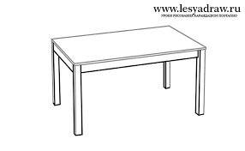

(i) The snake is ________ the table .

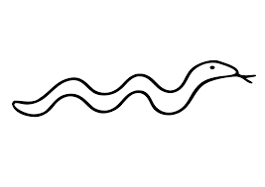



[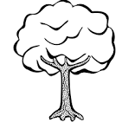](http://www.google.co.ug/url?q=https://www.kisscc0.com/clipart/drawing-line-art-coloring-book-tree-child-tree-lin-7cct3u/&sa=U&ved=0ahUKEwiZjd3B0NvgAhWJVRUIHXuhAFYQwW4IHzAF&usg=AOvVaw29Rqt_RFNObdzP1H8Xfacp)

(ii) The bird is flying ________ the tree .

(iii) The cup is ________ the chair .

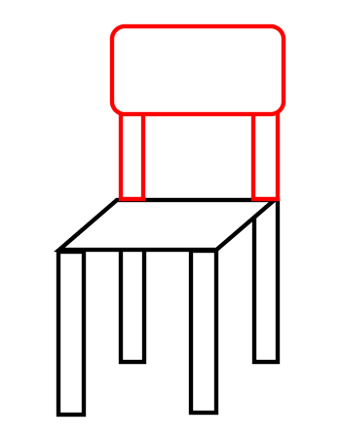

[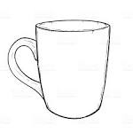](http://www.google.co.ug/url?q=https://www.istockphoto.com/vector/vector-sketch-of-cup-gm536011749-57313456&sa=U&ved=0ahUKEwiYuMWzpqLZAhUKlxQKHUdUAZAQwW4IFzAB&usg=AOvVaw0XoaAJOlcCJA0v-y0v29RL)

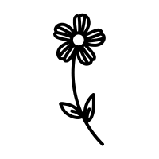

[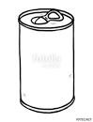](http://www.google.co.ug/url?q=https://www.fotolia.com/id/97811427&sa=U&ved=0ahUKEwiT9bDJgbbVAhVkL8AKHR09B0cQwW4IFzAB&usg=AFQjCNFbzkRtfpol9LBk4D7vOVL7B9UTfg)

(iv) The flower is _______ the tin .

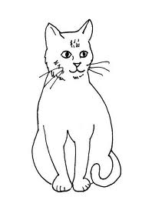



(v) The cat is _______ the table .

(**B**) **Use the words in the box to complete the story**

**correctly.**

My body is so nice. I have two 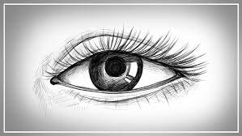  ________ for seeing. A 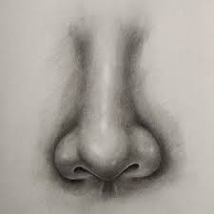 __________ for smelling . Two[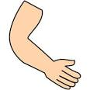](http://www.google.co.ug/url?q=http://clipground.com/hand-arm-clipart.html&sa=U&ved=0ahUKEwiZ7eWM45XZAhXJshQKHTAIBt4QwW4IKzAL&usg=AOvVaw0x-gmUf0WFgyRyPHlMtUcy) _________ for touching. My 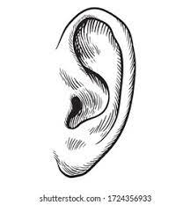________ for hearing. Long [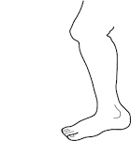](http://www.google.co.ug/url?q=http://typegoodies.me/clipart-of-leg/4507072-legs-clip-art-clipart-of-leg/&sa=U&ved=0ahUKEwjir8e61MjcAhUkCMAKHQ1CBQkQwW4IFzAB&usg=AOvVaw0l9wC93zb8SIcm7M2ey9Fl) [](http://www.google.co.ug/url?q=http://typegoodies.me/clipart-of-leg/4507072-legs-clip-art-clipart-of-leg/&sa=U&ved=0ahUKEwjir8e61MjcAhUkCMAKHQ1CBQkQwW4IFzAB&usg=AOvVaw0l9wC93zb8SIcm7M2ey9Fl) _________ for walking and a very nice head with black hair.

53. **Read the dialogue and answer questions correctly.**

John : Hullo, Mary.

**Mary:** Hullo, John.

John : Why are you sad ?

**Mary:** I cut my finger with a knife .

John : Oh sorry , go to the sickbay.

**Mary:** Thank you .

**Questions.**

(a) Who spoke first ?

_________________________________________

(b) How many people are talking ?

_________________________________________

(c) What cut Mary’s finger ?

_________________________________________

(d) Where should Mary go ?

_________________________________________

(e) Who was sad ?

_________________________________________

END