**EAGLE EXAMINATION BOARD**

PRE-MOCK EXAMINATION 2023 ***SET II***



**PRIMARY SEVEN**

INTEGRATED SCIENCE

**Time allowed: 2 hours 30 minutes**

|  |  |  |  |  |  |  |  |  |
| --- | --- | --- | --- | --- | --- | --- | --- | --- |
| **School EMIS**  **Index No.** | | | | | | **Personal NO.** | | |
|  |  |  |  |  |  |  |  |  |

**CANDIDATE’S NAME**……………………………………………………………………………….…..…

**CANDIDATES’ SIGNATURE**: …………………………………………………………………………

**READ THE FOLLOWING INSTRUCTIONS CAREFULLY**:

1. This paper has two sections: **A** and **B**.
2. Section A has 40 short questions (40 marks).
3. Section B has 15 questions (60 marks).
4. Attempt All questions. All answers to both Sections A and B must be written in the spaces provided.
5. All answers must be written using blue or black ball-point pen or ink. Only diagrams should be drawn using pencils in the spaces provided.
6. Unnecessary alteration of work may lead to loss of marks.
7. Any handwriting that cannot be easily read will lead to loss of marks.
8. Do not fill anything in the boxes indicated

|  |  |  |  |
| --- | --- | --- | --- |
| **FOR OFFICIAL USE ONLY** | | | |
| **SECTION** | **EXAMS MARKS** | **T/L MARKS** | **OFFICE** |
| **A** |  |  |  |
| **B** |  |  |  |
| **TOTAL** |  |  |  |

**SECTION A (40 MARKS)**

1. What is the main natural source of heat?

_______________________________________________________

2. When should one brush her / his teeth?

_______________________________________________________

3. State one device that uses electro magnets to work.

_______________________________________________________

4. How does a puff ball reproduce?

_______________________________________________________

5. Why should a person include a solvent in preparing oral rehydration salts?

_______________________________________________________

6. Why is carbon dioxide used in fire extinguishers?

_______________________________________________________

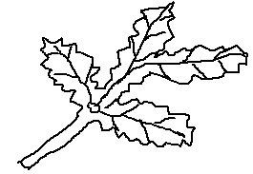7. **The diagram below show a type of a leaf**.

Name the type of leaf shown above.

_______________________________________________________

8. How is debeaking useful in poultry farming?

_______________________________________________________

9. Give one example of non-renewable resource in the environment.

_______________________________________________________

10. How are eggs of birds able to carry out gaseous exchange?

_______________________________________________________

_______________________________________________________

11. Identify one cereal crop in the environment.

_______________________________________________________

12. In the space below, draw a diagram to show convex lens.

13. To which group of invertebrates does a water snail belong?

_______________________________________________________

14. Give any one way white blood cells fight disease germs.

_______________________________________________________

15. The diagram below shows a simple machine. Show the direction of movement of the wheels using arrows.



16. Which part of the human tooth protects it from injury?

_______________________________________________________

17. State the function of the melanin found in the malphigian layer.

______________________________________________________________________________________________________________

18. In which way are butterflies friendly to farmers?

_______________________________________________________

19. Mention one disease which is controlled by encouraging people to wash hands after visiting a latrine.

_______________________________________________________

20. What is the function of blood in the body?

______________________________________________________________________________________________________________

21. Name the force which makes passengers in a bus to fall forward when the driver suddenly applies the brakes.

_______________________________________________________

22. By what process does heat move from point A to B?

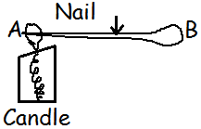

_______________________________________

_______________________________________

23. Mention the habitat for marine animals.

_______________________________________________________

24. Give one advantage of zero grazing method of keeping cattle.

______________________________________________________________________________________________________________

25. What causes sleeping sickness in man?

_______________________________________________________

26. How do conifer plants reproduce?

_______________________________________________________

27. Mention any one reason for planting trees together with crops in the garden. _________________________________________________

_______________________________________________________

28. State the law of levers (moments)

______________________________________________________________________________________________________________

29. Identify one activity carried out in the community that leads to deforestation.

_______________________________________________________

30. State the method used to maintain moisture in the vegetable garden.

______________________________________________________________________________________________________________

31. Give one importance of earthworms in the soil.

______________________________________________________________________________________________________________

32. Which organ in the body stores bile?

_______________________________________________________

33. Give one quality of laboratory manufacture drugs.

______________________________________________________________________________________________________________

34. State one characteristic of seeds of dispersed by wind.

______________________________________________________________________________________________________________

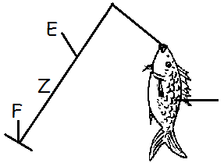35. To which class of levers does the diagram below belong?

________________________________________

________________________________________

36. State any one danger of weeds in a garden.

_______________________________________________________

37. A man uses a torch which has 3 dry cells. What is the voltage of the torch?

_______________________________________________________

38. What does an ovule develop into after fertilization?

_______________________________________________________

39. What name is given to the hair got from goats?

_______________________________________________________

40. Of what importance is breast feeding to a mother?

_______________________________________________________

***SECTION B***

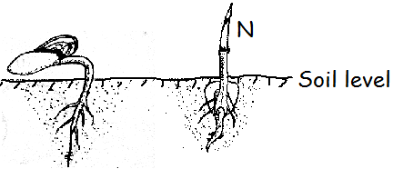41. **The diagram below shows two seeds germinating. Use it to answer questions that follow**.

(a) Name the type of germination shown in the diagrams M and N.

(i) M: ___________________________________________________

(ii) N: __________________________________________________

(b) Which type of leaf venation does seedling marked M have?

_______________________________________________________

(c) Name the type of root system possessed by seedling marked N.

_______________________________________________________

42. **The arrangement of organisms below shows a food chain**.

Grass Locust Lizard Eagle

(a) Use arrows to show the flow of energy among the organism.

(b) Which organism is regarded as;

(i) Producer? _____________________________________________

(ii) Tertiary consumer?

_______________________________________________________

(c) How are bacteria important in the food chain?

______________________________________________________________________________________________________________

43. (a) What do you understand by the term silting?

______________________________________________________________________________________________________________

(b) Identify one effect of silting.

_______________________________________________________

(c) Name one cause of silting.

_______________________________________________________

(d) Describe one way of conserving the environment.

_______________________________________________________

44. (a) Write any two activities which can be done by the family to promote family hygiene.

i) ______________________________________________________

ii) _____________________________________________________

(b) State two ways how the community can be sensitized about health issues.

i) ______________________________________________________

ii) _____________________________________________________

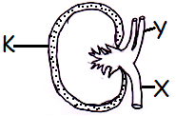45. **The diagram below is of the excretory organ. Use it to answer the questions that follow**:

(a) Name the parts marked with letters.

Y: _____________________________________________________

(b) State the function of part marked K.

______________________________________________________________________________________________________________

(c) Besides kidneys, name any other example of excretory organ.

_______________________________________________________

46. (a) How are bees important in the economy of a country like Uganda?

______________________________________________________________________________________________________________

(b) Why is it a bad practice to set an apiary in the school compound?

______________________________________________________________________________________________________________

(c) Give two causes of swarming in bees.

i) ______________________________________________________

ii) _____________________________________________________

47. (a) Complete the table below:

|  |  |  |
| --- | --- | --- |
| **Disease** | **Vaccine** | **site of immunization** |
|  | BCG | Upper right arm |
| Polio | Polio vaccine |  |
| Whooping cough |  | Left upper thigh |

(b) Why is DPT vaccine referred to as triple vaccine?

______________________________________________________________________________________________________________

48. (a) State the difference between pitch of sound and volume of sound.

______________________________________________________________________________________________________________

(b) Write any two factors which determine the pitch of sound.

i) ______________________________________________________

ii) _____________________________________________________

(c) Give one way of storing sound.

_______________________________________________________

49. **Use the diagram below to answer the following questions**.

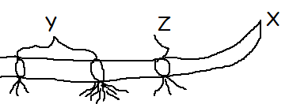

(a) Name the parts labeled Y and X.

(i) Y: ___________________________________________________

(ii) X: __________________________________________________

(b) What is the importance of part marked Z in propagation?

______________________________________________________________________________________________________________

(c) Name the type of roots marked P.

_______________________________________________________

50. **The diagram below shows the dispersion of light. Use it to answer the questions which follow**:

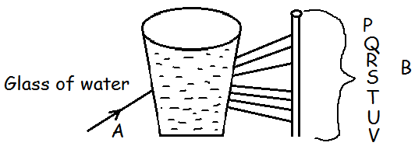

(a) Name the parts marked A and B.

(i) A: ___________________________________________________

(ii) B: ___________________________________________________

(b) Name the colour marked R.

_______________________________________________________

(c) Why does a blue shirt appear blue?

_______________________________________________________

(d) Write one example of an essential drug.

_______________________________________________________

51. (a) What is drug misuse?

______________________________________________________________________________________________________________

(b) State one way how people misuse drugs.

_______________________________________________________

(c) Why is it dangerous to buy drugs from any shop?

______________________________________________________________________________________________________________

(d) Give one example of an essential drug.

_______________________________________________________

52. (a) Why is dustbin important in a home?

_______________________________________________________

(b) Give two uses of windows on a house.

i) ______________________________________________________

ii) _____________________________________________________

(c) Why are ventilators put at a higher level than windows on a house?

_______________________________________________________

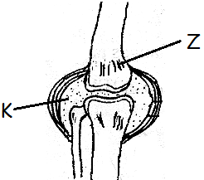53. **The diagram below shows a human body joint. Use it to answer the following questions**.

(a) Name the type of movable joint shown below.

_______________________________________________________

(b) Name the part labeled Z.

_______________________________________________________

(c) How useful is the fluid marked K in the joint?

______________________________________________________________________________________________________________

(d) Which part of the skeleton protects the Spinal cord?

_______________________________________________________

54. **Match the words in list A with those in list B**.

**A B**

Kwashiorkor lack of Vitamin D

Marasmus lack of calcium

Rickets lack of iron

Anaemia lack of carbohydrates

lack of proteins

(i) Kwashiorkor: _______________________________________

(ii) Marasmus: _______________________________________

(iii) Rickets: _______________________________________

(iv) Anaemia: _______________________________________

55. (a) Why are snakes classified under vertebrates?

_______________________________________________________

(b) Give any one example of poisonous snake.

_______________________________________________________

(c) State one health practice that can help one to avoid snake bites.

______________________________________________________________________________________________________________

(d) Give the first aid for snake bite.

______________________________________________________________________________________________________________

***\*\*\*\*\*GOD BLESS\*\*\*\*\****