**KING’S COLLEGE – BUDDO**

**INTERNAL MOCK EXAMINATIONS 2020**

**456/1 MATHEMATICS PAPER ONE**

**TIME: 2HOURS 30MINUTES**

**Instructions to candidates.**

* Answer all the questions in section A and any five from section B.
* Any additional questions answered will not be marked.
* All necessary calculations should be done on the same page as the rest of the answer.
* Therefore, no paper should be given for rough work.
* Graph paper is provided.
* Silent, non-programmable scientific calculators and mathematical tables with a list of formulae may be used where not prohibited.

**SECTION A (40marks)**

1. Given that evaluate  4marks
2. Factorise completely. 4marks
3. Find the inverse of the matrix  4marks
4. Make the subject of the formula  4marks
5. In the diagram below ABCD is a cyclic quadrilateral. O is the centre of the circle and AOB is a straight line. Angle BAC=38o

Calculate the angels marked B and D. 4marks

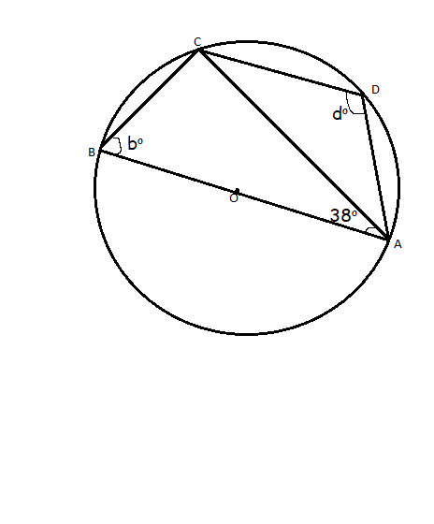

1. Use factorization method only to solve the equation  4marks
2. A two digit number is formed using the numerals 1, 3 and 5 without repeating any numeral.
3. List down the possibility space.
4. Find the probability that the number formed is a prime number. 4marks
5. A boy of height 1.2m is standing 15m away from the foot of a tree. When he looks up at the top of the tree the angle of elevation is 500. Determine the height of the tree, correct your answer to 2 decimal places. 4marks
6. Determine the inequality which is represented by the un shaded region below. 4marks



1

0 0 1 2 3 4 5 

-1

-2

1. Solve the equation:

 4marks

**SECTION B (60 marks)**

1. a) The difference between two square numbers is 20. If the larger number exceeds the smaller number by 2, find the two numbers. 6marks

b) A woman is now four times as old as her son. Eight years ago, the product of their ages was 160. Find the son’s age now. 6marks

12. The table below shows the marks obtained in a Mathematics   
 examination.

|  |  |  |  |  |  |  |  |
| --- | --- | --- | --- | --- | --- | --- | --- |
| Marks |  |  |  |  |  |  |  |
| Number of students | 5 | 11 | 16 | 26 | 28 | 10 | 4 |

1. Using an assumed mean of  calculate the mean mark. 7marks
2. i) Draw a histogram to represent this data.

ii) Use your histogram to estimate the modal mark. 5marks

13. Using a ruler, a pencil and a pair of compasses only,

a) Construct a triangle ABC in which angle BAC =600, Line AB=9.8cm,   
 and Line BC=9.5cm. Measure angel ACB and the length of AC. 3marks

b) Draw the bisectors of angles BAC and ABC to meet at point O.

C) Construct a perpendicular from the point O to the line AB. Hence   
 draw an inscribed circle to triangle ABC and measure the radius of   
 the circle. 3marks.

14a) Copy and complete the table below in which 

|  |  |  |  |  |  |  |  |  |  |
| --- | --- | --- | --- | --- | --- | --- | --- | --- | --- |
|  | 4 | 3 | 2 | 1 | 0 | 1 | 2 | 3 | 4 |
|  | 16 |  |  |  | 0 |  |  |  | 16 |
|  | 4 |  |  |  | 12 |  |  |  | 4 |

(02 marks)

b) Using a scale of 2 cm to represent 1 unit on the horizontal axis and 1 cm to represent 1 unit on the vertical axis, draw the graph of  for the domain 44. (04 marks)

c) Use your graph to solve the equation =0. (02 marks)

d) On the same axes draw the graph of . (01 mark)

e) Use your graphs to solve the equation + (03 marks)

15. A triangle ABC undergoes a transformation represented by the   
 matrix to be mapped on to A (B) and C(. The   
 triangle A1,B1 Cfurther undergoes a transformation   
 represented by the matrixsto be mapped on to triangle A, B  
,C.

Find the:

1. Coordinates of the vertices of A, B and C (05 marks)
2. Coordinates of the vertices of A, Band C (03 marks)
3. Single matrix of the formation which would map triangleA, Band C back on to triangle A, B and C. (04 marks)

16a) Use matrix method only to solve the equation:

 6marks

b) Given that       
 Find the value of p and q. 6marks

17) Karibu Hotel has 7 roasters of 200kg oven capacity and 5 roasters of 400kg oven capacity. Each 200kg oven capacity roaster can be used 5 times a day. Each 400 kg oven capacity roaster can be used 2 times a day. Each roaster must be operated by only one chef. On a given Saturday, the Hotel is contracted to roast 9,000 kg of meat for guests at a wedding ceremony. On that day, only 11 chefs were available. The 20 kg oven capacity roasters each need shs. 50,000 per day to run. If  and  represents the number of 200kg oven capacity roasters to be used respectively by the Hotel.

a) Write down six inequalities representing the above information.   
 6marks

b) Plot on the same axes, graphs for the inequalities, shading the un   
 wanted region. 4marks

c) Use the graph to find the number of each type of roster the Hotel   
 should use so as to minimize costs. 2marks

**END**