**PRIMARY FIVE**

**TOPIC 6: MATTER AND HEAT ENERGY**

**SUB TOPIC 1: MATTER**

1. What is mater?

* Anything that exists naturally
* Anything that occupy space and has weight
* Any thing that has mass and energy
* A solid, liquid or a gas

1. Which of the following is not a state of matter?

* Solid state
* Liquid state
* Gas
* Solids

1. Give any two examples of solids.

* Paraffin
* Bread
* Jam
* Stone

1. Identify the main characteristic of solids.

Molecules are packed

Molecules too close

1. In which state of matter are the following
   1. Paraffin _____________________________________________________________
   2. Stone ________________________________________________________
   3. Nitrogen _____________________________________________________________
2. a) What is energy?

____________________________________________________________________

____________________________________________________________________

b) Why is heat called a form of energy?

____________________________________________________________________

c) Apart from heat, give any other four forms of energy.

* 1. ______________________________ iii) _________________________________
  2. ______________________________ iv) _________________________________

1. Give any two appliances that change electric energy to heat energy.
   1. ______________________________ ii) _________________________________
2. Name the two types of energy.
   1. ______________________________ ii) _________________________________
3. Name the instrument used to measure heat.

____________________________________________________________________

1. Give two natural sources of heat.
   1. ______________________________ ii) _________________________________
2. Give any three effects of heat on matter.

____________________________________________________________________

____________________________________________________________________

____________________________________________________________________

1. The following diagram shows different ways how heat affect the states of matter. Use it to answer the questions that follow.

A

liquid

gas

**L**  Melting

Sublimation  **K**

condensation

M

1. Name the state of matter labelled A.

_____________________________________________________________________

1. Name the physical processes marked;
2. L __________________________ ii) M ____________________________
3. K __________________________
4. Which form of energy enables process K to take place?

_____________________________________________________________________

1. How is condensation useful in the environment?

_____________________________________________________________________

1. Give any one substance that undergoes process L.

_____________________________________________________________________

1. Why are gaps left between electric / telephone wires during construction?

_______________________________________________________________________

1. What would happen to the wires when tied tightly fixed on the poles?

_______________________________________________________________________

1. Why gaps left between the railway lines during construction?

_______________________________________________________________________

1. What happens to electric wires on the following
   1. Cold days__________________________________________________________
   2. Hot days __________________________________________________________
2. In which state of matter does heat travel;
3. Fastest_____________________________________________________________
4. Slowest ____________________________________________________________
5. a) Why do most people prefer using charcoal stove made out of clay to metallic ones?

____________________________________________________________________

b) How does the use of clay charcoal stoves help in preserving deforestation?

____________________________________________________________________

1. Why is space left while bottling drinks like soda?

_______________________________________________________________________

1. Give four ways in which heat is an important form of energy in our community.

____________________________________________________________________________________________________________________________________________________________________________________________________________________________________________________________________________________________

1. What is temperature?

_______________________________________________________________________

_______________________________________________________________________

1. State the difference between heat and temperature.

_______________________________________________________________________

_______________________________________________________________________

1. Name any two types of thermometer.
   1. ______________________________ ii) _________________________________
2. a) Which metallic liquids are used in doctors’ thermometers?

_______________________________________________________________________

b) Give two reasons why the above liquid used in the thermometer?

_______________________________________________________________________

_______________________________________________________________________

1. a) Why do doctors shake a clinical thermometer before using it on other patients?

______________________________________________________________________

**b)** Give a reason why a clinical thermometer is sterilized using surgical spirit than boiling it?

_______________________________________________________________________

1. What is the normal human body temperature?

_______________________________________________________________________

1. **The diagram below shows an experiment that was carried out in class.**

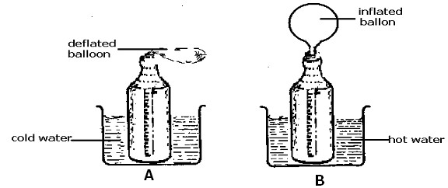

a) What does the experiment show?

______________________________________________________________________

b) What do you think can happen if the balloon in B is placed in cold water?

________________________________________________________________________

1. Convert the following from Celsius scale to Fahrenheit scale.

a) 100c

b) 300c

1. Study the diagram and answer questions that follow.

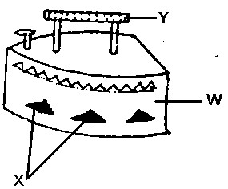

1. How does heat travel through part **W**?

___________________________________________________________________

1. How is part **X** important in the way the item in the diagram works?

___________________________________________________________________

1. Give one material from which part **Y** is made.

_____________________________________________________________________

1. Give a reason why the material above is used to make part Y

_____________________________________________________________________

1. Change the following from Fahrenheit scale to Celsius scale.
2. 770F

1. 500F

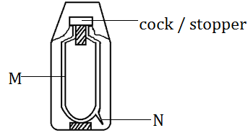**The diagram below is of a thermos flask**.

cork

**K**

1. State the function of the part marked N.

________________________________________________________________________

1. Name part marked **K**?

___________________________________________________________________________

1. What is the use of part M on the vacuum flask?

__________________________________________________________________________

1. Why are the walls of a vacuum flask double silvered**?**

___________________________________________________________________________

1. How does heat travel through the following state of matter?
2. Solids _____________________________________________________________
3. Liquids _____________________________________________________________
4. Gases _____________________________________________________________
5. Vacuum _____________________________________________________________
6. How does farmers crops receive heat from the sun?

___________________________________________________________________________

1. Why is a handle of a flat iron made out of wood?

________________________________________________________________________

1. Give two ways in which heat transfer by conduction is useful to the environment.

________________________________________________________________________

________________________________________________________________________

1. Of what use are the following parts in a clinical thermometer?
2. Kink _____________________________________________________________________
3. Bulb _____________________________________________________________________
4. Stem ____________________________________________________________________
5. Define the following terms.
6. Solute

________________________________________________________________________

________________________________________________________________________

1. Solvent

________________________________________________________________________

________________________________________________________________________

1. Solution

________________________________________________________________________

________________________________________________________________________

1. Mixture

________________________________________________________________________

________________________________________________________________________

1. (a) What is an insulator of heat? ___________________________________________________________________________

________________________________________________________________________

(b) Name two insulators commonly used.

* 1. ______________________________ ii) _________________________________

(c) Identify the type of accident that can be controlled by use of insulators.

___________________________________________________________________________

1. Study the diagram of a charcoal stove. Use it to answer the questions that follow.

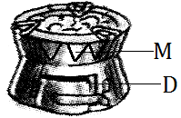

(a) What is the use of holes marked **M**?

_________________________________________________________________________

(b) Name the source of heat used in the above stove.

_________________________________________________________________________

(c) How are holes marked M similar to ventilators on a house?

_________________________________________________________________________

_________________________________________________________________________