**SET TWO**

**2018**

**MATHEMATICS**

***Time Allowed: 2 hours 15 minutes***

**Index No. :**

**Candidate’s Name : ………………………………………………………………………………………………………………**

**Candidate’s Signature : ………………………………………………………………………………………………………………**

**School Name : …………………………………………………………………………………………………………………………**

**District Name : …………………………………………………………………………………………………………………………**

**Read the following instructions carefully:**

**FOR EXAMINERS’**

**USE ONLY**

**Qn. No. MARKS EXRS’ IN.**

1 – 20

21 – 30

31 – 50

51 – 53

54 – 55

1. This paper has **two** sections: **A** and **B**.
2. Section **A** has 20 questions (40 marks)

Section **B** has 15 questions (60 marks)

1. Answer all questions. All questions to both Sections **A** and

**B** must be written in the spaces provided.

1. All answers must be written using a blue or black

ball-point pen or fountain pen.

1. Unnecessary changes of work may lead to **loss** of marks.

All diagrams must be drawn in pencil.

1. Any handwriting that cannot easily be read may lead to

**loss of marks.**

1. Do **not** fill anything in the boxes indicated:

**“For Examiners’ Use Only”**

**SECTION A (40marks)**

1. Subtract: $254 - 46$
2. Simplify: −12 – +9
3. Convert 5 base ten to a binary system.
4. Multiply: 106 $×$ 4
5. Find the size of angle marked y in the diagram.

59 $°$

63 $°$

y

1. Solve: 8 – 3r = 14
2. Workout the square root of $20\frac{1}{4}$
3. Find the value of the numeral expanded below: (4 102) + (7 101) + (9 100) + (5 10−2)
4. The cost of four books is 5,000 shillings. How many books will James buy if he has 8750 shillings.
5. Jogo walked 2.3km from his home to his daughter’s house. Express his distance in metres.
6. Subtract: 2 $x$ + 4 $y$ from 3 $x$– 2 $y$
7. In the space below construct an angle of 75◦
8. Calculate the number of subsets in a set having 4 elements.
9. Simplify: 3m – (2 + m)
10. Workout the area of the figure below:

D

A

C

B

5m

12m

3m

1. Factorise completely: 62 12 9
2. Calculate the value of P in the figure below:

4p

5p

1. Given that −, . Workout the value of 2

**For questions 19 and 20, use the graph below that shows number of trays of eggs Joshua collects in his farm per week.**

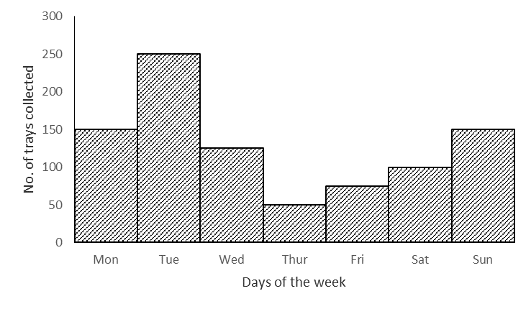

1. On which day did he receive the greatest increase in the number of trays collected?
2. How many trays does he collect in a week?

**SECTION B (60marks)**

1. (a) Workout: $\frac{0.3-0.1}{0.04}$ $(3marks)$

(b) The price of a goat increased from 64,000 shillings to 72,000 shillings; find the percentage increase in the price of a goat. $(3marks)$

1. In a class of 72 students, all the students like French (F), 41 students like French and Mathematics (M), 32 students like French and English (E), 9 students like all the three subjects while y students like French only.
2. Use the above data to complete the Venn diagram below. $(3marks)$

$n\left(\right)=$ 72

$n\left(M\right)$ =41

$n\left(E\right)$ = 32

$$9$$

$$n\left(F\right)=$$

____

____

____

1. How many students like only French? $(2marks)$
2. The average age of five boys is 12years, when their teacher joins them their average age becomes 15 years. Calculate the age of their teacher. $(4marks)$
3. (a) Solve: 2(p – 3) – 6 = 2 ( 3 marks )

(b) Workout: $\frac{2x+1}{3}=\frac{x+8}{2}$ 2(Marks)

1. A lorry driver drove his vehicles at a speed of 60km/hr. for one hour and 30 minutes, from Mbarara to Kasese. He made a return journey at a speed of 45km/hr.
2. Calculate the distance from Mbarara to Kasese. $(2marks)$
3. How long did he take for the whole journey? (to and fro) $(3marks)$

1. A poultry farmer had 300 chickens, he sold $\frac{1}{6}$ of them to Kiiza, $\frac{3}{5}$ of the remainder to Josephine and the rest to Peter.
2. How many chicken did Josephine buy? $(3marks)$
3. If the cost of one chicken is 4000sh. How much did Peter pay for his chicken? $(2marks)$
4. (a) Using a ruler, a pair of compasses and a pencil only construct a triangle ABC where AB = 6cm, BC = 5cm and AC = 4cm in the space below. $(4marks)$

(b) From your accurate diagram measure angle BAC in degrees. $(1mark)$

1. Okapel went to a local market and bought the following items:

−2kg of rice at sh. 2400 per kg.

− $1\frac{1}{2}$ kg of posho at sh. 3000 each kg.

−500gms of salt at sh. 800 per kg.

−One loaf of breadat sh. 1000 each loaf.

1. Calculate his total expenditure if he was given a 10% discount for all the items he bought. $(5marks)$
2. Juliet made circular table mats of diameter 7cm and of a rectangular sheet of cloth that measures 500cm long by 34cm wide as shown in the figure below:

34cm

50cm

7cm

1. How many circular table mats, did she make from the piece of cloth? $(3marks)$
2. Calculate the area of the piece of cloth used to make out circular table mats. $(2marks)$

20 $°$

62 $°$

136 $°$

2 $x$

$$y$$

1. Study the diagram below carefully.
2. Find the size of angle $y$. $(3marks)$
3. Workout the value of $x$. $(2marks)$
4. (a) Plot the following co-ordinates on the grid below: P(+1,2), Q(+4,0), R(+1,2), S(−4,0)

**+4**

**+5**

**−4**

**−3**

**−2**

**−1**

**−1**

**−2**

**−3**

**−4**

**+4**

**+3**

**+2**

**+1**

**+5**

|  |  |  |  |  |  |  |  |  |
| --- | --- | --- | --- | --- | --- | --- | --- | --- |
|  |  |  |  |  |  |  |  |  |
|  |  |  | **0**  **+1**  **+2**  **+3** |  |  |  |  |  |
|  |  |  |  |  |  |  |  |  |
|  |  |  |  |  |  |  |  |  |
|  |  |  |  |  |  |  |  |  |
|  |  |  |  |  |  |  |  |  |
|  |  |  |  |  |  |  |  |  |
|  |  |  |  |  |  |  |  |  |
|  |  |  |  |  |  |  |  |  |
|  |  |  |  |  |  |  |  |  |

(b) Join the points and name the figure formed. $(1mark)$

($2x-10$) $°$

($2x+30$) $°$

($x-80$) $°$

B

A

C

D

1. Study the figure below carefully and answer the questions below.
2. Find the value of x. $(3marks)$
3. Workout the size of angle BCA in degrees. $(2marks)$