**BISHOP ANGELO NEGRI PRIMARY SCHOOL**

**MOCK EXAMINATION SET I 2019**

**PRIMARY SEVEN**

**SOCIAL STUDIES WITH RELIGIOUS EDUCATION**

***Time allowed: 2 hrs 15 Minutes***

|  |  |  |  |  |  |  |  |  |
| --- | --- | --- | --- | --- | --- | --- | --- | --- |
|  |  |  |  |  |  |  |  |  |

Index No.

Candidates Name: …………………………………………………………

Candidate’s Signature ………………………….………………………….

**Read the following instructions carefully:**

**FOR EXAMINERS USE ONLY**

|  |  |  |
| --- | --- | --- |
| **Qn No** | **MARK** | **SIGN** |
| 1-10 |  |  |
| 11-20 |  |  |
| 21-30 |  |  |
| 31-40 |  |  |
| 41 - 43 |  |  |
| 44 - 46 |  |  |
| 47 – 48 |  |  |
| 49 – 51 |  |  |
| 52 – 53 |  |  |
| 54 - 55 |  |  |
| TOTAL |  |  |

1. The paper has **two** sections: **A** and **B**
2. **All** the working for sections **A** and **B** must be done in

the spaces provided.

1. **ALL** working must be done using a blue or black

ball-point pen or fountain pen.

Diagrams must be drawn in pencil.

1. Unnecessary alteration of wok may lead to loss of marks.
2. Any handwriting that cannot easily be read may lead

to loss of marks.

1. Do not fill anything in boxes indicated:

**“For Examiners’ Use Only”**

***Turnover***

**SECTION A: (40 MARKS)**

1. Name the main cash crop grown in Kalangala district.

………………………………………………………………………………………………….

1. State any one duty of a good citizen in promoting law and order.

………………………………………………………………………………………………….

1. Why is the blue colour used on physical maps?

………………………………………………………………………………………………….

1. How was Lake Bunyoyi in South Western Uganda formed?

………………………………………………………………………………………………….

1. Mention the tax charged on all goods locally manufactured in a country.

………………………………………………………………………………………………….

1. State any one way road transport can be made possible in highland areas.

………………………………………………………………………………………………….

1. Why was Kabaka Mwanga unable to sign the 1900 Buganda agreement?

………………………………………………………………………………………………….

1. Write IBEACO in full.

………………………………………………………………………………………………….

1. What is the role of secretary for older persons on the LCI executive committees?

………………………………………………………………………………………………….

1. How are newspapers important to the local community?

………………………………………………………………………………………………….

1. Mention any one challenge faced by security organizations in Uganda.

……………………………………………………………………………..…………………..

1. Why is it bad to fish using poison?

…………………………………………………………………………………………………

1. How is wind important to farmers in your neighbourhood?

…………………………………………………………………………………………………

1. What was the major role played by political parties in the struggle for independence?

…………………………………………………………………………………………………

1. Mention any one national symbol found on the Uganda currency.

…………………………………………………………………………………………………

1. Draw a map symbol of a seasonal lake in the space below.
2. Mention any one neighbouring country of East Africa that is not landlocked.

…………………………………………………………………………………………………

1. How are the Bagisu similar to the Bakonjo in terms of their settlement?

…………………………………………………………………………………………………

1. Give any one danger of massive cutting down of trees in an area.

…………………………………………………………………………………………………

1. What show that Lake Victoria is on a lower altitude than Lake George?

…………………………………………………………………………………………………

1. State the aspect of climate that greatly influences human settlement.

…………………………………………………………………………………………………

1. Why did Tooro Kingdom break away from Bunyoro Kingdom?

…………………………………………………………………………………………………

1. Why are areas along the equator too hot throughout the year?

…………………………………………………………………………………………………

1. Why did the British colonialists use native rulers to rule on their behalf?

…………………………………………………………………………………………………

1. Mention any one factor that promote population growth.

…………………………………………………………………………………………………

1. Why should wetlands be conserved in an area?

…………………………………………………………………………………………………

1. State the reason why Ugandan does not have a national language?

…………………………………………………………………………………………………

1. Mention any one role played by Judiciary in promoting peace in a country.

…………………………………………………………………………………………………

1. How did lack of fire in the Old Stone Age affect the life of early man?

…………………………………………………………………………………………………

1. How does the government of Uganda benefit from the tourism industry?

…………………………………………………………………………………………………

1. Mention any one common characteristic among Bank people.

…………………………………………………………………………………………………

1. State any one group of people found under the legislature.

…………………………………………………………………………………………………

1. Which type of education did the missionaries find in Uganda?

…………………………………………………………………………………………………

1. Why do some people fear to keep domestic animals?

…………………………………………………………………………………………………

1. Draw an illustration to show a surplus budget in the space below.

**For Questions 36 – 39, Answer Either Christianity or Islamic But Not Both**

1. **Either**: Mention one law book in the bible.

…………………………………………………………………………………………………

**Or**: Write one Holy Book that was received by prophets in Islam.

…………………………………………………………………………………………………

1. **Either**: Who was the mother of John the Baptist?

…………………………………………………………………………………………………

**Or**: Who was the mother of Prophet Muhammad?

…………………………………………………………………………………………………

1. **Eithe**r: Give one problem faced by the Israelites during Exodus.

…………………………………………………………………………………………………

**Or**: Give one problem aced by Prophet Mohammed during Hegira.

…………………………………………………………………………………………………

1. **Either**: How long does lent period take?

…………………………………………………………………………………………………

**Or**: How long does Saum take?

…………………………………………………………………………………………………

1. **Both**: Give any one quality of a good Christian / Muslim.

…………………………………………………………………………………………………

**SECTION B (60 MARKS)**

1. a) Give two importance of a National Constitution of Uganda.

i)………………………………………………………………………………………………...

ii)………………………………………………………………………………………………..

b) Mention any two roles played by the National Assembly.

i)………………………………………………………………………………………………...

ii)………………………………………………………………………………………………..

1. a) How does vegetation support the health sector of a country?

………………………………………………………………………………………………..

b) Give two human activities that lead top destruction of natural vegetation.

i)………………………………………………………………………………………………...

ii)………………………………………………………………………………………………..

c) Give any one way of conserving natural vegetation.

………………………………………………………………………………………………….

1. Complete the table below

|  |  |
| --- | --- |
| Ethnic group | Tribe |
|  | Ngoni |
|  | Iteso |
| Highland Nilotes |  |
|  | Acholi |

1. a) Give the climate zone that is hot and wet throughout the year.

………………………………………………………………………………………………….

b) Mention any two characteristics of the above-named climate zone.

i)………………………………………………………………………………………………...

ii)………………………………………………………………………………………………..

c) State any one factor that influences the climate of an area.

………………………………………………………………………………………………….

1. a) Which level of local council is a district?

………………………………………………………………………………………………….

b) What title is given to the political head of a district?

………………………………………………………………………………………………….

c) Give any two reasons why the government of Uganda carries out decentralization.

i)………………………………………………………………………………………………...

ii)………………………………………………………………………………………………..

1. a) What do we call a country’s estimation of income and expenditure for financial year?

…………………………………………………………………………………………………

b) Write any one part of a budget.

…………………………………………………………………………………………………

c) Give any two reasons why a country prepares a Budget every year.

i)………………………………………………………………………………………………...

ii)………………………………………………………………………………………………..

1. 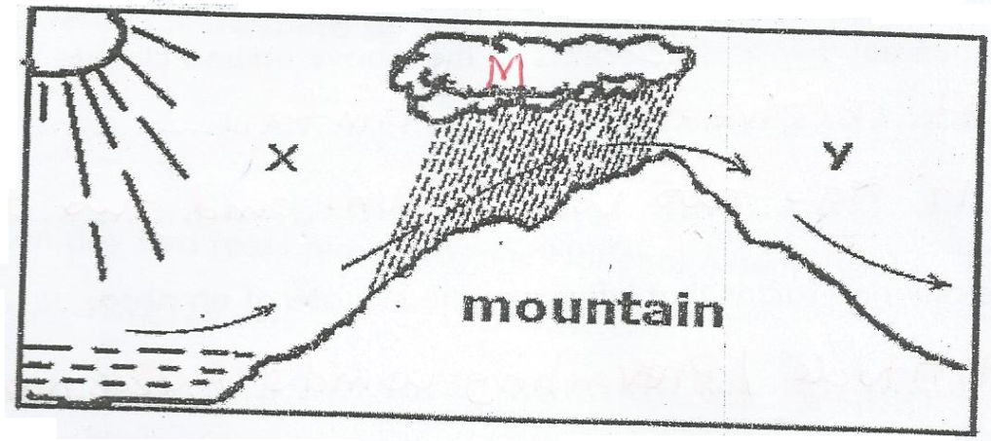Study the diagram below and answer questions that follow;
2. Name the two sides of the mountain marked.

X ……………………………………………………………………………………………

Y…………………………………………………………………………………………….

1. What type of rainfall is formed in the diagram above?

………………………………………………………………………………………………

1. Use letter M to show clouds on the diagram above.

………………………………………………………………………………………………

1. a) Identify any two terms of the 1900 Buganda agreement.

i)………………………………………………………………………………………………...

ii) ……………………………………………………………………………………………….

b) Mention two effects of the 1900 Buganda agreement.

i)………………………………………………………………………………………………...

ii) ……………………………………………………………………………………………….

1. a) Give any two duties of the Electoral Commission.

i)………………………………………………………………………………………………...

ii) ……………………………………………………………………………………………….

b) Write any two examples of voting materials used in Uganda.

i)………………………………………………………………………………………………...

ii) ……………………………………………………………………………………………….

1. 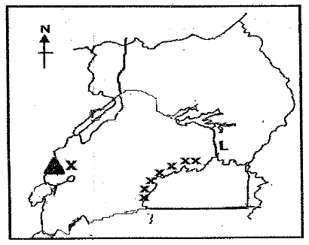Use the physical map below to answer the questions that follow.
2. Mention the highest peak of the mountain marked X.

…………………………………………………………………………………………

1. Why are there many people settling in area marked xxx?

…………………………………………………………………………………………

1. Why is water transport difficult along river marked L?

…………………………………………………………………………………………

1. Draw a western arm of the rift valley on the sketch map above.

**For questions 51 – 55, answer Either Christianity o Islam but not both**

1. **Either:** “…..The man I kiss is the one you want. Arrest Him.” Mathew 26:48.
2. Who spoke the above words?

……………………………………………………………………………………………

1. To whom were the above words spoken?

………………………………………………………………………………………….

1. Why did the person in 52 (a) speak the above words?

………………………………………………………………………………………….

1. Which lesson do you learn from the person in 52 (a)?

…………………………………………………………………………………………..

**Or**: (a) Name the person who withdrew from the battle according to the Quran.

……………………………………………………………………………………………….

b) Give one way the person in (a) showed acts of hypocrisy.

………………………………………………………………………………………………..

c) How can a Moslem avoid being a hypocrite?

………………………………………………………………………………………………..

d) Write one danger of hypocrites in the Islamic community.

……………………………………………………………………………..…………………..

1. **Either**: a) Who taught disciples how to pray?

………………………………………………………………………………………………….

b) Which prayer did the person named in (a) above teach the disciples?

………………………………………………………………………………………………..

c) Give any two benefits of a prayer to a Christian.

i) ………………………………………………………………………………………………..

ii) ……………………………………………………………………………..………………..

Or: a) State any one way in which Moslems get ready for Salat.

…………………………………………………………………………………………………

b) Write the first three daily prayers said by Muslims.

i) ………………………………………………………………………………………………..

ii) ……………………………………………………………………………..………………..

iii) ………………………………………………………………………………….…………..

1. **Either**: a) Who is a martyr?

………………………………………………………………………………………………….

b) Name the first Christian martyr in the Bible.

…………………………………………………………………………………………………

c) How did the above person meet his death?

………………………………………………………………………………………………….

d) State one lesson you learn from the Uganda Martyrs.

………………………………………………………………………………………………….

Or: a) Who is a martyr?

………………………………………………………………………………………………….

b) Name the first Muslim Marty.

…………………………………………………………………………………………………

c) How did the above person meet her death?

…………………………………………………………………………………………………

d) State one lesson learn from the above-mentioned martyr.

…………………………………………………………………………………………………

1. **Either:** a) Write UJCC in full.

**…**……………………………………………………………………………………………….

b) State two Christian sects under UJCC.

i) ………………………………………………………………………………………………..

iI) ……………………………………………………………………………………..………..

1. How does UJCC promote Christianity in Uganda?

………………………………………………………………………………………………

1. **FOR BOTH.** a) Give any two common beliefs of Christians And Muslims.

i)………………………………………………………………………………………………...

ii) ……………………………………………………………………………………………….

b) List any two Religious practices that make Christians and Muslims different from each other.

i)………………………………………………………………………………………………...

ii) ……………………………………………………………………………………………….

**END**