

UGANDA MUSLIM TEACHERS’ ASSOCIATION

UMTA JOINT MOCK PRIMARY LEAVING EXAMINATIONS 2015

SOCIAL STUDIES AND RELIGIOUS AFFAIRS

2 HOURS 15 MINUTES

|  |  |  |  |  |  |  |  |  |  |
| --- | --- | --- | --- | --- | --- | --- | --- | --- | --- |
| **INDEX NUMBER** |  |  |  |  |  |  |  |  |  |

**NAME………………………………………………SIGN…………………….......**

**SCHOOL………………………………………………DISTRICT……………….**

|  |  |  |
| --- | --- | --- |
| **FOR EXAMINER’S USE ONLY** | | |
| **QN.** | **MARKS** | **INITIAL** |
| 1-10 |  |  |
| 11-20 |  |  |
| 21-30 |  |  |
| 31-40 |  |  |
| 41-43 |  |  |
| 44-46 |  |  |
| 47-49 |  |  |
| 50-52 |  |  |
| 53-55 |  |  |
| **TOTAL** |  |  |

**INSTRUCTIONS TO CANDIDATES:**

1. Do not open this booklet until you are told to do so.
2. This paper is made of two sections **A** and **B**
3. Answer all questions in **A** and **B**
4. All Answers must be written in spaces provided.
5. Answers **must** be written in **blue or black ink**. Only diagrams must be drawn using a pencil.
6. Any handwriting which can not be read will lead to loss of marks.
7. Unnecessary alterations of work e.g. Crossings and changes may lead to loss of marks.
8. Do not fill any thing in the boxes shown on the right side, it is for Examiners use only.

**SECTION A**

1. Name the cash crop that is grown at the slopes of mountain Elgon.

**Arabicca Coffee**

1. Name the school symbol which helps parents to locate the school.

**School sign post**

1. In which one way is Lake Victoria important to the traders in East Africa?

**It provides Fish as a trade item.**

1. Who is a citizen of Uganda by naturalization?

**A citizen of Uganda by naturalization is a person who has stayed in Uganda for a long period.**

1. Why is poaching dangerous to the economy of a country like Uganda?

**Poaching reduces on wild animal which attract tourists who visit Uganda.**

1. Name the political party which led Tanganyika to independence.

**TANU (Tanganyika African national Union)**

1. Why do trees in the equatorial forests have broad leaves?

**To carry out transpiration easily.**

1. Give one reason why Liberia was not colonized by the Europeans.

**Liberia was a land for Freed slaves.**

1. Give one reason why the railway line was extended to Namasagali.

**To collect cotton.**

1. How can crop growing be made possible in Karamoja?

**By Irrigation – by Watering**

1. Name any one Bantustan that existed in South Africa during the period of apartheid.

**Trankeri-South Ndebere-Sharravile-Ciskei-Lebowa-Boputha swana-kwazulu-Swazi-Kwanqwa-Soweto**

1. How did William Dubois contribute to the development of Africans?

**William Dubois encouraged Africans to unite and oppose the whites.**

1. What is population census?

**Population census is the general counting of people in an area.**

1. Name the missionary who worked among freed slaves in Zanzibar.

**Bishop Tozer –Dr. Stere**

1. How did the 1900 Buganda agreement change land ownership in Buganda?

**The land was divided into two (Mailo and Crown land)**

**The peasants (local people) lost ownership (became tenants /quarters)**

1. Give any one evidence of the Portuguese stay at the coast of East Africa.

**They build fort Jesus.**

1. Why is Henry Marton Stanley remembered in the history of Christianity in Uganda?

**He convinced Kabaka Mutesa I to invite a letter inviting Missionaries in Uganda.**

1. How do warm ocean currents influence the climate of an area?

**Warm ocean currents help to bring rainfall in an area.**

1. Which arm of the government implements the Universal Primary Education (UPE) policy?

**Executive.**

1. Use the diagram below to answer questions that follow.

**150,000/=**

**200,000/=**

**Income**

**Expenditure**

Name the type of budget in the diagram above.

**Surplus budget.**

1. Give one way the type of budget in question 20 above is important to the family.

**It promotes saving /development /easy provision of basic needs/does not lead to debts.**

1. Write UIA in full.

**Uganda Investment Authority.**

1. 

Give one reason for raising the Uganda flag as indicated above.

* **When the head of state has died**
* **During national mourning.**

1. Name the body that replaced Organization of African Unity (OAU).

**African Union (AU)**

1. How is a market useful to the people in the community?

* **They buy and sell their goods**
* **Markets provide employment to the people in the community.**

1. Give one difference in the formation of Drakensburg Mountain and Mountain Rwenzori.

**Drakenburg was formed by volcanicity while mountain Rwenzori was formed by Faulting.**

1. How is Kakira plantation similar to Kenana irrigation scheme?

**They both grow sugarcanes.**

1. Give one way school assemblies help to promote discipline among the pupils.

**Teachers carry out counseling and guidance on school assemblies**.

1. State one basic need people get from hospitals.

**Medical services.**

1. What name is given to the parliament of East African Community?

**East African legislative Assembly (EALA)**

1. Name the instrument used by Pilots to find the direction of wind.

**Wind sock/wind cock /Wind Vane.**

1. How did the coming of the Indian coolies promote transport in east Africa?

**They constructed the Uganda Railway.**

1. Give any one cause of poverty in Africa.

* **Negative attitude towards work**
* **Civil wars**
* **Ignorance.**
* **Civil wars**
* **Epidermics**

1. Apart from Bagishu, name any other tribe that carries out male circumcision in Uganda as their culture.

**Bakonjo/Kub Sabins**

1. Give one reason why it was not easy to end slave trade in Africa.

**Kings and Chiefs were getting rich/benefiting from it.**

**For questions 36 to 40, answer either Christianity or Islam, but not both. No mark will be awarded to a candidate who attempts both alternatives in a number**.

1. **Either**

Name the final place for non- believers in God.

**Hell**

**Or**

Name the final place for non- believers in Allah.

**Hell/Jahanam**

1. **Either**

How is Angel Gabriel related to the spread of Christianity?

**Angel Gabriel brought the good news of the birth of Jesus crist to Virgin Mary.**

**Or**

How is Angel Jibril related to the spread of Islam?

**Angel Jibril brought the messages about Islam from Allah to prophet Muhammad (S.A.W)**

1. **Either**

Why do Christians visit Namugongo on 3rd June, every year?

* **To pray for their needs**
* **To get blessings/rewards.**
* **To strengthen their faith.**

**Or**

Why do Muslims visit Mecca in the month of Dhul- Hijjah every year?

* **To get blessings/rewards**
* **To ask for forgiveness.**
* **To strengthen their faith in Allah.**
* **To get closer to Allah.**

1. **Either**

Why did Judas Escariot betray Jesus Christ?

**He wanted money/silver.**

**Or**

Why did the pagans of Mecca want to kill Prophet Muhammad (S.A.W?)

* **He preached against their gods.**
* **He preached against their bad deeds/behavour.**

1. **For both**

Give one way angels are different from prophets.

* **Angels are spiritual beings while prophets are human beings.**
* **Angels deliver messages from God/Allah to prophet /messengers and God’s chosen people while prophets deliver messages to people.**

**SECTION B (60 MARKS)**

1. (a) What is population density?

**Population density is the number of people in an area per square unit**

(b) Mention any two advantages of a high population to the economy of a country.

**- High tax collection.**

**- Large local market.**

**- Easy provision of labour.**

**- High productivity of goods.**

(c) Why is it important for the government to know the number of people in the country?

**- To plan for them.**

**- To know the death and birth rate.**

1. (a) Name any one tributary of R. Nile in Uganda.

**R. Achwa, R. Agago.**

(b) How is Lake Victoria related to River Nile?

**Lake Victoria is the source of R. Nile.**

(c) Give any two ways River Nile is important to the economic development of East Africa.

**- provides water for irrigation.**

**- Helps in the making of HEP.**

**- Provides fish for fishing industries.**

1. 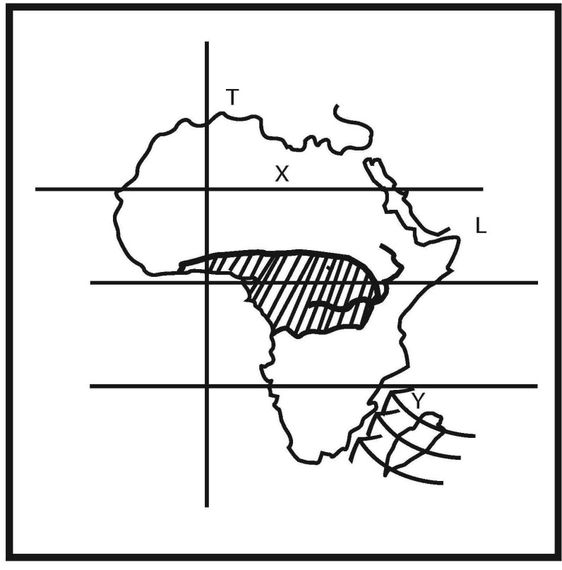 Use the map of Africa below to answer questions that follow.
2. Name one country crossed by latitude X

**Egypt, Libya, Algeria, Mali, Mauntania Western sahara.**

1. How does prevailing wind Y affect the climate of Africa?

**Prevailing wind Y brings rainfall to East Africa, Eastern part of South Africa, Madagascar and the Cong basin.**

1. Name the feature marked L.

**Red sea**

1. Name the climatic condition shaded

**Equatorial climate.**

1. (a) Name the Kabaka of Buganda who welcomed Arab traders.

**Kabaka Suuna.**

(b) Give one reason for the coming of Arabs to Uganda.

**- To trade**

**- To spread Islam**

**- To get land for settlement.**

(c) State any two contributions of Arabs to East Africa

- **They spread Islam.**

**- They introduced.**

**- They introduced Zebu cows.**

**- They brought a new culture.**

**- They introduced a cowrie shells.**

**- They introduced the architecture of stone houses.**

1. 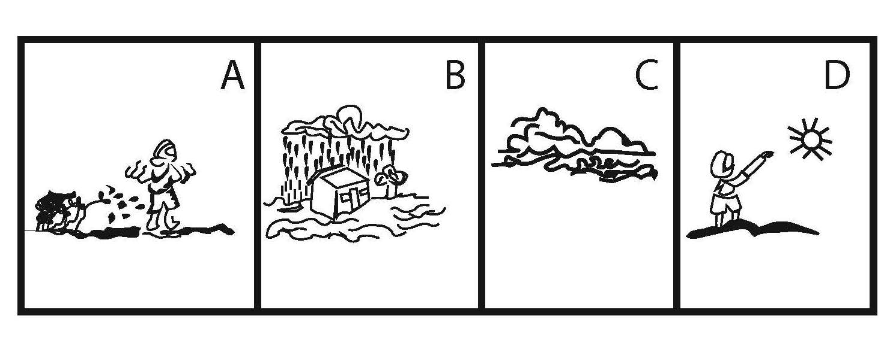 Study the diagram below and answer questions that follow.
2. Name the weather condition A.

**Windy**

1. Mention any one activity that can be carried out during the weather condition B.

**Harvesting rain water.**

1. How is weather condition D important to crops?

**It provides Sunlight for photosynthesis (helps plants to make their own food.)**

1. Give one effect of climatic change to farmers.

**Farmers’ crops might get destroyed.**

1. (a) State any two causes for the collapse of the East African Community in 1977.

- **Different political systems in the three countries.**

**- Each country wanted to develop on their own.**

**- Uganda and Tanzania thought Kenya had more social services centre (imbalance in social service allocations.)**

- **Misunderstandings among the three heads of states.**

**- Boarder conflicts.**

**- Poverty of community.**

**- Failure of the Chairman (Julius Nyerere) to call for the meetings.**

(b) State any two effects of the collapse of the East African Community in 1977 to the people of East Africa.

- **High taxation on imports.**

**- Money difference in buying goods from another country.**

1. Match the people in the list with their respective duties in B correctly.

A B

|  |  |
| --- | --- |
| 1. Police officer | treats people’s eyes. |
| 1. Fish monger | shaves people’s hair. |
| 1. Oculist | sells fish. |
| 1. Barber | maintains law and order. |

1. Police officer : **maintains law and order**
2. Fish monger : **Sells fish**
3. Oculist : **Treats people’s eyes**
4. Barber : **Shaves people’s hair.**
5. (a) State any two causes of low life expectancy among Ugandans.

- **Poverty**

**- Poor feeding.**

**- Illiteracy**

**- Poor medical services.**

**- Civil wars**

**- High patient/doctor ratio.**

(b) Mention any two reasons why most babies in Uganda die at birth.

- **Poor medical attention (lack of facilities)**

**- Ignorance – Young Parents (Early Pregnancies)**

**- Shortage of midwifes (Birth attendants)**

1. (a) Name any two organs of the democratic government.

**Executive, Legislature, Judiciary**

(b) Mention the organ of the government which is responsible for maintaining law and order.

**Executive**

(c) Give one cause of many crimes in Uganda today.

**- Poverty – Drug Abuse – Alcoholism – corruption – Moral decadence – Ignorance about the law of Uganda – Unemployment – lack of religious values in people.**

1. Arrange the following activities in order of their occurrences.
2. Formation of the Uganda National Congress.
3. Uganda was declared a British protectorate.
4. Kabaka Mutesa II was exiled by Sir Andrew Cohen.
5. **Uganda was declared a British protectorate**
6. **Formation of Uganda national Congress.**
7. **Kabaka Mutesa II was exiled by Sir Andrew Cohen.**

**For questions 51 to 55, answer either Christianity or Islam, but not both. No mark will be awarded to a candidate who attempts both alternatives in a number.**

1. **Either**
2. Where did Adam and Eve live?

**In the Garden of Eden.**

1. Why did the above people leave the place mentioned in 51 (a) above?

**They ate the forbidden fruit.**

1. State any two results of sin today.
2. **Suffering , Sorrow, Diseases, Hatred, Poverty, death , Misery**

**Or**

1. Where did Adam and Hawa live?

**In Janah /Adin/Paradise/garden of Adin.**

1. Why did the above people leave the place mentioned in (a) above?

**They ate the forbidden fruit.**

1. State any two results of sin today.

* **Suffering, Misery, Sorrow, Hatred, Poverty, Diseases, Drought, Famine.**

1. **Either**
2. Why do Christians pay a tithe?

**To help the needy / To get rewards/To get blessings/ To be forgiven/ To thank God.**

1. Give any two lessons we learn from the parable of “a good Samaritan”.

**-To be helpful/Generous /to be kind/love another.**

1. Why should a Christian child help others?

* **To get rewards/To help one another/ To show generosity/ Be part /Get blessings/one another.**

**Or**

1. What is Zakat?

**Zakat is Allah’s giving**

1. Give any one reason why Muslims pay Zakat.

* **To get rewards/Blessings /Increment in their wealth/protection /To help the needy /To show love/generosity.**

1. Mention any two categories people who qualify to get Zakat.

* **The needy – The debtors**
* **The poor – way farers**
* **New converts – Those in the way of Allah**
* **Zakat collectors – Ransoming slaves.**

1. **Either**
2. Give any two reasons why Christians all over the world pray during Christmas day.

* **To commemorate the birth of Jesus Christ.**
* **To pray for blessings from God**
* **To repent their sins.**

1. State any two reasons why it is not advisable to celebrate Christmas in wrong places.

* **To avoid temptations/sins**
* **In order not to annoy God.**
* **To workshop/Praise God Freely.**

**Or**

1. Give two reasons why Muslims all over the world pray on idd-al- fitri.

* **To mark the end of Ramadhan**
* **To ask Allah to accept their fasting.**
* **To ask for forgiveness/rewards.**

1. State any two reasons why it is not advisable to celebrate idd-al- fitri in wrong places.

* **To protect their fasting**
* **To avoid temptations/Sins.**
* **To workshop Allah freely.**

1. **Either**
2. Mention the prayer Jesus taught his apostles.

**The Lord’s Prayer.**

1. Mention any two things a Christian requests God in the above prayer.

* **Forgiveness – Guidance.**
* **Daily food – protection against temptation.**

1. What name is given to the prayer performed by Christians to ask for forgiveness?

**Petition Prayer.**

**Or**

1. Name the Surah (chapter) in the Quran recited in all the five daily prayers.

**Suratul Fafiha/Alihamudu…**

1. Mention any two things Muslims ask for in the Surah (chapter) in (a) above.

* **Forgiveness – Guidance – protection from going astray – Blessings.**

1. Name the night prayer performed by Muslims in the month of Ramathan.

Tarawehe

1. **Either**
2. Mention any two services provided by the church in Uganda today.
3. **Helping the needy – Religious marriages.**
4. **Counseling and guidance – Education**
5. Give any two causes of conflicts in churches today.

* **Greedy – Adultery – Selfishness – Poverty – Witch Craft – Arrogance – Misers**

**Or**

1. Mention any two services provided by the mosques in Uganda today.

* **Counseling and guidance.**
* **Education.**
* **Medical services.**
* **Religious rites – settling conflicts.**

1. State any two causes of conflicts in mosques today.

* **Selfishness**
* **Adultery**
* **Witch craft**
* **Murder**
* **Arrogancy**
* **Corruption**
* **Misers.**

**END**