LIGHT ACADEMY PRIMARY SCHOOL

HOMEWORK FOR P.6 TERM I 2020

Name: ……………………………………………………………….. stream: ……………………………..

**MATHEMATICS**

1. Write the place value of 4 in the number 24689
2. Write 12792 in words
3. Round off 99.98 to the nearest whole number.
4. What number has been expanded to give

(4 x 103) + (2 x 102) + (5 x 101) + (6 x 100)

1. Express 49 in Roman numerals.
2. Change 13five to base ten.
3. Work out: 4 + 3 = …………(finite 5)
4. (b) Subtract 3 2 five

+ 1 2 five

1. Find the sum of the place value of 2 and the value of 4 in the number 4267.
2. Expand 627.83 using exponents.

Name the figure drawn below.

1. Find the square of;
2. 4 (b) 16
3. Work out the square root of;
4. 144
5. 36

81

1

1. 7

9

1. 2.25
2. Find the smallest possible number which when divided by either 8 or 9 leaves 2 as a remainder.
3. The area of a square flower garden is 36cm2.
4. Find the length of each side of the garden.
5. Work out the total distance round the flower garden.
6. The volume of a cube is 27 dm3. Find the length of each side of the cube.
7. Two bells ring at intervals of 30 minutes and 40 minutes. If they ring together at 8:00am;
8. After how many hours will they next ring?
9. When will they ring together again?
10. Three men were firing at a target in intervals of 30, 40 and 50 minutes respectively. If they first fired together at 1:30pm.
11. After how many minutes will they fire together again?
12. When will they fire together again?

18. The diameter of a circular playground is 8m. Find its radius.

19. Find the value of y in degrees.

2y

30°

20. Solve: m + 7 = 15

21. Find the value of P if;

2P + 6 = 20

22. Solve: 6w = 30

23. Collect the like terms

4x + 3p – x + p

LIGHT ACADEMY PRIMARY SCHOOL

HOMEWORK FOR P.6 TERM I 2020

**MATHS**

1. Study the venn diagram below and answer questions that follow.

F X Fy

32 21

31 51

1. Find the value of;
2. X
3. Y
4. Work out the LCM of X and Y.
5. Find the GCF of X and Y.
6. F30 Fx

51

Y 21 22

1. Find the value of;
2. X
3. Y
4. Find the GCF of 30 and X.
5. Work out the LCM of 30 and X.
6. The intersection of two numbers A and B is {21, 31}

If A – B = {22, 32} and B – A = {51}

1. Represent the above information on a venn diagram.
2. Find the value of;
3. A
4. B
5. Work out the;
6. LCM of A and B
7. GCF of A and B
8. Peter had four cards labeled with digits 5, 8, 2, 6. He was asked to form 4 digit numerals using the digits.
9. Write down the;
10. Largest possible numeral formed.
11. Smallest possible numeral formed.
12. Find the sum of the largest and smallest numeral formed.
13. What is the difference between the largest and smallest numerals formed?
14. There are 986 students in Turkish Light Academy secondary. 236 in Turkish primary and 700 in Turkish Nursery. Find the total number of students in the 3 schools.
15. A box holds 20 books. How many boxes can be used to pack 14,000 books?
16. A father shared 4.500 shillings among his 5 children. How much did each child get?
17. A maize mill produced 6083 bags of posho. They sold 2817 bags. How many bags remained?
18. Find the difference between 740 and 228.
19. What is the sum of the next two numbers in the sequence 2, 3, 5, 7, ____, ____?
20. Divide 2424 by 6
21. Subtract 247 from 983.
22. Find the next number in the series. 0, ,4, 8, 12, ____, _____

LIGHT ACADEMY PRIMARY SCHOOL

HOMEWORK FOR P.6 TERM I 2020

Name: ………………………………………………………………………. Stream: ……………………

**MATHS**

1. Find the next number in the sequence:
2. 2, 3, 5, 7, …………….
3. 1, 3, 6, 10, 15, …………………..
4. 1, 8, 27, 64, ……………………
5. 81, 64, 49, 36, 25, ………………….
6. What is the GCF of 18 and 12.
7. Find the LCM of 9, 6 and 8.
8. List down all the factors of 24.
9. What number has been prime factorised to give; {21, 22, 31, 51}
10. Find the sum of the first five odd numbers.
11. Prime factorise 36 and give the factors in set notation.
12. Draw a venn diagram and represent the prime factors of 24 and 30.
13. Work out: 3 + 2 = ____ (finite 4)
14. Subtract: 2 – 5 = _____(finite 7)
15. Change 24five to base ten.
16. Change the following to base two.

(a) 23ten

1. Add: 2 3 1five

+ 4 4five

_____________

1. Subtract: 2 3 3seven

- 2 5seven

1. Multiply: 23five x 2
2. Express 24 in finite 5
3. Use a dial to work out the following:

(a) 3 + 4 = _____ (finite 5)

(b) 3 – 5 = _____ (finite 6)

1. Subtract 1 4 3five from 324five
2. Add: 1 0 1two

+ 1 1two

1. In a class of 50 pupils, 40 like MTC (M), 25 like Science (S), P like both Maths and Science while 2 don’t like any of the two subjects.

M S

P

……

1. Represent the above information on the venn diagram (7 marks)
2. How many pupils like both subjects?
3. Find the number of pupils who like only one subject.
4. What is the probability of picking a pupil at random who like only Science?
5. Write 1/8 in decimal form.
6. Simplify: 0.48 x 0.5 (3marks)

0.04

LIGHT ACADEMY PRIMARY SCHOOL

 HOMEWORK FOR P.6 TERM I 2020

Name: ……………………………………………………………………………. Stream: ……………………

**SOCIAL STUDIES**

1. By what process was the western arm of the rift valley formed?
2. How was Lake Victoria formed?
3. Explain why the Kenya highlands are densely populated?
4. Name the mineral mined in sukuru hills.
5. What industry was developed in Tororo as result of the above mentioned mineral?
6. State one way in which Lake Victoria is useful to the East African countries.
7. Why is transport on river Nile difficult between Jinja and Pakwarch?
8. Mention any one advantage that is enjoyed by people who live on mountain slopes.
9. Give one reason why Kalangala district has a low population.
10. Give two reasons why there is a low population in the Rift valleys.
11. Identify any two ways man has affected lakes and rivers in East Africa.
12. Outline any two problems that pastoralists of East Africa face.
13. How can the governments of E. Africa solve the above mentioned problems?
14. State one problem caused by overgrazing.
15. How are the Turkana and the Bahima similar?
16. What factors have promoted tourism industry in Uganda today? (give two)
17. Why are gorillas and chimpanzees found in Bwindi and not in Kidepo National Game Park?
18. Which National Park in East Africa is famous for flamingoes?
19. Why is tourism more developed in Kenya than in Uganda?
20. What do we call the steep sides of a rift valley?
21. From which forests do we get water-proof timber?
22. Which is the biggest National Game Park in East Africa?

LIGHT ACADEMY PRIMARY SCHOOL

 HOMEWORK FOR P.6 TERM I 2020

**SOCIAL STUDIES**

1. Why does Nairobi get more rainfall than Kotido?
2. Outline three human activities that affect the climate of East Africa.
3. How does swamp drainage affect the climate of East Africa?
4. How does climate affect the activities of man?
5. Give one way rainfall is useful to man.
6. What is the use of these imaginary lines?
7. How doe the natural vegetation cover affect rainfall distribution?
8. What is an Equinox
9. What does the road sign below mean.

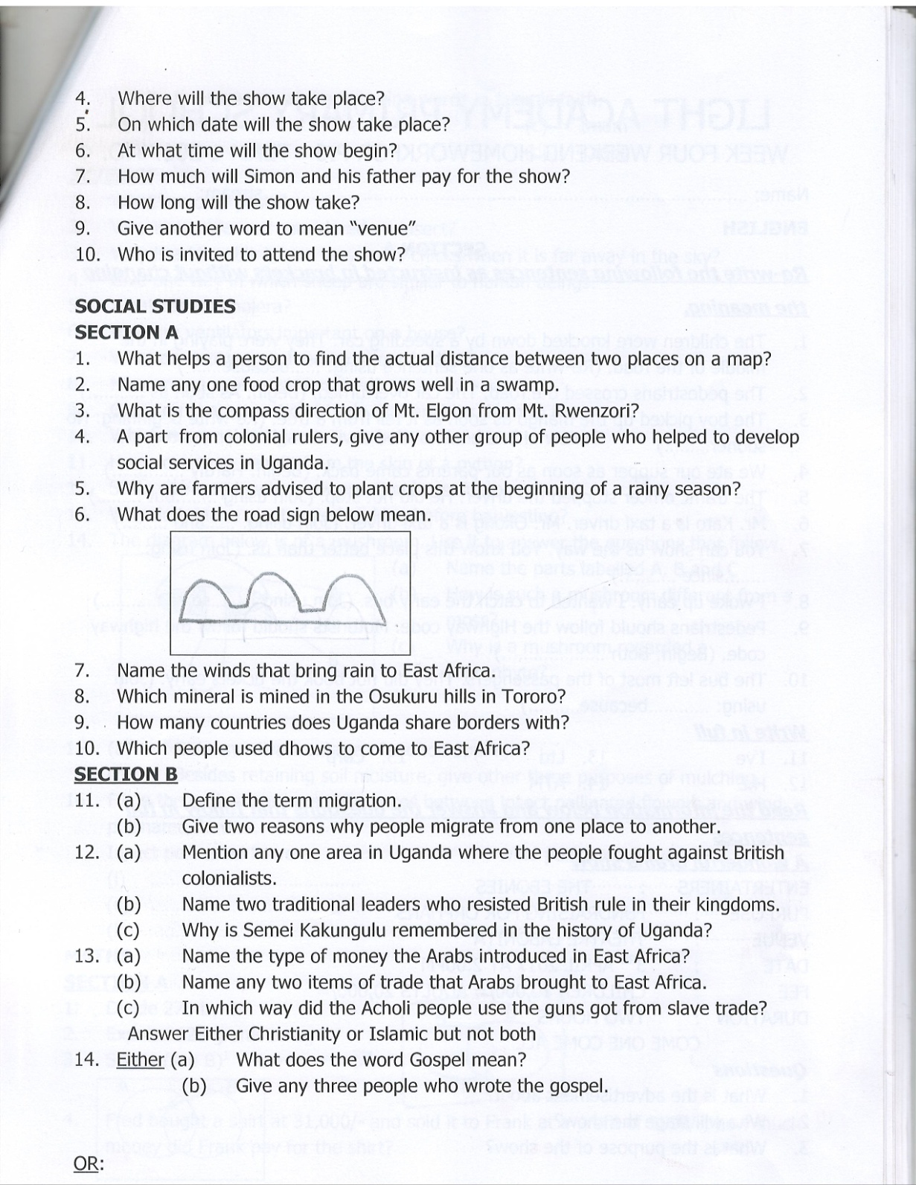

1. Which mineral is mined in the Osukuru hills in Tororo?
2. How many countries does Uganda share borders with?
3. Which people used dhows to come to East Africa?
4. Define the term migration.

(b) Give two reasons why people migrate from one place to another.

1. (a) Mention any one area in Uganda where the people fought against British colonialists.

(b) Name two traditional leaders who resisted British rule in their kingdoms.

(c) Why is Semei Kakungulu remembered in the history of Uganda?

1. (a) Name the type of money the Arabs introduced in East Africa?

(b) Name any two items of trade that Arabs brought to East Africa.

(c) In which way did the Acholi people use the guns got from slave trade?

1. Answer Either Christianity or Islamic but not both
2. Either (a) What does the word Gospel mean?

(b) Give any three people who wrote the gospel.

OR: Write the meaning of the following words in Islamic faith.

Saum

Umra

Imam

Kaaba

LIGHT ACADEMY PRIMARY SCHOOL

 HOMEWORK FOR P.6 TERM I 2020

**SOCIAL STUDIES**

1. What is Bwindi National Park famous for?
2. How did the discovery of iron improve the life of early man?
3. Mention one way nomadic pastoralism in North Eastern Uganda can be controlled.
4. How does Uganda benefit from being a member of the East African Community?
5. Why is it difficult to travel by boat along the Victoria Nile?
6. In which agreement were the boundaries of Buganda drawn?
7. Give one reason why Muteesa I was not happy with missionaries.
8. Mention one source of income for the colonial government in Uganda.
9. Why is air transport used by few people in East Africa?
10. State one reason why the coastal areas of East Africa have high temperature.
11. Name the country that borders Uganda on the Eastern side.
12. How did I.K. Musaazi contribute to the struggle for independence in Uganda?
13. In which way was the formation of Mt. Elgon different from that of Mt. Rwenzori?
14. Give any one reason why you think that Lake Victoria is at a higher altitude than L. Kyoga.
15. Why does Kalangala district receive convectional rainfall?
16. In which way was the coming of Captain F.D Lugard of an advantage to Tooro kingdom?
17. Write the organization which writes all religions in Uganda.
18. How did the Asians contribute to economic development of East Africa?
19. What type of coffee grows best in volcanic mountains?
20. How are traditional leaders important in Uganda?
21. Outline any four factors that determine the climate of an area.
22. What is vegetation?
23. Give the two types of vegetation.
24. Write down any four factors that influence vegetation distribution.
25. Explain why tropical forests are found around the shores of L. Victoria?
26. Why are the areas of tropical forests getting smaller in East Africa?
27. Why is deforestation bad?
28. What is the importance of weather forecasting to farmers?

LIGHT ACADEMY PRIMARY SCHOOL

HOMEWORK FOR P.6 TERM I 2020

**SCIENCE**

1. What name is given to reflected sound?
2. How can echo be reduced in disco halls?
3. To which group of musical instruments does the instrument drawn below belong?
4. How does the above instrument produce sound?
5. Which of the gases forms the greatest percentage of air in the atmosphere?
6. In which process can water be turned into vapour?
7. What first aid would you give to a person suffering from severe diarrhoea?
8. State any one reason why people should keep their finger nails short.
9. How do animals benefit from plants?
10. How do bacteria help in soil formation?
11. Why is a mushroom different from other plants?
12. Which substance can exist in all the three states of matter?
13. Why does smoke go up when firewood is burning?
14. Which part of blood helps in the clotting of blood?
15. Why is dew formed at night?
16. What is the importance of debeaking in poultry?
17. Besides use of seeds, what other part of a flowering plant can be used for propagation?
18. How can a child acquire artificial immunity?
19. Why is carbondioxide used in a fire extinguisher?
20. Define the following terms as used in sound energy?
21. Volume (b) pitch (c) frequency
22. Name the amphibian that lays eggs as shown below

A B

LIGHT ACADEMY PRIMARY SCHOOL

HOMEWORKFOR P.6 - TERM 1 2020

**SCIENCE**

1. How does a banana plant multiply?
2. What insect pest attacks bananas?
3. State one method you would use to control the insect pest.
4. What fracture enables a housefly to spread germs?
5. How is a tadpole similar to a fish?
6. Why are tapeworms regarded as parasites?
7. Why is a spider not considered an insect?
8. State the role of the tongue during digestion.
9. Why can’t fungi make their own food?
10. Give one example of an egg laying mammal.
11. In which way are reptiles similar to birds?
12. How are earthworms important in the soil?
13. What are arthropods?
14. How does a millipede protect itself?
15. Why are telephone wires loosely fixed between poles?
16. What does a vulture feed on?
17. Why is mercury commonly used in thermometer?
18. Give one way in which we can protect ourselves from hookworm infection.
19. (a) How does a fish take in oxygen?

(b) What is the importance of the lateral line to a fish?

(c) How are nostrils useful to a fish?

1. Name the instrument used to measure the amount of water vapour in the atmosphere.
2. Why should human faeces be disposed off properly in latrines?
3. State one artificial source of sound energy.
4. How is the beak of a hawk adapted to its function?
5. Mention one factor which can reduce the rate of transpiration.
6. To which group of mammals does a whale belong?
7. Why is a whale able to maintain its body temperature yet it spends all its life in water?

LIGHT ACADEMY PRIMARY SCHOOL

HOMEWORKFOR P.6 - TERM 1 2020

**SCIENCE**

1. How is the absence of iodine harmful to our health?
2. Which of the following : fish, frog, lizard, rat and snails is warm blooded?
3. Give any one function of the human kidney.
4. Give one example of each of the following groups of mammals.
5. primates
6. rodents
7. marsupials
8. monotremes
9. (a) Why is a stone regarded as matter?

(b) In which state of matter is cassava flour?

(c) Name the smallest individual particles that make up matter.

(d) How is cohesion different from adhesion?

1. (a) Name the class of food whose digestion begins in the mouth.

(b) How are the following substances important in the digestion process?

(i) Enzymes (ii) Hydrochloric acid (iii) Bile juice

7. How are the brightly coloured petals important to the plant?

1. To which group of musical instruments do you classify the guitar?
2. Suggest one disadvantage of having a home near a factory.
3. The diagram below shows a tape worm.

P

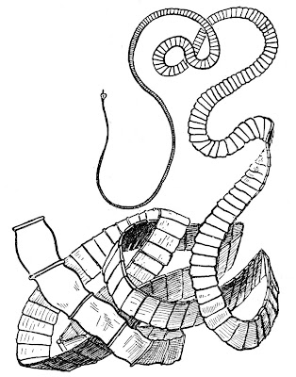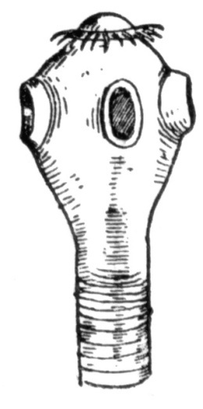

C

1. Name parts labelled p and c.
2. What do tapeworms feed on?
3. What is the effect of tapeworm infection to our health?

LIGHT ACADEMY PRIMARY SCHOOL

HOMEWORK FOR P.6 TERM I 2020

Name: …………………………………………………………. Stream: ……………

**Give the opposite of the underlined words**

1. Hardworking pupils are good to sit next to.
2. How many princesses has the king got?
3. His absence in the meeting was a misfortune.

**Re-arrange the given words in alphabetical order**

1. journey, judge, journal, jubilee
2. coffin, coin coffee, coke

**Re-write as instructed in the brackets**

1. The visitor arrived at our school at mid-day. (Re-write using: …………reached ………)
2. I joined this school four years ago. (Begin: I have been …………………….)
3. She is clever. She failed the test. (Begin: Despite …………………..)
4. She is so young that she cannot cross the road alone. (Re-write using: ………..enough ……..)
5. I cannot eat this food because it is too hot. (Re-write using: ………….too ……….to………)

**Rewrite the sentences giving a single word for the underlined group of words**

1. Very many people travelling on foot died in motor accidents last month.
2. Her uncle passed away in a car accident.
3. The policeman is standing at the place where two or more roads meet.
4. People who ride bicycles should obey traffic rules.
5. My uncle works as a person who drives a motor vehicle in that hotel.

**Give the plural forms of the following nouns**

1. Wheelbarrow
2. Sign post
3. Roadblock
4. Toothbrush
5. Wheel chair
6. Commander-in-chief
7. Head-of-state
8. Teacher-on-duty
9. Passer-by
10. Prisoner-of-war

***Write in full***

1. I’ve
2. H.E
3. Ltd
4. ATM
5. Corp

LIGHT ACADEMY PRIMARY SCHOOL

HOMEWORK FOR P.6 TERM I 2020

Name: …………………………………………………………. Stream: ……………

**English**

**Read the passage below and in full sentences answer the questions that follow.**

**THE ROAD ACCIDENT**

Atieno’s teacher, Mr. Wafula, had always emphasized the need to be careful when at a zebra crossing. Since Atieno always walked home from school, she knew it was important to follow Mr. Wafula’s advice.

On leaving school that day, Atieno called her friend Auma to go home with her. When they reached the road, they heard a loud bang followed by screams and noise. They got very shocked but they ran to the source of the noise.

Already a crowd of pedestrians had gathered to have a look at the badly damaged taxi which has overturned. The traffic police had also arrived at the scene and were busy controlling other vehicles. Soon, an ambulance arrived and the injured victims were put inside using stretchers. Some victims were bleeding while others had fractures and bruises.

Some people from the crowd offered First Aid to the accident victims while others were busy stealing things like phones from the victims.

**Questions**

1. What is the passage about?
2. Who was Athieno’s friend?
3. What was Mr. Wafula’s advice?
4. What made Athieno and Auma get shocked?
5. What were the traffic police doing?
6. What did the two friends hear when they reached the road?
7. How were the victims put inside the ambulance?
8. Which injuries did the victims get?
9. Who offered First Aid to the accident victims?
10. Give one word or group of words to mean the same as the underlined words in the passage.
11. emphasized (ii) pedestrians

LIGHT ACADEMY PRIMARY SCHOOL

HOMEWORK FOR P.6 TERM I 2020

***Re-write the following sentences as instructed in brackets without changing the meaning.***

1. The children were knocked down by a speeding car. They were playing in the middle of the road. (Re-write as one sentence using: ……because…… )
2. The pedestrians crossed the road. The car overturned. (Begin: As soon as ………..)
3. The boy picked up the mango as soon as it fell from a tree. (Re-write beginning: No sooner………)
4. We ate our supper as soon as our parents came back. (Begin: Hardly …………..)
5. The traffic officer stopped the driver. He did not stop. (Join using ……..but ………)
6. Mr. Kato is a taxi driver. Mr. Okong is a taxi driver. (Join using: ……and ………)
7. You can show us the way. You know this place better than us. (Join using: ……..since ………..)
8. I woke up early. I wanted to catch the early bus. (Join using ………so as …………)
9. Pedestrians should follow the Highway code. Motorists should follow the highway code. (Begin: Both ………………..)
10. The bus left most of the passengers. They did not book the tickets early. (Join using: …………because……….)

***Read the information below and answer the questions that follow in full sentences***

***A wonderful drama show***

ENTERTAINERS : THE EBONIES

PURPOSE : FUNDRAISING FOR ORPHANS

VENUE : THEATRE LABONITA

DATE : 3RD APRIL 2020 AT 2:00PM

FEE : CHILDREN 10,000/= ADULTS 20,000/=

DURATION : TWO HOURS

COME ONE COME ALL

***Questions***

1. What is the advertisement about?
2. Who will stage the show?
3. What is the purpose of the show?
4. Where will the show take place?
5. On which date will the show take place?
6. At what time will the show begin?
7. How much will Simon and his father pay for the show?
8. How long will the show take?
9. Give another word to mean “venue”
10. Who is invited to attend the show?

**LIGHT ACADEMY PRIMARY SCHOOL**

**HOMEWORK FOR P.6**

**ENGLISH**

***Read the dialogue and answer in full sentences the questions that follow.***

Joyce : Hello Mariam

Mariam: Hello Joyce

Joyce : You look sad, what’s the matter?

Mariam: Jane, our head prefect had an accident this morning as she was coming to school.

Joyce : That’s sad news. What really happened?

Mariam: A speeding motorcycle knocked her down as she was crossing the road at the junction near the market. She was given first aid and then rushed to Mengo Hospital by an ambulance.

Joyce : By the way, did she look right, look left and right again before crossing the road?

Mariam: Not at all! She was in a hurry. She was afraid of being late for the first English lesson.

Joyce : Oh my God! That was a big mistake pedestrians must always be careful while crossing a busy road.

***Questions***

1. Who got an accident according to the dialogue?
2. How many people are talking in the dialogue?
3. What do you think was Jane’s mistake?
4. During what time of the day did the accident happen?
5. How was the accident victim taken to the hospital?
6. To which hospital was Jane taken?
7. Where was Jane going?
8. What is Jane’s responsibility at school?
9. Do you think Jane was a careful girl? Give a reason to support your answer.
10. Give a suitable title for this dialogue.