**LIGHT ACADEMY PRIMARY SCHOOL**

**P.1 ENGLISH HOMEWORK EXERCISE TERM I 2020**

My name is ____________________________Stream____________

1. **Fill in the gaps with “a” or “ an”.**

  _____ egg  ____ box

_____umbrella  ____envelope

 ____flower  ______chair

2. **Complete the sentences with “a” or “an**.

a. Bring me ________apple with ______knife.

b. _____aeroplane is a means of transport.

c. _____ teacher teaches pupils.

d. It is _______ school.

3. **Change these nouns into plural**.

**Singular ( one) Plural ( many)**

1. School schools
2. pencil ________________
3. office ________________
4. kitchen ________________
5. pen ________________
6. flag ________________
7. badge ________________

**LIGHT ACADEMY PRIMARY SCHOOL**

**P.1 ENGLISH HOMEWORK EXERCISE TERM I 2020**

Name: ________________________________________ Stream ____

My school is :________________________________________________

1. **Give the plural form of the nouns in brackets.**

a. Put the ___________________in the basket. ( tomato)

b. The _________________are in the kitchen. ( cook)

c. Juma put eight _____________ in the cupboard. ( plate)

d. All my __________________ are torn. ( dress)

e. ____________________are fruits. ( apple)

f. They have broken all the ___________________ . ( bench)

2. **Complete the sentences with “is” or “are”.**

a. _________________these garden tools?

b. There _______________very many fruits in the market.

c. The boys ____________________playing football.

d. _____________________this a gatekeeper?

3. **Write their plural form.**

**Singular ( one) plural ( many)**

**a**. fox __________________ **b**. bus ____________________

**c**. box __________________ **d**. girl ____________________

**e**. tomato _______________ **f**. child __________________

**LIGHT ACADEMY PRIMARY SCHOOL**

**P.1 ENGLISH HOMEWORK TERM I 2020**

Name: ________________________________________ Stream ____

1. **Complete the sentences.**

a. Jane has a _______________

b. Here is a _______________

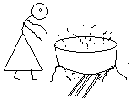2. **Answer correctly using (No, she is not or Yes, she is )**

a. Is she a cook?

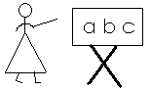 ____________________________________

b. Is she a nurse ?

___________________________________

3. **Fill in the missing letters.**

t__acher do__ tor d__ __ver

4. **Write these words correctly.**

a. ncilpe - _____________________

b. ookb - _____________________

c. airch - _____________________

**LIGHT ACADEMY PRIMARY SCHOOL**

**P.1 LITERACY I HOMEWORK TERM I 2020**

Name: _____________________________________ Stream ____

1. ________________ is the way we keep our bodies clean. **(sanitation, personal hygiene)**
2. Name any one example of a body exercise.

_________________________________________________________

1. We wash our hands to remove_________________.(germs, sweets)
2. We do body exercise to be ______________________.(weak, strong)
3. **Write yes or no**
4. a broom is used for sweeping___________________.
5. A comb is used for eating________________________.
6. We iron our uniforms to kill germs._________________
7. Draw the following items we use to keep our classroom clean.

|  |  |  |
| --- | --- | --- |
|  |  |  |
| water | broom | soap |

**LIGHT ACADEMY PRIMARY SCHOOL**

**P.1LITERACY I HOMEWORK EXERCISES TERM I 2020**

Name: ______________________________________ Stream __

1. We get __________________ and ________________________ from a cow.
2. Draw the following animals we keep at home.

|  |  |  |
| --- | --- | --- |
|  |  |  |
| cat | dog | cow |

1. A hen gives us _____________________________.
2. We wash our hands to remove_____________________________.
3. A dirty home has ________________________________.
4. Name this item that gives us light.

|  |
| --- |
| **D:\desktop\folders\geo\em\profession\all desktop\new images\nature\sun.bmp** |
|  |

**LIGHT ACADEMY PRIMARY SCHOOL**

**P.1 HOMEWORK EXERCISE TERM I 2020**

**Literacy I**

1. **Write down only common diseases from the list below**.

Flu ______________________

Polio ______________________

Malaria ______________________

Cough ______________________

2. __________________spread diseases. ( food, germs)

3. How do we protect ourselves from mosquito bites?

_________________________________________________________

4. **Tick ways of keeping the home clean.**

by sweeping

by eating dirty food

by covering the toilet

5. Why do we cut our fingernails short?

_________________________________________________________

6. **Circle immunisable diseases.**

Measles, flu, polio, cough, tetanus

7. Which immunisable disease makes us lame.

________________________________________________________

8. **Draw a child suffering from polio.**

**LIGHT ACADEMY PRIMARY SCHOOL**

**P.1 ENGLISH HOMEWORK EXERCISE TERM I 2020**

Name: ________________________________________ Stream ____

1. **Circle the verbs.**

a. He plays football every day.

b. She walks to town every day.

c. Girls put on dresses.

d. We are sleeping now.

e. They danced well yesterday.

2. **Use the given verbs in present continuous tense.**

a. I am ______________________my teeth. ( **brush**)

b. Daddy is _____________________a car. ( **drive**)

c. We are __________________ very fast. ( **move**)

d. Are they _________________food. ( **eat**)

e. The water is _______________now. ( **boil**)

f. Mummy is ___________________ a cake. ( **bake**)

**Make three sentences from the table below.**

|  |  |  |
| --- | --- | --- |
| You  She  Mary  He  I | has  have | a red doll.  many books  nice bags  mangoes and oranges |

a. _________________________________________________________

b. _________________________________________________________

c. _________________________________________________________

**LIGHT ACADEMY PRIMARY SCHOOL**

**P.1 NUMBER HOMEWORK TERM I 2020**



Name: ________________________________________ Stream ____

My school is ________________________________________________

1a. **Arrange the numbers starting from the smallest to the biggest**.

a. 3, 5, 2, 4 ______________________

b. 40, 20, 30, 10 ______________________

c. 12, 10, 11, 15 ______________________

2. **Write the number names correctly**.

a. hteig - _____________ b. ntytwe - ______________

c. teenfif - _____________ d. tythir - ______________

e. tow - _____________

3. **Arrange numbers starting from the biggest to the smallest**.

a. 7, 8, 1, 3 ______________________________

b. 15, 20, 19 ______________________________

c. 30, 10, 50, 20 ______________________________

**LIGHT ACADEMY PRIMARY SCHOOL**

**P.1NUMBER HOMEWORK EXERCISES TERM I 2020**

My name is ________________________________________________

My school is ________________________________________________

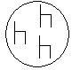1. **Name these sets.**

**a.** A set of ___________ b. ______________

**c**. A set of ___________________

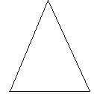2. **Read and draw the sets.**

**a**. b.

A set of 2 balls. A set of 4 sweets.

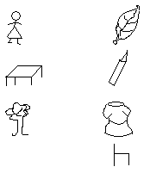3. **Match the related.**



4. **Use the words to complete correctly.**

Empty elements set

a. A group of objects is __________________________

b. Things found in a set are called _____________________

c. A set with no members is an ________________________

**LIGHT ACADEMY PRIMARY SCHOOL**

**P.1 MATHEMATICS II HOME WORK EXERCISES TERM I 2020**

Name: ________________________________________ Stream ___

**1. Join these sets.**

a. 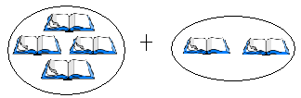

=

b. 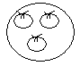 plus  equals 

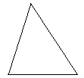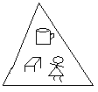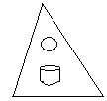

c. and make

2. **Form a big set from small sets.**

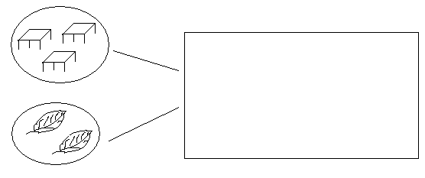

3. **Make new sets.**

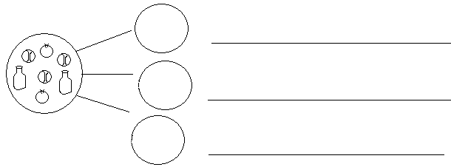

**LIGHT ACADEMY PRIMARY SCHOOL**

**P.1 LITERACY II HOME WORK EXERCISES TERM I 2020 NO. 6**

Name: ________________________________________ Stream ____

My school is :_________________________________________________

1. **___________________ are things man cannot live without.(people, Basic needs)**
2. **Name the four basic needs of man.**

**___________________________ ___________________________**

**__________________________ ___________________________**

1. **What is a home?**

**_______________________________________________________________**

1. **Mention any three activities done at home.**

**_____________________________________________________________________________________________________________________________________________________________________________________________**

1. **Give one role of a**
2. **father _______________________________________________**
3. **mother ______________________________________________**
4. **Draw and name any four things found in a home.**

|  |  |  |  |
| --- | --- | --- | --- |
|  |  |  |  |
|  |  |  |  |

**LIGHT ACADEMY PRIMARY SCHOOL**

**P.1LITERACY II HOME WORK TERM I 2020**

Name: ________________________________________ Stream ____

School:____________________________________________________________________

1. What is a home**?**

___________________________________________________________________

1. Name any two rooms found in a house.

______________________________________________________________________________________________________________________________________

1. Mention any three activities done at home.

_________________________________________________________________________________________________________________________________________________________________________________________________________

1. Give one role of a father at home.

__________________________________________________________________

1. A good house must have a ________________________________________.
2. List down any four things found in a kitchen.

____________________________________________________________________________________________________________________________________________________________________________________________________________________________________________________________________________

**LIGHT ACADEMY PRIMARY SCHOOL**

**P.1 LITERACY II HOMEWORK EXERCISES TERM I 2020**

Name:_____________________________________________ stream:__________

1. A _____________________ is a group of people living and working together. (home, community)
2. Name any four people found in the community.

_________________________________________ _______________________________

________________________________________ ________________________________

1. **Draw these basic needs.**

|  |  |  |  |
| --- | --- | --- | --- |
|  |  |  |  |
| food | water | shelter | clothes |

1. **Circle the weak building materials.**

grass, cement, sticks, nails

1. Give one role of children at home.

_______________________________________________________________

1. **Draw these examples of houses.**

|  |  |
| --- | --- |
|  |  |
| flat | hut |