

**NAME: INDEX NUMBER: EMIS NUMBER: DISTRICT NAME:**

**SCIENCE SECTION A**

1. Give any one common root vegetable used in the preparation of sauce at home.
2. How is the work of a switch different from that of a fuse in an electric circuit?
3. Sanitation is the general cleanliness of an area. State any one material / item used in keeping the environment clean.

# Maria’s parents put a potted plant in their sitting room as shown below

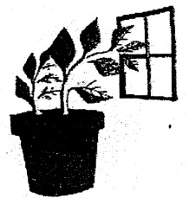

1. What attracted the plant towards the window?
2. State any one way in which people can use cow dung and animal urine at home.
3. How is a guitar as a musical instrument different from the xylophones?
4. Name any one problem of poor feeding that is common in many rich families in the city / urban areas.
5. Apart from tree planting, identify any one income generating project at home.
6. How are houseflies dangerous to the sense of sight?

# The sign post below was found in a school compound

1. What does the message on the sign post encourage people in the school community to do?
2. The water hyacinth is a weed that is dangerous on our lakes. State any one danger of this weed.

_

1. How is comparing of prices a good factor to consider before spending money on any goods or services?

# The diagram below shows a property of Air.

1. Which of the balloons has more matter?

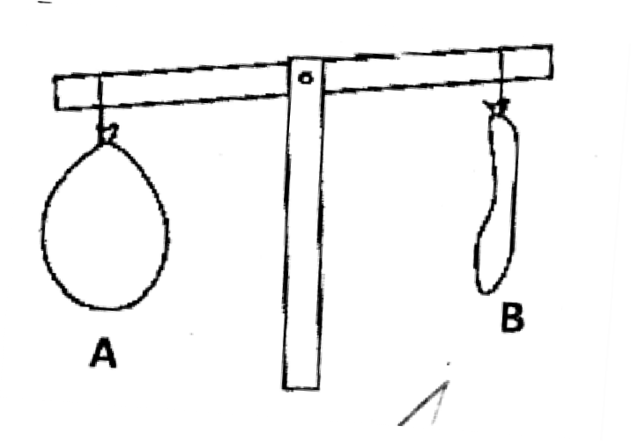

1. Give any one advantage of lightning in the environment.

# In the space provided below, draw a blood cell that is affected by Malaria parasites.

1. Identify any one perennial crop in Uganda.
2. There are four types of teeth in human beings. Name the two types which have a similar function.

# ii) The diagram below is of a cylindrical tank

1. How many litres of water can fill the above tank to the brim?
2. Identify the fungi that helps local people in our community in the brewing of alcohol from sugar and water.
3. State any one economic importance of insects such as mosquitoes. houseflies, cockroaches and tsetse flies.
4. State any one thing that can go wrong if we do not keep our bodies clean.

# The diagram below shows the path of a soccer ball as it travels from Mess to Neymar Jr.

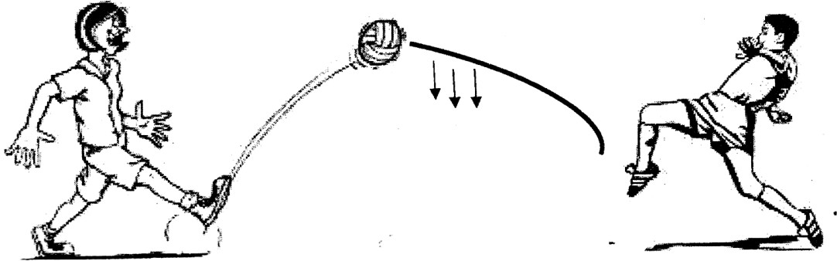

1. Which force is represented by the arrows?
2. State any one effect of deforestation to wild birds and animals.
3. Name the instrument that you would best use to measure the volume of a liquid.
4. In the space provided below, draw a seed dispersed by wind
5. Give any one function of the stomach in humans.
6. What is hibernation?
7. There are several pests that attack and destroy root crops in our garden. State any one method of controlling such pests.
8. State any one property of water

# When a glass with cold water with ice was put on a table, water droplets were seen on the outside of the glass.

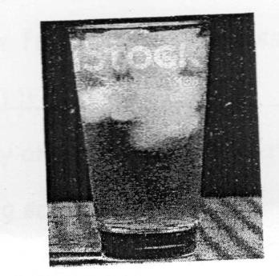

1. Which process causes the water droplets on the outside of the glass?
2. Give any one common use of shadows to people and other animals.
3. In which state of matter is ghee at room temperature?

# The diagram below is of a bean seed.

1. Name the part marked X.

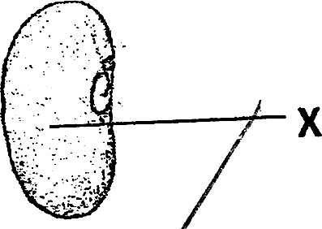

1. State the type of weather that people usually manage by wearing gumboots.
2. A safety pin is one common item found in a first aid box. Give any one use of this item when giving first aid.
3. Identify the group of birds that commonly keep our environment clean and free from rotting carcasses.
4. Identify any one life skill that may guard you against drug abuse in a boarding school.
5. State any one difference between a frog and a toad.
6. Give any one condition that influences the rate of transpiration in plants.
7. Name the raw material from which local salt can be made.

**SECTION B (60 MARKS)**

1. a) Give any two ways in which you can be involved in keeping the school environment clean.
   1. _ ii)

b) Explain any one way school children can put to good use polythene bags that have been picked from the school compound.

|  |  |  |  |
| --- | --- | --- | --- |
|  | c) |  | Why is it important for the sports teacher to plant grass in patched areas on the field or play ground? |
| 42. | a) |  | What is the cause of the following immunizable diseases?   1. Hepatitis B   _   1. Haemophilus Influenza b.   _ |
|  | b) |  | Name the major body organ that is affected by Hepatitis B. |
|  | c) |  | Which vaccine is given to babies to protect them against Haemophilus |
|  |  |  | influenza b? |
|  |  |  | _ |
| 43. | a)  b)  c) |  | There are several processes through which we prepare clean and safe water for drinking and washing.  Name any two of these processes.  i) ii) Identify any one common water impurity.  _  Why is it important for one to sort clothes before washing them? |

1. a) Give any one example of each of the following:-
   1. antisocial behaviour

_

* 1. sexual deviations

_

b) Give any two community and health problems among young people today.

ii)

# The diagram below shows a tool we use to keep ourselves clean



1. How is the tool above used in keeping ourselves clean?

_

1. In the absence of the above, what else can you use for the same task?

_

1. State any two possible dangers of using the above tool at school.
2. a) A girl used a plastic comb to make her long hair. Name the electricity she is likely to produce in the process.

_

1. Name the installation in schools that is used to prevent the electricity in (a) above from killing students.
2. Give any two ways in which electricity can be used to solve everyday problems.
   1. ii)

# The diagram below shows a modern garden tool.

1. Name it
2. Give any two uses of the above tool on a farm.
3. State any one advantage of the above compared to the other local tools.

_

1. a) State any one similarity between coal and petroleum as energy resources.

_

* 1. Give any one use of each of the above energy resources to people.
     1. Petroleum
     2. Coal
  2. Write down one use of biogas at home.

_

1. a) State any two disadvantages of air.
   1. _ ii)
2. Why is it important for a family to harvest water?

_

1. Mention any one danger of rain on soil

_

_

1. a) Give any two domestic animals that neither give us milk nor meat.
2. State any one importance of keeping any of the animals you have given in (a) above.
3. Name one wild hoofed animal with an even number of toes.

# Rods made of different materials were fixed into a trough with hot water. The rods has wax on them and the arrows show the extent to which wax melts.

1. Which of the rods is the best conductor of heat?
2. Which rod is the lowest conductor of heat?

_

1. What does the above experiment show?

_

1. How do people in your community use conduction of heat to solve their day to day problems?
2. Some people in Uganda keep rabbits to get income and meat.
3. Give any two ways in which the farmers can keep these rabbits healthy i) _ ii)
4. Why do farmers keep records about their rabbits on the farm?
5. How can you care for any of the groups of people you have given in (b) above?
   1. _
6. a) Identify any one suitable lifestyle / good health practice done by individuals in your community.

_

1. Name any two groups of people with special needs in your community.
   1. _ ii)
2. How can you care for any of the groups of people you have given in (b)

above?

_

# The illustration below shows a food chain

**Grass Caterpillar hen cat**

1. Which of the above living things is both a predator and a prey?

_

1. What do the arrows represent in the illustration above?

_

1. What general name is given to the caterpillar, hen and the cat in the illustration above?
2. Why is grass said to be a producer?
3. Respiration is necessary for human life
4. Name any one end product and by-product of respiration
   1. end-product
   2. by-product
5. State any one campaign you would participate in to keep other people’s respiratory systems in good working conditions.
6. Identify one disorder of the respiratory system.

_

# END