**TWALIBAH ISLAMIC PRIMARY SCHOOL**

** PLE MOCK EXAMINATION, 2019**

**PRIMARY SEVEN**

**ENGLISH**

**TIME ALLOWED: 2 HOURS 15 MINUTES.**

**Candidates Name: ______________________________________________________**

**Candidates Signature: __________________________________________________**

**EMIS Number: __________________________________________________________**

**District Name: _________________________________________________________**

**Read the following instructions carefully:**

1. The paper has **two** sections: **A** and **B**
2. Section **A** Sub-Section I has 30 questions (30 marks)

and Sub-Section II has 20 questions (20 marks)

1. Section **B** has 5 questions (50 marks)
2. Answer **ALL** questions. All answers to both Sections **A**

and **B** must be written in the spaces provided.

1. All answers must be written using a blue or black ball

point pen or ink. Diagrams should be drawn in pencil.

1. Unnecessary crossing of work may lead to loss of marks.
2. Any handwriting that cannot be easily read may lead to

loss of marks.

1. Do **not** fill anything in the boxes indicated

For Examiners use only.

***Turn over***

**SECTION A: 50 MARKS**

**Sub-Section I**

***Questions 1 to 50 carry one mark each.***

**In each of the questions 1 to 7, use the correct form of the word given in brackets to complete the sentences.**

1. The mock … timetable was done by the deputy headteacher. (invigilate)

2. All the  chairs were taken to upper primary. (metal)

3. My school uniform has already been . (sew)

4. He was ranked the  during the competitions. (twelve)

5. The  nationals attended the regional meeting. (Rwanda)

6.  daily participation helped them to improve on their performance. (they)

7. Ochom  asked the baker to pack the bread for him. (polite)

**In questions 8 to 15, fill the gap with the most suitable word.**

8. What is the relationship .the two girls?

9. One must respect . before one is respected.

10. Most schools will . up for holidays next Friday.

11. The driver didnt know to do in order to save the child.

12. A good cake should have all the necessary ..

13. They needed a . to carry the coffin to the burial ground.

14. They need to conduct fresh prefect elections, . they?

15. That . sells lean meat.

**In each of the questions 16 and 17, use each of the given words in a sentence to show that you understand their meaning.**

16. bit

17. beat ..

**In questions 18 to 20, re-write the sentence giving one word for the underlined group of word.**

18. The people who attended the burial gave a lot of support to the bereaved family.

19. We have enough spoons, forks, knives for the function.

20. The pupils who were going to sit for a national examination have been prepared well.

**In questions 21 and 22, write the given abbreviations in full.**

21. p.m.

22. ASAP.

**In questions 23 and 24, arrange the given words in dictionary order.**

23. wear, ring, cream, folly

24. break, brake, broke, breath

**In each of the questions 25 and 26, re-arrange the given words to form a good sentences.**

25. come they will back soon.

26. examination very should one for an prepare well.

**In questions 27 to 29, re-write the sentence giving the plural form for the underlined word.**

27. The toolbox in the garage belonged to Mr. Kasolo.

28. Which formula should we use to solve these numbers?

29. The piece of advice he gave us has helped us a lot.

30. As black as  (Complete sensibly)

**Sub-Section II**

**In each of the questions 31 to 50, re-write the sentence as instructed in the brackets.**

31. If the farmer had water, she would irrigate her crops. (Re-write using: ..would have)

32. When I received your letter, I was pleased. (Re-write the sentence beginning: I was)

33. He was sick. He didnt come to school yesterday. (Re-write as one sentence using: due to..)

34. These candidates will pass their mock examinations. (Re-write using.succeed)

35. Kalebo started the journey. The car got a mechanical fault there and then. (Re-write as one sentence beginning: As soon as.)

36. You will get good marks only if you write well. (Re-write the sentence using: or else)

37. Resty didnt pay all the school fees. Resty will not sit the mock examinations. (Join the sentences using: who)

38. It is not necessary for you to switch off the DVD player. (Re-write using: neednt)

39. My father will buy a television set. My father will buy a radio. (Join the sentences using: either)

40. The choir members preferred traditional dances to western pieces. (Re-write the sentence using: more interested)

41. Rick had enough time during the holidays. He didnt complete his holiday work. (Re-write as one sentence using: despite)

42. I wrote a letter. I put it in an envelope. (Join the sentences beginning: Having)

43. The teacher was very angry with us. He marked our books. (Join the sentences using: Much as)

44. The headmaster told the timekeeper to ring the bell. (Re-write beginning: The timekeeper)

45. My friend sent me an invitation card. (Begin: A friend)

46. The school matron ordered all the pupils to get out of the dormitory. (Re-write and end:  ordered the school matron.)

47. All the primary seven children come to school early. (Use: None)

48. Mr. Mulongo is a very tall man. (Re-write and begin: How..!)

49. It is very difficult to teach learners who dont pay attention. (Re-write and end; difficult.)

.

50. The staff members had a meeting. They wanted to plan for the holiday. (Re-write the sentences beginning: In order that)

**SECTION B**

***Questions 51 to 55 carry 10 marks each***

**51. Read the story below and then answer in full sentences the questions that follow.**

Most schools in Uganda hold their annual sports day in term one. During this time, there are a number of preparations that take place. Some of these preparations include, recruiting pupils who are good at athletics, identifying sports activities and intensive training. The overall seer of these activities is always the sports master. He makes sure that there is a training programme, the sports equipment, participants for sports activities. The training takes a full month.

When sports day comes, the games teacher makes sure that there are teams to compete against each other and these teams are given specific places where they base. There is always an announcer who informs the participants which race or game is next. There is also a table where participants points are recorded. Each game has people to start it. These are called starters.

When all these races are over, all the points scored are totalled and then final results are announced to determine the winners. The winning teams jubilate and sing songs of victory and the losers walk away quietly and wait for the coming year.

**Questions:**

(a) What is the story about?

(b) What is done before the sports day?

(c) Who is in charge of the sports day?

(d) Give one role of the sports master.

(e) What is the work of the starter?

(f) How are the winners determined?

(g) What does the winning team do after the results have been announced?

(h) Who walks away quietly?

(i) Give another word to mean the same as:

(i) preparations

(ii) determine

**52. (A) Read the information below and answer questions that follow.**

**Music Festival! Music Festival!**

All schools in Kasenge Town Council

**Date**: 15th August, 2019

**Venue**: Sailing Hall

**Time**: 9:00 a.m.  4:00 p.m.

**Mukwaya Samuel, Schools Zonal secretary**

**30/07/2019**

**Questions**

(a) Who is being addressed?

(b) When will the festival take place?

(c) What will be the venue for the festival?

(d) How long will the festival last?

(e) Who wrote the information?

**52.(B) Study the table below and answer in full sentences questions that follow.**

|  |  |  |  |  |
| --- | --- | --- | --- | --- |
| **BOT** | **MTC** | **ENG** | **SST** | **SCIE** |
| KAUTHA | 2 | 1 | 2 | 4 |
| AINEMUGISA | 1 | 2 | 1 | 3 |
| **END OF TERM** | **MTC** | **ENG** | **SST** | **SCIE** |
| KAUTHA | 1 | 2 | 2 | 5 |
| AINEMUGISA | 1 | 1 | 3 | 3 |

**Questions:**

(a) How many exams were recorded?

(b) Which subject did Ainemugisa perform best in BOT?

(c) What was Kauthas total aggregate in End of term?

(d) What was the poorly performed subject by the two candidates?

(e) How many distinctions did Kautha get in the End of Term exams?

**53. Pictures 1  6 tell a story. Study them carefully and write one sentence for each picture to describe what is happening. The following words can help you.**

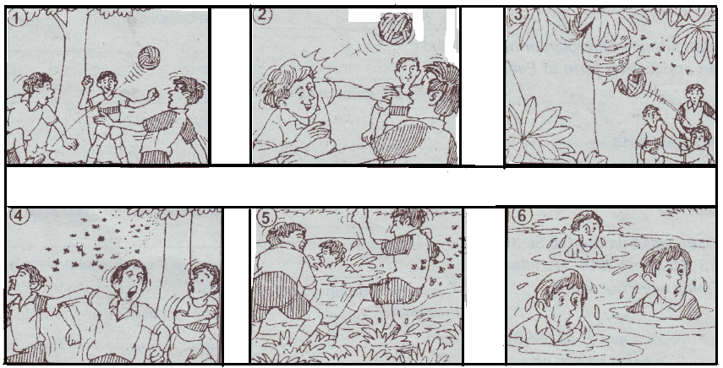

\\

1. Picture 1: **...............................................................................................................................**

**...............................................................................................................................**

2. Picture 2: **...............................................................................................................................**

**...............................................................................................................................**

3. Picture 3: **...............................................................................................................................**

**...............................................................................................................................**

4. Picture 4: **...............................................................................................................................**

**...............................................................................................................................**

5. Picture 5: **...............................................................................................................................**

**...............................................................................................................................**

6. Picture 6: **...............................................................................................................................**

**...............................................................................................................................**

7. Why did the bees sting the boy?

**...............................................................................................................................**

**...............................................................................................................................**

8. How did the boys escape from the bees?

**...............................................................................................................................**

**...............................................................................................................................**

9. Where are the boys playing from according to picture one?

**...............................................................................................................................**

**...............................................................................................................................**

10. Suggest another suitable title to the story.

**...............................................................................................................................**

**54. Read the poem below carefully and then answer, in full sentences the questions that follow.**

My father, oh my father

Suffering from hospital

From unknown disease

Fighting for his life

I prayed to God to help him

But he refused

He took my fathers life

Away from his family

I asked God in a quiet voice

Why my father?

Surely he has never done anything wrong

Did he?

And then I heard a voice

Telling me to calm

The voice told me

My father is rejoicing in heaven

Watching over his family

It was then, I felt happy.

Doom Suum (P.3)

***Questions***

(a) What is the poem about?

(b) Where was the father when the writer prayed?

(c) What was the father suffering from?

(d) Where is the writers father now?

(e) Did the father do anything wrong?

(f) What did the voice tell the writer?

(g) In which class was the poet?

(h) In which stanza does the poet show happiness?

(i) Give another word to mean the same as;

(i) rejoicing ..

(ii) calm ..

**55. Imagine you are a pupil in Kampala Primary School P.O. Box 7462, Kamapala. Write a letter to the headmaster of your school and tell him that you will not be able to start school on the first day of term three. You will start in the second week of the term, this is because you will return from abroad on Saturday of the first week. Promise to do all the work you will have missed in that period.**

..

....…

..

..

..

..

..

..

..

..

.

.

.

...

..

..

....

***Good Luck***