PU PIL’S COMPLETE INDEX NUMBER

|  |
| --- |
| CITY/PROVINCE DISTRICT SECTOR SCHOOL STUDENT |

Sur Name:.....................................................................................................

Other Name: .................................................................................................

**DURATION: 2 HOURS**

* This paper has two sections A and B
* Read each question carefully before answering it.
* Poor hand writing may led to loss of marks
* Use blue or black ball point pens

SECTION A

* 1. Name the type of bees which visit flower.

………………………………………………………………………………………………………………………………………

* 1. Which blood vessel takes away blood from the right ventricle of the heart?

………………………………………………………………………………………………………………….

* 1. Of what importance are cilia found in the trachea?

………………………………………………………………………………………………………

* 1. What is the main function of white blood cell in the body?

…………………………………………………………………………………………………………………………

* 1. Why milk is called a complete diet?

……………………………………………………………………………………………………………………..

* 1. What is the sense organ for tasting?

……………………………………………………………………………………………………………………

* 1. Give one use of electricity in our homes.

…………………………………………………………………………………………………………………..

* 1. What name is given to the three small bones found in the ear?

…………………………………………………………………………………………………………………..

* 1. Give one reason why is it important to give first aid?

……………………………………………………………………………………………………………………..

* 1. Write the function of iris in the human eye.

…………………………………………………………………………………………………………………….

* 1. Define respiration.

…………………………………………………………………………………………………………………………….

* 1. Give one process by which candle wax will be made to be melt by heat?

………………………………………………………………………………………………………………………..

* 1. How is government of Rwanda controlling the spread of polio?

………………………………………………………………………………………………………………………..

* 1. Which part of the skeleton protects the brain?

…………………………………………………………………………………………………………………….

* 1. Which blood group is universal donor?

……………………………………………………………………………………………………………………

* 1. A change from solid to gas is called…………………………………………………………
  2. How does heat travel through light?

…………………………………………………………………………………………………………………………….

* 1. Give the function of the heart.

……………………………………………………………………………………………………………………………

* 1. Write AIDS in full.

……………………………………………………………………………………………………………………….

* 1. What vitamin do we get from the sun?

…………………………………………………………………………………………………………………….

* 1. Mention one use f roots to plant.

…………………………………………………………………………………………………………………..

* 1. What does a fish use for breathing?

……………………………………………………………………………………………………………………………

* 1. How is mulching important to farmers?

………………………………………………………………………………………………………………………..

* 1. The natural source of water is……………………………………………………………………………..
  2. Water change into ice that process is called…………………………………………………………….
  3. Why is a moon not a true source of light?

…………………………………………………………………………………………………………………………..

* 1. What is a flower?

…………………………………………………………………………………………………………………………..

* 1. What is a seed?

…………………………………………………………………………………………………………………………

* 1. What is a fruit?……………………………………………………………………………………………………………………..
  2. Which type of gas plants breath out?

…………………………………………………………………………………………………………………………….

* 1. Which group of mammals do cat belong?

………………………………………………………………………………………………………………………….

* 1. What are cash crops?

…………………………………………………………………………………………………………………………..

* 1. Explain the grafting.

………………………………………………………………………………………………………………………….

* 1. What is advertising?

………………………………………………………………………………………………………………….

* 1. Give one reason why people plant trees around the houses.

………………………………………………………………………………………………………………………..

**SECTION B**

* 1. Name the parts of the skin.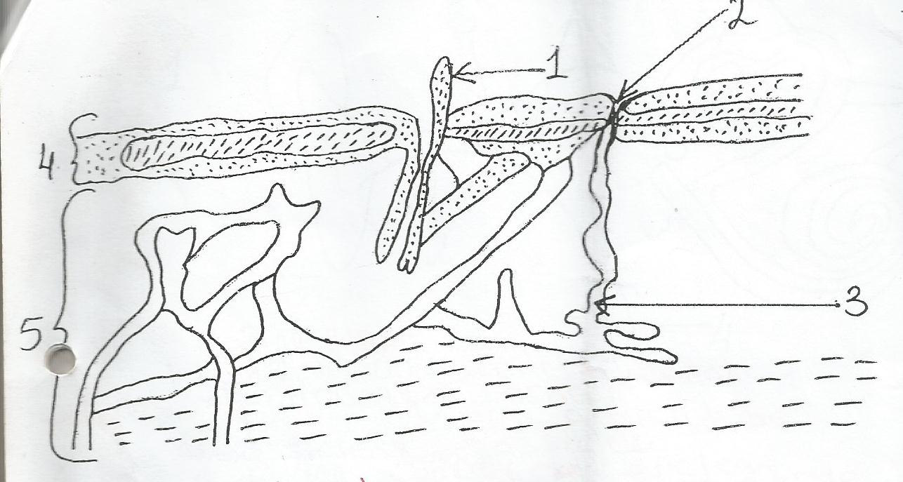  
      1……………………………………………………………

2……………………………………………………………

3………………………………………………………….

4………………………………………………………..

5……………………………………………………….

* 1. Show is the process involved in water cycle.

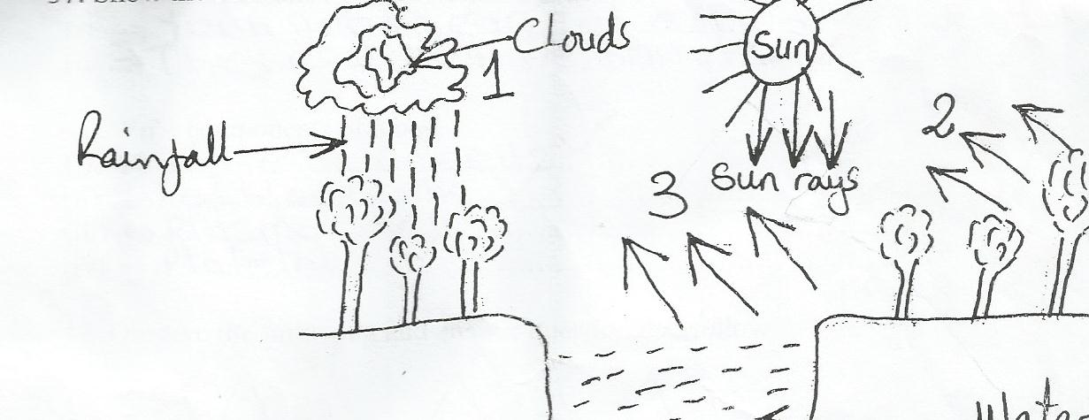

1………………………………………………………………………

2……………………………………………………………………..

3……………………………………………………………………

38.Use the human ear diagram to answer the parts.

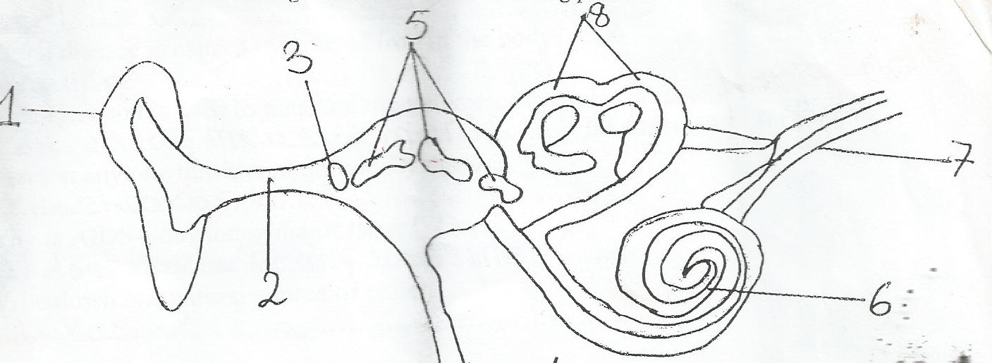

1……………………………………………………….

2………………………………………………………..

3……………………………………………………..

4……………………………………………………………

5……………………………………………………………

6………………………………………………………………….

7…………………………………………………………………………

8………………………………………………………………………

* 1. Give two methods of advertising goods.

i…………………………………………………………..……ii……………………………………………………….

* 1. Give two effects of advertising goods.

i………………………………………………………….…….ii…………………………………………………………………….

* 1. Write four components of blood.

i……………………………………………………………ii……………………………………………………………..

ii…………………………………………………………..iv………………………………………………………….

* 1. What is the temperature of normal person?

………………………………………………………………………………………………………………………….

* 1. Mention the virus that causes AIDS.

……………………………………………………………………………………………………………………………..

* 1. When a bone break and comes out of the skin is called…………………………………………….
  2. What name is given to anything that burn and give heat and light?

…………………………………………………………………………………………………………………………………

* 1. Why are flat iron handles made of wood or plastics?

…………………………………………………………………………………………………………………………………….

* 1. Give one example of alcoholic beverages.

……………………………………………………………………………………………………………………………….

* 1. What is the work of the cortex?

……………………………………………………………………………………………………………………………….

* 1. In which state of matter does sound travel faster?

……………………………………………………………………………………………………………………………..

* 1. Why is AIDS a day today major issue?

…………………………………………………………………………………………………………………………………

* 1. Mention one nutritional deficiency disease.

……………………………………………………………………………………………………………………………………

* 1. Which disease is caused by lack of iron in the body?

…………………………………………………………………………………………………………………………………

* 1. Which method is used to measure the volume of irregular objects?

…………………………………………………………………………………………………………………………………..

* 1. Define the term matter.

…………………………………………………………………………………………………………………………………………

b)Name three states of matter.

i…………………………………………………………………….ii……………………………………iii………………………………..

* 1. Define the term sound

………………………………………………………………………………………………………………………………

b)Outlineone artificial source of sound.

…………………………………………………………………………………………………………………………………..

c)State one device which can store sound.

………………………………………………………………………………………………………………………………….

d)How is sound produced?

…………………………………………………………………………………………………………………………………..

e)Define the following terms in sound

Pitch…………………………………………………………………………………………………………………………..

Echo …………………………………………………………………………………………………………………………

f)Give one importance of echo.

………………………………………………………………………………………………………………………………….

g)Sound travel by means of……………………………………………………………………………………

* 1. What is a magnet?

………………………………………………………………………………………………………………………………….

b)State any one material attracted by magnet.

…………………………………………………………………………………………………………………………………

c)State three properties of magnets.

* 1. Write five stages of digestion in human being.

i………………………………………………………………ii………………………………………………………….........

iii…………………………………………………………….iv……………………………………v…………………………..

* 1. Name three stages of life cycle of coca roach

i……………………………………………………….…..ii…………………………………………………….

iii………………………………………………………………………………………………..

* 1. Name the stage of housefly which is dormant.

……………………………………………………………………………………………………………………….

* 1. What is digestion?

………………………………………………………………………………………………………………………..

b)Name two types of digestion.

i……………………………………………………………ii………………………………………………..

c)Where does absorption of water take place?

………………………………………………………………………………………………………………..

* 1. Why is a mosquito regarded as a vector?

………………………………………………………………………………………………………………..

**END**