**BISHOP ANGELO NEGRI PRIMARY SCHOOL**

**MOCK EXAMINATION SET I 2019**

**PRIMARY SEVEN**

**INTEGRATED SCIENCE**

***Time allowed: 2 hrs 15 Minutes***

|  |  |  |  |  |  |  |  |  |
| --- | --- | --- | --- | --- | --- | --- | --- | --- |
|  |  |  |  |  |  |  |  |  |

Index No.

Candidates Name: …………………………………………………………

Candidate’s Signature ………………………….………………………….

**Read the following instructions carefully:**

**FOR EXAMINERS USE ONLY**

|  |  |  |
| --- | --- | --- |
| **Qn No** | **MARK** | **SIGN** |
| 1-10 |  |  |
| 11-20 |  |  |
| 21-30 |  |  |
| 31-40 |  |  |
| 41 - 43 |  |  |
| 44 - 46 |  |  |
| 47 – 48 |  |  |
| 50 - 52 |  |  |
| 53 – 55 |  |  |
| 54 - 55 |  |  |
|  |  |  |
|  |  |  |
|  |  |  |
| TOTAL |  |  |

1. The paper has **two** sections: **A** and **B**
2. Section **A** has 40 questions (40 masks)
3. Section **B**has15 questions (60 marks)
4. Answer ALL questions. All answers to both section

A and B must be written in the spaces provided.

1. All answers must be written using a blue or black ball

point pen or ink. Diagrams should be drawn in pencil.

1. Unnecessary crossing of work may lead to loss of marks.
2. Any handwriting that cannot be easily read may lead

to loss of marks.

1. Do not fill anything in the boxes indicated;

for Examiner’s use only.

***Turnover***

**SECTION A: (40 MARKS)**

***(Questions 1 to 40 carry one mark each)***

1. Name the main cash crop grown in Kalangala district.

………………………………………………………………………………………………….

1. In which part of a sweet potato plant is food for the plant stored?

…………………………………………………………………………………………………

1. State one advantage of brushing teeth regularly.

………………………………………………………………………………………………….

1. What is the use of a wheel barrow at school?

………………………………………………………………………………………………….

1. Name the type of lens used to correct short sightedness.

………………………………………………………………………………………………….

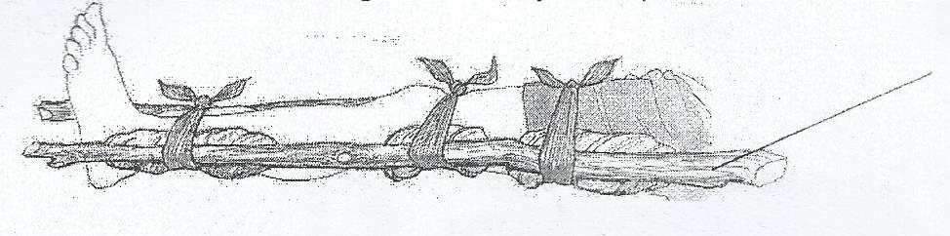***The diagram below shows the le fog an injured person. Use it to answer question 6.***

1. How useful is the structure marked K to the injured person?

………………………………………………………………………………………………….

1. Apart from beans, give one other example of a crop that is a legume.

………………………………………………………………………………………………….

1. Name any one birth that does not fly.

………………………………………………………………………………………………….

1. Give one reason why people keep rabbits.

………………………………………………………………………………………………….

1. Why does a tomato grower first plant tomato seeds in a nursery bed?

………………………………………………………………………………………………….

1. Apart from smoking, given any one way meat can be prevented from smelling bad.

…………………………………………………………………………………………………

1. Why is it important for sexually active people to have their blood tested for HIV?

………………………………………………………………………………………………….

1. Why do some of cattle keepers divide up their grazing land into paddocks?

…………………………………………………………………………………………………

1. State one way of preventing germs from hiding in our fingers.

…………………………………………………………………………………………………

1. State one use of forests to monkeys.

………………………………………………………………………………………………..

***The diagram below shows a method of planting millet grains. Study it carefully and answer question 16.***

1. What is the method of sowing seeds shown in the diagram above?

……………………………………………………………………………………………….

1. Name the sense organ that is affected by Tuberculosis.

………………………………………………………………………………………………….

1. Apart from proteins, name one other class of food that we get from eating fish.

…………………………..……………………………………………………………………..

1. In which way are bacteria important in the formation of soil?

………………………………………………………………………………………………….

1. State any one method used to separate alcohol that is mixed with water.

………………………………………………………………………………………………….

1. How can the pitch of a string of a musical instrument be changed?

………………………………………………………………………………………………….

***The diagram below is of a head of a bird. Use it to answer question 22.***

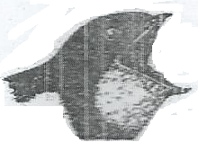

1. What does a bird with this type of beak eat?

…………………………………………………………………………………………………

1. Give one problem we can avid by smoking latrines.

………………………………………………………………………………………………….

1. Why do flies lay their eggs on faeces and rotting bodies.

………………………………………………………………………………………………….

1. Give any one advantage of cooking on a clay-made charcoal stove.

………………………………………………………………………………………………….

1. Mention the function of a uterus in the human body.

………………………………………………………………………………………………….

1. Why are infant children (babies) easily attached by diseases?

………………………………………………………………………………………………..

1. What is a strain?

………………………………………………………………………………………………

1. State any one use of carbon dioxide in industries.

…………………………………………………………………………………………………

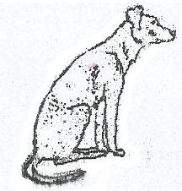***The diagram below is of a common animal. Use it to answer question 30***

1. Which disease can the above animal spread to humans?

………………………………………………………………………………………………….

1. Why is it advisable to dip the burnt body part f a person in cold water as a way of giving first aid?

………………………………………………………………………………………………….

1. What name is given to the structure at home where dried seeds are kept for a long time?

………………………………………………………………………………………………….

1. Which component of blood fights germs in the body?

………………………………………………………………………………………………….

1. Name any one disease that is caused by plasmodium.

………………………………………………………………………………………………….

1. Where in the digestive system of man are proteins digested?

…………………………………………………………………………………………………

1. Give one reason why farmers should not kill earth worms.

………………………………………………………………………………………………….

1. Give one reason for including calcium in the feeds given to layers on a poultry farm.

………………………………………………………………………………………………….

1. In the space below, draw a simple diagram of a tap root system.
2. Name the machine used to castrate animals on a farm.

…………………………………………………………………………………………….

1. Give one reason why oxygen is matter.

…………………………………………………………………………………………………

**SECTION B**

***(Questions in this section carry four marks each)***

1. a) Give any two examples of natural changes that happen in the sky.
2. ………………………………………………………………………………………….
3. …………………………………………………………………………………………

b) Mention one characteristic of each type of change below;

i) physical change

………………………………………………………………………………………………..

ii) chemical change

………………………………………………………………………………………………

***The diagram below is of a human heart. Use it to answer question 42***

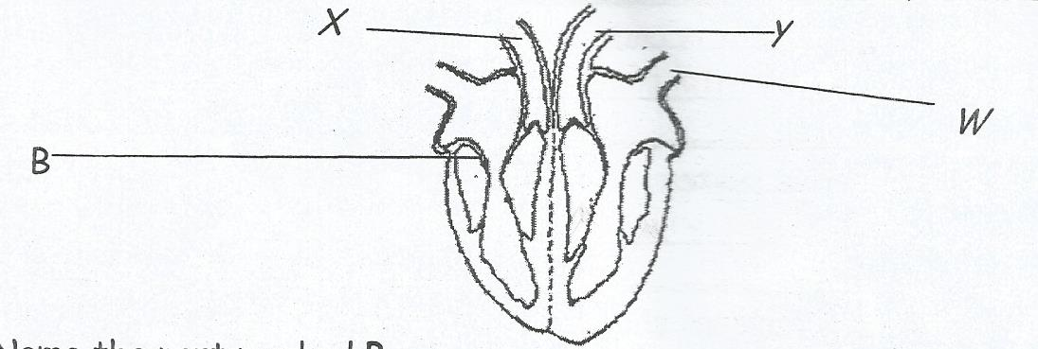

1. a) Name the part marked **B**.

………………………………………………………………………………………………

b) How is the blood in vessel **Y** different from the bleed in vessel **X**?

………………………………………………………………………………………………

c) Name the bleed vessel marked **W**.

………………………………………………………………………………………………

d) Mention one disorder of the organ shown above.

………………………………………………………………………………………………

1. a) State the importance of bees in a garden of beans.

………………………………………………………………………………………………

b) Give one reason why bees are common in a garden of beans at the flowering stage.

………………………………………………………………………………………………….

c) Suggest any two reasons why a bean plant may fail to bear seeds.

………………………………………………………………………………………………

1. a) Give any two disadvantages of keeping goats on free range system.
2. ………………………………………………………………………………………….
3. ………………………………………………………………………………………….

b) Give the main reason why people keep each goat below.

i) saanen; ………………………………………………………………………………..

ii) somali got ……………………………………………………………………………

***The list below shows animals. Study it and answer question 45.***

|  |
| --- |
| A – TILAPIA  B – FROG  C – ADDER  D – CROCODILE |

1. a) Apart from laying eggs, give one similarity between animal A and B in the way they reproduce.

………………………………………………………………………………………………….

b) Which of the animals above moves by slithering?

………………………………………………………………………………………………

c) To which group of vertebrates does animal D belong?

………………………………………………………………………………………………

d) Name the common habitat for animals A, B and D.

……………………………………………………………………………………………….

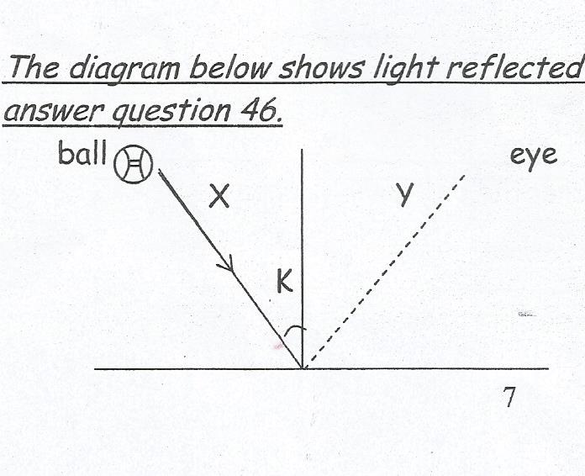***The diagram below shows light reflected by a mirror. Study and use it to answer question 46.***

1. a) Name the rays X and Y
2. X ………………………………………………………………..…….………………..
3. Y ………………………………………………………………………………………..

b) Name the angle marked K.

………………………………………………………………………………………………

c) State how the image of the ball reaches the eye.

……………………………………………………………………………………………..

1. a) Give one reason why water is important in a human body.

……………………………………………………………………………………………..

b) Give any two reasons why people in a home should not drink rain water before boiling it.

i) ………………………………………………………………………………………………..

ii) ……………………………………………………………………………………………….

c) Name the mineral salt that is common in water drawn from rivers and wells.

………………………………………………………………………………………………..

1. The table below shows elements of weather, weather conditions and the instruments used. Complete it correctly.

|  |  |  |  |
| --- | --- | --- | --- |
| **Element** | | **Condition** | **Instrument** |
|  | Rain |  | ………………….. |
|  | ……………………………….. |  | Barometer |
|  | Temperature |  | Six’s thermometer |
|  | wind | windy |  |

1. a) Name the body system to which the lungs belong.

………………………………………………………………………………………………….

b) Mention any two products we breathe out during respiration.

i) ……………………………………………………………………………………………..

c) Give one reason why we should not breathe in through the mouth.

………………………………………………………………………………………………

***The diagram below shows one of the methods of separating mixtures. Study and use it to answer question 50***

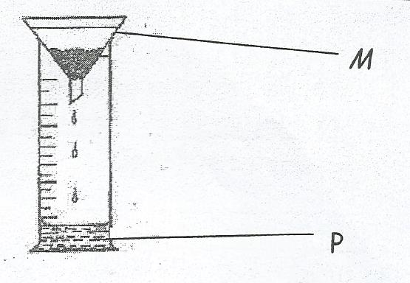

1. a) Name the method shown above.

………………………………………………………………………………………………

b) Give one reason why the above method was used.

………………………………………………………………………………………………

c) Name the part marked M.

………………………………………………………………………………………………

d) Name the liquid marked P.

……………………………………………………………………………………………..

1. a) Apart from weaning babies, give two other examples of vulnerable groups.
2. ………………………………………………………………………………………….
3. ………………………………………………………………………………………….

b) What is bottle feeding as used in human nutrition?

……………………………………………………………………………………………….

c) State any one advantage of breastfeeding to the baby.

………………………………………………………………………………………………

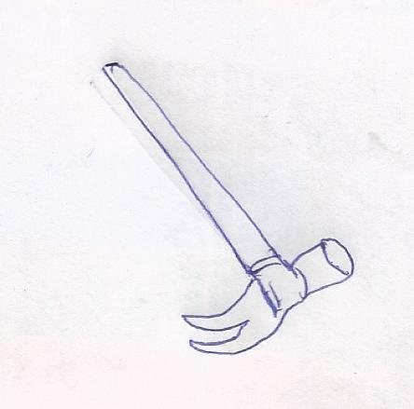***The diagram below shows a simple machine. Use it to answer questions 52.***

1. a) Name the machine shown above.

………………………………………………………………………………………………

b) State two uses of the above machine in a workshop.

1. ………………………………………………………………………………………….
2. ………………………………………………………………………………………….

c) Give one reason why the above machine is grouped under first class lever.

………………………………………………………………………………………………

1. a) What is soil erosion?

………………………………………………………………………………………………

b) Name the type of soil erosion common in;

i) flat land ………………………………………………………..………………………

ii) sloping land …………………………………………………………………………..

c) Why is there more soil erosion in hilly (sloppy) areas?

i) …………………………………………………………………..………………………

ii) ……………..…………………………………………………………………………..

1. a) Give two examples of fungi.

i) ……………….…………………………………………………..………………………

ii) ……………….…………………………………………………………………………..

b) How do fungi feed?

…………………………………………………………………………………………..

c) Why are fungi unable to make their own food?

…………………………………………………………………………………………..

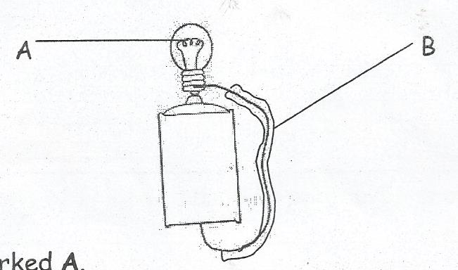***Study the diagram of a simple electric circuit below and use it to answer question 55***

1. a) Name the part marked A.

………………………………………………………………………………………………….

b) What material is part B made of?

………………………………………………………………………………………………

c) Give one reason why the material named in (b) above was used.

………………………………………………………………………………………………

d) Give any one reason that may lead to failure to produce light in the above simple circuit.

………………………………………………………………………………………………..

**END**