**PRIMARY FIVE MATHEMATICS**

**MOSTLY FAILED AND CHALLENGING COMPETENCES**

**NAME:_____________________________________________________________**

1. Workout the following.
2. 214 x 3

s

1. 56421 – 32196
2. Share 459 books equally among 3 classes
3. Simplify: 9y + 8m – 2y +m
4. (a) I think of a number, add 8 to it and the result is 29. What is the number?

(b) Solve for the unknown.

1. $\frac{p}{5}$ = 12

$3m+60=80$

(c) I think of a number, double it and take away 9, the result is 1. Find the number?

1. Kasimagwa is p years old and his brother Dodo is ( P+8) years old. If there total age is 30 years old.
2. Find the value of p
3. How old is Dodo?
4. How old will Kasimagwa be after 10 years?
5. If m =8, a = 10 and n = 2. Find the value of;
6. m + a + n
7. ma + 5n
$\frac{ma}{4}$

8. (a)The cost of 2 books is shs. 2000. Find the cost of 6 similar books.

(b) Osama bought a pen at shs. 10,000 and sold it at shs. 7500. Find his loss.

(c) Tom bought 10 tomatoes at shs 2500 and later sold each tomato at shs. 200. What loss did he make?

1. On the tour day, Rodrick was given the following notes:

3 notes of one thousand shillings

5 notes of five thousand shillings

2 notes of ten thousand shillings.

1. How much money was he given?
2. If he used shs. 35,000 find his change.
3. Oluka bought the following items from the shop.

3 rulers at shs. 1200 per ruler

4 books at shs. 4800

2 pens at shs. 1500 each.

1. How much money did he spend on all the items?
2. If he was given change of shs. 1100. How much did he have at first?
3. If he later sold pens at shs. 2000 each, how much did he gain.
4. Study the map below and answer the questions that follow.

**A**

**10Km**

**B**

**C**

**7Km**

**5Km**

1. Find the longest distance from town A to town C
2. A rally car was driven around the three towns five times. What distance did it cover?
3. Lynette took a direct route from A to town B. her vehicle broke down after covering 2400m. find the distance left to cover the journey.
4. (a) Jovia poured 10 cups of 300ml each into a bucket to fill it. Find the capacity of the bucket.

(b)The length of a building is 8 metres. Change the height in cm.

(c) Find the sum of 42kg and 957kg

(d)Dan and Musa carried 6kg of meat each from the butchery. Find the total mass they carried altogether in grams.

(e) Convert 4 $\frac{1}{2}$ kg to grams

(f) John moved around the rectangular room measuring 10m by 9m thrice. What distance did he cover?

1. Use the figure below to answer the questions that follow.

**8hm**

**12hm**

**m**

**n**

1. Find the value of m and n

m=____________

n =_____________

1. Calculate its area
2. What distance will an insect cover if it moves around the above figure twice?

1. (a) convert 2 weeks to days

(b) Our teacher had a maternity leave of five days. For how many hours was her leave?

(c) Show a quarter to five on the clock face below.

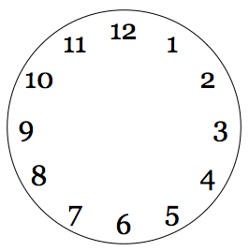

1. (a) Ochodi covered a distance of 120km at a speed of 60km/hr. what time did he take?

(b) A bus took 3 hours to travel from Jinja to Kampala a distance of 81km. find its speed.

(c) The driver covered a distance in 3 hours at an average speed of 80km/hr. find the distance covered.

(d) Write the morning time shown on the clock faces below



1. (a) How many days are in the month of February of a leap year?

(b) A vehicle covered a distance of 120km in 2 hours. At what speed was it travelling?

(c) If the same vehicle is to cover the same distance above at a speed of 40km/hr, what time will it take?

1. (a) Use the numberline below to work out 3 x $\frac{2}{3}$

$0 \frac{1}{3} \frac{2}{3} \frac{3}{3} \frac{4}{3} \frac{5}{3} \frac{6}{3} \frac{7}{3} \frac{8}{3}$

1. Find the fourth equivalent fraction of $\frac{2}{3}$
2. Convert 10 $\frac{2}{3}$ as an improper fraction.
3. In a class of 40 pupils, $\frac{2}{5}$ are girls and the rest are boys.
4. Find the fraction of boys
5. How many more girls than boys are in the class
6. If $\frac{1}{4}$ of the boys have watches, how many boys do not have watches?
7. The tank contains 480 litres of water. $\frac{3}{4}$ of the water is used to water the crops and the rest for washing.
8. Find the fraction used for washing?
9. How many more litres were used for watering crops than washing?
10. If represents 5 cups, how many cups are represented by 4 such pictures?
11. The graph below shows the the number of mangoes collected from a farm in five days.

Mon- 40, Tue – 25, Wed – 45, Thu -40, Fri – 30

**0**

**10**

**20**

**30**

**40**

**50**

**Mon**

**Tue**

**Wed**

**Thur**

**Fri**

**Number of mangoe**s

**Days of the week**

From the graph above,

1. On which day was the least number of mangoes collected?
2. Find the range of the mangoes collected
3. Find the median number of mangoes
4. Find the modal number of mangoes
5. Find the average number of mangoes collected.
6. (a) Use the table below to complete the bar graph below.

|  |  |  |  |  |  |
| --- | --- | --- | --- | --- | --- |
| Names | John | James | Joseph | Joshua | Joel |
| Marks | 80 | 90 | 95 | 80 | 100 |

**John**

**James**

**Joseph**

**Joshua**

**Joel**

**Marks scored by pupils**

**Names of pupils**

**0**

**10**

**20**

**30**

**40**

**50**

**60**

**70**

**80**

**90**

**100**

1. Find the range of marks
2. What was the modal score?
3. Calculate the average mark
4. Five children of the same family collected the following apples from the forest.

* Emma collected 42 apples
* Daniel collected 18 aples
* Aga collected 30 apples
* Evelyne collected 36 aples
* Daniella collected 24 apples

Using a scale of to represent 6 apples, draw a bar graph to represent the above information.

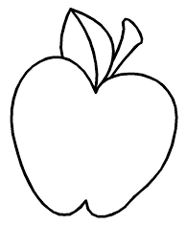

|  |  |
| --- | --- |
| **Name of pupil** | **Number of apples** |
|  |  |
|  |  |
|  |  |
|  |  |
|  |  |

1. (a) Find the larger angle between East and South West?

(b) Find the smaller angle between south and west.

(c) What is the larger angle between East and South West?

(d) Nambuya turned clockwise from North to West. Through what angle did she turn?

(e) Preston turned clockwise through an angle of 1350 from North. In which direction is he facing?

1. (a) Using a protractor, draw an angle of 550

**400**

**2k**

**K**

**2k**

(b) Measure the angle below.

(c) Draw a line segment ZX of length 6.3 cm

(d) Measure the line segment PG

(d) Draw a line perpendicular to line XY to meet at point K.

**X**

**Y**

1. Find the value of k

**3k**

**100**

**2k**

**400**

**600**

**4k**

**500**

1. Draw the following figures and show their lines of folding symmetry.
2. Isosceles triangle
3. Kite
4. Square
5. Rectangle
6. Equilateral triangle
7. (a)With the help of a pencil, a ruler and a pair of compasses only, construct a triangle ABC where AB = 7cm, BC= AC = 5cm

(b) Find its perimeter

1. (a)Complete the abacus below

**O**

**T**

**H**

**O**

**O**

**O**

**O**

**O**

**O**

**O**

**O**

**O**

**O**

**O**

**O**

**O**

**O**

**T**

**H**

**O**

**O**

**O**

**O**

**O**

**O**

**O**

**O**

**O**

**O**

**T**

**H**

**+**

**=**

(b) Write in figures. Four thousand ninety –six

(c) Expand four thousand eight hundred forty-six using values

(d) Write the expanded number in words.

(4 x10) + (9 x 1000) + (3 x 100)

(e) Correct 463 to the nearest hundreds.

1. (a) Complete the abacus below

**O**

**O**

**O**

**O**

**O**

**O**

**O**

**O**

**O**

**O**

**O**

**O**

**O**

**O**

(b) Write the number shown on the above abacus in words.

(c) Round off the above number to the nearest tens.

(d) Find the sum of the values of the digits in the place values of thousands and tens on the above abacus.

(e)Write the place value of the 6 in 4689.

1. (a) Add 143five + 101five
2. Subtract 13five from 221five
3. What is the place value of each digit in 234five
4. Write 203five in words.
5. (a) find the missing number:

1, 4, 9, 16, ____________

(b) Find the sum of the missing numbers in the sequence:

45, 42, 39, 36, _______,_________

1. Study the venn diagram below and answer the questions that follow.

**PF24**

**21**

**31**

**22**

**23**

**32**

**PFX**

1. Find the value of X
2. Using the above diagram,
3. Find the GCF of 24 and X
4. Find the LCM of 24 and X
5. (a) Find the GCF of 10 and 8

(b) P.5 pupils can be made to sit in groups of 6 boys or 8 girls leaving no remainder of any child. Find the least number of pupils in P.5.

(c) Fill in the value of the unknown.

**24**

**6**

**2**

**1**

(d) Find the square root of 36

1. (a) What is additive inverse of -12?
2. Staring from -3, show +5 on the numberline below.
3. write an integer to show the movement of;
4. 8 steps backward
5. Five steps forward
6. Study the numberline below and use it to answer the questions that follow.

**M**

**K**

-5 -4 -3 -2 -1 0 +1 +2 +3 +4 +5 +6 + 7 + 8

**N**

1. Find the value of;

(i) K =__________ (ii) N=___________ (iii) M=____________

1. Write the mathematical statement shown above.

1. Study the numberline below

**X**

-5 -4 -3 -2 -1 0 +1 +2 +3 +4 +5 +6 + 7 + 8

**P**

**Y**

1. Find the value of;
2. X =____________
3. Y =_________
4. P=______________
5. Write the mathematical statement shown above.
6. Complete the table below by filling in the unknown and draw the tallies for each

|  |  |  |
| --- | --- | --- |
| **Mangoes** | **5 + 9 = ________** |  |
| **Books** | **2 x _____ = 8** |  |
| **Pencils** | **24 – 6 = ______** |  |
| **Oranges** | **30 $÷2$ = 15** |  |

1. Name the set below (4 trees)

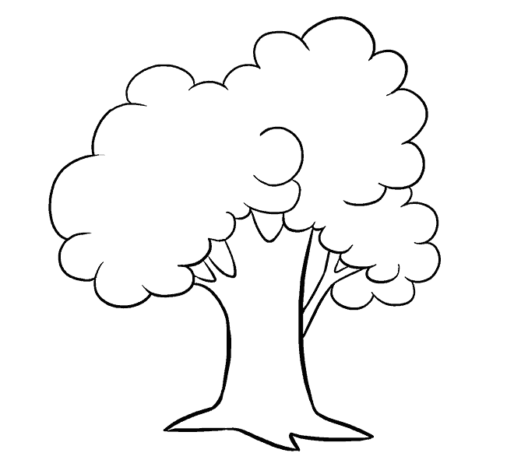







(b) Draw a set of 4 pots.

1. If A = {1, 2, 3, 4, 5} and B = {2,3,5,7,11}. Find AnB

(d) If P= (first six alphabet letters) and

K = {all vowel letters}. Find n(P nK)

1. Use the venn diagram below to answer the questions that follow.

**cat**

**man**

**doe**

**pen**

**cup**

**ruler**

**P**

**K**

1. List the elements of set;
2. K
3. P
4. Find n(p-k)
5. How many members are in p u k?
6. Given that set K={a, b, u, s, e} and L={all vowel letters}
7. Represent the above information on the venn diagram below

**L**

**K**

1. Find K u L
2. Find n( L- K)
3. Given that A = {first odd numbers less than 9} and set B = {first five prime numers}
   1. list down the elements of set
4. A
5. B
   1. Represent the above information on the venn diagram below

**B**

**A**