**SECTION A (40 MARKS)**

1. Name the major source of water in your environment.

_________________________________________________________________________

2. Give one source of food.

_________________________________________________________________________

3. Mention the organ of the body used for seeing.

_________________________________________________________________________

4. State one way of keeping ourselves clean.

_________________________________________________________________________

5. What is a habitat?

_________________________________________________________________________

6. Which direction does the sun rise from?

_________________________________________________________________________

7. Mention one animal kept at home.

_________________________________________________________________________

8. From which component of the environment is the item below made?

____________________________________________________

9. Give one use of water at home.

_________________________________________________________________________

10. Which insect pollinates flowers at night?

_________________________________________________________________________

11. How are toilets important at school?

_________________________________________________________________________

12. Besides a mosquito, mention one other insect that undergoes a complete life cycle.

_________________________________________________________________________

13. Which part of a flower protects it in bud stage?

_________________________________________________________________________

14. Which gas do animals need during respiration?

_________________________________________________________________________

15. Why do school children wash hands before eating?

_________________________________________________________________________

16. In the space below, draw an egg.

17. A car can move. Why is it not regarded to as a living thing?

_________________________________________________________________________

18. Give any one example of an aquatic animal.

_________________________________________________________________________

19. How can we promote sanitation at school?

_________________________________________________________________________

20. Which clouds gives man rain?

_________________________________________________________________________

21. What is food preservation?

_________________________________________________________________________

_________________________________________________________________________

22. Name part marked X of hen’s leg below.

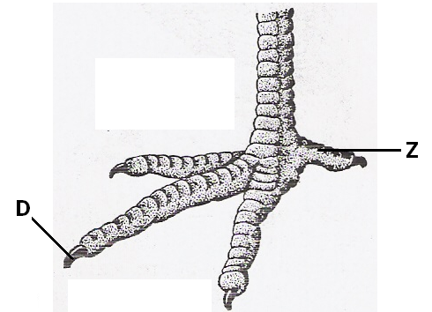

_____________________________________________________

23. Why isn’t a mushroom regarded to as a plant?

_________________________________________________________________________

24. How is a fire extinguisher useful at home?

_________________________________________________________________________

25. ____________________are to spider as gills are to fish.

26. Why do birds move from place to place?

_________________________________________________________________________

27. Give one agent of pollination.

_________________________________________________________________________

28. How are houseflies able to carry disease germs?

_________________________________________________________________________

29. Give one type of germination.

_________________________________________________________________________

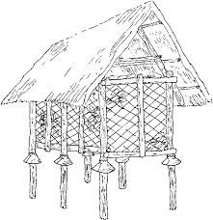30. Name part marked Y on the diagram below.

y

_____________________________________________________

31. How useful is part Y above to the granary?

_________________________________________________________________________

32. Identify one responsibility of a child at home.

_________________________________________________________________________

33. Inwhich way is electricity helpful at home?

_________________________________________________________________________

34. Write P.H.C in full.

_________________________________________________________________________

35. Which activity is done after eating food to keep teeth healthy?

_________________________________________________________________________

36. How can you make water safe for drinking?

_________________________________________________________________________

37. Mention one way of caring for crops.

_________________________________________________________________________

38. What is the use of a trowel to a farmer?

_________________________________________________________________________

39. Which eye disease is spread by a housefly?

_________________________________________________________________________

40. _____________________are to animals as stomata are to plants.

**SECTION B (60 MARKS)**

41. a) What are vectors? _____________________________________________________

_________________________________________________________________________

b) Give any two examples of vectors.

i) _________________________________ ii) ______________________________

c) How can we prevent mosquitoes at home?

_________________________________________________________________________42. Name the parts of a flower below.

[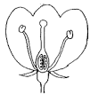](http://www.google.com/url?url=http://www.oldschool.com.sg/index.php/module/PublicAccess/action/Wrapper/sid/9595afb87c8cf767f034c3ae53e74bae/coll_id/6789/recs_ppg/5/desc/Continual+Assessment+2+(#1):+Section+B/pg_id/2&rct=j&frm=1&q=&esrc=s&sa=U&ved=0CBgQwW4wADgoahUKEwjqsdviw_bHAhUGjtsKHe4iDEA&sig2=P_S-AUWYqVtN0R_behVnUw&usg=AFQjCNEqGKWkfzQLLJtBfs31z9z_IQJjWA) X X ___________________________

T ___________________________

T V ___________________________

Q ___________________________

V

Q

43. a) Define personal hygiene.

_________________________________________________________________________

_________________________________________________________________________

b) Identify one activity done to promote personal hygiene.

_________________________________________________________________________

c) Draw and name any two items used to promote personal hygiene.

|  |  |
| --- | --- |
|  |  |
|  |  |

44. Match the following.

**A B**

kidding rabbits i) kidding ______________________

calving sheep ii) calving ______________________

lambing goats iii) lambing ______________________

kindling cows iv) kindling ______________________

[](https://www.google.com/url?q=http://hasloo.com/freecliparts/?p=822&sa=U&ei=t_4fVJ6DJM_baMKWgvAM&ved=0CCYQ9QEwBzgU&usg=AFQjCNEYyeUAZzwaTdnszKEo8_8mUrBn-w)45. **Study the diagram below carefully.**

[](https://www.google.com/url?q=http://www.tropical-plants-flowers-and-decor.com/sun-clip-art.html&sa=U&ei=iBIyVOmnIZTvasu-gJgG&ved=0CDQQ9QEwDg&usg=AFQjCNEiNqQtgypPCHK8EyzzvZ089nE5Pg)

V

K

a) Name the processes marked.

i) K _________________________________ ii) V _________________________

b) Identify the function of the sun to the above process.

_________________________________________________________________________

c) Mention any one example of a water source.

_________________________________________________________________________

46. a) Besides oxygen and moisture, state any other requirement for a seed to germinate.

_________________________________________________________________________

b) Mention any two types of germination.

i) _________________________________ ii) ______________________________

c) Which part of a seed grows into a seedling?

_________________________________________________________________________

47. a) Tom left his hoe outside for a night. Later in the morning, he found the reddish

brown coating on his metal. Name the reddish brown substance.

_________________________________________________________________________

b) Give any two ways of preventing the above reddish brown substance.

i) ____________________________________________________________________

ii) ____________________________________________________________________

c) Identify the similarity between rusting and germination.

_________________________________________________________________________

48. a) Give one reason why food is preserved.

_________________________________________________________________________

b) Give any two methods of preserving food.

i) _________________________________ ii) ______________________________

c) Identify one way how seeds are preserved.

_________________________________________________________________________

49. a) What isan accident?

_________________________________________________________________________

_________________________________________________________________________

b) Identify any two common accidents at school.

i) _________________________________ ii) ______________________________

c) How is the structure below useful to a firstaider?

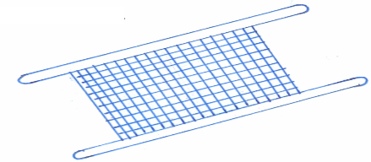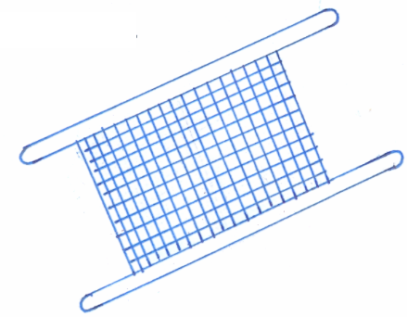

x

________________________________________________

50. Weeding is the removal of unwanted plants from the garden.

a) Give two examples of such plants.

i) _________________________________ ii) ______________________________

b) Which garden tool is used for weeding?

_________________________________________________________________________

c) Besides weeding, identify any one other activity done to care for crop.

_________________________________________________________________________

51. Study the weather instrument below.

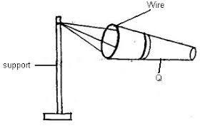

a) Name the instrument above.

_________________________________________________________________________

b) Identify the major function of the instrument above to farmers.

_________________________________________________________________________

c) Which element of weather is measured by the above weather instrument?

_________________________________________________________________________

d) Give one danger of wind to people.

_________________________________________________________________________

52. a) What is air? __________________________________________________________

_________________________________________________________________________

b) Mention any three gases that make up air.

i) _________________________________ ii) ______________________________

iii) _________________________________

53. a) What name is given to the food made by plants?

_________________________________________________________________________

b) Mention any two requirements needed by plants to make the above food.

i) _________________________________ ii) ______________________________

c) What is given out during the process of photosynthesis?

_________________________________________________________________________

54. a) What are germs?______________________________________________________

_________________________________________________________________________

b) Mention any two types of germs.

i) _________________________________ ii) ______________________________

c) Identify one place where germs are found.

_________________________________________________________________________

55. Give the habitat of the following animals.

a) fish _________________________ b) rabbit ___________________________

c) pig __________________________ d) dog ____________________________

***Success!***