

UGANDA MUSLIM TEACHERS’ ASSOCIATION

UMTA JOINT MOCK PRIMARY LEAVING EXAMINATIONS 2015

MATHEMATICS

2 HOURS 30 MINUTES

|  |  |  |  |  |  |  |  |  |  |
| --- | --- | --- | --- | --- | --- | --- | --- | --- | --- |
| **INDEX NUMBER** |  |  |  |  |  |  |  |  |  |

**NAME…………………………………………..SIGN…………………………….**

**SCHOOL……………………………………………………………………………**

**Instructions to candidates: FOR EXAMINERS’ USE ONLY**

|  |  |  |
| --- | --- | --- |
| **QN.** | **MARKS** | **INITIAL** |
| **SECA**  1 – 05 |  |  |
| 06-10 |  |  |
| 11 – 15 |  |  |
| **SEC B**  18-20 |  |  |
| 23 – 24 |  |  |
| 25-26 |  |  |
| 27-28 |  |  |
| 29 - 30 |  |  |
| 31-32 |  |  |
| **TOTAL** |  |  |

Do not open this Booklet until you are told to do so.

* The paper has two Sections **A** and **B.**
* Answer all questions sections **A** and **B** in the spaces provided.
* All answers must be written in Blue or Black pen or Ink.
* Unnecessary changes (crossings) or alternation of answers may lead to loss of marks.
* Any handwriting that cannot easily be read may lead to loss of marks.
* The use of calculators or other mathematical tables is not allowed.
* Do not fill anything in the boxes indicated for “Examiners use only”.

**SECTION A (40 MARKS**)

1. Divide 3 $\sqrt{27}$.
2. Simplify 2m + m + m
3. Write $LXIV$ in Hindu -Arabic numerals.
4. Work out: $\frac{2}{3}$ x 1 $\frac{1}{5}$
5. Divide: 1827 by 3
6. Double the supplement of 1780
7. Given that set M = {3, 4}, how many proper subsets are in set M?
8. The price of a cup in a market is shs 1600. After a discount, the customer paid 1350, how much was the discount.
9. Express $\frac{1}{10}$ of a kg as Hectograms.
10. Seven children had the following ages;

2, 7, 1, 3, 5, 4 and 6. Find their median age in years.

1. The square root of a number is 0.9, find the number.
2. Solve for P if 4+ p = 7.
3. Using a pair of compasses, ruler and a pencil only bisect the angle below.
4. Pieces of paper labeled 1 to 6 are folded, put in a basket and mixed up. What is the probability of picking a piece of paper having a composite number?

9

P

3

M

T

$ε$ = 14

1. Use the Venn diagram below to find the value of P.
2. What is the next number in the sequence?

0, 4, 16, 36……………….

1. How many 2 litre bottles can fill a 20 litre jerrycan of milk?
2. Jane has 24kg of maize and bean seeds in the store. If $\frac{2}{3}$ are maize seeds. How many Kilograms of bean seeds are in the store?
3. Find the H.C.F of 15 and 12.
4. Moses is 14 years younger than Sarah, Sarah is 23 years old. How old is Moses?

**SECTION B (60 MARKS)**

**Answer all questions in this section, Marks for each question are indicated in the brackets**.

1. (a) Shade $\frac{3}{5}$ of the diagram below, (2 marks)

|  |  |  |  |  |
| --- | --- | --- | --- | --- |
|  |  |  |  |  |
|  |  |  |  |  |

(b) Work out: $\frac{0.36 x 6.3}{0.06 x 0.9}$ (3 marks)

1. (a) Add 111two

+11two (2 marks)

(b) Find the number which has been expanded to;

(6 x 104) + (3 x 100) + (2 x 102) (2 marks)

1. (a) Given that P = 8, M= -3 and C = -6, find the value of $\frac{PM}{C}$ (2 marks)
2. A parent distributed 25 books to his children as follows; Jumah got three times as much as Sarah and Musa got three less than Jumah. How many books did Jumah get? (3 marks)
3. 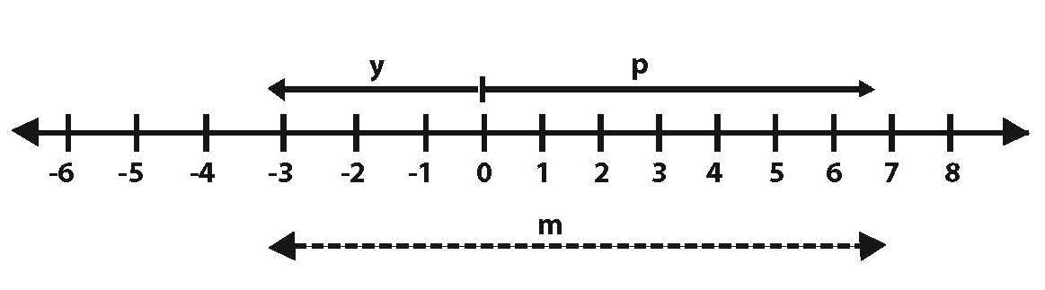Use the number line below to answer the questions that follow.

1. Name the integers represented by letters;

p……………………………….

y………………………………

m……………………………….. (3 marks)

1. Find the value of pym (2 marks)
2. (a) The time on the 12 hour clock is a half past 8 o’clock in the morning. Express the time in the 24 hour clock. (1 mark)

(b) A lorry took 4 hours travelling from Mbarara to Kampala at an average speed of 60km per hour. How much longer will the lorry take if it travels at an average speed of 40km per hour?

(3 marks)

1. In a class of 37 pupils, t pupils like Maths (M) only, while 17 pupils like science, 12 pupils like both Maths and science while 3 pupils like none of the two subjects
2. Complete the Venn diagram below (3 marks)

$ε$ = 37 pupils

------

12

----

M

S = 17

------

1. Find the number of pupils who do not like Maths. ( 1 mark)
2. (a) Increase shs 400 by 20%. (2 marks)

(b) By selling a radio at shs 180,000. A trader made a loss of 10%. How much did he buy the radio? ( 3 marks)

1. The Venn diagram below shows prime factors of x and 30.

22

71

51

21

y

fx

F30

1. Find the value of x (2 marks)
2. Find the value of y (2 marks)
3. Work out the GCF of x and 30 (1 mark)
4. A plane left town S on a bearing of 1350 to town T 10 km away. It left town T on a bearing of 0900 to town W, 8 km away.
5. Sketch the route taken by the plane (01 mark)
6. Using a scale of 1cm represents 2km, draw an accurate diagram to show the flight of the plane (04 marks)
7. Show the shortest route for the flight from town S to town W and measure it in Km.

(2 marks)

1. Namusoke bought the following items from a market

2 kg of rice at sh. 3000 per kg

1½ kg of sugar at sh 2600 per kg

0.5 kg of salt at sh 1,200 per kg

A bar of soap at sh 3550.

How much money did she spend altogether? (5 marks)

1. The table below shows how Mr. Opio uses his land 120 acres from different farm activities

|  |  |  |
| --- | --- | --- |
| Animal grazing | Coffee growing | Banana growing |
| 60 | y | 40 |

1. How many acres are used for coffee growing? (1 mark)
2. Using a radius of 4cm, construct an accurate Pie chart to show the above information

(4 marks)

1. The circumference of a circular fish pond is 88 m. Find its area. (4 marks)

**END**