**SECTION A**

1. Name the gas which occupies the largest percentage in the atmosphere.

_______________________________________________________________________

1. Name the advantage of breast feeding to mother.

_______________________________________________________________________

1. Give **one** reason why a bulb may fail to light.

_______________________________________________________________________

1. In which way is a dirty environment harmful to man?

_______________________________________________________________________

_______________________________________________________________________

1. Why is food digested in the human body?

_______________________________________________________________________

______________________________________________________________________

1. Which vaccine is administered on the right upper arm?

_______________________________________________________________________

1. Why is the earth referred to as a natural magnet?

_______________________________________________________________________

_______________________________________________________________________

1. Which structure in the foot of a duck enables it to swim in water?

_______________________________________________________________________

1. How do plants benefit from others?

_______________________________________________________________________

_______________________________________________________________________

1. State **one** way you can reduce the risk of getting malaria in your bedroom.

_______________________________________________________________________

1. Give **one** example of a root tuber.

_______________________________________________________________________

1. Why is blood pumped to the lungs before it is circulated to all body parts?

_______________________________________________________________________

_______________________________________________________________________

1. Give **one** example of animals that move by leaping.

_______________________________________________________________________

1. Mention any **one** natural source of sound in the environment.

_______________________________________________________________________

1. 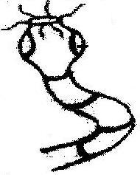Identify the type of worm shown below.

___________________________________________

___________________________________________

1. Which health habit is practiced by most people after visiting a latrine?

_______________________________________________________________________

______________________________________________________________________

1. State any **one** advantage of using electricity over wood fuel.

_______________________________________________________________________

1. Which type of movable joint allows movement in all direction?

_______________________________________________________________________

______________________________________________________________________

1. Apart from water, give other condition required for rusting of metals.

_______________________________________________________________________

1. Give **one** example of a ruminant animal.

_______________________________________________________________________

1. How can a P.7 candidate find the volume of a mango fruit?

_______________________________________________________________________

_______________________________________________________________________

1. How does bathing with soap help to control skin diseases?

_______________________________________________________________________

_______________________________________________________________________

1. Give **one** local breed of cattle.

_______________________________________________________________________

1. State **one** way in which a short circuit can be dangerous.

_______________________________________________________________________

1. Identify **one** way a pupil can help to improve sanitation in a class.

_______________________________________________________________________

1. Why is smoking of cigarette dangerous to human health?

_______________________________________________________________________

_______________________________________________________________________

1. In which state of matter does sound travel fastest?

_______________________________________________________________________

1. State any **one** method of weed control.

_______________________________________________________________________

1. Mention **one** item you can use to keep your body clean.

_______________________________________________________________________

1. Which property of magnet is shown in the diagram below?

______________________________________________________________________

1. How does the fish help on the prevention of Kwashiorkor in children?

_______________________________________________________________________

1. State the farm animal which is affected by the ear cancer.

_______________________________________________________________________

1. Give the importance of collecting plastic materials in the environment.

_______________________________________________________________________

1. State an advantage of a VIP latrine over convectional pit latrine.

_______________________________________________________________________

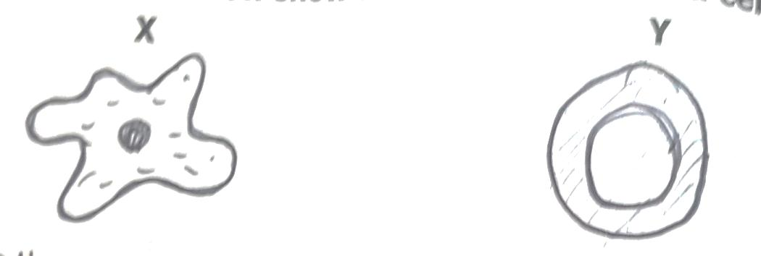**Use the diagram below to answer the questions that follow**.

1. Which sexually transmitted diseases destroy blood cell **Y**?

_______________________________________________________________________

1. Name the blood cells **x**.

_______________________________________________________________________

1. Give any **one** way of preventing the spread of scabies.

_______________________________________________________________________

1. How does a fuse work?

_______________________________________________________________________

_______________________________________________________________________

1. In which state of matter is chalk?

_______________________________________________________________________

1. How does man use animals as energy resource?

_______________________________________________________________________

_______________________________________________________________________

**SECTION B (60 MARKS)**

1. (a) In which way is heat energy similar to light energy?

_______________________________________________________________________

_______________________________________________________________________

1. How is **Sound produced**?

_______________________________________________________________________

1. What is the difference between volume and pitch of sound?

_______________________________________________________________________

_______________________________________________________________________

1. Name the organ in mammals which detects sound waves.

_______________________________________________________________________

1. (a) State **one** reason why some farmers prefer keeping goats to cattle.

_______________________________________________________________________

1. Give **one** dairy breed of goats.

_______________________________________________________________________

1. Mention any **one** disease which attacks goats.

_______________________________________________________________________

1. Give the importance of housing goats.

_______________________________________________________________________

1. **Below is a structure of an egg. Use it to answer the questions that follow**.

**Q**

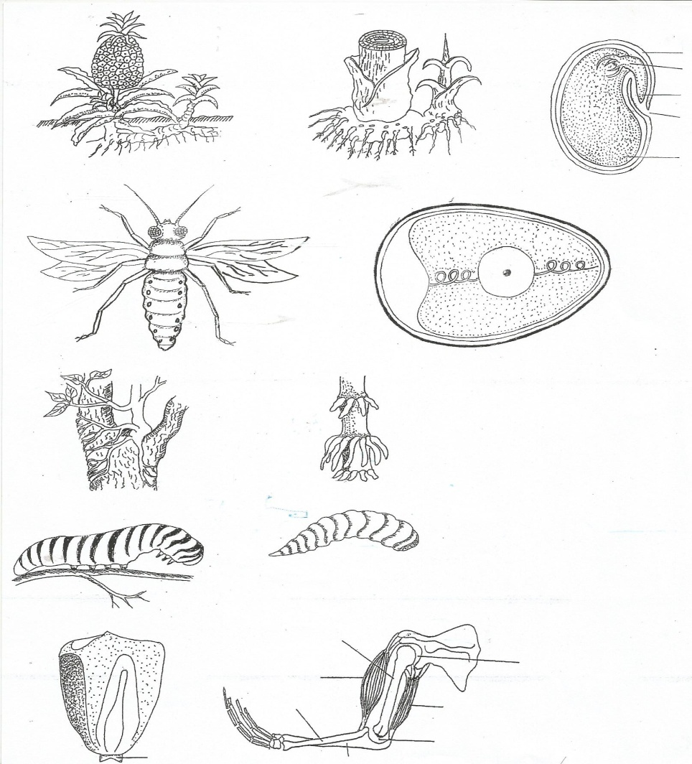

**S**

**T**

**R**

1. Name the part marked **T**.

_______________________________________________________________________

1. Give the function of part **R**.

_______________________________________________________________________

1. Why is part **Q** porous?

_______________________________________________________________________

1. Which part of an egg grows into a chick?

_______________________________________________________________________

1. (a) What do the following animals use to protect themselves against their enemies?
2. Wasp _______________________________________________________
3. Cat _______________________________________________________
4. Caterpillar _______________________________________________________
5. Cow _______________________________________________________
6. (a) What type of pollination occurs in a flower with long filaments than the style?

_______________________________________________________________________

_______________________________________________________________________

1. State **two** living agents of pollination.
2. _______________________________________________________________________
3. _______________________________________________________________________
4. In which part of a flower does fertilization take place?

_______________________________________________________________________

1. (a) State the basic unit for measuring the following;
2. Mass _______________________________________________________
3. Weight _______________________________________________________
4. Give **one** reason why paraffin floats in water.

_______________________________________________________________________

1. Mention any **one** object that sinks in water.

_______________________________________________________________________

1. (a) A good house must have windows, ventilators and door. State the role of the following items in a house.
2. Roof _______________________________________________________
3. Window _______________________________________________________
4. Doors _______________________________________________________
5. Ventilators _______________________________________________________
6. (a) What are **communicable diseases**?

______________________________________________________________________________________________________________________________________________

1. Give **one** example of communicable diseases that affects.
2. Eyes ____________________________________________________________
3. Skin ____________________________________________________________
4. Why is scurvy classified as a non-communicable disease?

_______________________________________________________________________

_______________________________________________________________________

1. **Match items in A with those in B**.

**A B**

Pig byre

Fish nest

Cow water

Bird sty

1. (a) Write **STDs** in full.

_______________________________________________________________________

1. Give any **two** STDs caused by virus.
2. _______________________________________________________________________
3. _______________________________________________________________________
4. How best can P.7 pupils prevent STDs?

_______________________________________________________________________

1. (a) Give the meaning of photosynthesis.

_______________________________________________________________________

1. Mention any **two** raw materials needed for photosynthesis.
2. ______________________________________________________________________
3. ______________________________________________________________________
4. Which gas is given off during photosynthesis?.

_____________________________________________________________________

1. **The diagram below shows changes of states of matter. Study it carefully and**

**answer the questions that follow**.

D

A

C

B

E

1. Name the processes **A** and **E**.

**A** _________________________________________________________________

**E** _________________________________________________________________

1. What type of change is shown above?

______________________________________________________________________

1. State the effect of heat on matter.

______________________________________________________________________

1. A skeleton has many roles in the human body including protection.
2. Name any **one** body organ protected by;
3. Rib cage _______________________________________________________
4. Vertebral column _______________________________________________________
5. Mention the diseases which affect both the skeleton and respiratory system.

______________________________________________________________________

1. How can you maintain skeletal and muscular system in a good working condition?

______________________________________________________________________

1. (a) What type of venation does rice have?

_______________________________________________________________________

1. How does germination of a bean plant differ from that of rice?

______________________________________________________________________

______________________________________________________________________

1. State the similarity between a bean plant and rice.

____________________________________________________________________________________________________________________________________________

1. What food value does one get from eating rice?

______________________________________________________________________

1. 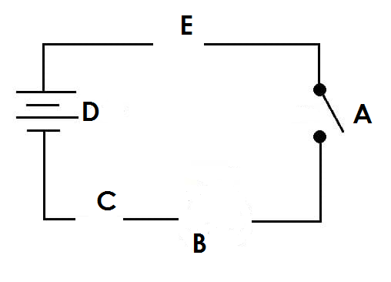**Use the diagram of a simple circuit below to answer the questions that follow**.



1. Name the parts marked **C** and **E**.

C ____________________________________________________________________

E ____________________________________________________________________

1. What happens to **B** when **A** is closed?

______________________________________________________________________

1. How does **E** safe guard the appliances?

______________________________________________________________________

**END**