**Musiye primary school**

**END OF TERM II EXAMINATIONS 2019**

**CLASS : P.I**

**SUBJECT : MATHEMATICS**

**DURATION : 2 ¼ HOURS**

**Name ________________________________________________**

**Stream _______________________________________________**

1. ***Avoid unnecessary crossing of work.***
2. ***Write well.***
3. ***Wrong spellings will lead to loss of marks.***

**SECTION A1**

1. Add:5 + 7 = ___
2. Write the number word.

17 _______________________________________________

1. Read and draw

A set of 5 pots

1. Name this shape

______________________________

1. Eight take away three is equal to _________________________
2. How many groups of 2s are in 8?
3. Add the fraction

1 + 2 =

5 5

1. Complete correctly

5 tens = ______

1. Write the number shown on the abacus

T O

7 2

1. Count in threes

6, 9, 12, ____

1. Complete correctly

3 + 4 is the same as ____ + _____ = _____

1. Write the shaded part
2. Add: 8

+ 6

___

1. Fill in the missing numbers

41, 42, ____, 44

1. Take away 1 3

- 6

_____

1. Multiply:

4

X 3

_____

1. Write the number before

_____, 56

1. Count in tens and ones. 52

____ tens and _____ ones make ______

1. Join the sets

+ =

5 + ____ = 9

1. 5 groups of 3s are equal to ______

**SECTION B**

1. Write the number for the word
2. Eight-______
3. Seventeen-_______
4. a) Add:

1 0

+ 1 2

______

b) Jane has 6 sweets and Sarah has 4 sweets. How many sweets do they have altogether?

1. 2 + 2 + 2 + 2 + 2 + 2 = ___
2. a) Write the place values.

9 7

_________

_________

b) Fill in correctly.

38 = ____ tens and ____ ones

1. a) Write the fractions

A half

A quarter

b) Shade 1

3

1. a) 8 girls have ___ legs

b) Multiply :

1 2

X 3

______

c) 4 threes is the same as ___ x ___ = _____

1. Draw tens and ones
2. 42 = b) 60 =
3. a) Tell the time

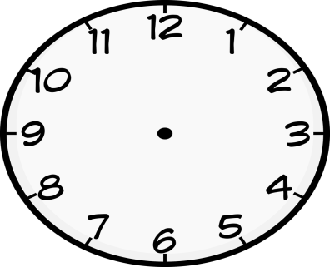 _________________

1. Show the given time on the clock face.

It is 7 O’clock

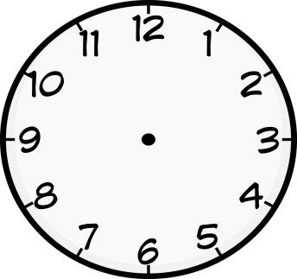

1. Subtract
2. Tens ones

2 8

- 2 5

____________

b) Maria had 9 balls. Joy removed 5 balls. How many balls remained?

1. Use a numberline to work out

a) 6 + 2 =

b) 5 – 3 =

1. Find the missing number in the puzzle

**6**

**2**

**1**

**4**

1. Draw the shapes

|  |  |  |
| --- | --- | --- |
| triangle | oval | rectangle |
|  |  |  |

1. 3 children have balls as shown below

|  |  |  |
| --- | --- | --- |
| Don | Mary | Bob |
|  |  |  |

* 1. Who has three balls?
  2. How many balls does Mary have?
  3. How many balls do they have altogether?

END