

**735/3**

**Technical Drawing**

**Paper 3**

*MAY-JUNE-2023*

**3 hours**

**ACEITEKA JOINT MOCK EXAMINATIONS 2023**

**UGANDA CERTIFICATE OF EDUCATION**

**TECHNICAL DRAWING**

**BUILDING DRAWING**

**PAPER 3**

**3 HOURS**

**Instructions to Candidates:**

The paper consists of **four** questions.

Answer **All** the questions.

A sheet (s) of drawing paper is provided.

Use both sides of the paper if necessary where dimensions are not given, use your own discretion to determine suitable specifications.

Fig 1. Show a line diagram plan of A RESIDENTIAL HOUSE drawn not to scale.

SPECIFICATIONS:

ROOF:

* Double pitched roof at 30o pitch covered with iron sheets.
* Timber rafters 100 x 50mm
* Struts 100 x 50mm
* Purlins 100 x 50mm
* Tie beam 100 x 75mm
* Wall plate 100 x 75mm
* Fascia and Barge boards 225 x 25mm

WALLS

* 3000mm high from the floor level to the underside of the wall plate
* All walls are 230mm

DOORS

* External doors are two paneled doors 1350 x 2100mm.
* Internal doors are flush doors 900 x 2100mm

WINDOWS:

* Casement windows 1200 x 1200mm
* Casement window 600 x 600mm

FLOOR

* Solid concrete floor
* Sand cement screed 25mm
* Oversite concrete 100mm
* Hardcore 150mm

FOUNDATION

* Strip foundation 750 x 230mm
* Below ground level. 750mm

APRON:

* 600mm wide x 150mm deep

COLUMNS

* 300mm thick

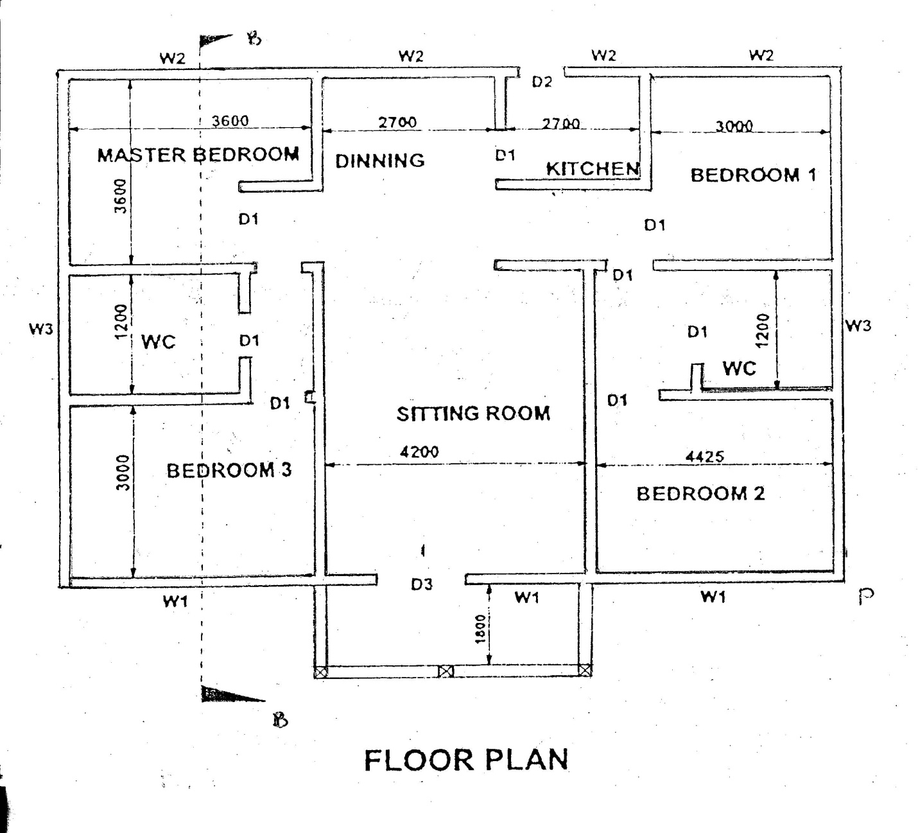

Fig 1

Qn.1

Using the specifications given above, draw a proportional free hand pictorial of the building with corner P in the fore ground (25 marks)

Qn.2

To scale of 1:50, draw the ground plan with all symbols indicating Door, Windows, and Sanitary fittings in their correct places. (24 marks)

Qn.3

To scale of 1:50, draw the vertical section on the cutting place B – B showing all the construction details. (25 marks)

Qn.4

At the bottom right hand corner of your drawing paper, print in the Title block your, Name, School, Title of the drawing, Subject Code, Scales and Date. (06 marks)

***END***