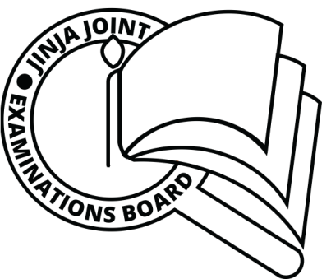**JINJA JOINT EXAMINATIONS BOARD**

**MOCK EXAMINATIONS 2019**

**612/1 STUDIO TECHNOLOGY**

**MARKING GUIDE**

* Shape refers to the outward appearance of an object

OR

* Shape refers to figures with two dimensions (2D) i.e. length and width

The types of shapes are

* Regular/geometric/Artificial shapes
* Irregular/free-form/natural/organic
* / A sketch is a guide to the artist to make a more refined drawing
* A sketch acts as a proof to ownership of an art work
* Examples of materials commonly used in art

Paper banana fibers wood

Water sisal clay

Dyes raffia candle works

Seeds adhesives fabric

* Functional crafts are those that are made for daily use by man. They are utilitarian crafts e.g. pots, hats, door mats, baskets, mats, mortars e.t.c
* A craft refers to an object that has been skillfully produced by hand **OR** An activity involving skills of making things by hand
* Materials used in craft making include

Papyrus banana fiber sisal raffia

Reeds clay grasses shells

Seeds wood straws dyes

* The major difference between mosaic and collage work is that mosaic involves the use of a specific material e.g. glass, pebbles, tiles, banana fiber while collage involves the use of a variety of material in combination
* The major purpose of adhesives in either mosaic or collage is that they are used as gluing materials. They attach other materials onto the base
* Sculpture refers to three dimensional forms that are made from materials such as wood, stone, cement, metals, paper, Mache, clay either by construction, carving, casting, or modeling.
* The basic types of sculpture

Free standing/ round sculpture

Relief sculpture (low relief or sunken and High relief)

* Materials for sculpting include

Clay metal fiber glass plastic

Wood glass Mable plaster of parish

Stone cement Gold

* Weaving refers to the process of interlacing vertical yarns (warps) with horizontal yarns (wefts) on a device called a loan to form a wave fabric
* Warps are yarns that run from top to bottom on a loom while wefts are yarns the run from side to side on a loom
* Types of weave structure include

Plain weave

Twill weave

Satin weave

Ghiordes knot

Jacquard weave

* Pottery refers to the craft of making utilitarian objects / articles form clay
* Techniques used in forming pottery include

Coil technique

Slab technique

Pinch technique

Throwing technique

Slip casting technique

* The main purpose of slip in pottery production is to join different clay bodies/parts
* Terracotta is fired clay articles while green ware is unfired clay articles
* Basketry refers to that art of using flexible material (wefts) and inflexible ones (warps) to make baskets from materials such as canes, twigs, bamboo, and creepers e.t.c.
* Techniques used in basketry include

Coil technique

Plaiting technique

Wicker works technique

Twining technique

* Definition of terms below

**Kiln** –a special equipment / oven used to fire clay articles

**Armature**- refers to supportive frame work in most cases made out of wires that is put in a sculpture

OR

A wire frame work around which other materials are built

* Green ware- refers to an unfired clay article
* Emphasis- this is a principle of art that aims at creating a centre of focus in an art work

OR

It refers to that making of given aspect in an artwork to stand out

* Clay refers to an earthly plastic material that is soft when wet and hard when fired
* Properties of clay are:

Elasticity/plasticity

Porosity

Vitrification

* Advantages of using clay as crafting material include:

It is very cheap

It is abundant in supply

It is user friendly

It permits both additive and subtractive techniques

Easy to recondition

Not subject to expiry

Clay articles if well fixed are durable

Surfaces of most clay articles are very easy to paint

* A material refers to anything that is used in the making of an artwork e.g. seeds, bananas fibers, paper, dyes, papyrus e.t.c.

**END**