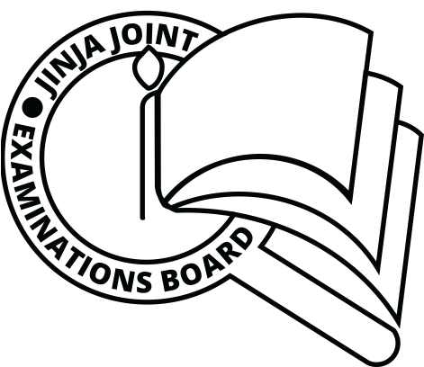**JINJA JOINT EXAMINATIONS BOARD**

**MOCK EXAMINATIONS**

**MARKING GUIDE**

**535/1 PHYSICS**

**JJEB 2019**

**SECTION A**

|  |  |  |  |  |  |  |  |
| --- | --- | --- | --- | --- | --- | --- | --- |
| 1 | **D** | 11 | **A** | 21 | **C** | 31 | **A** |
| 2 | **B** | 12 | **D** | 22 | **A** | 32 | **A** |
| 3 | **C** | 13 | **C** | 23 | **D** | 33 | **C** |
| 4 | **B** | 14 | **B** | 24 | **B** | 34 | **B** |
| 5 | **A** | 15 | **D** | 25 | **A** | 35 | **D** |
| 6 | **B** | 16 | **B** | 26 | **C** | 36 | **B** |
| 7 | **A** | 17 | **A** | 27 | **D** | 37 | **A** |
| 8 | **B** | 18 | **C** | 28 | **D** | 38 | **C** |
| 9 | **D** | 19 | **C** | 29 | **B** | 39 | **D** |
| 10 | **C** | 20 | **B** | 30 | **C** | 40 | **B** |

**SECTION B**

41. a) (i) It states that when a body is in mechanical equilibrium the sum of clockwise moments about a point is equal to the sum of anticlockwise moments about the same point. (01mk)

(ii) - The resultant force acting on a body is zero;

* Sum of clockwise moments about any point must be equal to the sum of anticlockwise about the same point. (02 mks)

b) Centre of gravity is the point of application of the resultant force due to earth’s attraction on it. (01 mk)

42. a) Archimedes principle states that when a body is wholly or partially immersed in a fluid, it experiences an upthrust equal to the weight of the fluid displaced.

(01 mks)

b) Upthrust = $⍴_{⍺}$ gV = 1.2 x 10 x 100 = 12000N

Weight, w = 7200 + 0.18 X 1000 X 10 = 9000N

Tension in the rope, T = (12000 - 9000)

T = 3000N (03 mks)

43. a) Gaps’ allow room for expansion and contraction during hot and cold days.

(1½ mks)

b) Gases expand more than solids because the spaces between the gas molecules are far apart than in solids, so intermolecular forces of gases are weaker and can

easily be broken compared to those of solids. (1½ mks)

c) - Thermostats (in flat iron,fridges,cookers etc)

- Ringing alarm bells;making of fire alarms

-used in bimetallic thermometers

- used in making car indicators (01 mks)

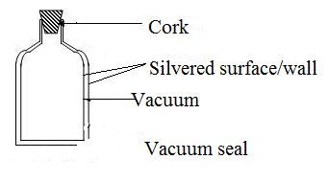

44. a)

b) (i) - volume

- Length

- Electrical resistance

- Electromotive force

- Pressure

- Wavelength etc. (01 mk)

(ii) From T = $θ$ + 273

T = -73 + 273

T = 200K (01 mk)

45. a) Potential energy – energy a body has because of its position in a gravitational field while kinetic energy is the energy a body has due to its motion. (02 mks)

b) m = 2kg, g = 10ms-2, KE = 900J, h = ?

P.E = mgh

900 = 2 x 10 x h

h = 4.5m

46. a) Transverse wave is one in which the particles of the medium vibrate perpendicularly to the direction of wave motion. (01 mk)

b) (i) N $≡$ Crest (01 mk)

(ii) M is wavelength = 20cm, $λ$ = 0.2m

using V = $fλ$

8 = 0.2 x $f$

$f$ = 40Hz (02 mks)

47.a) (i) Atomic number is the number of protons in the nucleus of an atom of the

element. (01 mk)

(ii) Mass number is the total number of protons and neutrons in the nucleus of an atom of the element. (01 mk)

b) ${}_{92}^{238}X$ ${}_{q}^{p}Y$ + ${}_{2}^{4}{He}$ (01 mk)

238 = P + 4 P = 234

92 = q + 2 90 = q

+ (02 mks)

48. a) - The angle of incidence is equal to the angle of reflection. (02 mks)

- The incident ray, reflected ray and the normal at the point of incidence all lie in

the same plane.

Diffuse reflection

Reflected parallel

beam

Scattered reflected

bean

Regular reflection

Incident parallel beam

Incident parallel

beam

b)

(02 mks)

Smooth surface Rough surface

49. a) A transformer is a device for stepping up or stepping down a.c voltages. (01 mk)

b) From efficiency = $\frac{P_{out}}{P_{in}} ×100\%$

${80}/{100}$ = $\frac{12I_{s}}{240 × 2 }$

$∴$ $I_{s}$ = 0.125A (03 mks)

50. a) - small insects walking on water without sinking

- A needle floating on an undisturbed water surface through made of material

which is denser than water.

- Liquid drops are almost spherical.

- A liquid surface tends to curve downwards or upwards.

-mercury gathering into small droplets when spilt on a dish (01 mk)

b) - Temperature

- Level of impurities. (01 mk)

- Nature of the liquid.

c) From

1.1 x 10-5 = x 102h

h = 3.5 x 10-8 cm (02 mks)

END