**JINJA JOINT EXAMINATIONS BOARD**

**MARKING GUIDE FOR GEOGRAPHY**

**PAPER TWO (273/2) 2019**

1. a) i) The name of lake marked:

A. is lake volta

B. is lake Tana 02

ii) The name of the ocean marked 1 is

Atlantic ocean 01

iii) The name of Rivers marked

2 is River Congo

3 is River Zambezi 02

iv) The name of waterfalls marked

C. is Livingstone /Inga falls

D is Victoria falls 02 07

b) Description of the processes that led to the formation of the water falls named in

(a ) (iv) above. (The process for each water fall is more less the same).

**Either:**

A water fall is a sharp break in the channel bed over which a river flows waterfalls

usually occur in the youth/mountain/upper stage of a river where vertical erosion

is dominant a waterfall is formed where there is an interruption in the flow of the

river caused by the existence of a hard resistant rock lying over a soft rock and a

cross the river valley/ a faulty scarp; causing the erosion of the soft rock to form a

plung pool.

**Or: Max**

**River**

**Hard**

**resbfall Water fall**

**soft gorge**

**rock**

**Plunge pool Max 06**

c) Explanation of the benefits of a waterfall chosen in ( b) above to the people living

in the area. The benefits are more less the same for all water falls:

***id***

* water falls form spectacular sceneries which attract tourists leading to generation of foreign exchange. **Ex**
* Water falls offer suitable sites for Construction of dams**id** Which generate Hydro Electric Power **Ex** that is used in industries and people’s homes.
* Water falls are associated with narrow gorges **id** which offer suitable sites for construction of Bridges **Ex** leading to development of transport and communication.

**id Ex**

* Plunge pools at the base waterfalls offer suitable sites for water sports/ water rafting

id

* Water falls help to generate employment opportunities to the people in the area who work as guides leading to their increased income hence improved standards of living. **Ex**
* Water falls have contributed to the development of Social and Economic infrastructure **id** such as schools and roads **Ex** in areas near the waterfalls.

id – mx 04

Ex – mx 04 **08**

d) An outline of the problems faced by the people living near rivers in Africa.

* People living near rivers in Africa are faced with the problem of floods which destroyed people’s property.
* People living near rivers in Africa are faced with the problem of waterfalls and floating vegetation which hinder navigation along the river.
* People living near rivers are faced with the problems of suffering from water borne diseases such as Bilharzia which claim people’s lives.
* People living along rivers in Africa are faced with the problem of dangerous animals such as Crocodiles and Hippocampus which claim people’s lives.
* People living near rivers are faced with problem of land fragmentation/shortage of land due to the fertile soils found along the river valley.
* People living near rivers a faced with the problem of floating vegetation such as surds and water hyphens which limit fishing activities.
* People living near rivers in Africa are also faced with the problem of water pollution due to discharge of industrial wastes in the rivers making river water unsuitable for human consumption. **Max 04**

25

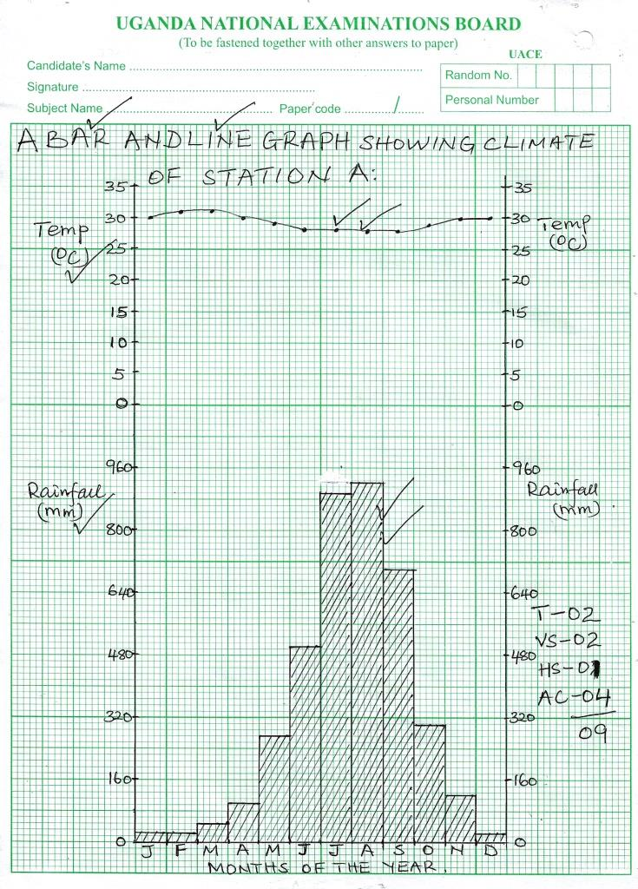

2.a Graph **09**

b) i) The mean Annual rainfall for station A

25+25+50+100+275+500+900+925+700+300+125+25

1

M.A.R = 3,950mm 02

ii) The Annual range of temperature for

station A = Ht – Lt

= 310C – 280C = 30C. 02 **04**

c)Description of the climate of station A:

* Station A receives heavy rainfall of per annum.
* Stations A experiences hot temperatures of over 270C throughout the year.
* Station A has a small annual range of temperature of 30C.
* Station A experiences a high relative humidity of over 75% throughout the year.
* Station A experiences one long rainfall season and a small dry period of three months from December to February.
* The wettest month at station A is the month of August.
* The driest month at station A is February.
* Station A experiences dense cloud cover for nine months between march and November.

**Max 06**

d) i) The Hemisphere in which station A is found in Northern Hemisphere **01**

ii) An outline of the economic activities that can be carried out around station A:

* Arable farming/plantation farming can be carried out at station A due to the heavy rainfall received from a large part of the year.
* Lumbering can be carried out at station A due to the heavy rainfall that supports the growth of dense forests.
* Stations A are likely to promote Tourism due to the forests growing in the area which act as habitants for wildlife.
* Industrialisation can take place at station A in order to process agriculture raw materials.
* Station A is likely to have water bodies such as rivers and lakes which can promote fishing activities.
* Mining of sand and other minerals can be carried out from station A especially from the river valleys.
* Bee –keeping/Apiary can be carried out around station a due to the dense forest.

Max 05  **06**

**(25)**

**A SKETCH MAP OF BOTSWANA SHOWING OKAVANGO BASIN, MAKARIKARI SALT PAN KALAHARI DESERT, DEMONSTRATION FARMS AND CHOBE GAME RESERVE.**

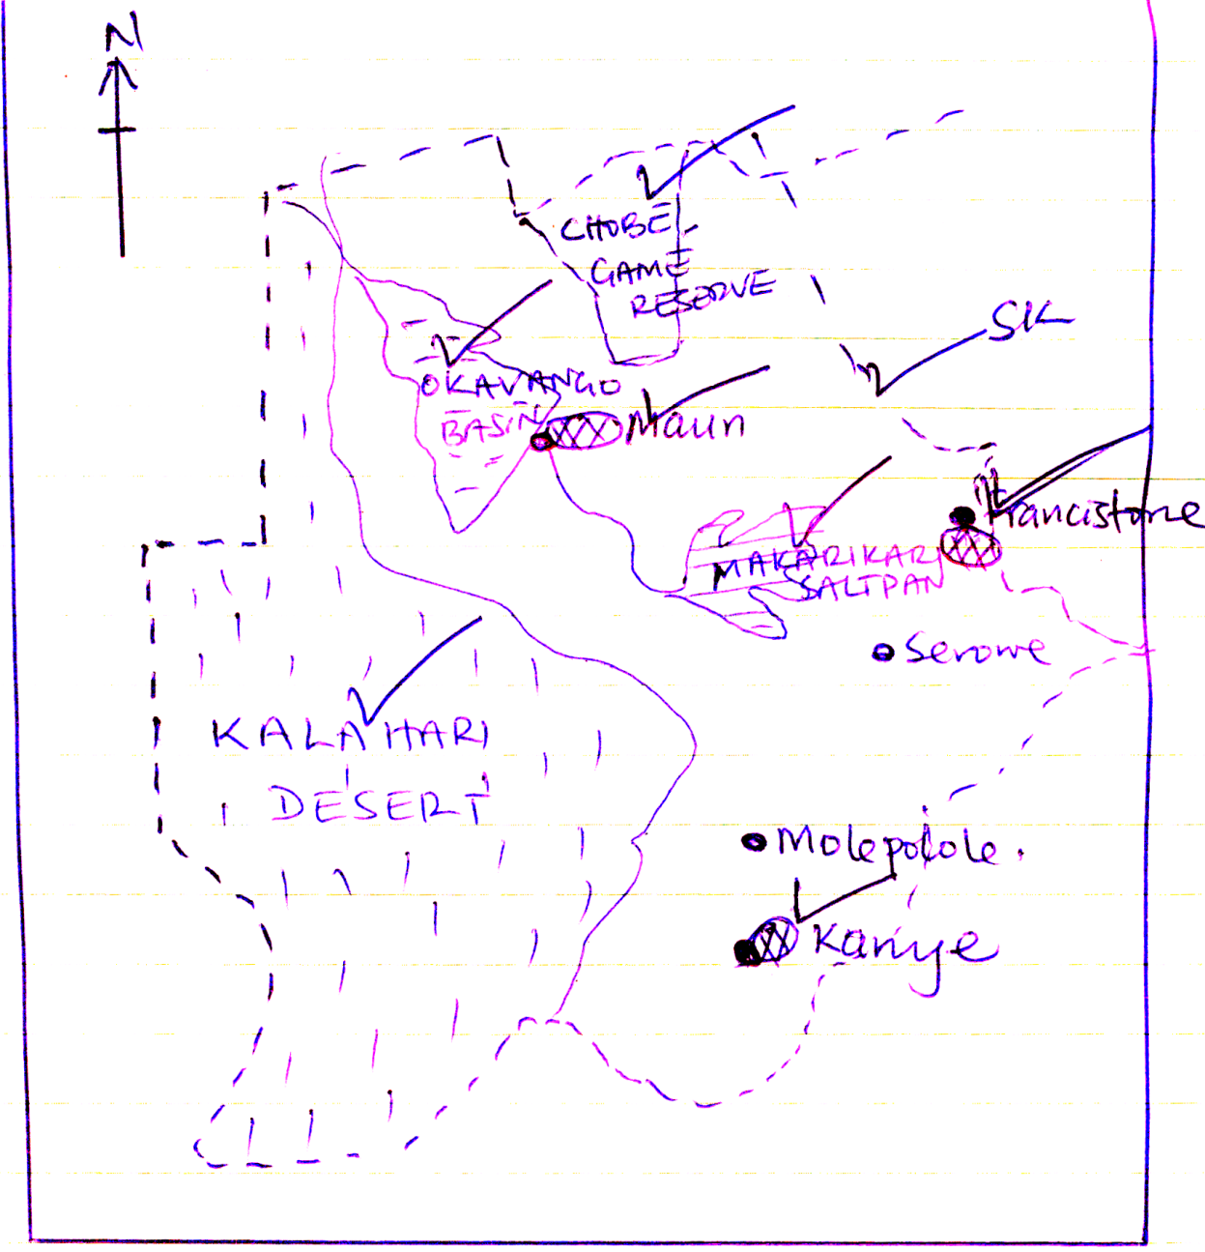

SK - 1

(i) -2

ii) - 1

ii - 3

iv) - 1

8 **(08)**

b) An outline of the characteristic of demonstration farms in Botswana:

* Demonstration ranches in Botswana are divided into paddocks by wire fences to confine the animals in one area for a definite time.
* Ranches in Botswana keep the cattle according to land carrying capacity.
* Cattle grazed on ranches in Botswana are regularly sprayed/dipped in order to control pests.
* Ranches in Botswana cover large areas ranging between 1600 to 2800 hectares.
* Animals on ranches in Botswana are fed majorly on Natural pastures.
* The farms are largely owned by co-operatives to enable farmers sell the beef on competitive basis.
* Exotic animals are mainly reared on Botswana ranches e.g Africander, Friesian ,Sussex etc

**Max 05**

c) Description of the factors that favoured the establishment of demonstration farms in Botswana.

* The presence of large tracts of land **id** on which ranches were established **ds** contributed to the establishment of demonstration farms in Botswana.
* The presence a relatively flat/**id** gently sloping landscape which enabled easy movement **ds** of the animals on the ranches.
* The presence of abundant pastures **id** to feed **ds** the cattle on the ranches.
* The availability of skilled and semi skilled labour **id** to work **ds** on demonstrations ranches in Botswana.
* The availability of large sums of capital **id** to invest **ds** in ranching enabled farmers purchase the necessary farm in-puts.
* The availability of a large market **id** both at home and abroad where animal products are readily sold **ds**
* The availability of developed transport **id** routes by road, railways **ds** and air which enable easy movement of animal products to the markets.
* The availability of a high level of technology **id** where by machines **ds** are used in processing/packing beef contributed to the establishment of ranches in Botswana.
* The availability of a favourable Government policy **id** That encouraged/supported **ds** people to engage in ranching in order to increase beef production in Botswana.

**id – mx 03**

**ds – mx 03 06**

d) Explanation of the contribution of demonstration farms to the economic

development of Botswana:

* Demonstration farms have generated employment **id** opportunities to the people of Botswana leading to improved standards of living income **Ex**
* Demonstration farms have led to the growth and development of towns urbanisation **id** such as Francistown/Gaborone **Ex** where marketing of Beef takes place.
* Ranches have contributed to the development of infrastructure **id** such as roads /railway/schools **Ex** which are used by ranches to meet their economic and social needs.
* Demonstration farms in Botswana have contributed to the development of industries **id** which use animals as their raw materials **Ex**
* Ranches in Botswana have generated local revenue **id** through taxing **Ex** people engaged in animal production.
* Demonstration farms have diversified **id** the economy of Botswana reducing **Ex** over dependence on other economic sectors such as mining.
* Demonstration farms have generated foreign exchange **id** to the government of Botswana through beef exports to **Ex** the foreign market.
* Demonstration farms have promoted international relations **id** between Botswana and other countries such as Zambia **Ex** which buy import beef from Botswana.

**Id – mx 03**

**Ex – mx 03 06**

**25**

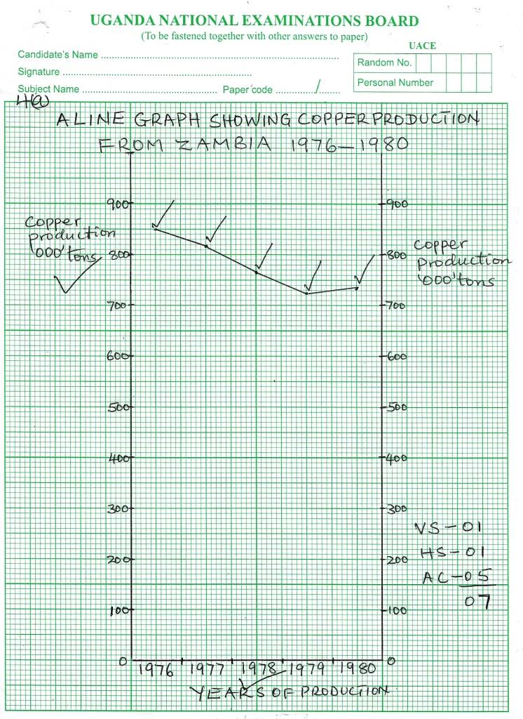

4.a) Graph **07**

b) Description of

i) The trend of copper production in Zambia between 1976 and 1980

there was a gradual decrease in copper production between 1976 and 1979. Then

followed by a slight increase in copper production in Zambia between 1979 and

1980. **02**

ii) Conditions that could be responsible for the trend described in (b)(i) above:

**Decrease:**

* Exhaustion of copper could have led to a decline/decrease in copper production in Zambia.
* Price fluctuation of copper on the world market could have reduced copper production in Zambia.
* There could have been shortage of labour that led to a decline in the volume of work of extracting copper from the mines.
* Workers could have left the copper mining sector for other forms of employment due to low wages paid to workers in Zambia.
* Competition for market with other copper producing countries such as Democratic Republic of Congo could have led to a decline in copper production in Zambia.

**Mx (03)**

**Increase:**

* There could have been new copper deposits that were opened up in Zambia leading to an increase in copper production.
* Zambia could have expanded the market for her copper leading to an increase in copper production.
* More Foreign investors could have been allowed to invest their capital in copper production which could have increased copper production in Zambia.
* There could have been developed transport routes e.g Tanzania railway which made transportation of copper to the markets easy leading to an increase in copper production.
* A large labour force both skilled and semi skilled could have been employed to work in the mining sector. This could have led to an increase in copper production in Zambia.

**Mx (03) 08**

c) Explanation of the contribution of copper mining to the economic development of Zambia.

* Copper mining has generated employment **id** opportunities to the people of Zambia leading to increase in income/standards of living **Ex**
* Copper mining has led to the development of infrastructure **id** such as roads/schools/railway **Ex** that are used by the people in Zambia.
* Copper mining has led to the growth and development of urban centres **id** /urbanization such as Ndola/Chingola **Ex** where copper is processed contributed to the economic development of Zambia.
* The copper mining has led to the development of industries **id** such as cable industries which use copper ore as raw materials **Ex**.

* Copper mining has diversified**id** Zambia’s economy reducing **Ex** over dependence on other economic sectors.
* Copper mining has contributed to the generation of local revenue **id** by

Taxing **Ex** to people and companies engaged in copper production.

* Copper mining has generated foreign exchange **id** which is got after exporting **Ex** copper from Zambia to the foreign countries e.g Britain.
* Copper mining has promoted international relations **id** between Zambia and other countries such as Britain/ **Ex** Germany which import Zambia’s copper.

Id – mx 03

Ex – mx 03 **06**

d) An outline of the steps being taken to solve the problems facing the mining sector in Zambia.

* Outdated machines are being replaced by modern machines to increase efficiency and production in Zambia.
* Immigrant labour is being recruited to increase daily output of copper in Zambia.
* Market research is being carried out in order to increase mineral sales in the foreign market.
* Mineral exploration /prospecting is being carried out to establish new copper deposits in Zambia.
* People living in areas rich with mineral deposits are being resettled else where to enable the mining of mineral take place.
* Transport routes are being developed to enable easy transportation of minerals such as copper to the markets.
* Foreign investors are being attracted to Zambia to invest in the mining sector.
* Hollows are being back filled with top soul in order to cover up the breeding grounds of vectors that could spread disease.

**Max 04**

**(25)**

5 a) **A SKETCH MAP OF NEW ENGLAND SHOWING BOSTON, NEW HAVEN AND NEW BEDFORD, RIVERS CONNECTICUT AND MERRIMARK, POTATO AND TOBACCO GROWING AREAS.**

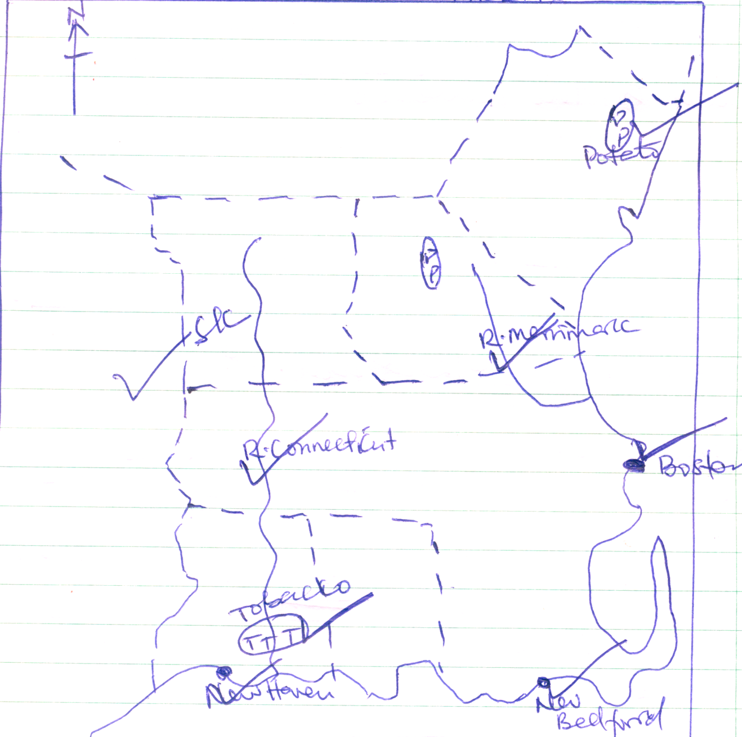

SK - 01

i) - 03

ii) - 02

iii) -01

iv - 01

**08**

b) Description of the factors t hat favoured the development of the Agricultural sector

in New England.

* The presence of large tracts of land **id** on which to grow/establish farms **ds** led to the development of the agricultural sector in New England.
* The presence of a gently slopping landscape **id** enabled/encouraged use of machines/mechanization **ds** hence developing the agricultural sector in New England.
* The presence of fertile soils **id** which ensured high crop yields **ds** in New England.
* The presence of reliable rainfall **id** the ensured fast growth **ds** of crops in New England.
* The presence of warm summer **id** temperature promoted ripening **ds** of the crops in New England.
* The presence of large sum of capital **id** to invest in **ds** the agricultural sector enabled farmers to purchase farm inputs.
* The availability of large skilled **id** and semi skilled labor force to work **ds** in the agricultural sector led to its development.
* The availability of a large market **id** both at home and abroad where agricultural products from new England are readily sold **ds** contributed to the development of the agricultural sector in New England.
* The availability of a high level of technology **id** that was applied through the use of machines **ds** such as tractors developed the agricultural sector in New England.
* The availability of a favourable government policy **id** that encouraged supported people to engage in agricultural sector in New England.

id – mx 03

ds – mx 03 - **06**

c) Explanation of the challenges facing the agricultural sector in New England.

* The agricultural sector is faced with a challenge of soil exhaustion **id** which has reduced the crop yields **Ex**
* The agricultural sector in New England is faced with a challenge of pests **id** that destroy Ex the crops lowering the yields.
* The agricultural sector in New England is faced with a challenge of diseases **id** which have lowered the quality and quantity of the crop yields **Ex**
* The agricultural sector in New England is faced with a challenge of Price fluctuation **id** which reduces the income of the farmers. **Ex**.
* The agricultural sector is also faced with the challenge of limited land **id** which has hindered expansion of the farms. Ex
* The Agricultural sectors also faced with the challenge of limited home

market **id** hindering the selling of much the crop products  **Ex**.

* The agricultural sector in New England is faced with the challenge of shortage of labour **id** leading to reduced crop output **Ex**

**id – mx 03**

**wx – mx 03 06**

d) An outline of the steps being taken to address the challenges facing the agricultural

sector in New England.

* Farmers in New England are applying chemical fertilizers/ manure to replenish the exhausted soils.
* Farmers in New England are spraying. The crops with chemicals to protect them against pests and diseases.
* Market research is being carried out in order to increase the sales of agricultural products in New England.
* Scientific Research is being carried out in New England to develop disease resistant and high yielding crop varieties.
* Automation/use of machines is being encouraged to enable farmers in New England solve the challenge of limited labour.

Max 05

**(25)**

6. a) Cultivated land x 360 = 3.60 = 40

Rock mountain and glaciers x 3600 = 201.60 = 2020

Agricultural x3600 = 14.40 = 140

Forests x 3600 = 140.40 = 1400

Cal 01

A PIE CHART SHOWING THE RELATIVE IMPORTANCE OF DIFFERENT LAND USES IN BRITISH COLUMBIA. **01**

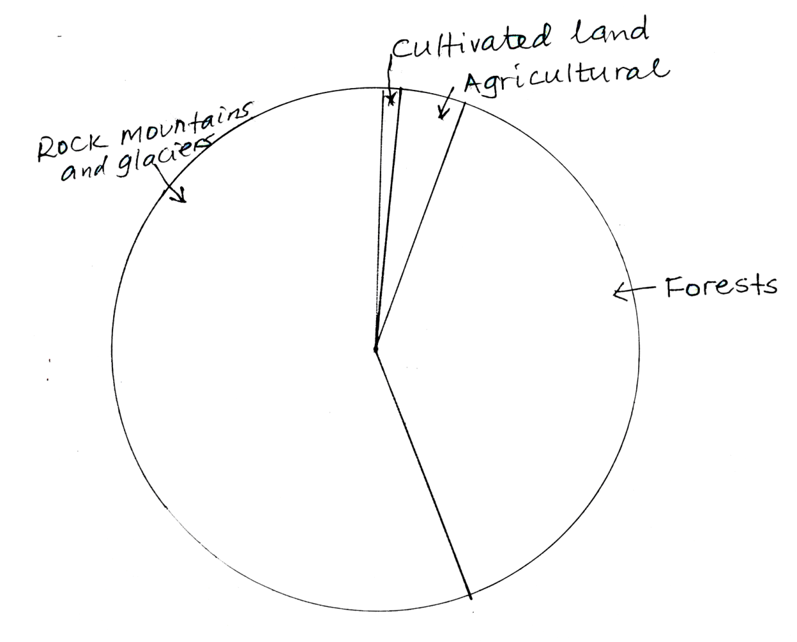

**07**

T – 01

C – 01

K/L – 01

AC - 04

**K/L**

b) i) The three species of commercial trees in British Columbia’s forests are

Western Hemlock,

Red cedar

Douglas fir

Pine

Spruce

Balsam fir **Any 03**

ii) Description of the factors that favoured the development of the forestry industry in British Columbia.

* The presence of vast/Extensive/large land **id** on which to establish **ds** the forests led to the development of the forests led to the development of the forest industry in British Columbia.
* The presence of rugged landscape **id** which could not support settlement **ds**
* The presence of thin infertile soils **id** that could not support arable farming **ds** contribution to the development of the forest industry in British Columbia.
* The presence of numerous tree species of commercial value **id** such as Dauglas fir/Red cedar/Western Hemlock **ds**.
* The availability of skilled labour **id** to work **ds** in the forestry sector.
* The availability of large sum of capital **id** to invest **ds** in forestry sector helped in the purchase of machines.
* The availability of developed transport **id** routes, by road railway and water **ds** enabled easy movement of logs to the sawmills.
* The availability of large market **id** for Timber products both at home and abroad where they are readily sold **ds** contributed to the development of forestry industry in British Columbia
* The availability of a high level of technology **id** enabled them use machines such as power saw **ds** to ease the work of felling trees.
* The availability of a favourable government policy **id** that encouraged/support **ds** people to invest in the forestry sector led to the development of the forest industry in British Columbia.

id - mx 3

ds - mx 03 **09**

6. c) Explanation of the problems facing the forest industry in British Columbia.

* The forest industry in British Columbia is facing the problem of over exploitation **id** leading to exhaustion **Ex** of valuable tree species.
* The forest industry is facing a problem of Pests **id** that eat up/destroy **Ex** the trees lowering the quality of timber.
* The forest industry in British Columbia is facing a problem of limited/shortage of labour **id** lowering production of timber. **Ex.**
* The forest industry is facing a problem of price fluctuation **id** leading to low income of the lumbers **Ex**.
* The forest industry in British Columbia is faced with the problem of Fire out breaks **id** which destroy **Ex** large areas of valuable forest land.
* The forest industry in is faced with a problem of severe winters **id** which bring lumbering activities to a halt **Ex**
* The forest industry is faced with the problem of accidents **id** that occur during the felling of trees that lead to death **Ex** of the workers.

**Id – mx 03**

**Ex – mx 03 06**

d) Outline of the steps being taken to solve the problems facing the forest industry in British Columbia.

* Re-a forestation is being carried out in areas that have been over exploited in British Columbia.
* Regular spraying of the forest with chemicals is being done to control pests and diseases.
* Large scale mechanisation is being practiced in British Columbia in order to solve the problem of labour shortage.
* Market research is being carried out to solve the problem of limited market and increase the sale of forest products.
* Fire guards are being employed in order to watch from control towers any occurrence of fire.
* Workers are being provided with protective equipment such as high coloured steel helmets to avoid accidents during the felling of trees.
* Scientific Research is being carried out to develop fast maturing and disease resistant tree species. **Max 03**

7.a) i) The name of the state marked:

A is Texas

B is Florida 02

ii) The name of the mineral mined from area marked :

1 –is oil

2 –is coal

3 – is Phosphates 03

iii) The name of the industrial town marked

C- is Houston

D - is Birmingham 02 **07**

b) i) The industries in Houston

* Food processing
* Engineering
* Ship building
* Electronics
* Fertilizers
* Chemicals

Industries found in Birmingham include:

* Food processing
* Engineering
* Metal fabrication
* Air crafts
* Chemicals any 02

b) ii) Description of the factors that favoured the development of industries in either Houston or Birmingham : are more or less the same.

* The presence of large/Extensive/vast land **id** on which to establish **ds** the industries
* The presence of abundant raw materials **id** that are processed **ds** into manufactured goods
* The presence of abundant water **id** to cool **ds** machines/cleaning the industrial establishment.
* The availability of abundant power  **id** such as Hydro Electric power to run **ds** the machines.
* The availability of skilled and semi skilled labour **id** to work **ds** in the various industries.
* The availability of large sums of capital **id** that is invested **ds** in industrial development.
* The availability of developed transport routes **id** such as roads, railway and water **ds** to enable easy movement of raw materials to the factories and manufactured goods to the markets.
* The availability of high level of technology **id** that is applied through the use of machines **ds** to carry out much of the work in the industries.
* The availability of a wide/large market **id** both at home and abroad where manufactured goods are readily sold **ds**
* The availability of a favourable Government policy **id** that encouraged/supported **ds**. People to invest in the industrial sector.

id – mx 03

ds – mx 03 **08**

c) Explanation of the contribution of industries to the economic development of the southern states of U.S.A

* Industries have generated Employment **id** opportunities to the people in the Southern states of USA leading to their increased income/improved standards of living **Ex**
* Industries have led to the development of infrastructure **id** such as roads/schools/Health centres**Ex** in the Southern states of USA.
* Industries have led to the growth and development of urban centres **id** in the southern states of USA such as Houston/Birmingham **Ex** etc
* Industries have diversified **id** the economy of the Southern States of USA reducing over dependence **Ex** on other economic sectors.
* Industries have led to the generation of local revenue **id** to the Southern states of USA through taxing **Ex** companies and people engaged in the manufacturing sector.
* Industries in the Southern states of USA have generated foreign exchange **id** through Exportation **Ex** of manufactured goods to the foreign countries.
* Industries in the Southern states of USA have promoted international relations **id** between USA and other countries eg Britain **Ex** that import manufactured goods from USA

id - mx 03

Ex - mx 03 **06**

d) An outline of the environmental challenges caused by industrial development to the people living in the southern states of USA.

* Industries in the southern states of USA have polluted the environment leading to respiratory diseases. e.g lung cancer.
* Industries in the southern states of USA have caused unemployment which is caused by increased use of machines.
* Industries have led to congestion of people in urban centres causing easy spreading of diseases.
* Industries have attracted a large number of people causing shortage of accommodation and development of slums.
* The development of industries in the Southern states of USA have led to high crime rate due to a large number of people getting un employed.
* Industrial development has led to destruction of Bio diversity/clearing of vegetation in order to create land for industrial expansion.
* Industrial development has led to exhaustion of raw materials leading to reduced out put.

Max 04

**25**

8. a) SKETCH MAP OF THE RUHR INDUSTRIAL REGION OF GERMANY SHOWING RIVER LIPPE WESEL – DATTELN CANAL CONCEALED AND EXPOSED COAL FIELDS AND INDUSTRIAL CENTRES DUISBURG, ESSEN AND DORTMUND.

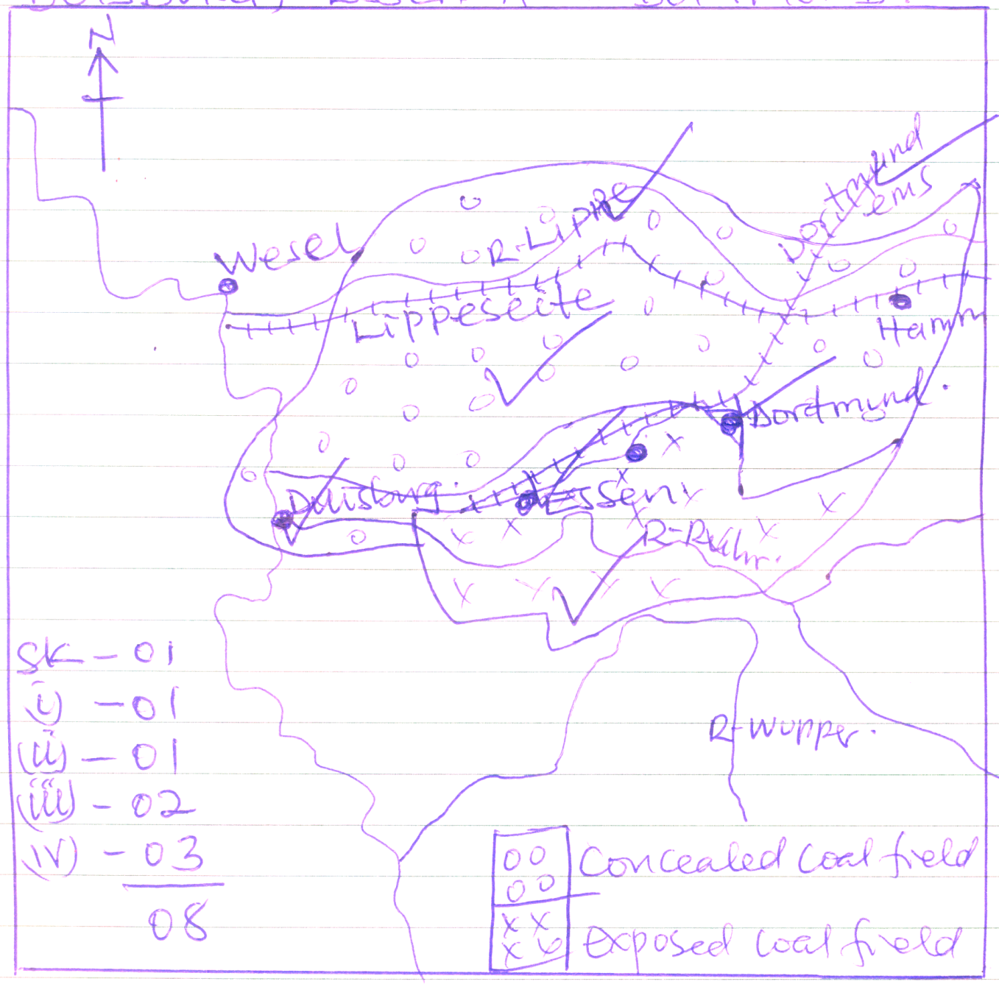

**08**

b) i) The industries found in the Ruhr industrial region of Germany include:

* Food processing
* Engineering
* Machinery
* Iron and steel
* Chemical industry
* Textile industry Any 02

b)ii) Description of the factors that favoured the development of industries in the Ruhr industrial region.

* The presence of vast/large land **id** on which to establish/set up **ds** the industries led to industrial development in the Ruhr region of Germany.
* The availability of abundant raw materials **id** such as Iron Ore **Ex** that are processed into manufactured goods.
* The presence of numerous rivers that provide water **id** that used to cool **ds** the machines and cleaning of the industrial establishments.
* The availability of abundant power supply **id** such as Hydro Electric power and coal that are used to run **ds** the machines in the industry.
* The availability of skilled and semi skilled labour **id** that is employed to work **ds** in the industrial sector.
* The availability of large sums of capital **id** that is invested **ds** in industrial development.
* The availability of ready/large market **id** both at home and abroad where industrial goods are readly sold **ds**.
* The availability of developed transport **id** routes by road railway and water **ds** enables easy movement of raw materials and manufactured goods.
* The availability of a high level of technology **id** that is applied using machines **ds** to carry out much of the work in the industries.
* The availability of a favourable government policy **id** that encouraged/supported **ds** people to invest in industrial sector.

id – mx 03

ds – mx 03 ( 08)

c) Explanation of the problems resulting from the development of large industrial centres in the Ruhr region.

* Industries in the Ruhr region have caused pollution **id** of air, water and land causing respiratory diseases such as cancer. **Ex**
* The development of industries in the Ruhr region has caused overcrowding **id** leading to easy spreading of diseases.
* Industrial development in the Ruhr region has caused shortage of accommodation **id** leading to the growth of slums Ex.
* The development of industries in the Ruhr region has caused unemployment leading to high crime rate **Ex**
* Industrial development in the Ruhr region has caused a problem of Traffic congestion **id** causing delay in delivery of raw materials **Ex** to the factories.
* Industrial development in the Ruhr id region has led to destruction of vegetation In order to create land for industrial expansion leading to loss of Biodiversity.**Ex**
* Industrial development has led to over population **id** leading to Ex shortage of social services such as medical, water etc.
* Industrial development in the Ruhr region has caused exhaustion of raw materials **id** leading to a reduction in industrial output. **Ex**

Id – mx 03

Ex – mx 03 **(06)**

d) An outline of the measures being taken to solve the problems resulting from the development of large industrial centres in the Ruhr region.

* Industrial wastes are being treated before they are discharged into the environment.
* Low cost houses are being constructed accommodate low income earners to avoid the emergence of slums.
* The police is enforcing law and order in order to reduce on the crime rate.
* Underground tunnels and flyovers are being constructed to minimize traffic congestion.
* Laws are being enacted preventing people from destroying the vegetation.
* Vertical expansion is being carried out to save the vegetation from destruction.
* Raw materials are being imported in order to increase production.

Mx 03 **(25)**

9.a)i) The Name of the water body marked 1 is the North sea. 01

ii) The name of the port marked

2 is Koblenz

3 is Basel 02

iii) The name of rivers marked

A is R – Main

B is R Mosel 02

iv) The name of canal marked 4 is Rhine Mosel canal 01

v) The name of the country marked C is Netherlands/Holland 01

**(07)**

b) Description of the factors which contributed to the development of River Rhine as an important water way.

* The presence of the Rhine river **id** and its tributaries such as Moses on which ships could sail **ds** led to the development of the Rhine water way.
* The ice free conditions**id** experienced on the river could allow its use through out the year **ds** led to the development of river Rhine as an important water way.
* The Rhine river had little seasonal fluctuation of water **id** which made it ideal for large water vessels **ds** through out the year.
* The presence of large and productive winter land **id** comprising of rich contours such as Germany, Switzerland and Belgium**ds** whose import and exports could pass through the water way at a reduced cost of transport.
* The availability of a high level of technology **id** that enabled them use the machines **ds** when carrying out dredging and building canals.
* The availability of highly skilled labour **id** that carried out the work **ds** of constructing the canals led to the development of the Rhine water way.
* The availability of adequate capital **id** that was invested **ds** in the construction of ports along the water way, contributed to the development of River Rhine as an important water way.
* The availability of a favourable Government policy **id** by the Rhineland countries that supported **ds** the development River Rhine and a water way

id -mx 03

ds -mx 03 **06**

c) Explanation of the benefits of the Rhine water way to the Rhine lands.

* The Rhine water way has generated employment **id** to the people in Rhinelands leading to increased income /improved standard of living **Ex**.
* The Rhine water way has stimulated industrial development **id** since raw materials **Ex** are easily moved/transported to the factories and finished goods to the markets.
* The Rhine water way has led to the growth and development of Ports **id** e.g Born, Basel **Ex** etc. where goods are handled.
* The Rhine water way has contributed to the development of infrastructure **id** such as roads, railway and canals **ex** linking to the Rhine waterway.
* The Rhine water way has contributed to the generation of local revenue **id** by taxing **Ex** the people working in various sectors that use the Rhine water way.
* The Rhine water way has generated foreign exchange **id** as goods are easily exported **Ex** along the water way.
* The Rhine water way has diversified **id** the economies of the Rhineland countries reducing over dependence on other economic sectors **Ex**

id – mx 03

Ex – Mx 03 **06**

d) i) An outline of the problem faced by the Rhine water way.

* The Rhine water way is faced with the problem of congestion which leads to delay in delivery of goods.
* The Rhine water way is faced with the problem of silting of the River channel which is very costly when carrying out dredging.
* The Rhine water way is faced with the problem of having narrow gorges that hinder movement of large ships along the water way.
* The Rhine water way is faced with the problem of fog which hinders visibility.
* The Rhine water way is faced with the problem of high crime rate especially at the ports.
* The Rhine water way is faced with the problem of pollution that adulterates the water leading to diseases.

Mx 03

d) ii) An outline of the steps being taken to solve the problems faced by the Rhine water way.

* Containerization is being carried out to reduce congestion at ports along the Rhine water way.
* Regular dredging is being carried out to increase the depth that is reduced by silting.
* Canals are being constructed to by pass waterfalls and narrow gorges found along the Rhine water way.
* Floods lights are being used at the port and on water vessel to increase visibility during the time when fog occurs.
* Laws are being made to stop the emission of pollutants in the Rhine water way.
* Police has beefed up security along the water way crime

Mx 03 **06**

**(25)**

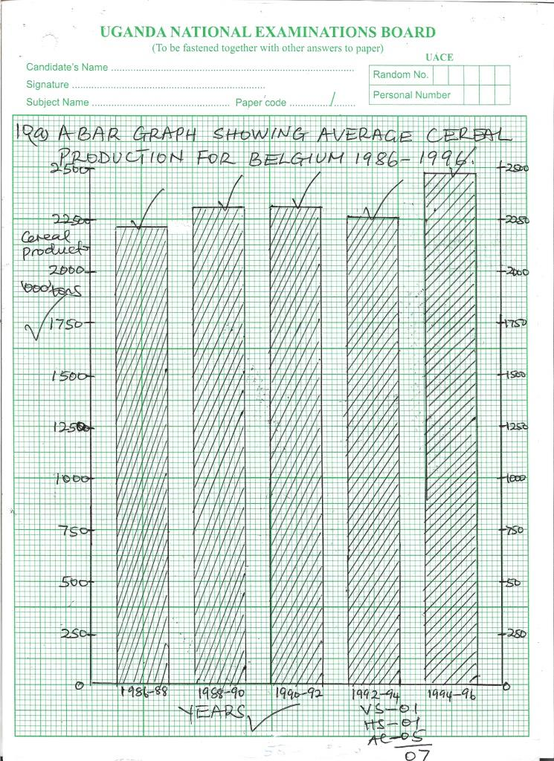

10. a Graph **(07)**

10.b) i) Description of the trend of cereal production in Belgium between

1986-88 and 1994-96.

There was an increase in cereal production between 1986-88 to 1988-90 between 1988-90 to 1990-92 cereal production remained constant between 1990-92 and 1992-94 cereal production decreased and then in 1994-96 it increased and then in 1994-96 it increased 03

ii) Description of the conditions that favoured cereal production in Belgium

* The presence of vast land **id** on which to establish set up **ds** cereal farms led to cereal production in Belgium.
* The presence of a gently sloping landscape **id** that promoted the use of machines **ds** such as tractors contributed to cereal production in Belgium.
* The presence of fertile soils **id** that ensured high crop yields **ds** led to cereal production in Belgium.
* The availability of reliable rainfall **id** that facilitated fast growth **ds** of the crops promoted cereal production in Belgium.
* The availability of highly skilled labour **id** to carry out work **ds** on the farms led to the production of cereals in Belgium.
* The availability of large/adequate capital **id** to invest **ds** in cereal production helped in the purchase of farm in puts hence contributing to cereal production in Belgium.
* The availability of developed transport**id** routes by road/railway/and water **ds** enabled easy movement of cereals from Belgium to the markets.
* The availability of a large/wide market **id** where cereals from Belgium are readily sold **ds** contributed to cereal production in Belgium.
* The availability of a high level of technology **id** that is applied through the use of machines **ds** such as combined harvesters led to the production of cereals in Belgium.
* The availability of a favourable government policy **id** that encouraged/ **ds** supported people to engage themselves in cereal production contributed to the production of cereals in Belgium.

id – mx 03

ds – mx 03 **09**

c) Explanation of the benefits of cereal production to the people of Belgium.

* Cereal production in Belgium has generated employment **id** opportunities to the people increasing their income/ improving their standards of living.**Ex**
* Cereal production in Belgium has led to the development infrastructure **id** such as schools/roads **Ex** ets that are used by cereal producers.
* The production of cereals in Belgium has led to the growth of towns **id** such as Liege and Brussels **Ex** where marketing and processing of cereals takes place.
* The production of cereals in Belgium has promoted industrialisation **id** by providing cereals as raw materials **Ex**
* Cereal production in Belgium has contributed to the generation of local revenue **id** through taxing **Ex** the people and companies engaged in cereal production.
* Cereal production in Belgium has generated foreign Exchange **id** got through Exporting **Ex** cereals to the foreign market.
* The production of cereals in Belgium has diversified **id** the economy of Belgium reducing over dependence **Ex** on other economic sectors.
* Cereal production has promoted International **id** relations between Belgium and other countries such as France and Britain**Ex** which import cereals from Belgium.

Id mx 03

Ex mx 03 **06**

d) The name of cereal crops grown in Belgium include:

* Wheat
* Maize
* Barley
* Oats
* Rye

Any 03

(**25)**

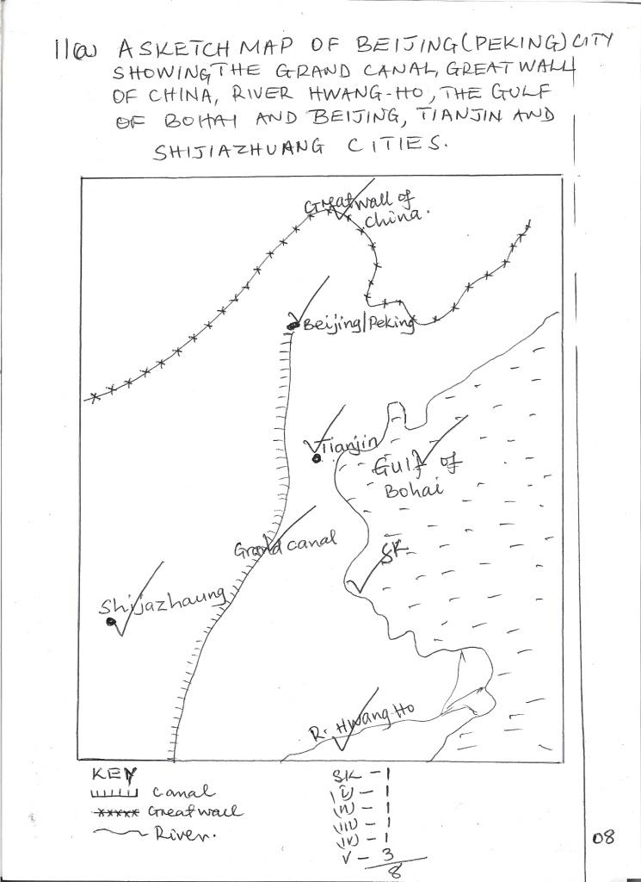

b) Description of the factors which led to the development of Beijing as an urban centre:

* The presence of a large piece of land **id** on which to establish/set up **ds** Beijing town led to its development as an urban centre.
* The availability of highly skilled labour **id** to carry out the work **ds** of constructing the necessary infrastructure such as roads led to the development of Beijing as an urban centre.
* The presence of a large population **id** that provided a large local market **ds** led to the development of Beijing as an urban centre.
* The presence of a gently sloping landscape **id** which made it easy to construct **ds** tall buildings in Beijing.
* The presence fresh water **id** to cool **ds** clean industrial and domestic premises.
* The strategic location **id** of Beijing near the coast provided easy access **ds** to the international routes.
* The availability of stable power supply **id** to run **ds** machines in industries and people’s homes led to the development of Beijing as an urban centre.
* The presence of well developed transport id routes by road railway **ds** air and water which made movement of people and goods easy.
* The availability of a high level of technology **id** that was applied in using machines **ds** to construct the necessary infrastructure developed Beijing as an urban centre.
* The availability of a favourable Government policy id that encouraged ds people to invest their capital in developing Beijing as an urban centre

id m03

ds mx 03 **06**

c) An outline of the functions of Beijing as an urban centre:

* Beijing is an Administrative centre because it is the capital city of China.
* Beijing is an industrial centre with Food processing and Petro chemical industries.
* Beijing is an Education centre with education institutions such as colleges and universities.
* It is a Transport centre with various modes of transport such as roads, railway and airports.
* Beijing is a commercial centre with large shopping malls.
* Beijing is a Residential centre with residences for business people.
* Beijing is a Recreational centre with facilities such as museums

Max 05

d) Explanation of the problems facing Beijing as an urban centre:

* Beijing is facing a problem of over crowding **id** which leads to easy spreading **Ex** of diseases.
* Beijing is facing a problem of Traffic congestion **id** which leads to delay Ex in delivery of goods to the markets.
* Beijing is faced with the problem of high crime rate **id** due to high level of

un employment **Ex**.

* Beijing is facing a problem of pollution **id** which leads to respiratory diseases **Ex** such as lung cancer.
* Beijing is facing a problem of limited accommodation **id** facilities leading to development of slums **Ex** with associated evils.
* Beijing is facing a problem of limited **id** land which has hindered **Ex** further expansion of the city.

Id – mx 03

Ex mx 03 **06**

**(25)**

12. a) i The name of Town marked:

1. Is Beijing/Peking

2. Is canton/Guangzhou

3. Is Kunming 03

ii) The name of the water body marked A is East China Sea 01

iii) The name of river marked

B is Hwang Ho

C is Sikiang

D is Yangtse Kiang 03 **(07)**

b)Description of the steps that were taken by China to develop the Yangste Kiang

river Basin.

* Strong dykes **id** were constructed in order to cut off **ds** the East China sea incursion.
* Numerous canals **id** were constructed to facilitate the flow **ds** of water to the cultivatable land.
* Numerous resrvours **id** were constructed to store flood water **ds** for irrigation during the dry season.
* Numerous dams **id** were constructed to generate Hydro Electric Power to run **ds** machines in people’s homes and industries.
* Constructed embarkments **id** in order to control periodic floods **ds**
* Regular dredging **id** was carried to allow fast flow **ds** of water in river Yangtse.
* Numerous Bridges **id** were constructed to ease communication **ds** across the river basin..
* Modern roads and **id** railway stems were constructed to connect **ds** the Yangtse Kiang Basin to other parts of China.

id - mx 04

ds - mx 04 **08**

c) Explanation of the benefits of the Yangtse Kiang River Basin to the people living in the surrounding areas.

* The Yangtse Kiang river has provided water **id** that is used to carry out extensive irrigation **Ex** farming by the people around it.
* The Yangtse Kiang river is used for generation of Hydro Electric power **id** which is used to run **Ex** machines in the peoples homes and industries around the river.
* The Yangtse Kiang river basin has promoted urbanization **id** as towns such as Shangai and Nanjing **Ex** are located along this river.
* The Yangtse Kiang river basin has promoted Industrialisation **id** especially those industries processing Agricultural raw materials.**Ex**
* The Yangtse Kiange river has led to the development of infrastructure **id** such as roads/railway **Ex** making it easy to transport goods to and from the Hinterland.
* The Yangtse Kiang river basin has promoted Tourism in china leading to generation of foreign Exchange **Ex**
* The Yangtse Kiang river basin has promoted crop production **id** improving the food security of China.Ex
* The Yangtse Kiang river Basin has generated employment **id** opportunities to the people working in the industries improving their standards of living **Ex**
* The Yangtse Kiang river has promoted fishing **id** activities providing fish food **Ex** which is rich in proteins.

Id -Mx 03

Ex -Mx 03 **06**

d) An outline of the problems that resulted from the development of the Yangtse Kiang river basin.

* The development of the Yangtse Kiang river basin has caused a problem of pollution of air water and land from the established industries.
* It has led to loss of soil fertility due to the intensive use of the land.
* The development of Yangtse Kiang river basin has caused siltation of rivers which require periodic dreading.
* There is high spread of water borne disease such as Bilharzia caused by snails.
* The development of Yangtse Kiang river basin has led to displacement of people in order to create water reservoirs.
* There is salination of the soils due to high evaporation rates experienced along the river Basin.

Mx 04

**(25)**

13.a) i) The percentage change in the population of china between 2000and 2005 is

1,321,623,490 – 1,283,198,870 x 100

1,283,198,870

=2.99% 3% **02**

ii) The percentage change in the population of china between 2005 and 2010 is

1,359,755,102 - 1,321,623,490 x 100

1,321,623,490

= 2.89% 3% **02**

iii) The percentage change in the population of China between 2010 and 2015 is

1,397,028,553 - 1,359,755,102 x 100

1,359,755,102

= 2.74% 3% **02** **(06)**

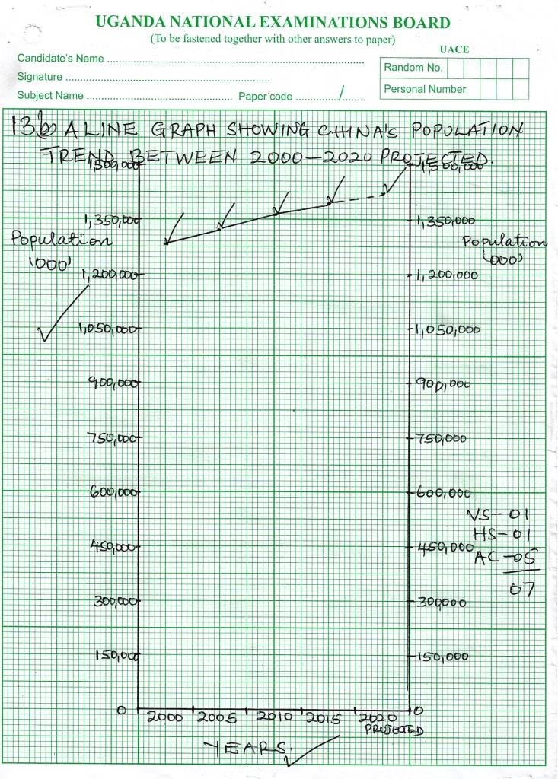

b)Graph **(07)**

c) Explanation of the factors that led to the population increase in China.

* The availability of abundant food **id** that support **Ex** a large population led to population increase in China.
* The presence of improved medical **id** services reduced the death rates **Ex** hence increasing the population of China.
* The presence of a large population **id** in China lead to a high growth rate **Ex** as many children are born.
* The high standard of **id** living by the people of China ensured improved sanitation and **Ex** nutrition hence increasing the population of China.
* The High life expectancy id of China due to improved medical services **Ex** contributed to the population increase in China.
* The High rate of migrants **id** into China in search of Employment **Ex** and Education led to population increase in China.
* The Political stability **id** of China led to increased life expectancy **Ex**
* The presence of a large number of industries **id** that offered employment opportunities **Ex** attracted a large population in china.
* The high rate of urbanization **id** attracted traders **Ex** leading to a large population in China.

Id -Mx 04

Ex -Mx 04 **08**

d) An outline of the population problems facing China.

* China is facing a problem of overcrowding which leads to easy spreading of diseases and encroachment on marginal lands.
* China is faced with a problem of unemployment due to limited employment opportunities.
* China is faced with a problem of shortage of food calling for importation of food for the growing population.
* China is facing a problem of shortage of accommodation facilities leading to emergence of slums.
* China is facing a problem of land shortage limiting other economic activities.
* China is facing a problem of high crime rates due to un employment.
* China is faced with the problem of traffic congestion leading to delays and accidents.

Mx **04**

**(25)**

END