**JINJA JOINT EXAMINATIONS BOARD**

**MOCK EXAMINATIONS**

**273/1 GEOGRAPHY PAPER 1**

**MARKING GUIDE**

SECTION A OBJECTIVE TYPE OF QUESTIONS

|  |  |  |  |  |  |
| --- | --- | --- | --- | --- | --- |
| 1 | B | 11 | D | 21 | A |
| 2 | C | 12 | B | 22 | A |
| 3 | C | 13 | B | 23 | B |
| 4 | A | 14 | D | 24 | A |
| 5 | A | 15 | C | 25 | B |
| 6 | C | 16 | B | 26 | B |
| 7 | B | 17 | A | 27 | B |
| 8 | A | 18 | B | 28 | C |
| 9 | A | 19 | B | 29 | B |
| 10 | C | 20 | C | 30 | C |

**MAP WORK: ALOI MAP EXTRACT:**

a) i)GR of the Bridge at Moroto is 245624 (01)

ii) The drainage feature at 269516 is a River confluence (01)

iii) the distance of the railway line is 2.4km (01)

b) A sketch map of Aloi showing Transport routes, Boundary lines, culverts, Town

and Dam.

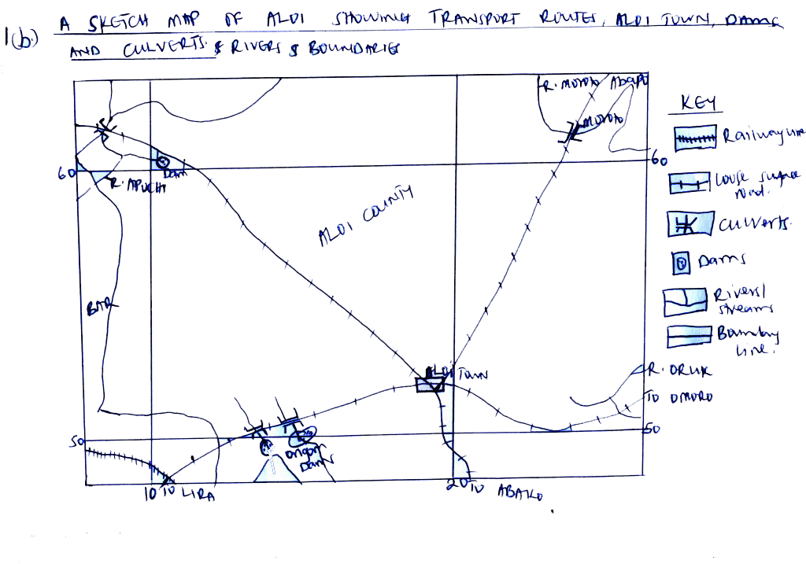

c) Settlement partners on the map extract

i) Linear settlement partner along the loose surface from Aloi town to Abako (01)

ii) Planned settlement pattern at Aloi town. (01)

iii) Clustered/nucleated settlement pattern at Aloi Ginnery

* Dispersed settlement all over the area on the map extract. (01)

iv) Description of relief on the Aloi map extract.

* The area is generally low and flat.
* The highest elevation of Aloi stands at 3850 feet at Aloi
* The lowest elevation of Aloi stands at 3300 feet along River Moroto banks.
* The amplitude of relief of Aloi map extract therefore is 3850 – 3300 = 550feet
* The average relief of Aloi map extract is 3850 + 3300 = feet

2

* There is a wide low land and a wide valley in North Eastern part of Aloi.

(05marks)

d. Explanation of the relationship between relief and drainage on the Aloi map extract.

* Rivers are found in valleys for example R. Moroto is the valley North east of Aloi map.
* Other rivers do drain the flat and low lands for example R. Ongom is in a flat land West of Aloi.
* Dams are in lowlands for example the Dams at Ongom in a low land.

(any 02marks)

2. PHOTOGRAPHY INTERPRETATION (15 marks)

a) i) Water transport. (01mark)

b) A landscape sketch of the photograph showing vegetation types, settlement,

ferry and the water body.

**Trees**

**Settlements**

**Settlements**

**Ferry**

**Grass**

c) Describe the conditions which have favoured the economic activity in (a) above.

(04marks)

* Presence of a Ferry in the middle background which enables easy transportation of goods and people on water.
* The presence of calm water in the right fore ground that favours navigation on the water body.
* High levels of technology in the right middle ground by use of engines which fastens transportation.
* Presence of dense population along the shores which creates/promotes the transport activity as in the back ground availability of passengers in the left background.
* Availability of passengers in the left background, middle and right middle ground.

2d.i) About the importance of the activity

* It is a source of employment to passengers for example Ferry operators hence improve on people’s standards of living.
* If enables tourism hence a source of foreign exchange which has been used in development of social services.
* It enables people to transport products to the market for sale hence earning income.
* It is a source of revenue to the government which has enabled development of social services.

d) ii) Problems faced:

* Pollution from the engines of the ferry which has led to death of acquatic animals.
* Attacks from wild animals like crocodiles to the people.
* Accidents of drawing in the water body which has led to death and destruction of property.
* High changes imposed on the activities where some people can not afford it.
* Water transport is too slow
* Poor quality ferries hence destruction of property/products transported.
* Problem of pirates who steal the equipments which leads to delays.

iii) Murchison falls National Park in West-Nile of Uganda due to the presence of thick vegetation in the background representing a national park and tourists who may have come to tour the place.

**FIELD WORK** – (15marks)

a) i) Topic: This should show the WHAT and WHERE the study took place.

NB: If the study was on a landing site, then the Name of the water body must come up.

If the field work was on a specific item/activity e.g mining, the name and type of item being mined/quarried must come up e.g the growth and development of Mases stone quarry in Jinja District. (02marks)

Objectives

These should be measurable and achievable.

* Any objective that repeats the topic of study is wrong.
* The objectives should be stated in a chronological order e.g to find out the location should come first and then to find out the future plans should come last. **(Any 03, objectives = 03marks)**

b) For the methods used, the following should be taken into account

* The method should be identified
* Explained and illustrated (what information was collected using that particular method)
* The information collected should also be part of the objectives. Listed above

**Any two methods = (04 marks)**

c) Regarding the problems faced while using the methods above

the examiners please look for what was missed and why? **(03marks)**

d) On the Geographical importance of the field work please look for what is where and why.

These a geographical relationships that should vary e.g

Physical to physical = 01

Physical to human = 01

Human to human = 01

**03marks**

**SECTION B EAST AFRICA: 20 MARKS**

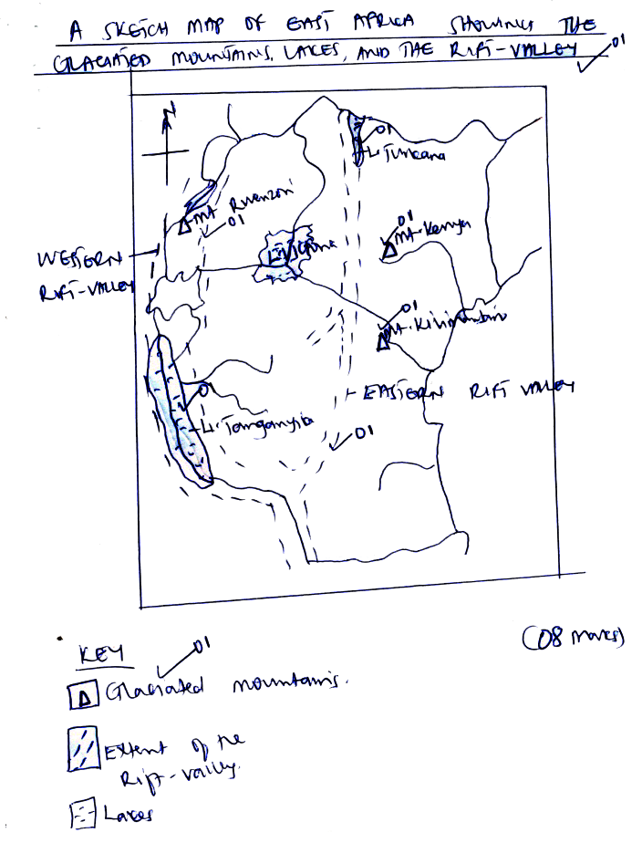

Glaciated mountains

Extent of the rift valley

Lakes

4.b Describing the processes that led to the formation of any two of the following glacial features.

i) Cirques – These are small hollours found on glaciated mountains. They are formed by frost action. The alternating freezing and thawing of water which penetrates into cracks makes the rocks break up, thereby enlarging the depression. When cirque is filled with water, it forms a lake called Tarn. Examples do exist on Mt. Rwenzori and Kilimanjaro. **(03marks)**

ii) Glacial Troughs: These are broad flat bottomed steep sided valleys with a roughly U-shaped cross profile. Examples are Bujuko Mobuku and Kamusoso valleys on Mt. Rwenzori. They were formed when the main river valley was eroded deeper by glacial erosion. **(03marks)**

iii) Hanging valleys: these are valleys formed above the Glacial trough. They are formed when the glacial trough (main river valley) are deepened by glacial erosion than the tributary river valleys above them. **(03marks)**

**Mode of formation = 01**

**Explanation of process 01**

**e.g 01**

4. i) Explain the importance of Glaciated mountain in East Africa.

* Glaciated, highlands and peaks e.g Kilimanjaro and Rwenzori have beautiful scenery which attracts tourists.
* Rivers originating from snow copped mountains e.g Rwenzori and Kilimanjaro obtain water from the melting glaciers.
* This water can be used domestically and industrially e.g R. Mobuku for Kases-Hima cement factory and Mobuku irrigation scheme.
* Glacial erosion and deposition have led to the formation of fertile soils for agriculture along the Feleki valley.
* Water falls develop along hanging valleys can be harnessed to generate hydro electricity e.g on Mt. Kenya.
* Glacial lakes on Mt. Rwenzori are potential grounds for fish farming.

**Any 03 well**

**Explained = (03marks)**

4ci) On problems

* Formation of infertile soils
* Advancement of cold conditions
* Glaciers can cause loss of lives
* Flooding from the melt waters
* Engedness and promotion of remoteness from erractics and pyramid peaks and eskers

5 i) water body marked

1 is Indian Ocean

2 is lake Malawi

3 is lake Kyoga

ii)Rivers marked

A is R. Maragarsi

B is R. Tana

iii) Countries marked

X is Rwanda

Y is Burundi

Z is Tanzania

b. Mode of formation of lake marked T (Lake Tanganyika)

- Lake Tanganyika is a rift –valley lake which was formed as a result of secondary faulting.

Faulting refers to the fracturing of the old rocks of the earth’s crust leading to their eventual displacement using either Tension or compression forces, all lead to the formation of a rift valley and at the basement of the Rift valley secondary faulting takes place using either Tension or compression leading to the formation of a narrow deep valley and when it is filled with water from either rainfall or any rivers, then a rift valley lake is formed e.g L. Tanganyika

**Clear description = 04mark**

5C Explain the value of lakes to people:

* Water for domestic and industrial use e.g L. Victoria
* Climatic modification
* Lakes promote transport and navigation
* Tourist attraction/research purpose
* Promote fishing
* Promote mining

**Etc any 04, well explained and illustrated**

**= (04marks)**

d) Problems faced by people living around lakes

* Flooding
* Pest and disease spread
* Slum emergency with related problems
* Homes for wild animals
* Accidents
* Piracy at a high ratenetc

**Any four well explained and illustrated = 04mark**

6 i) On the Graph paper

ii) Description of the trend

Between 2004 and 2005, there was a sharp increase in the number of tourists by 30000 tourists. **01**

Between 2006 and 2007, there was a slight in the number by increase 20000 tourists.

**½**

between 2007 and 2008 there was still a slight increase in the number of tourists 20000 tourists **½**

**Total 03marks**

b. Explain the factors which have led to trend above ( a steady increase)in the number of tourists

* Political stability
* Variety of wildlife and other tourist attractions
* Improved transport system
* Improved technology
* Abundant skilled labour
* Adequate capital
* Good international relationships

**Etc**

**Any 03 points well explained and illustrated**

**= 03marks**

c) On problems facing the tourists industry

* Political instability
* Poaching
* Arid conditions leading to death of stock
* Un developed roads
* Remoteness of the tourist sites
* Limited market

**Any 03 points well illustrated = 03marks**

d) measures being taken to improve the tourist industry

* Rehabilitation of transport
* Subsidization of entry fees at national parks
* There is maintainance of political stability
* Improvement of the accommodation facilities
* Training of more skilled labour tour guides

**Etc**

**Any 03 points well explained = 03 marks**

7.a) soil profile refers to the vertical arrangement of soil particles in layers or horizons from top to bottom while soil catena is the sequence of soil arrangement from top of the hill to the valley **(02 marks)**

Soil profile

b) Explain the factors that influence soil formation

* Parent rock
* Climate
* Relief or topography
* Living organisms
* Time factor

**Any four factors but well explained = 04marks)**

c) Causes of soil erosion

* Over grazing
* Bush burning
* Effect of strong prevailing winds
* Scanty vegetation
* Hilly landscape
* Reforestation
* Poor farming practices e.g up and down ward cultivation
* Swamp reclamation

**Etc**

**Any 06 points well explained = (06marks)**

d. On measures that have been taken to control soil erosion in East Africa

* Afforestation
* Re-afforestation
* Mulching
* Contour ploughing
* Strip cropping
* Terracing
* Controlled bush burning
* Rotational grazing
* Educating the masses
* Construction of ctabiors

**NB:** The tense used must be in line with the measures being taken.

**Any 04 measures explained using the correct tense = 04 marks**

**END**