Bar Interval Outweighs Entry Mechanism in Short-Horizon Systematic Trading:
Evidence from 222 Pre-Registered Trials in Spot Gold
Muhammad Ubaida Butt
Suleman Dawood School of Business
Lahore University of Management Sciences, Lahore, Pakistan
mubaidabutt@gmail.com
This version: August 2026

Abstract
Research on retail algorithmic trading is characterised by publication bias toward positive results, and the number of configurations examined before a result is reported is rarely disclosed. We evaluate whether exploitable short-horizon structure exists in spot gold (XAU/USD) traded through a retail broker, under a written protocol committed before any strategy was executed. Four mechanism families and an institutional time-series momentum construction were tested across hourly, four-hourly, daily and weekly bars. Significance thresholds were derived a priori from random-entry null distributions matched to each strategy's directional exposure, and the 2024 to 2026 period was sealed before analysis. Across 222 pre-registered trials spanning 22 years of daily and six years of hourly data, no configuration cleared its threshold and no expectancy estimate produced a 95% confidence interval excluding zero. Every trial, including failures and an implementation defect detected by the protocol, is published in an append-only registry. Three ancillary results are reported: transaction cost drag scaled steeply with trade frequency, at 0.14 against 0.80 Sharpe units below 300 and above 700 trades; short-side profitability was negative in all trend families despite a four-year bear market; and random long-only entries exceeded random symmetric entries by approximately 0.50 Sharpe units. In a family-matched paired comparison holding mechanism constant, four-hourly expectancy exceeded hourly expectancy by 0.158R per trade (95% CI [0.093, 0.233]), indicating that bar interval, an implementation parameter usually chosen by convention, influences realised performance more reliably than the choice of entry mechanism.

Keywords: systematic trading; pre-registration; multiple testing; backtest overfitting; transaction costs; time-series momentum; null results
JEL classification: G11; G14; G17; C12; C52

1. Introduction
The practitioner literature on algorithmic trading is dominated by positive results. Strategies are presented with favourable equity curves and Sharpe ratios exceeding unity, but rarely with the number of configurations examined before that result was obtained, the benchmark against which it should be judged, or the confidence interval surrounding the estimate. The asymmetry produces a systematic bias in which readers observe only the survivors of an undisclosed search and infer that such performance is routinely attainable.
The problem is well characterised in the academic literature. Bailey et al. (2014) demonstrate that a sufficiently large search over strategy configurations will produce an apparently excellent backtest from pure noise, and that the expected maximum Sharpe ratio grows with the logarithm of the number of trials. Harvey, Liu and Zhu (2016) argue that conventional significance thresholds are inappropriate in financial research precisely because the number of hypotheses tested across the literature is unobservable. López de Prado (2018) formalises the deflated Sharpe ratio to correct point estimates for selection intensity. The common thread is that the trial count is the quantity on which inference depends, and the common obstacle is that the trial count is almost never reported.
This study addresses that obstacle directly. Rather than arguing that undisclosed multiple testing invalidates retail trading research, we adopt the full apparatus of pre-registration, comprising written hypotheses with falsification conditions, a locked configuration budget, thresholds derived before testing, a sealed holdout period and a stopping rule, and we publish every configuration executed, including those that failed and one that was defective. The trial registry is append-only and public. Whether the protocol is sufficient can therefore be assessed by a reader rather than asserted by the author.
The study originated in an exploratory exercise exhibiting each of the pathologies described above. One hundred sixty strategy configurations were evaluated on XAU/USD hourly data over a five-year window, and fourteen satisfied a screening rule requiring a Sharpe ratio above 1.0 and a maximum drawdown below 40%. Those fourteen were initially regarded as candidates for live capital deployment. Four features rendered the exercise uninterpretable. First, no correction was applied for the 160 configurations examined. Second, no transaction cost model was incorporated. Third, the evaluation window contained no sustained bear market, and passive holding over the same window produced a Sharpe ratio of approximately 0.94, comparable to most of the surviving configurations. Fourth, the simulation engine had not been validated against lookahead bias, intrabar event ordering, or gap fill assumptions. Three competing explanations, namely a real edge, 160 lottery tickets of which 14 won, and inherited directional drift, could not be distinguished from one another.
The primary result is negative. Across 222 pre-registered trials, no configuration cleared its exposure-matched threshold and no expectancy estimate produced a confidence interval excluding zero. Under the pre-registered stopping rule, the conclusion is that no strategy should be deployed.
Four secondary findings have wider application. Transaction cost drag scales steeply and non-linearly with trade frequency, and the configurations with the strongest raw signal were precisely those unable to survive execution costs. Gold's apparent trend persistence is directionally asymmetric, since short-side profitability is negative in every trend family tested despite a sample containing a four-year bear market, and is therefore substantially attributable to drift rather than to a trend mechanism. Random long-only entries outperform random symmetric entries by roughly half a Sharpe unit, a quantity handed to any long-biased system before it demonstrates anything. And in a family-matched comparison holding mechanism constant, lengthening the bar interval from one hour to four hours improved expectancy by 0.158R per trade, an effect larger and more reliably measurable than any difference between the entry mechanisms examined.
The contribution is therefore methodological rather than substantive. We do not establish that gold contains no exploitable structure, since the search space was narrow and used price-derived features exclusively. We establish that the mechanisms most commonly advocated in retail practice do not survive evaluation once multiple comparisons, appropriate benchmarking, transaction costs and confidence intervals are incorporated, and we demonstrate a protocol under which that conclusion is verifiable rather than merely asserted. A protocol that validated only when it produced positive findings would have demonstrated nothing. A null result is the more demanding test of it.
The remainder of the paper is organised as follows. Section 2 describes the data, the simulation engine and its adversarial validation, the derivation of significance thresholds, and the pre-registered protocol. Section 3 reports results across five studies. Section 4 discusses interpretation and limitations. Section 5 concludes.
2. Data and method
2.1. Research design
The study employs a pre-registered, quasi-experimental design applied to historical price data. Each phase was governed by a written protocol committed before any strategy in that phase was executed, specifying hypotheses and their falsification conditions, the configuration budget, significance thresholds, the evaluation sequence, the sealed holdout period, and a stopping rule. Amendments were permitted only as dated, append-only entries accompanied by justification. Two protocols were committed in sequence: one governing hourly and four-hourly work, and a second governing daily work, written after the hourly study had concluded and explicitly recording that the earlier study stood as a completed, failed result rather than being reinterpreted. The stopping rule stated that if no mechanism family cleared the coherence criterion, the appropriate conclusion was to deploy no strategy.
2.2. Price series
Two sources were used. The primary source comprises broker-native hourly data retrieved through the MetaTrader 5 application programming interface from an Exness live retail account (symbol XAUUSDm), yielding 56,670 bars from January 2014 through July 2026. The secondary source is an archived hourly series covering June 2004 through January 2026.
The archived series was initially excluded. Diagnostic analysis established that its timestamps followed an Eastern European Time clock, at UTC+2 in winter and UTC+3 in summer, rather than Coordinated Universal Time. Three observations supported the inference. The daily maintenance break occupied a fixed local hour in both seasons, which a fixed-offset feed cannot produce. The series contained no Sunday bars, whereas a UTC feed would exhibit them given a 21:00 to 22:00 UTC market open. And the Friday closing hour shifted by one hour during approximately three weeks in March and one week in October, corresponding to intervals in which European and North American daylight saving transitions are misaligned. Because four-hourly candles constructed on a misaligned clock do not correspond to those constructed by the execution venue, the archived series was unsuitable for intraday analysis.
For daily-timeframe analysis the objection is materially weaker, as a two to three hour boundary displacement alters the precise daily close but not multi-week trend classification. The archived series was therefore converted to UTC using full European daylight saving rules, with ambiguous and non-existent timestamps at transition boundaries dropped rather than imputed, and validated against the broker series over 3,088 overlapping trading days. Agreement was close: median absolute difference in closing price 0.003%, 95th percentile 0.044%, and correlation of daily returns r = .9994. The merged daily series comprises 5,711 bars spanning 22.1 years, with the archived source used through 2017 and the broker source from 2018 onward.
2.3. Data quality verification
The broker series contained zero open-high-low-close integrity violations and zero duplicate timestamps. All sixteen intervals exceeding 72 hours corresponded to documented market closures. Annual coverage was approximately 5,900 bars from 2018 onward. Entries for 2014 through 2016 contained approximately 300 bars each and were identified as terminal cache fragments rather than complete history, restricting the usable hourly window to 2018 onward. Feed integrity was confirmed by the break hour signature: a genuine UTC+0 open-labelled series is missing hour 21 in summer and hour 22 in winter, and exactly that pattern was observed.
The per-bar spread field recorded by the trading terminal was evaluated as a candidate empirical cost measure and rejected. In every year the median equalled the 95th percentile, indicating a constant rather than a distribution, and the median spread during the daily rollover hour was lower than at midday, an ordering incompatible with a floating spread account. The field was concluded to reflect backfill padding rather than observation, and cost was modelled parametrically instead.
2.4. Simulation engine and adversarial validation
A simulation engine that systematically favours the researcher constitutes a threat to internal validity, because the resulting error is detected only through capital loss. The engine was therefore constructed such that every ambiguous event resolves against the strategy. Signals computed on a completed bar execute at the next bar's opening price, with the delay enforced by the engine rather than by the strategy author. Stop-loss levels are evaluated before trailing stops advance, so a bar containing both a stop trigger and a favourable trail update resolves as a stop. A bar gapping through a stop fills at the open rather than at the stop price. Costs are charged adversely on both legs, and position sizes respect the broker's minimum and lot step, rounded down.
The engine was subjected to nine adversarial tests, each targeting a specific mechanism by which simulated profit may be fabricated (Table 1). All nine pass. Tests 1, 6 and 7 detected genuine defects during development, which were repaired before any analysis was conducted. A separate test verifies that strategy signal generation is truncation invariant, requiring that signals computed over bars 0 to k be identical whether the function observed bars 0 to k or the full series.
Table 1
Adversarial validation tests applied to the simulation engine
Test | Failure mode | Discriminating criterion
1 | Lookahead bias | Trades closing before bar k identical whether the engine observed bars 0 to k or the full series
2 | Execution timing | A signal generated on bar i must execute at the opening price of bar i + 1
3 | Phantom edge | Random entries on a driftless random walk must average zero return
4 | Cost monotonicity | Increased transaction cost must strictly reduce net profit
5 | Accounting identity | Terminal equity equals initial equity plus the sum of trade profit and loss
6 | Gap handling | A bar gapping through a stop level fills at the open, not at the stop price
7 | Intrabar ordering | Stop-loss triggers are evaluated before trailing stops advance
8 | Position sizing | Position sizes are legal broker multiples and never exceed intended risk
9 | Determinism | Identical inputs produce identical outputs across runs
Note. All nine tests pass. Tests 1, 6 and 7 detected genuine defects during development, repaired prior to analysis.
2.5. Cost model
The trading account was Islamic, or swap free, eliminating overnight financing charges. Every strategy was additionally run at the standard swap rate to establish whether it depended on that account policy. Spread and slippage were modelled at $0.30 and $0.10 per ounce respectively, applied adversely on both legs of each transaction. The spread assumption is conservative relative to the $0.24 observed live. Slippage is invisible in bar history and is therefore assumed rather than measured.
Primary analyses for the daily, four-hourly and momentum studies were conducted at zero cost, with realistic cost results reported in parallel. The decision is recorded explicitly so that no reader mistakes a zero cost result for a net of cost one. Its effect is symmetric: removing costs raises strategy results and equally raises the random entry benchmarks against which those results are compared, so the comparison remains fair and only the bar moves. Measured cost drag on random hourly entries was approximately 0.36 Sharpe units, a quantity every strategy pays before earning anything.
2.6. Derivation of significance thresholds
A Sharpe ratio is uninterpretable without a benchmark. Two benchmarks were established empirically before any strategy was evaluated. Random entry null distributions were generated through 300 Monte Carlo trials for each directional configuration, using average true range scaled stops and time based exits matched to the trade frequency of the strategies under test. Passive buy and hold performance was computed over the identical window.
Selecting the best of N configurations does not constitute a single draw from the null distribution but rather the maximum of N draws, whose sampling distribution is centred substantially higher. This maximum was obtained by fitting a normal distribution to the observed null and simulating 20,000 replicates of the maximum of N draws. Parametric simulation was used rather than bootstrap resampling, because resampling N values from a few hundred observations returns the sample maximum nearly every time, collapsing all percentiles onto a single number and producing false precision.
Crucially, the null must match the strategy's directional exposure. A predominantly long strategy competes against random long entries, not against a symmetric coin flip, and comparing it to the symmetric null credits it with the underlying's drift. Each configuration therefore reports the proportion of its signals that are long, and that proportion, a property of the strategy's behaviour rather than of its author's intent, selects which threshold applies. Figure 1 presents the resulting null distributions and Table 2 the thresholds derived from them.
Figure 1
Null distributions and selection thresholds derived from random entry benchmarks
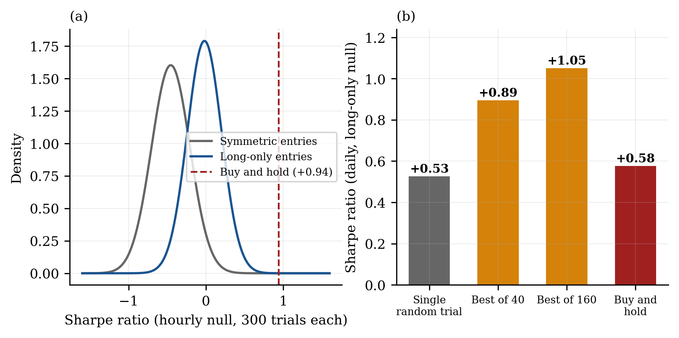
Note. Panel (a) presents fitted hourly null distributions for symmetric and long-only random entries, each over 300 trials, against the passive buy and hold benchmark. Panel (b) presents daily long-only thresholds, showing that the Sharpe ratio attainable by luck alone rises with the number of configurations tested.
Table 2
Empirically derived significance thresholds by study
Study | Null (symmetric) | Null (long-only) | Best-of-N | Buy and hold | Threshold
Hourly, 2018 to 2023 | −0.455 (0.249) | −0.019 (0.223) | +0.74 | +0.94 | +0.94
Daily, 2004 to 2023 | +0.026 (0.225) | +0.526 (0.173) | +1.05 | +0.58 | +1.05
Four-hourly, 2018 to 2023 | −0.027 (0.358) | n/a | +0.99 | +0.58 | +0.99
Note. Null distributions are reported as mean Sharpe ratio with standard deviation in parentheses across 300 random entry trials. Best-of-N denotes the 95th percentile of the simulated maximum for the exposure matched null. Direction neutral strategies faced thresholds of +0.39 (hourly) and +0.705 (daily).
The difference between the symmetric and long-only nulls is the most consequential quantity in Table 2. On daily data, random long-only entries achieved a mean Sharpe ratio of +0.526 against +0.026 for random symmetric entries. That difference of approximately 0.50 Sharpe units, observed across 22 years including a four-year bear market, represents directional drift in the underlying rather than strategy skill. Predominantly long strategies were consequently held to a threshold more than double that applied to direction neutral strategies. The hourly window shows the same asymmetry at 0.44 Sharpe units.
2.7. Hypotheses
Each hypothesis states an economic mechanism, a directional prediction, and a falsification condition. A family with no stated mechanism is curve fitting with additional steps.
H1: Trend persistence. Gold trends are driven by slow moving macroeconomic flows, including real interest rates, central bank reserve accumulation and currency debasement, that persist over multi-week horizons. Positioning adjusts gradually, so price continues in the direction of an established trend more often than a random walk implies. Because the proposed mechanism is symmetric, the hypothesis predicts profitability in both directions. Falsified if performance is positive only in rising regimes, or if the short side loses money across the full sample.
H2: Volatility regime reversion. Volatility clusters and mean reverts. Compressed ranges resolve into directional expansion, and the signal concerns volatility state rather than price direction, so the family should not inherit drift. Falsified if the volatility compression filter adds nothing over the same entry taken unconditionally, a comparison built into the design as an explicit unfiltered control.
H3: Session boundary liquidity. Gold trades nearly continuously but liquidity is uneven. The London open at 07:00 UTC and the New York open at 13:00 UTC bring order flow discontinuities, while the Asian session is thin and range bound. Falsified if the session filter's advantage is within noise of arbitrary hours. This family carries a built-in control, since one third of its configuration grid is assigned to non-session hours.
H4: Long horizon range breakout. Breaks of multi-month price extrema mark genuine regime transitions rather than noise, unlike intraday breakouts. Falsified if breakout entries do not beat entries taken at random times with identical exits.
A fifth construction, time series momentum with volatility targeting (Moskowitz, Ooi and Pedersen 2012), was evaluated subsequently because it represents the dominant institutional implementation and differs mechanically from the retail constructions in H1 through H4. It holds continuous exposure, uses no stop loss orders, and scales position size inversely to realised volatility.
One hypothesis was deliberately excluded and the exclusion recorded in advance. News driven strategies were not tested because no historical spread or slippage data exist for the windows around scheduled macroeconomic releases, which are precisely the windows in which execution quality is worst. Backtesting them under a flat cost model would produce results that could not be trusted.
2.8. Evaluation sequence, configuration budget and stopping rule
A configuration must pass each stage to reach the next. Stage 0 requires a minimum trade count and no disproportionate contribution from a single trade. Stage 1 requires the configuration to clear its exposure matched threshold. Stage 2 requires family coherence, meaning that the median configuration in the family must clear the bar rather than merely exceed zero, on the reasoning that a single configuration clearing a threshold may be the best of many lottery tickets whereas a family whose median configuration is profitable cannot be produced by locating one favourable parameter. Later stages address parameter surface stability, regime robustness, direction balance, walk forward efficiency, the sealed period, and a demonstration cost check.
The daily protocol tightened two stages relative to the hourly protocol, deliberately and before any daily result existed. The hourly Stage 0 permitted a single trade to contribute up to 100% of profit, and configurations passed while showing a top trade equal to 974% of profit, meaning that every other trade combined lost money. The daily limit was set at 25%. The hourly Stage 2 asked only for a positive median and flagged a family as coherent at +0.060 while 0 of 16 configurations cleared the actual bar. The daily criterion requires the median configuration to clear the threshold itself.
The configuration budget was locked in advance at 48 hourly configurations, comprising 16 trend, 20 volatility and 12 session, and 40 daily configurations, comprising 20 per family, because the selection threshold scales with the number of configurations tested and a budget chosen after seeing results is not a budget. Parameters were selected at economically meaningful horizons of a day, a week and a month rather than by gridding every integer value, and no parameter was tested at more than four values.
The holdout period from 1 January 2024 through 31 July 2026 was sealed before analysis and has never been examined. It is not merely unused in this paper. It remains available for future validation, and evaluating it on configurations that had already failed earlier stages would have converted a single use holdout into an exploratory dataset. The window matters more than its length suggests, containing both the strongest trend and the sharpest volatility regime break in the dataset.
Every configuration executed was logged to an append-only trial registry recording its parameters, evaluation window, cost setting and outcome. The registry count is what the multiple comparison correction consumes, so an unlogged trial would silently invalidate every threshold in the protocol. The registry contains 222 entries and is published in full.
2.9. Statistical analysis
Analysis was conducted in Python 3.13 using pandas 3.0.2 and NumPy 2.4.4. Sharpe ratios were computed on daily equity returns and annualised by the square root of 252 trading days, rather than on per trade returns, which are not comparable across strategies with differing trade frequencies and which are precisely the comparison this study needs to make. Expectancy was expressed in units of risk (R), where 1R denotes the capital risked to the stop loss level, permitting comparison across position sizing regimes. Confidence intervals for expectancy were computed as M ± 1.96 × SD/√n. Standard errors for Sharpe ratios follow Lo (2002).
Two inferential procedures were applied. First, observed maxima were compared against the expected maximum Sharpe ratio under the null given the number of configurations evaluated and their cross-sectional dispersion, following Bailey and López de Prado (2014). Second, one sample t tests were conducted for expectancy against zero, and Welch t tests for embedded control comparisons, with Cohen's d reported as the effect size and the Bonferroni correction applied where families of tests were conducted.
For the timeframe comparison reported in Section 3.10, configurations were paired across timeframes by identical family and parameter set, and the paired difference was additionally evaluated by a sign flip permutation test with 20,000 replicates. This addresses the fact that all configurations are evaluated on a single price series and are therefore not independent observations, so conventional standard errors are optimistic.
3. Results
3.1. Attrition across the evaluation sequence
Across 222 pre-registered trials, no configuration exceeded its threshold and no expectancy estimate yielded a confidence interval excluding zero. Of the 222 logged trials, 152 satisfied Stage 0 criteria requiring a minimum trade count and no disproportionate contribution from a single trade. None cleared its pre-registered Stage 1 threshold, and consequently none reached Stage 2. Figure 2 presents the attrition.
Figure 2
Attrition of strategy configurations across the evaluation sequence
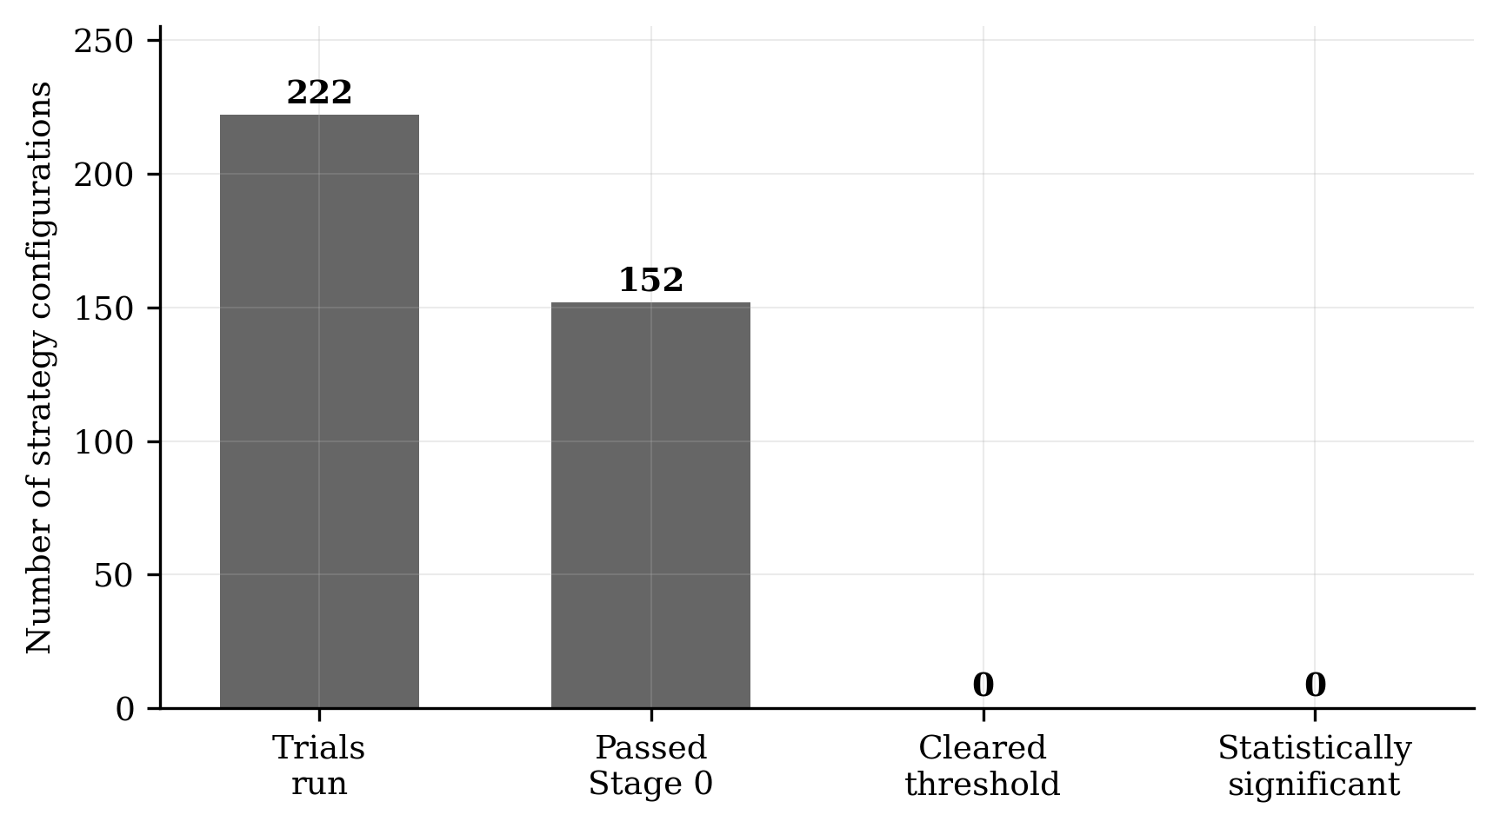
Note. Of 222 logged trials, 152 satisfied Stage 0 criteria. None cleared its pre-registered threshold and none reached statistical significance. Counts are computed directly from the published trial registry.
The trials comprise six executions: three hourly studies of 48 configurations each, being an initial run subsequently found to be defective, a corrected run at realistic cost, and a corrected run at zero cost; a daily study of 40 configurations; a four-hourly study of 22 configurations; and a momentum study of 16 configurations. Stage 0 status for the momentum configurations is recorded as not applicable, since a continuously exposed strategy has no discrete trades to which a concentration criterion could be applied, and those sixteen are counted as passing Stage 0 in Figure 2.
3.2. Regime structure of the underlying
Gold prices over 2004 to 2023 do not constitute a stationary process. Table 3 partitions the sample into five regimes defined a priori from documented market history rather than fitted to results. The 2011 to 2015 bear market, a 41.9% decline over four years with a 44.5% peak to trough drawdown, is absent from the post-2018 window on which most retail research is conducted. Its absence is a plausible explanation for a finding reported below, namely that the hourly trend filter reported approximately 50% long exposure against a protocol prediction of 60% or more, because the window contained no sustained downtrend to detect.
Table 3
Passive buy and hold performance by market regime, 2004 to 2023
Regime | Period | Sharpe | Return | Max. drawdown
Early bull | Jun 2004 to Jan 2008 | +1.32 | +116.6% | 22.0%
Parabolic bull | Jan 2008 to Sep 2011 | +1.00 | +113.5% | 28.9%
Bear market | Sep 2011 to Jan 2016 | −0.64 | −41.9% | 44.5%
Low volatility range | Jan 2016 to Jan 2018 | +0.81 | +21.4% | 17.4%
Development window | Jan 2018 to Jan 2024 | +0.59 | +56.3% | 21.4%
Full sample | Jun 2004 to Jan 2024 | +0.58 | +437.1% | 44.8%
Note. Sharpe ratios computed on daily returns and annualised by the square root of 252.
Figure 3
Regime dependent behaviour of gold prices, 2004 to 2023
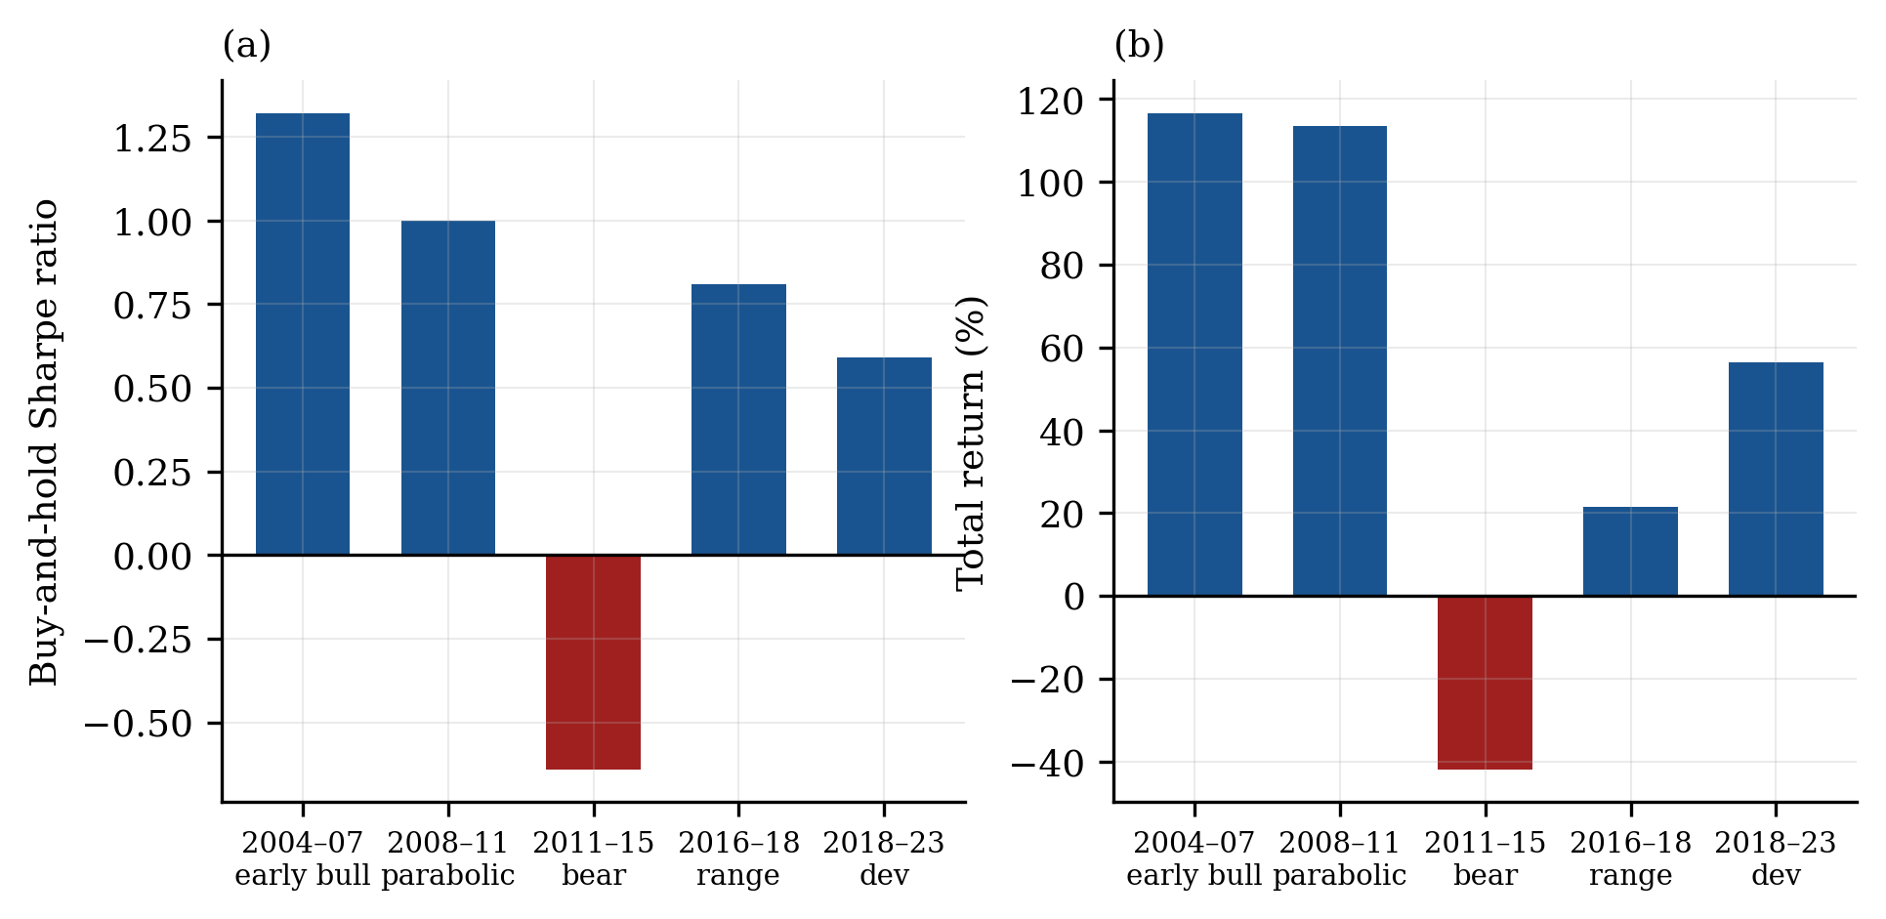
Note. Panel (a) presents risk adjusted returns by regime and panel (b) presents cumulative returns. Four of five regimes are positive and one is strongly negative. Regimes were defined a priori from documented market history.
3.3. Study I: hourly mechanism families
Forty-eight configurations across three families were evaluated on hourly data from 2018 to 2023. The study was executed three times: once with an implementation subsequently found to be defective, as described in Section 3.4, once corrected at realistic cost, and once corrected at zero cost. All three runs are retained in the registry.
In the corrected realistic cost run, median Sharpe ratios were +0.060 for trend persistence, −0.781 for volatility regime and −0.463 for session breakout, against a symmetric random entry null of −0.455 and a direction neutral threshold of +0.39. The best configuration in the study reached +0.275. No configuration cleared its threshold. Removing costs raised the medians to +0.318, −0.156 and +0.158 respectively, with a best configuration of +0.609, still below the buy and hold benchmark of +0.94 applicable to long biased strategies and below the selection adjusted benchmark reported in Section 3.9.
The session boundary family was rejected by its embedded control. Four of twelve configurations were assigned to arbitrary intraday hours rather than to the London or New York opens. At realistic cost, session boundary configurations achieved a median Sharpe ratio of −0.506 against −0.430 for arbitrary hour controls, so the hypothesised liquidity effect performed worse than chance timing. At zero cost the ordering reversed but the magnitude did not qualify, at +0.181 against +0.041, a difference of 0.140 against a pre-registered retention criterion of 0.20. Under that pre-specified rule, H3 did not meet its retention criterion and was rejected. The comparison is underpowered, with Welch t(4.1) = 1.17, p = .305, d = 0.77, and should therefore be read as the outcome of a decision rule fixed in advance rather than as statistical evidence of no effect.
3.4. An implementation defect detected by the protocol
The initial trend persistence implementation specified entry as a persistent state rather than as a discrete event. The condition obtained on approximately 33% of bars compared with 4% for the intended event, an eightfold difference. The strategy consequently maintained near continuous market exposure with effectively arbitrary entry timing, which accounts for performance sitting at the random entry noise floor: median Sharpe ratios of −0.257, −0.702 and −0.463 across the three families, drawdowns of 69% to 84%, and up to 1,854 trades over six years.
The defect was identified independently of performance. The protocol predicted that this family would exhibit predominantly long exposure, and observed exposure was 51%. That is a failed pre-registered prediction about the implementation, detectable without reference to any performance metric. The correction, which required the indicator to cross its threshold rather than merely to sit beyond it, introduced no free parameter and no additional degree of freedom. All 48 original trials were retained in the registry and the corrected study was logged as a separate execution.
This episode is reported in full because it illustrates the protocol's principal function. A researcher who observes a poor result and then modifies the implementation is indistinguishable, from the outside, from a researcher who observes a poor result and then searches for a modification that improves it. The distinguishing evidence is that the anomaly triggering the investigation was a pre-registered prediction about exposure rather than a disappointing Sharpe ratio, and that the corrected implementation was specified without reference to its performance. Without a written prediction about exposure committed in advance, no such distinction would be available.
3.5. Study II: transaction cost and trade frequency
Executing the corrected hourly study at both zero and realistic cost isolates the cost effect. Aggregate drag was approximately 0.50 Sharpe units, but the aggregate conceals substantial structure. Configurations trading fewer than 300 times over six years lost a mean of 0.141 Sharpe units to costs, while configurations trading more than 700 times lost 0.803. The relationship is close to linear in trade count and is economically decisive rather than second order at the upper end.
The consequence is an inversion. The two configurations with the strongest zero cost signal, at +0.598 and +0.609, were the two weakest at realistic cost, at −0.387 and −0.358. A researcher evaluating this family without a cost model would have selected precisely the two configurations guaranteed to lose money in deployment. This is not a marginal adjustment to a ranking but a reversal of it, and it is the clearest single argument in this study against reporting backtests without transaction costs.
Figure 4
Transaction cost drag as a function of trade frequency
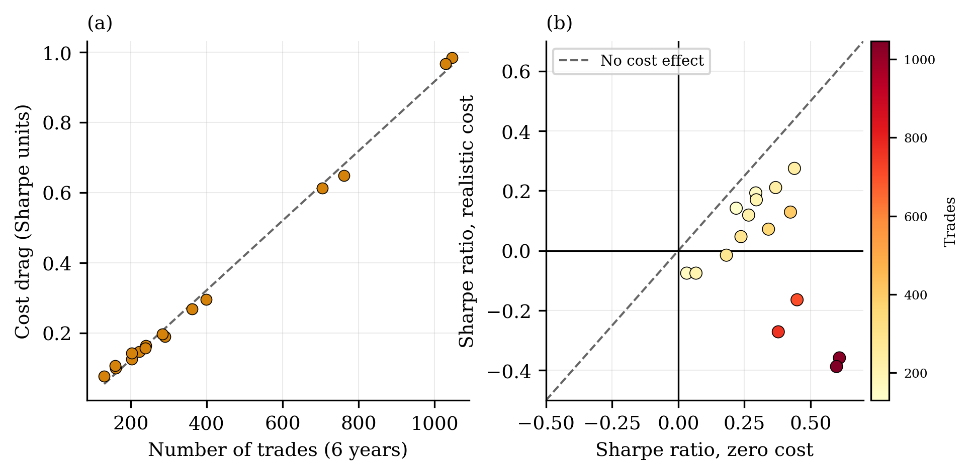
Note. Panel (a) presents cost drag against trade count for the hourly trend family. Panel (b) plots zero cost against realistic cost Sharpe ratios, coloured by trade frequency. Points below the diagonal were degraded by costs, and the highest frequency configurations cross from positive to negative.
3.6. Study III: daily timeframe and directional asymmetry
Forty configurations across two families were evaluated on the merged daily series from 2004 to 2023, permitting a test unavailable at hourly frequency: whether trend persistence is directionally symmetric, as its stated economic rationale requires. Both families were constructed to trade both directions by design, since the direction neutral threshold of +0.705 is materially lower than the long biased threshold of +1.05 and the underlying mechanism is identical either way. Taking short trades is not a concession in this design but the condition that makes the hypothesis testable, since the short only null has a 95th percentile of +0.045 and a profitable short side would be doing something random short entries essentially never do.
Table 4
Daily study results and directional decomposition of profit and loss
Family | Mdn SR | Best SR | Threshold | Long P&L | Short P&L | Passed
Trend persistence | −0.055 | +0.281 | +0.705 | +2,688 | −5,865 | 0/20
Horizon breakout | +0.169 | +0.423 | +1.05 | +29,202 | −12,622 | 0/20
Note. Profit and loss aggregated across all configurations within each family, expressed in account currency. SR denotes the Sharpe ratio.
Short side profit and loss was negative in both families despite a sample containing a four-year bear market in which the underlying declined 41.9%. The symmetry required by H1 was therefore absent. Gold's apparent trend persistence is a long only phenomenon, and a long only trend phenomenon in an asset with persistent upward drift is substantially attributable to that drift rather than to trend structure. H1 was rejected. Neither family cleared Stage 2, since the median configuration fell below its bar in both cases, and 0 of 40 configurations cleared Stage 1.
3.7. Study IV: four-hourly volatility regime and statistical precision
An expectancy analysis across hourly and four-hourly configurations revealed a systematic timeframe effect, reported formally in Section 3.10. The strongest four-hourly family was volatility regime, the family that had failed most decisively at hourly frequency. Twenty-two four-hourly configurations were therefore evaluated, comprising 20 compression filtered configurations and 2 unfiltered controls, with confidence intervals reported for every estimate.
The most favourable configuration achieved a 29.0% win rate with a payoff ratio of 3.89 and expectancy of +0.4287R over 69 trades, 95% CI [−0.351, +1.208]. All 20 confidence intervals for the filtered configurations contained zero (Figure 5). Point estimates as large as +0.43R are not statistically distinguishable from the absence of an edge at these sample sizes, a constraint quantified in Section 3.11. The family median was +0.048R at zero cost and −0.014R at realistic cost.
Figure 5
Expectancy estimates with 95% confidence intervals for four-hourly configurations
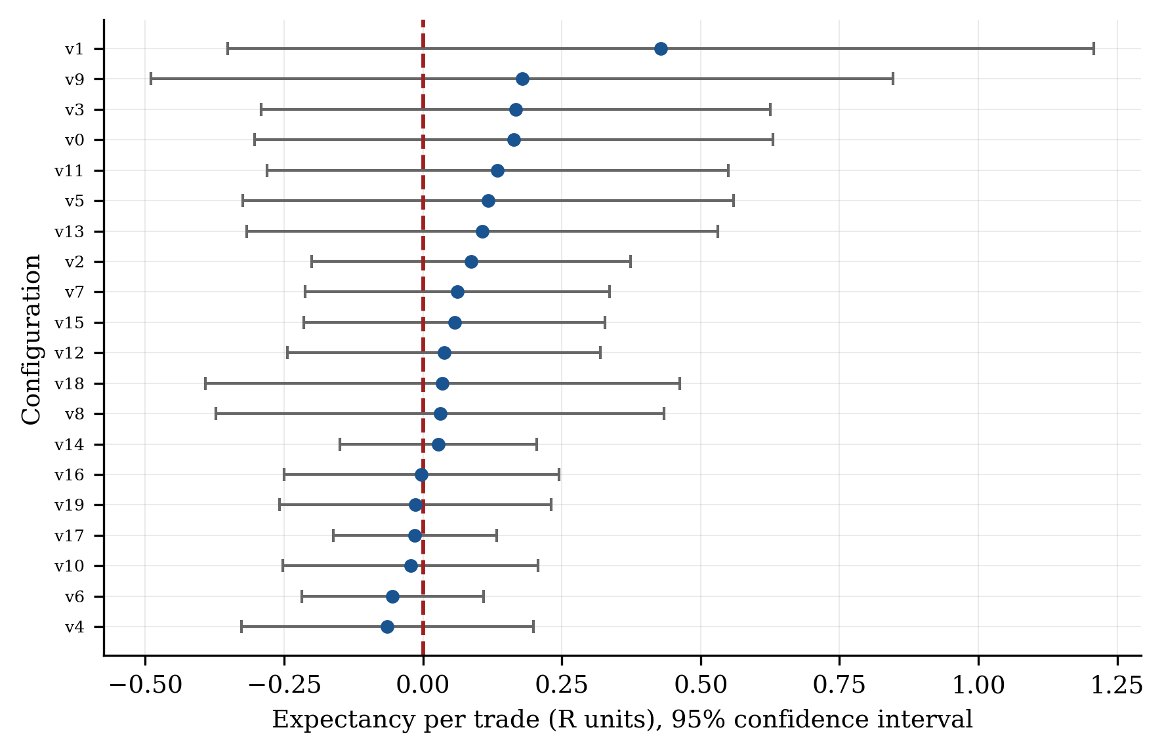
Note. All 20 intervals span zero. Point estimates as large as +0.43R are not statistically distinguishable from the absence of an edge at these sample sizes. The two unfiltered control configurations are excluded.
The embedded control is decisive for H2. Unfiltered configurations produced a median expectancy of +0.027R against +0.048R for filtered configurations, a difference of 0.021R that is negligible relative to interval widths of approximately ±0.4R, with Welch t(5.5) = 1.44, p = .204, d = 0.57. The volatility compression filter constitutes the entire hypothesised mechanism, so a filter contributing no measurable effect leaves the hypothesis without content. As with H3, the rejection follows a pre-specified criterion and the comparison is underpowered. The conclusion is that the mechanism was not demonstrated, not that it has been shown absent.
Regime decomposition of the three highest expectancy configurations indicates that all three derived essentially all profit from the 2020 to 2021 period, corresponding to the COVID-19 volatility episode, and two of three were negative during 2018 to 2019. The pattern is consistent with exposure to a single exceptional period rather than with a persistent effect.
3.8. Study V: institutional time series momentum
All preceding studies employed retail implementation mechanics, comprising discrete entries, volatility scaled stops and trailing exits. Institutional managed futures programmes typically implement a structurally different construction, featuring continuous market exposure with position size scaled inversely to realised volatility and no stop loss orders (Moskowitz, Ooi and Pedersen 2012):
position(t) = sign[r(t − k, t)] × (σtarget / σrealised)
Sixteen configurations were evaluated, comprising four timeframes crossed with four lookback horizons of 1, 3, 6 and 12 months, at a 15% annualised volatility target with leverage constrained to 3.0. Both the momentum signal and the volatility estimate use data through t − 1 only, and the position is applied to the return realised at t.
Table 5
Time series momentum compared with passive holding by timeframe, 2018 to 2023
Timeframe | Buy and hold SR | Best momentum SR | Momentum MDD | Buy and hold MDD
Hourly | +0.607 | +0.582 | −24.5% | −21.9%
Four-hourly | +0.578 | +0.622 | −27.5% | −21.7%
Daily | +0.531 | +0.409 | −39.7% | −21.4%
Weekly | +0.578 | +0.259 | −37.4% | −18.9%
Note. SR denotes the Sharpe ratio and MDD the maximum drawdown. Fifteen of 16 configurations underperformed the passive benchmark at the same timeframe. The single exception exceeded it by 0.044 Sharpe units, within sampling error. No configuration produced a Sharpe ratio whose 95% confidence interval excluded zero.
Two features of Table 5 are decisive. Momentum drawdowns ranged from 24.5% to 49.1% against 18.9% to 21.9% for passive holding, indicating materially inferior risk for equivalent or lower return. And the lookback ordering contradicts theoretical expectation. The documented effect rests primarily on 12 month momentum, with 1 month horizons typically exhibiting reversal, whereas observed median Sharpe ratios peaked at 3 months at +0.495 and declined to +0.225 at 12 months. An interior maximum lacking theoretical justification is characteristic of noise rather than of a weak instance of the documented effect.
Figure 6
Time series momentum performance and lookback ordering, 2018 to 2023
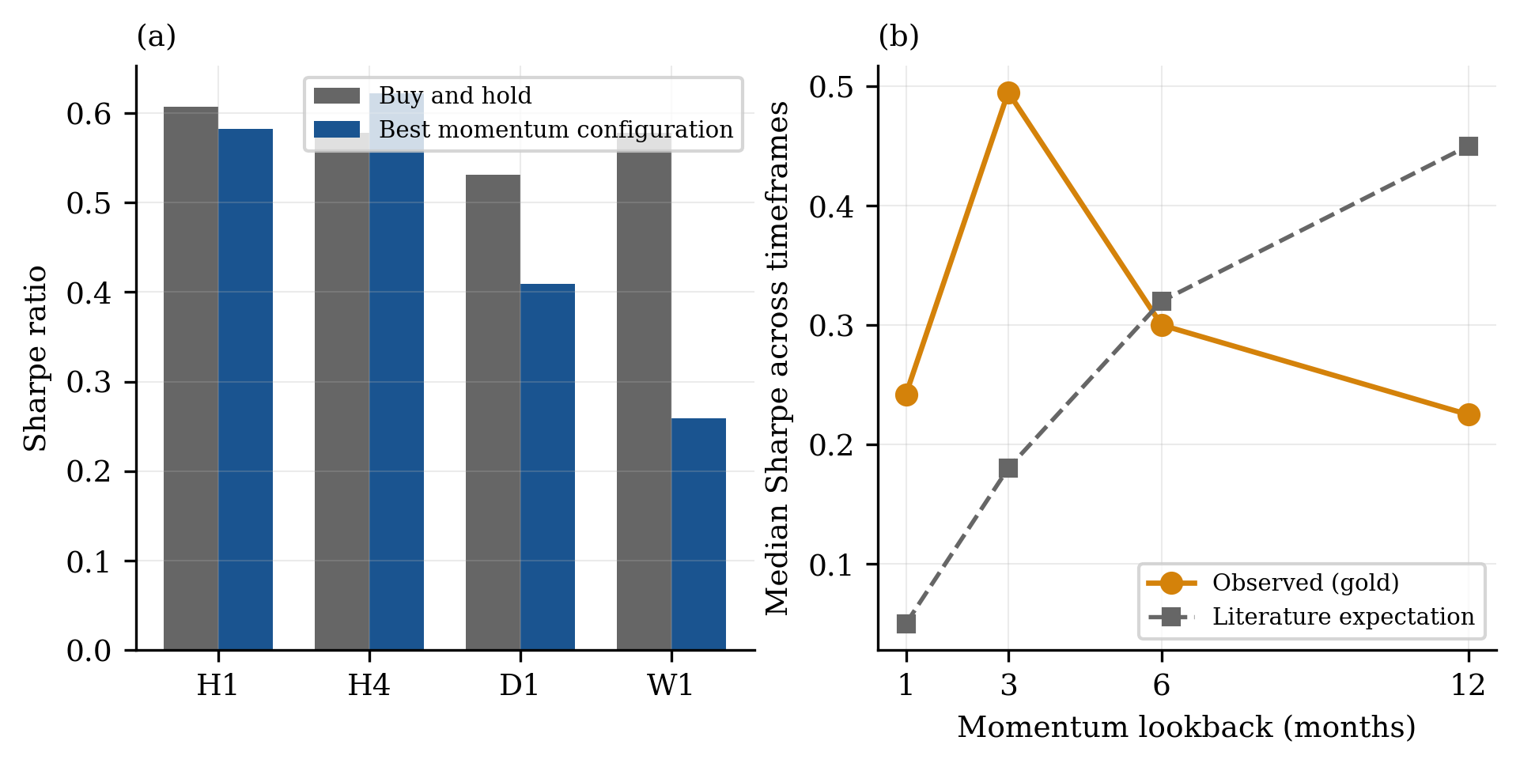
Note. Panel (a) compares the best momentum configuration with passive holding at each timeframe. Panel (b) presents median Sharpe ratio by lookback horizon against the ordering predicted by the time series momentum literature. The observed interior maximum at three months is characteristic of noise.
3.9. Selection adjusted benchmarks
Table 6 compares the best observed Sharpe ratio in each study against the expected maximum under the null, computed from the number of configurations evaluated and the cross-sectional dispersion of Sharpe ratios within that study. In four of five studies the observed maximum falls below the expected maximum, indicating results not distinguishable from the best of N noise draws.
Table 6
Observed maximum Sharpe ratio against the selection adjusted benchmark
Study | N | Max SR | Cross-sec. SD | E[max SR] | Exceeds
I Hourly, realistic cost | 48 | +0.275 | 0.373 | +0.431 | No
II Hourly, zero cost | 48 | +0.609 | 0.278 | +0.725 | No
III Daily | 40 | +0.423 | 0.184 | +0.475 | No
IV Four-hourly | 22 | +0.582 | 0.197 | +0.541 | Yes
V Momentum | 16 | +0.622 | 0.193 | +0.653 | No
Note. E[max SR] is the expected maximum Sharpe ratio under the null given N configurations and the observed cross-sectional dispersion, following Bailey and López de Prado (2014).
Study IV constitutes an apparent exception and is reported rather than suppressed. Its observed maximum of +0.582 exceeds the selection adjusted benchmark of +0.541, reflecting the smaller number of configurations evaluated and correspondingly lower selection intensity. Three considerations govern its interpretation. The configuration fails its pre-registered Sharpe threshold of +0.989 by a wide margin. Its expectancy confidence interval contains zero, as do all others in that study. And its profit derives almost entirely from a single volatility episode. The selection adjustment and the pre-registered economic criteria therefore disagree, and the latter govern: a configuration that survives correction for multiple comparisons but fails the threshold set for it in advance, and cannot be distinguished from zero expectancy, is not evidence of an edge. Reporting whichever criterion favoured a positive conclusion is precisely the practice this study was designed to avoid.
One sample t tests of expectancy against zero were conducted for all 20 filtered four-hourly configurations. None reached significance at the uncorrected level, with all ps > .285, and consequently none survived Bonferroni correction at α = .0025.
3.10. The timeframe effect
A single comparison in this study reached statistical significance. Because the configurations producing sufficient trades at each timeframe were not balanced across mechanism families, with twelve session boundary configurations qualifying at hourly frequency but only one at four-hourly frequency, an unmatched comparison confounds bar interval with mechanism. The unmatched contrast is therefore reported as descriptive only: expectancy on four-hourly configurations (M = +0.071R, SD = 0.169, n = 37) exceeded hourly configurations (M = −0.086R, SD = 0.084, n = 48), Welch t(49.6) = 5.16, p < .001, d = 1.22.
The primary test paired configurations sharing an identical family and parameter set across the two timeframes, holding mechanism constant, giving 37 pairs. Four-hourly expectancy exceeded hourly expectancy by 0.158R per trade, 95% CI [0.093, 0.233], t(36) = 4.35, p < .001, dz = 0.71. The result was confirmed by a Wilcoxon signed rank test, p < .001. Because all configurations are evaluated on a single price series and are therefore not independent observations, a sign flip permutation test was conducted on the paired differences with 20,000 replicates, and the effect persisted, p < .001.
Figure 7
Benchmark comparison across studies and the timeframe effect
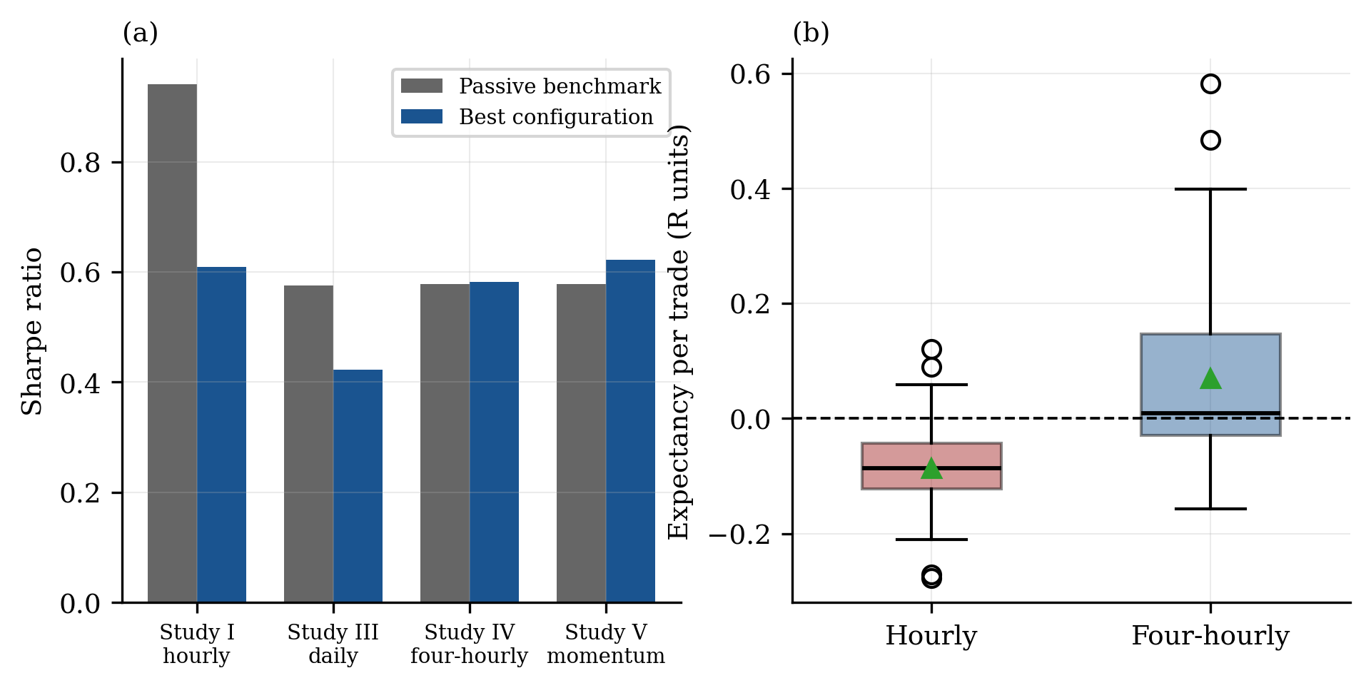
Note. Panel (a) presents the best configuration in each study against its passive benchmark. No study exceeded its benchmark. Panel (b) presents expectancy distributions by timeframe, with n = 48 hourly and n = 37 four-hourly. The family matched paired comparison holding mechanism constant was significant, t(36) = 4.35, p < .001, dz = 0.71.
The effect is not uniform across mechanisms. Lengthening the bar interval produced a large improvement in the volatility regime family, from a mean of −0.150R to +0.112R, t = 5.44, p < .001, but no detectable improvement in trend persistence, from −0.008R to +0.033R, t = 1.49, p = .147. The benefit therefore concentrates in the family with the higher signal rate, which is the family paying the largest cumulative transaction cost. This is consistent with the frequency and cost relationship documented in Section 3.5 and suggests an arithmetic rather than a behavioural mechanism, since lengthening the bar interval reduces trade frequency, which reduces cumulative transaction cost relative to the magnitude of the price movements captured.
The finding is methodologically consequential without being a claim about strategy design. Bar interval is an implementation parameter typically chosen by convention rather than tested, and it is rarely reported as a design decision at all. Within the range of mechanisms examined here, it exerted a larger and more reliably measurable influence on realised expectancy than the choice of entry mechanism. We emphasise that this is a statement about relative measurability rather than about profitability, since no configuration at either timeframe produced an expectancy estimate distinguishable from zero.
3.11. Statistical power
A finding generalising beyond this instrument concerns the sample sizes required to validate strategies of this type. For a strategy with win probability p and payoff ratio b expressed in units of risk, per trade expectancy and standard deviation are given by E[R] = pb − (1 − p) and SD[R] = √{p(b − E)² + (1 − p)(−1 − E)²}, and the confidence interval half width on estimated expectancy equals 1.96 × SD/√n. The payoff profiles observed throughout this study, comprising win rates of 25% to 45% with payoff ratios of 1.5 to 5.0, produce per trade standard deviations approaching 2.6R.
Table 7
Sample size required to estimate expectancy within ±0.2R at 95% confidence
Win rate | Payoff | E[R] | SD[R] | n required | Years at 12 trades/yr
25% | 5.0 | +0.500 | 2.60 | 649 | 54
30% | 3.5 | +0.350 | 2.06 | 409 | 34
35% | 2.5 | +0.225 | 1.67 | 268 | 22
40% | 2.0 | +0.200 | 1.47 | 208 | 17
45% | 1.5 | +0.125 | 1.24 | 149 | 12
Note. Expectancy and standard deviation expressed in units of risk (R).
Configurations with the most attractive apparent profiles are consequently the least verifiable. A 25% win rate with a 5.0 payoff ratio requires more than 640 trades, or approximately 54 years at four-hourly trading frequency on a single instrument, to establish expectancy within ±0.2R. The constraint is structural rather than incidental, and it accounts for the twenty consecutive non-significant results reported in Section 3.7 despite a positive family median. It also implies that the four-hourly configurations, which trade a median of 84 times over six years against 343 for their hourly counterparts, purchase their cost advantage at the price of statistical precision.
4. Discussion
4.1. Interpretation
Across 222 pre-registered trials spanning four mechanism families, four timeframes, 22 years of daily price history, both retail and institutional strategy constructions, and evaluation at both zero and realistic transaction costs, no configuration cleared its pre-registered threshold and no configuration produced an expectancy estimate statistically distinguishable from zero. In accordance with the pre-registered stopping rule, the conclusion is that no strategy should be deployed.
These results do not establish that gold prices contain no exploitable structure. The search space was narrow, comprising a single instrument, price derived features exclusively, four mechanism families, rule based logic without regime conditioning, and no exogenous variables. Gold's principal economic determinants, including real interest rates, central bank reserve accumulation, exchange rate dynamics and exchange traded fund flows, were not examined despite constituting the stated rationale for the trend hypotheses. The study tested whether price predicts price, and found that it does not, at these horizons, through these mechanisms, at retail cost levels.
What the results do establish is that the mechanisms most commonly advocated in retail practice, comprising moving average trend systems, volatility compression breakouts, session breakouts and range breakouts, do not survive evaluation once multiple comparisons, appropriate benchmarking, transaction costs and confidence intervals are incorporated. This is the expected outcome for widely disseminated rules applied to a heavily traded instrument, and is consistent with the adaptive markets framework (Lo 2004).
The failure of the institutional momentum construction is the most informative single result, because that strategy carries the strongest prior empirical support. Its failure here is consistent with, rather than contrary to, the existing literature. Managed futures programmes apply time series momentum across 50 to 100 markets simultaneously, and diversification across weakly correlated instruments converts per market Sharpe ratios of approximately 0.30 into portfolio Sharpe ratios exceeding 1.0 (Hurst, Ooi and Pedersen 2017). The effect was never expected to be tradeable on a single instrument, and the appropriate inference from its absence here concerns single instrument application rather than the effect itself.
4.2. The protocol as the contribution
The substantive findings above are, individually, unsurprising. Their value lies in having been produced under conditions where a surprising finding would have been credible. Three features of the protocol carried most of that weight, and each is transferable to studies of this kind.
First, thresholds derived from the instrument's own null distribution and matched to directional exposure. A Sharpe ratio has no interpretation without knowing what random entries achieve on the same series, and what the best of N random entries achieves. The exposure matching matters as much as the correction, because without it a long biased strategy in a rising market is compared against a benchmark that gives it credit for drift it did not generate.
Second, embedded controls. H2 and H3 were each designed with configurations that deliberately remove the hypothesised mechanism while retaining everything else. This converts a hypothesis about a mechanism into a testable comparison rather than a description of a result, and in both cases the control is what produced the rejection. A family without a control can only be evaluated against an external benchmark, which conflates the mechanism with everything else the strategy does.
Third, predictions about implementation rather than merely about performance. The defect described in Section 3.4 was found because the protocol had committed to a prediction about directional exposure, which is an observable property of the implementation independent of whether it makes money. This is, in our experience, the single most useful and least practised element of the protocol. Performance predictions are checked by everyone, whereas implementation predictions catch the class of error that silently corrupts performance measurement in the first place.
4.3. Limitations
Five limitations qualify these conclusions. First, slippage was assumed rather than measured, as no tick level execution data were available. Forward testing would be required for calibration, and the zero cost primary analyses partially mitigate but do not remove this dependence. Second, the hourly window was restricted to 2018 onward by broker data depth and consequently rests on a period containing no sustained bear market, which limits what the hourly trend results can establish about a symmetric mechanism. Third, the daily series merges two sources, and although agreement over the 3,088 day overlap was close at r = .9994, residual inconsistency in the pre-2018 segment cannot be excluded.
Fourth, and most consequentially for the inferential claims, all configurations are evaluated on a single realisation of a single price series. Configurations are not independent observations, and conventional standard errors computed across them are optimistic. The permutation test in Section 3.10 addresses this for the primary comparison, but the confidence intervals reported elsewhere should be read as descriptive of dispersion across configurations rather than as inferential statements about a population of strategies.
Fifth, the sealed 2024 to 2026 period was never evaluated, since no candidate survived to warrant its use. This is a limitation on what the study demonstrates, because no out of sample validation was performed, but it preserves the window's single use value for future work and we regard that trade as correct. Evaluating a sealed holdout on configurations that had already failed would have provided no information while destroying the holdout.
4.4. Directions for future research
Three directions follow. First, exogenous macroeconomic variables, particularly real interest rates as measured by inflation protected security yields, constitute the stated mechanism underlying the trend hypotheses and were never tested. Gold is a zero yield asset whose opportunity cost is the real rate, which supplies clear theoretical justification for examining the relationship directly rather than through price alone.
Second, since diversification across instruments is the mechanism by which time series momentum becomes tradeable, applying the identical protocol to a multi-instrument portfolio would test the effect under the conditions in which it is documented to operate. This would also permit a stronger test of the timeframe effect reported here, since the confounding of bar interval with mechanism family arises partly from the small number of configurations that qualify at each timeframe on one instrument.
Third, the power constraint documented in Section 3.11 suggests that research effort in this domain is more productively directed toward strategies with higher win rates and lower payoff ratios, which converge to statistical significance an order of magnitude faster. A strategy profile that cannot be validated within a practitioner's investing lifetime is not a research target regardless of its apparent expectancy.
5. Conclusion
This study produced four transferable findings despite its negative primary result. Transaction cost drag scales steeply with trade frequency, and the configurations exhibiting the strongest raw signal were precisely those unable to survive execution costs, which is a reversal of ranking rather than an adjustment to it. Gold's apparent trend persistence is directionally asymmetric and therefore substantially attributable to drift, worth approximately 0.50 Sharpe units to any long biased system before it demonstrates any skill. Significance thresholds must be derived from the null distribution of the specific instrument, corrected for the number of configurations examined, and matched to the strategy's directional exposure. And the payoff profiles characteristic of short horizon trend systems require several hundred trades for validation, placing single instrument verification beyond practical horizons.
The practical outcome is that fourteen configurations initially identified as deployment candidates were demonstrated to be artefacts of undisclosed multiple testing, an unrepresentative evaluation window, and the absence of a transaction cost model. Establishing this required several weeks of computation and no capital.
Negative results of this kind appear under-represented in the practitioner literature relative to their informational value. The asymmetry is self reinforcing. Because failures are not published, each practitioner rediscovers them privately and at their own expense, and the aggregate number of configurations the community has examined, which is the quantity on which any inference about the survivors depends, remains permanently unobservable. Publishing the registry rather than the result is the only remedy we can identify, and it costs nothing but the willingness to report what did not work.
Data accessibility
All analysis code, both pre-registration protocols, complete execution logs, and the append-only trial registry of 222 configurations are archived at Zenodo (DOI: 10.5281/zenodo.XXXXXXX) under an MIT licence and mirrored at github.com/[username]/xauusd-systematic-study. Underlying price data are licensed from the executing broker and cannot be redistributed. The retrieval script obtains an equivalent series directly from a MetaTrader 5 terminal, and the archived hourly series is commercially available. Version control commit timestamps for both pre-registration documents are included in the archive.
Competing interests and funding
The author declares no competing interests. No external funding supported this research. The author held no position in the instrument studied during the research period and derives no revenue from trading education, signal provision, or related activities.
References
Bailey, David H., Jonathan Borwein, Marcos López de Prado, and Qiji Jim Zhu. 2014. "Pseudo-Mathematics and Financial Charlatanism: The Effects of Backtest Overfitting on Out-of-Sample Performance." Notices of the American Mathematical Society 61 (5): 458–471.
Bailey, David H., and Marcos López de Prado. 2014. "The Deflated Sharpe Ratio: Correcting for Selection Bias, Backtest Overfitting, and Non-Normality." Journal of Portfolio Management 40 (5): 94–107.
Harvey, Campbell R., Yan Liu, and Heqing Zhu. 2016. "… and the Cross-Section of Expected Returns." Review of Financial Studies 29 (1): 5–68.
Hurst, Brian, Yao Hua Ooi, and Lasse Heje Pedersen. 2017. "A Century of Evidence on Trend-Following Investing." Journal of Portfolio Management 44 (1): 15–29.
Lo, Andrew W. 2002. "The Statistics of Sharpe Ratios." Financial Analysts Journal 58 (4): 36–52.
Lo, Andrew W. 2004. "The Adaptive Markets Hypothesis: Market Efficiency from an Evolutionary Perspective." Journal of Portfolio Management 30 (5): 15–29.
López de Prado, Marcos. 2018. Advances in Financial Machine Learning. Hoboken, NJ: Wiley.
Moskowitz, Tobias J., Yao Hua Ooi, and Lasse Heje Pedersen. 2012. "Time Series Momentum." Journal of Financial Economics 104 (2): 228–250.
Wilder, J. Welles. 1978. New Concepts in Technical Trading Systems. Greensboro, NC: Trend Research.

Appendix A. Reproducibility
The complete analysis toolchain is available as Python source. Data extraction and validation are performed by the terminal retrieval and audit scripts, and daily series construction and cross source validation by the daily builder. The simulation engine and its adversarial test suite are contained in the engine and test modules. Null distributions and significance thresholds are computed by the hourly and daily null benchmark scripts. Strategy families are defined in separate hourly and daily modules, each accompanied by a truncation invariance test verifying the absence of lookahead in signal generation. Study execution is managed by dedicated runners for each timeframe. The institutional momentum analysis is self contained with its own vectorised backtester, since a continuously exposed strategy has neither discrete entries nor stops for the main engine to model.
The trial registry records all 222 configurations together with their parameters, evaluation window, cost setting and outcome, under a single unified schema. Pre-registration documents are dated and append-only. All figures are generated programmatically from recorded study output, with no values entered manually. Execution logs for every study are archived verbatim.

