Software Design Document
Car Rental Portal



Submitted by
Muhammad Mubarak Abbasi (F22BINFT1E02097)

Submitted to
Dr.Musarat karim

Department of Information Technology
Faculty of Computing
The Islamia University of Bahawalpur

Summery
This Software Design Document (SDD) presents a complete design of the Car Rental Portal, a web-based application developed to automate the traditional car rental process. The system provides an online platform where customers can search for available cars, make reservations, and manage their bookings, while administrators can manage car inventory, users, and reservations through a secure admin panel. This document explains the application architecture, UML diagrams, database schema, and user interface design. The design is based on the approved Software Requirement Specification (SRS) and project proposal and serves as a technical blueprint for system implementation.

Table of Contents
1. Application Architecture
1.1 Overview
1.2 Architectural Pattern
1.3 Architecture Layers
1.3.1 Presentation Layer
1.3.2 Application Layer
1.3.3 Data Layer
1.4 Controllers and Their Functions
1.5 APIs and Libraries
1.6 Coding Conventions
1.7 UML Diagrams
1.7.1 Class Diagram Explanation
1.7.1.1 User Class
1.7.1.2 Car Class
1.7.1.3 Booking Class
1.7.1.4 Class Relationships
1.8 Sequence Diagram Explanation
1.8.1 Login Sequence
1.8.2 Car Booking Sequence
2. Data Model Schema
2.1 Overview
2.2 Entities and Attributes
2.2.1 Users Entity
2.2.2 Cars Entity
2.2.3 Bookings Entity
2.3 Relationships
2.4 ER Diagram
3. User Interface
3.1 Design Philosophy
3.2 List of Screens
3.2.1 Customer Pages
3.2.2 Admin Pages
3.3 Controls and Inputs
3.4 Input Constraints

1. Application Architecture

1.1 Overview
The Car Rental Portal is designed as a web-based client-server application following a three-tier architecture. The system separates presentation, application logic, and data storage to improve maintainability, scalability, and security.

1.2 Architectural Pattern
The system loosely follows the MVC (Model–View–Controller) pattern:
- Model: Handles database interaction and business data (users, cars, bookings)
- View: User interfaces developed using HTML, CSS, Bootstrap, and JavaScript
- Controller: PHP scripts that process user requests, apply business logic, and communicate between View and Model

1.3 Architecture Layers
Presentation Layer:
- HTML5, CSS3, Bootstrap for UI design
- JavaScript and jQuery for form validation and dynamic behavior
Application Layer:
- PHP handles authentication, booking logic, availability checks, and admin operations
Data Layer:
- MySQL database stores users, cars, and booking information

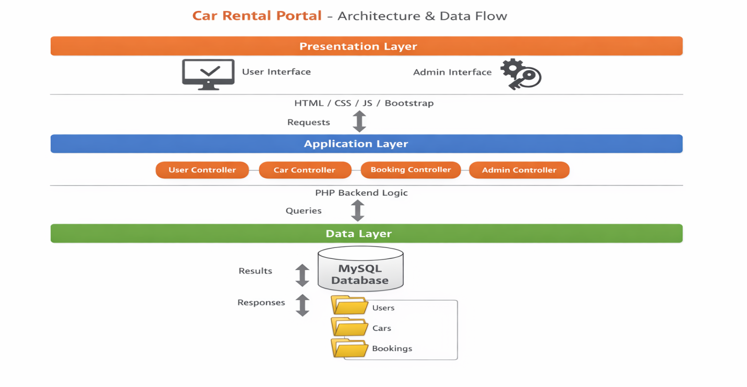

1.4 Controllers and Their Functions:

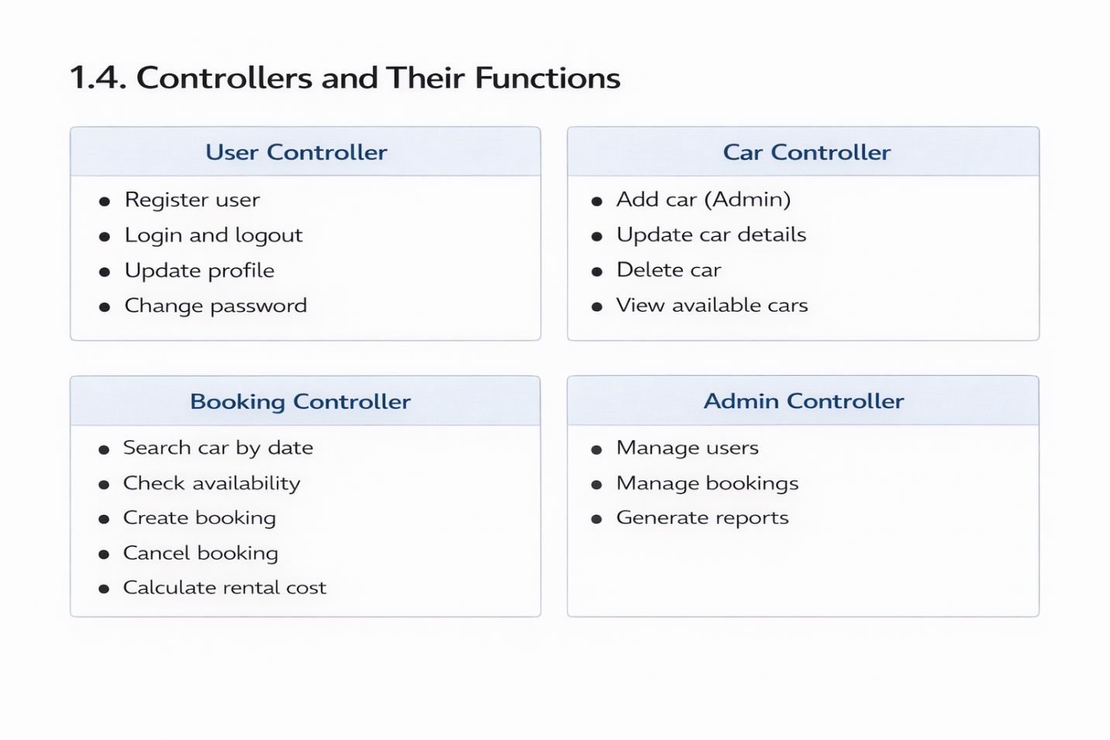

1.5 APIs and Libraries
- Bootstrap: Used for responsive UI design
- jQuery: Used for client-side validation and AJAX requests
- PHP Sessions: Used for authentication and role-based access control

1.6 Coding Conventions
- Meaningful variable and function names
- Separate files for controllers and database connection
- Consistent indentation and comments
- Secure coding practices (input sanitization, password hashing)

1.7 UML Diagrams

UML Overview
Unified Modeling Language (UML) diagrams are used to visually represent the structure and behavior of the Car Rental Portal system. These diagrams help in understanding system components, their relationships, and interaction flow.

1.7.1 Class Diagram Explanation
The Class Diagram represents the static structure of the system by showing system classes, their attributes, methods, and relationships.
Main Classes:
User:
  - Attributes: user_id, full_name, email, password, phone, role
  - Methods: register(), login(), updateProfile(), logout()
Car:
  - Attributes: car_id, brand, model, category, price_per_day, status
  - Methods: addCar(), updateCar(), deleteCar(), viewCar()
Booking:
  - Attributes: booking_id, start_date, end_date, total_price, status
  - Methods: createBooking(), cancelBooking(), calculatePrice()

Relationships:
• User has a one-to-many relationship with Booking
• Car has a one-to-many relationship with Booking

The class diagram ensures modular design and clear separation of responsibilities.
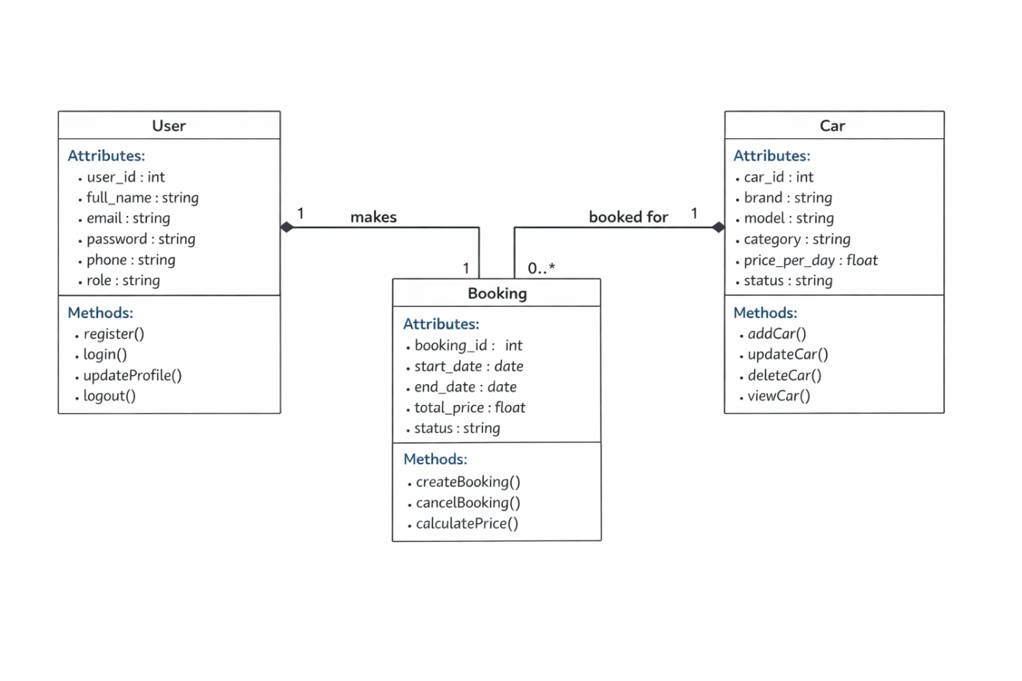

1.8 Sequence Diagram Explanation
The Sequence Diagram explains how objects interact with each other in a specific order over time.

1.8.1 Login Sequence:
- User enters email and password
- Login request is sent to Authentication Controller
- Controller validates credentials from User table
- System creates session on successful login
- User is redirected to dashboard

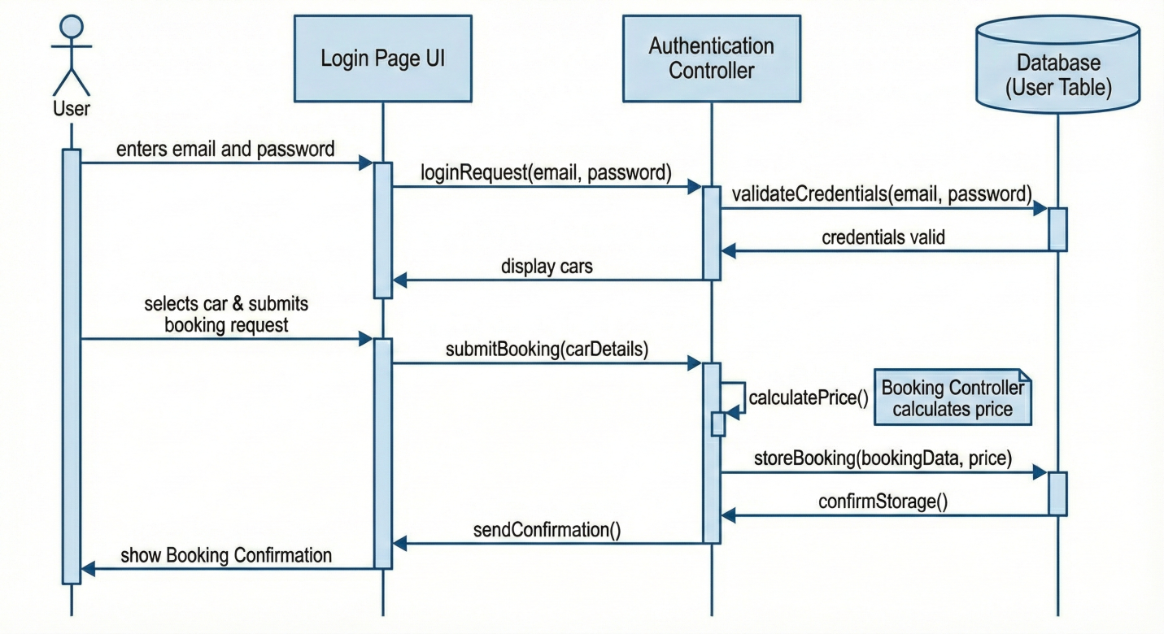
1.8.2 Car Booking Sequence:
- User searches available cars
- System checks availability from Bookings table
- User selects a car and submits booking request
- Booking Controller calculates price
- Booking is stored in database
- Confirmation is shown to user

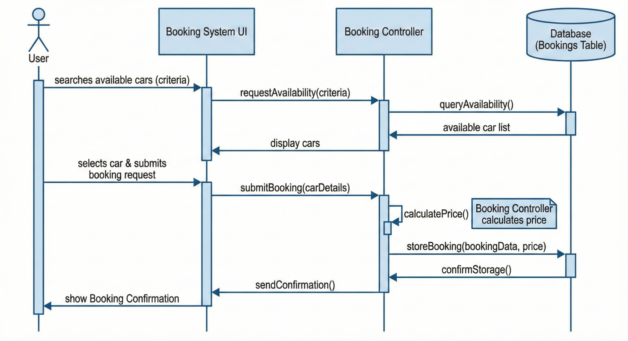

2. Data Model Schema

2.1 Overview
The database schema is designed using a relational model in MySQL. It ensures data integrity, avoids redundancy, and supports efficient booking operations.

2.2 Entities and Attributes

2.2.1 Users Entity
Attribute | Description
user_id (PK) | Unique user identifier
full_name | Customer/Admin name
email | Login email
password | Encrypted password
phone | Contact number
role | customer / admin

2.2.2 Cars Entity
Attribute | Description
car_id (PK) | Unique car identifier
brand | Car brand
model | Car model
category | SUV, Sedan, etc.
price_per_day | Rental price per day
status | Available / Unavailable

2.2.3 Bookings Entity
Attribute | Description
booking_id (PK) | Booking identifier
user_id (FK) | References Users
car_id (FK) | References Cars
start_date | Rental start date
end_date | Rental end date
total_price | Calculated amount
status | Confirmed / Cancelled

2.3 Relationships
- One User can have multiple Bookings
- One Car can be associated with multiple Bookings
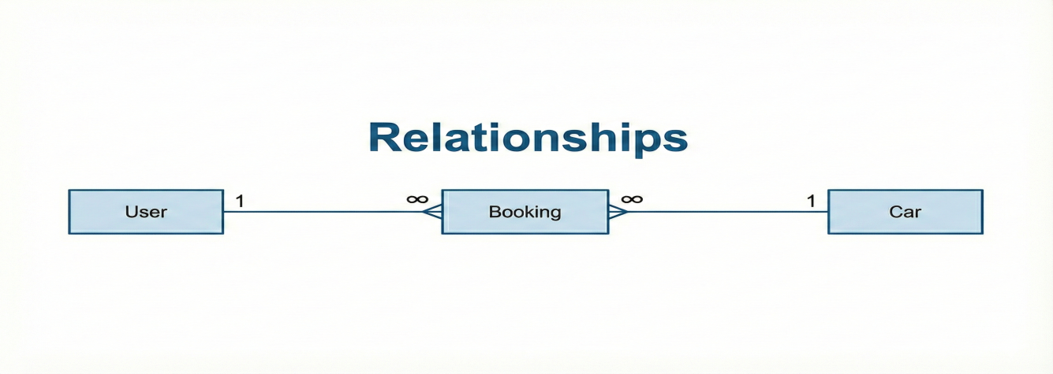

2.4 ER Diagram
The ER diagram shows customers, Cars, Admins and Bookings entities with one-to-many relationships between Users–Bookings and Cars–Bookings.
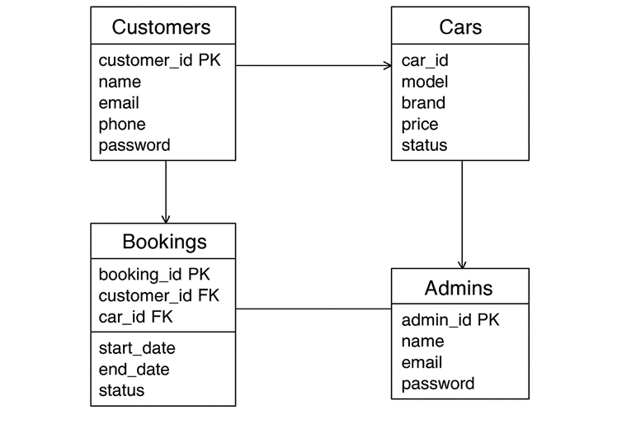

3. User Interface

3.1 Design Philosophy
The user interface is designed to be simple, clean, and responsive. Bootstrap is used to ensure compatibility across desktop, tablet, and mobile devices. The color scheme is minimal, with readable fonts and clear navigation.

3.2 List of Screens
Customer Pages:
- Home Page
- Sign Up Page
- Login Page
- Car Search Page
- Car Details Page
- Booking Page
- User Dashboard
Admin Pages:
- Admin Login Page
- Admin Dashboard
- Manage Cars Page
- Manage Bookings Page
- Manage Users Page

3.3 Controls and Inputs
- Textboxes: Name, Email, Password, Phone
- Dropdowns: Car category, dates
- Buttons: Login, Register, Book Car, Cancel Booking

3.4 Input Constraints
- Email must be in valid format
- Password must be encrypted
- Booking dates must not overlap
- Required fields cannot be empty

