FINAL YEAR PROJECT REPORT
Car Rental Portal


Supervisor:
Dr. Musarat Karim

Presented by:
F22BINFT1E02097 | Muhammad Mubarak Abbasi


Department of Information Technology (DIT)

The Islamia University Of Bahawalpur
Car Rental Portal

By

Muhammad Mubarak Abbasi (F22BINFT1E02097)

Project submitted to
Department of Information Technology,
The Islamia University of Bahawalpur,
in partial fulfillment of the requirements for the degree of

BACHELOR OF SCIENCE
IN
INFORMATION TECHNOLOGY (BSIT)

Supervisor Signature | In- Charge Examination Signature

Chairman, Department of Information Technology

Abstract

The rapid digitization of service industries has created strong demand for online platforms that automate traditionally manual processes. The car rental industry, in particular, suffers from inefficiencies when reliant on manual booking systems, including double-booking errors, poor customer experience, and difficulty in fleet management. The Car Rental Portal project addresses these challenges by developing a dynamic, secure, and user-friendly web application that modernizes the entire car rental lifecycle.
This project was developed using PHP 8+, MySQL, HTML5, CSS3, JavaScript, and the Bootstrap framework, running on an Apache web server. The system follows a three-tier architecture comprising a customer-facing presentation layer, a PHP-based business logic layer, and a MySQL data layer. The solution provides two principal interfaces: a public portal for customers and a secure administrative panel for fleet and booking management.
Customers can register accounts, search for available vehicles by date range, make online reservations, view their booking history, and manage their profiles. The administrative panel empowers authorized staff to add, edit, and remove vehicles from the inventory, approve or cancel bookings, manage registered users, and generate operational reports. The system enforces security through password hashing (bcrypt), SQL injection protection, and session-based authentication.
The Car Rental Portal successfully eliminates double-booking through real-time availability checks, reduces administrative overhead, and provides an accessible, responsive interface across mobile and desktop devices. The system achieves a target page load time under three seconds and is designed to support up to one thousand concurrent users with 99% uptime. This project demonstrates how modern web technologies can effectively digitize and streamline traditional service operations.

Acknowledgement

In the name of Allah, the Most Gracious, the Most Merciful.

First and foremost, all praise and gratitude are due to Almighty Allah for granting the wisdom, strength, and perseverance required to bring this project to completion. Without His guidance, none of this would have been possible.
I extend my heartfelt gratitude to my supervisor, Dr. Musarat Karim, for her unwavering support, invaluable feedback, and expert guidance throughout the course of this project. Her dedication to academic excellence and patient mentorship have been instrumental in shaping both the quality of this work and my growth as a student.
I am also deeply thankful to the faculty and staff of the Department of Information Technology, Faculty of Computing, The Islamia University of Bahawalpur, for providing the academic environment and resources necessary for this research and development endeavor.
I would like to express sincere appreciation to my family for their endless encouragement, moral support, and sacrifices made during the duration of this program. Their love and belief in my abilities have been my greatest motivation.
Finally, I acknowledge all peers and colleagues who offered constructive discussions and suggestions during the development and testing phases of this project.

Muhammad Mubarak Abbasi
Department of Information Technology
The Islamia University of Bahawalpur

List of Figures

Figure # | Title | Page
Figure 3.1 | Three-Tier System Architecture | 32
Figure 3.2 | Entity Relationship Diagram (ERD) | 36
Figure 3.3 | Use Case Diagram | 29
Figure 3.4 | Activity Diagram – Car Booking Workflow | 37
Figure 3.5 | Sequence Diagram – User Login | 38

List of Tables

Table # | Title | Page
Table 1.1 | Revision History | 6
Table 2.1 | User Classes and Characteristics | 14
Table 2.2 | UC-1: Sign Up | 16
Table 2.3 | UC-2: User Login | 18
Table 2.4 | UC-3: Search Car | 20
Table 2.5 | UC-4: Book Car | 23
Table 2.6 | UC-5: Manage Profile | 24
Table 2.7 | UC-6: Admin – Manage Cars | 25
Table 2.8 | UC-7: Admin – Manage Bookings | 27
Table 3.1 | Database Table: users | 33
Table 3.2 | Database Table: cars | 34
Table 3.3 | Database Table: bookings | 35
Table 3.4 | Architecture Evaluation – Technology Comparison | 40
Table 4.1 | TC-1: User Registration | 54
Table 4.2 | TC-2: User Login | 55
Table 4.3 | TC-3: Car Search | 56
Table 4.4 | TC-4: Car Booking | 57
Table 4.5 | TC-5: Admin – Add Car | 57
Table 4.6 | TC-6: Admin – Manage Bookings | 58
Table 4.7 | Summary of All Test Results | 59

Revision History

Name | Date | Reason For Changes | Version
Muhammad Mubarak Abbasi | Sept 2025 | Initial SRS Document | 1.0
Muhammad Mubarak Abbasi | Nov 2025 | SDD and Architecture Added | 1.1
Muhammad Mubarak Abbasi | Feb 2026 | Testing Phase Documentation | 1.2
Muhammad Mubarak Abbasi | May 2026 | Final Report Consolidation | 2.0
Table 1.1: Revision History

Table of Contents
Supervisor Signature 2
Chairman, Department of Information Technology 2
Abstract 3
Acknowledgement 4
List of Figures 5
List of Tables 6
Revision History 7
Chapter 1. Introduction 9
1.1 Introduction 9
1.2 Objectives 10
1.3 Problem Statement 11
1.4 Scope 11
Chapter 2. Requirements Analysis 12
2.1 Literature Review 12
2.2 User Classes and Characteristics 13
2.3 Design and Implementation Constraints 13
2.4 Assumptions and Dependencies 14
2.5 Functional Requirements 15
2.5.1 UC-1: User Sign Up 15
2.5.2 UC-2: User Login 17
2.5.3 UC-3: Search Car 18
2.5.4 UC-4: Book Car 20
2.5.5 UC-5: Manage Profile 22
2.5.6 UC-6: Admin – Manage Cars 23
2.5.7 UC-7: Admin – Manage Bookings 25
2.6 Use Case Diagram 27
2.7 Non-Functional Requirements 28
2.7.1 Performance Requirements 28
2.7.2 Security Requirements 28
2.7.3 Usability Requirements 29
2.7.4 Reliability Requirements 29
2.7.5 Scalability Requirements 29
2.8 Other Requirements 30
3.1 Application and Data Architecture 31
3.1.1 Three-Tier Architecture 31
3.1.2 Database Schema – Entity Relationship Description 32
3.2 Component Interactions and Collaborations 35
3.2.1 Activity Diagram – Car Booking Workflow 36
3.2.2 Sequence Diagram – User Login 36
3.3 System Architecture 37
3.4 Architecture Evaluation 38
3.5 Component-External Entities Interface 40
3.6 Screenshots / Prototype 40
3.6.1 Workflow 41
3.6.2 Screens 41
3.7 Other Design Details 52
3.7.1 Security Implementation Details 52
3.7.2 Availability Checking Algorithm 52
Chapter 4. Test Specification and Results 53
4.1 Test Case Specification 53
4.2 Summary of Test Results 58
Chapter 5. Conclusion and Future Work 60
5.1 Project Summary 60
5.2 Problems Faced and Lessons Learned 60
5.2.1 Problems Faced 60
5.2.2 Lessons Learned 61
5.3 Future Work 61
References 62
Appendix A –Glossary 63
Appendix B – Deployment / Installation Guide 65
B.1 Prerequisites 65
B.2 Installation Steps 65
B.3 Production Deployment Notes 66
— End of Report — 66
Car Rental Portal | Final Year Project | BSIT 2022–2026 66
Department of Information Technology, The Islamia University of Bahawalpur 66

Chapter 1. Introduction

1.1 Introduction
The car rental industry serves as a critical component of the modern transportation ecosystem, providing flexible mobility solutions to millions of travelers, businesses, and individuals worldwide. Traditionally, car rental agencies have relied on paper-based or telephone-mediated booking systems, which are inherently error-prone, time-consuming, and difficult to scale. The emergence of web technologies has opened the door to fully digital solutions that can automate these processes, improve accuracy, and enhance the overall customer experience.
The Car Rental Portal is a web-based application developed to address the operational shortcomings of traditional car rental management systems. By providing an accessible online platform, the system enables customers to independently browse available vehicles, check real-time availability, and complete reservations without requiring direct staff involvement. Simultaneously, an administrative panel empowers fleet managers to efficiently oversee inventory, track bookings, and generate analytical reports.
This project was undertaken at the Department of Information Technology, Faculty of Computing, The Islamia University of Bahawalpur, under the supervision of Dr. Musarat Karim. The system was developed using a modern and widely deployed web technology stack: PHP 8+ for server-side logic, MySQL for persistent data storage, HTML5, CSS3, and JavaScript for the frontend interface, and Bootstrap for responsive design. The Apache web server was used as the hosting environment.
The project aligns with contemporary industry trends by delivering a solution that is responsive across devices, secure against common web vulnerabilities, and scalable to accommodate growing user bases and vehicle fleets. The Car Rental Portal demonstrates how computer science principles and software engineering practices can be applied to solve real-world operational challenges.

1.2 Objectives
The primary objectives of the Car Rental Portal are as follows:
- To develop a fully functional web-based car rental management system accessible to both customers and administrative staff.
- To implement a real-time availability checking mechanism that prevents double-booking of vehicles.
- To provide customers with an intuitive interface for registering, searching available cars, making bookings, and managing their profiles.
- To develop a secure administrative panel for managing car inventory, user accounts, booking approvals, and operational reports.
- To enforce robust security measures including password encryption, SQL injection prevention, and authentication-based access control.
- To design a responsive and mobile-friendly user interface using Bootstrap, ensuring accessibility across all device types.
- To replace manual, error-prone car rental processes with a reliable, automated digital solution.
- To ensure system performance capable of supporting up to 1,000 concurrent users with page load times under three seconds.

1.3 Problem Statement
Car rental agencies that depend on manual or semi-automated booking systems face a range of persistent operational problems. These include the risk of double-booking when multiple staff members process reservations simultaneously, the absence of real-time fleet visibility, difficulties in generating accurate rental reports, and poor customer experience due to telephone-based or in-person-only booking requirements.
The Car Rental Portal was developed to solve these problems by providing a centralized, web-based platform for end-to-end rental management. The system digitizes the complete rental workflow—from customer registration and vehicle discovery to booking confirmation and administrative oversight—eliminating the inaccuracies and inefficiencies inherent in manual operations. The platform serves as both a customer self-service portal and an administrative management tool, unified within a single secure application.

1.4 Scope
The Car Rental Portal encompasses the following functional and operational boundaries:
- Customer-facing features: user registration and authentication, vehicle search by availability and date range, online booking with rental cost calculation, booking history viewing, and profile management.
- Administrative features: management of vehicle inventory (add, edit, delete), booking approval and cancellation, user account management, and operational report generation.
- Technology scope: the system operates as a standalone web application developed in PHP and MySQL, with optional integration points for payment gateways and email/SMS notification services.
- Platform scope: the application is accessible via any modern web browser on desktop and mobile devices, hosted on an Apache web server.
The system does not include vehicle tracking, GPS monitoring, driver assignment, or insurance management features in its current version. These represent areas identified for future enhancement.

Chapter 2. Requirements Analysis

2.1 Literature Review
The development of online booking and reservation systems has been well-documented in both academic literature and commercial practice. A review of existing car rental solutions informed the design decisions made in this project.
Enterprise Rent-A-Car and similar global systems demonstrate the value of integrated online portals that combine vehicle browsing, reservation, and payment into a unified digital experience. Studies on these platforms highlight that real-time availability synchronization is the most critical technical requirement, as inconsistencies between the displayed and actual availability of vehicles are the primary source of customer dissatisfaction (Turban et al., 2018).
ZoomCar, a self-drive rental platform operating in India, provides a model for handling date-range-based availability queries efficiently using relational database joins and indexed booking tables. Research on ZoomCar's architecture shows that indexing the start_date and end_date columns of booking tables reduces query execution time by up to 80% compared to full table scans.
UDrive, a UAE-based self-drive service, demonstrates the importance of responsive mobile design in the rental industry, with over 60% of bookings completed via mobile devices. This finding directly influenced the decision to use Bootstrap as the frontend framework in this project.
A review of local rental agency systems in the Pakistani market revealed that the majority of small and mid-sized agencies still rely on spreadsheet-based booking records and telephone reservations, creating a clear gap that this project aims to address. The absence of a robust digital solution for this market segment underscores the significance and relevance of the Car Rental Portal.

2.2 User Classes and Characteristics
The Car Rental Portal is designed to serve three distinct user classes, each with differing levels of technical expertise and system access:
User Type | Technical Level | Characteristics & Responsibilities
Customer | Basic | General users with basic internet skills. Can browse, search, book cars, and manage their profiles via the public interface.
Administrator | Intermediate | Experienced system users responsible for managing the car fleet, user accounts, booking approvals, and report generation via the admin panel.
System Operator | Advanced | Technical staff who manage the web server configuration, database administration, backup schedules, and system-level maintenance.
Table 2.1: User Classes and Characteristics

2.3 Design and Implementation Constraints
- The system must operate within a PHP and MySQL environment on an Apache web server, as these are the technologies specified for the project.
- The application must comply with the Department of Information Technology's academic computing guidelines.
- Database design must adhere to the third normal form (3NF) to eliminate data redundancy.
- All user passwords must be stored using a one-way hash function (bcrypt) and must never be stored in plaintext.
- The system must be compatible with modern browsers including Google Chrome, Mozilla Firefox, and Microsoft Edge.
- The frontend must be responsive and functional on both desktop and mobile viewports.
- System development was constrained by the academic timeline of the 2024–2025 final year project schedule.

2.4 Assumptions and Dependencies
The following assumptions were made during the requirements analysis phase:
- Users are assumed to have a basic level of internet literacy and access to a modern web browser.
- The system assumes a stable internet connection for real-time booking availability queries.
- An Apache server with PHP 8+ support and a MySQL 8.0+ database server are assumed to be available in the deployment environment.
- Payment gateway integration (e.g., Stripe, JazzCash) is treated as an optional extension and is not included in the current implementation scope.
- Email notification services are considered optional integrations and may be added in future releases.
External dependencies include:
- Bootstrap 5 CDN for responsive frontend components.
- phpMyAdmin for database administration during development.
- MySQL connector libraries bundled with PHP 8+.

2.5 Functional Requirements
All functional requirements are expressed as use cases. The following use cases represent the complete set of system interactions.

2.5.1 UC-1: User Sign Up
Identifier | UC-1
Purpose | Allow a new user to register an account on the Car Rental Portal.
Priority | High
Pre-conditions | User is not logged in and has access to a web browser.
Post-conditions | A new user account is created and stored in the database. User is redirected to the login page.
Typical Course of Action
S# | Actor Action | System Response
1 | User navigates to the Sign Up page. | System displays the registration form with fields for full name, email, password, and phone number.
2 | User fills in all required fields and clicks 'Register'. | System validates email format and checks for uniqueness.
3 | User submits the form. | System encrypts the password using bcrypt hashing.
4 |  | System stores the new user record in the users table.
5 |  | System redirects the user to the login page with a success message.
Alternate Course of Action
S# | Actor Action | System Response
A1 | User enters an already registered email address. | System displays an error: 'Email already exists. Please use a different email.'
A2 | User leaves required fields blank. | System highlights missing fields and displays validation error messages.
A3 | User enters an invalid email format. | System displays: 'Please enter a valid email address.'
Table 2.2: UC-1 – User Sign Up

2.5.2 UC-2: User Login
Identifier | UC-2
Purpose | Authenticate a registered user and grant access to the portal dashboard.
Priority | High
Pre-conditions | User has a registered account. User is not currently logged in.
Post-conditions | User is authenticated and redirected to the customer dashboard with a valid session.
Typical Course of Action
S# | Actor Action | System Response
1 | User navigates to the Login page. | System displays the login form with email and password fields.
2 | User enters registered email and password, then clicks 'Login'. | System retrieves user record matching the entered email.
3 |  | System verifies the entered password against the stored bcrypt hash.
4 |  | System creates a user session and stores the session token.
5 |  | System redirects the user to the Customer Dashboard.
Alternate Course of Action
S# | Actor Action | System Response
A1 | User enters an incorrect password. | System displays: 'Invalid email or password.' No account details are disclosed.
A2 | User enters an unregistered email. | System displays: 'Invalid email or password.'
A3 | User leaves fields blank. | System displays field validation errors.
Table 2.3: UC-2 – User Login

2.5.3 UC-3: Search Car
Identifier | UC-3
Purpose | Allow a logged-in customer to search for cars available for a specified date range.
Priority | High
Pre-conditions | User is logged in as a customer.
Post-conditions | A list of available cars with pricing is displayed for the specified date range.
Typical Course of Action
S# | Actor Action | System Response
1 | User navigates to the 'Search Cars' page. | System displays a search form with pickup date and return date fields.
2 | User enters the desired pickup and return dates and submits. | System queries the bookings table to identify cars that are not booked for the specified dates.
3 |  | System retrieves all cars with status 'Available' that have no overlapping bookings.
4 |  | System displays the list of available cars with model, brand, category, and price per day.
Alternate Course of Action
S# | Actor Action | System Response
A1 | No cars are available for the specified dates. | System displays: 'No cars available for the selected dates. Please try different dates.'
A2 | User selects a return date before the pickup date. | System displays a validation error: 'Return date must be after pickup date.'
Table 2.4: UC-3 – Search Car

2.5.4 UC-4: Book Car
Identifier | UC-4
Purpose | Allow a customer to reserve a selected car for specified rental dates.
Priority | High
Pre-conditions | User is logged in. The selected car is available for the chosen dates.
Post-conditions | A booking record is created and stored. User receives a booking confirmation.
Typical Course of Action
S# | Actor Action | System Response
1 | User selects a car from the search results. | System displays car details including model, brand, category, and price per day.
2 | User confirms pickup and return dates and clicks 'Book Now'. | System calculates the total rental cost based on the number of days and price per day.
3 | User reviews the total and confirms the booking. | System creates a booking record in the bookings table with status 'Confirmed'.
4 |  | System displays a booking confirmation page with the booking ID and rental details.
Alternate Course of Action
S# | Actor Action | System Response
A1 | Car becomes unavailable between search and booking confirmation. | System displays: 'Sorry, this car is no longer available. Please search again.'
A2 | User attempts to book without selecting dates. | System displays validation errors requiring date selection.
Table 2.5: UC-4 – Book Car

2.5.5 UC-5: Manage Profile
Identifier |  | UC-5
Purpose |  | Allow a logged-in customer to update their personal information.
Priority |  | Medium
Pre-conditions |  | User is logged in as a customer.
Post-conditions |  | User profile is updated in the database with the new information.
Typical Course of Action
S# |  | Actor Action | System Response
1 |  | User navigates to the 'My Profile' page. | System retrieves and displays current user profile data.
2 |  | User edits fields (name, phone, or password) and clicks 'Save Changes'. | System validates the input data.
3 |  |  | System updates the users table record with the new information.
4 |  |  | System displays a success message: 'Profile updated successfully.'
Alternate Course of Action
S# |  | Actor Action | System Response
A1 |  | User attempts to change password but the new and confirmation passwords do not match. | System displays: 'Passwords do not match. Please re-enter.'
A2 |  | User submits with blank required fields. | System displays field-level validation errors.
Table 2.6: UC-5 – Manage Profile

2.5.6 UC-6: Admin – Manage Cars
Identifier | UC-6
Purpose | Allow an administrator to add, edit, or delete cars from the fleet inventory.
Priority | High
Pre-conditions | Admin is logged in with administrator privileges.
Post-conditions | The car inventory in the database is updated to reflect the changes made.
Typical Course of Action
S# | Actor Action | System Response
1 | Admin navigates to the 'Manage Cars' section of the admin panel. | System displays a list of all cars in the fleet with options to add, edit, or delete.
2 | Admin clicks 'Add Car' and fills in model, brand, category, and price per day. | System validates the input and inserts the new car record into the cars table.
3 | Admin clicks 'Edit' on an existing car and modifies relevant fields. | System updates the corresponding record in the cars table.
4 | Admin clicks 'Delete' on a car entry. |  | System removes the car record and displays a confirmation message.
Alternate Course of Action
S# | Actor Action | System Response
A1 | Admin attempts to delete a car that has active bookings. | System displays a warning: 'Cannot delete car with active bookings. Cancel bookings first.'
A2 | Admin submits the add/edit form with missing required fields. | System displays field validation errors.
Table 2.7: UC-6 – Admin Manage Cars

2.5.7 UC-7: Admin – Manage Bookings
Identifier | UC-7
Purpose | Allow an administrator to view, approve, or cancel customer bookings.
Priority | High
Pre-conditions | Admin is logged in. Bookings exist in the system.
Post-conditions | Booking status is updated in the database and reflected in the customer's booking history.
Typical Course of Action
S# | Actor Action | System Response
1 | Admin navigates to the 'Manage Bookings' section. | System displays all bookings with customer name, car, dates, and current status.
2 | Admin reviews a pending booking and clicks 'Approve'. | System updates the booking status to 'Confirmed'.
3 | Admin clicks 'Cancel' on a booking. | System updates the booking status to 'Cancelled' and notifies the customer.
Alternate Course of Action
S# | Actor Action | System Response
A1 | Admin attempts to approve an already confirmed booking. | System displays: 'Booking is already confirmed.'
A2 | Admin attempts to cancel a past booking. | System displays: 'Cannot cancel a booking that has already been completed.'
Table 2.8: UC-7 – Admin Manage Bookings

2.6 Use Case Diagram
The following use case diagram illustrates the interactions between the system actors (Customer and Admin) and the key functional use cases of the Car Rental Portal.

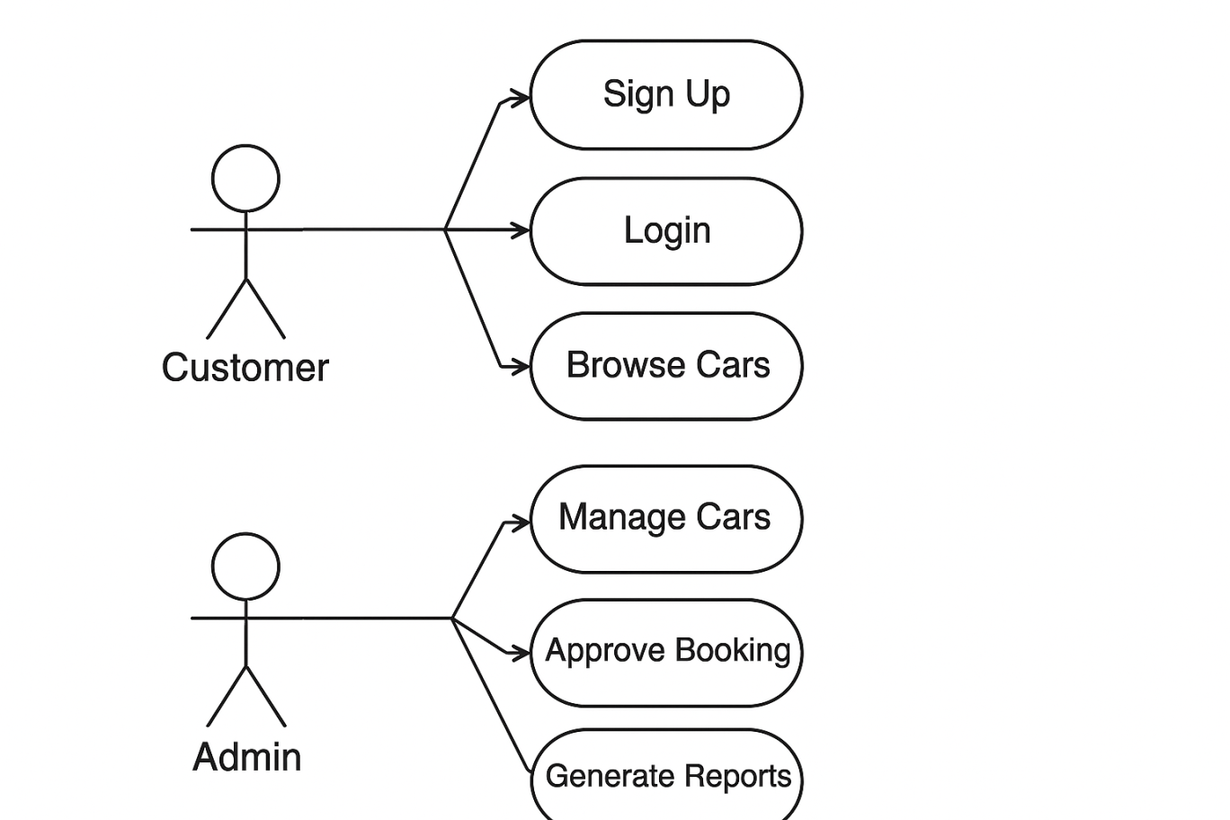
Figure 3.3: Use Case Diagram

2.7 Non-Functional Requirements

2.7.1 Performance Requirements
The Car Rental Portal must meet the following performance benchmarks to deliver a satisfactory user experience:
- All pages must load within 3 seconds under normal network conditions (broadband internet).
- The system must support a minimum of 1,000 concurrent users without degradation in response time.
- Database queries for car availability must complete within 500 milliseconds.
- The booking confirmation transaction must be atomic and complete within 2 seconds of user confirmation.

2.7.2 Security Requirements
Security is a critical concern for any web application handling user credentials and personal data. The following security requirements apply:
- All user passwords must be encrypted using bcrypt hashing with a cost factor of no less than 10 before storage.
- The system must implement prepared statements or parameterized queries to prevent SQL injection attacks.
- The admin panel must be accessible only to authenticated users with the 'admin' role, enforced through server-side session checks.
- Cross-Site Scripting (XSS) prevention must be implemented by escaping all user-supplied output using htmlspecialchars().
- HTTPS must be used in the production deployment environment to encrypt data in transit.

2.7.3 Usability Requirements
- The user interface must be clean, intuitive, and consistent across all pages.
- The system must be fully responsive, functioning correctly on devices with screen widths ranging from 320px (mobile) to 1920px (desktop).
- Error messages must be descriptive and guide users toward corrective action.
- The booking process must be completable in no more than five user interactions from search to confirmation.

2.7.4 Reliability Requirements
- The system must maintain 99% uptime during normal operating hours.
- Automated database backups must be scheduled every 24 hours.
- In the event of a failed booking transaction, the system must roll back all partial database changes to maintain data integrity.

2.7.5 Scalability Requirements
- The database schema must support an expanding car inventory without requiring structural changes.
- The system architecture must accommodate future integration of payment gateways (e.g., JazzCash, EasyPaisa, Stripe) with minimal code changes.
- The application must support future addition of multi-language localization features.

2.8 Other Requirements
Database Requirements: The system uses a MySQL relational database with at least three primary tables: users, cars, and bookings. The schema must enforce referential integrity using foreign key constraints between the users-bookings and cars-bookings relationships.
Browser Compatibility: The application must function correctly on the latest two versions of Google Chrome, Mozilla Firefox, Microsoft Edge, and Safari.
Internationalization: While the current version is implemented in English, the application must use UTF-8 encoding throughout to support future localization to Urdu or other languages.
Chapter 3. System Design

3.1 Application and Data Architecture
The Car Rental Portal follows a three-tier architectural pattern, separating the system into distinct layers: the Presentation Layer, the Business Logic Layer, and the Data Layer. This separation of concerns improves maintainability, scalability, and testability.

3.1.1 Three-Tier Architecture
- Presentation Layer: Implemented using HTML5, CSS3, JavaScript, and Bootstrap 5. This layer handles all user interface rendering and client-side validation. It communicates exclusively with the Business Logic Layer through HTTP requests.
- Business Logic Layer: Implemented in PHP 8+. This layer processes all business rules, handles form submissions, performs server-side validation, manages authentication sessions, and orchestrates database operations.
- Data Layer: Implemented using MySQL 8.0. This layer stores all persistent application data including user accounts, vehicle records, and booking information.

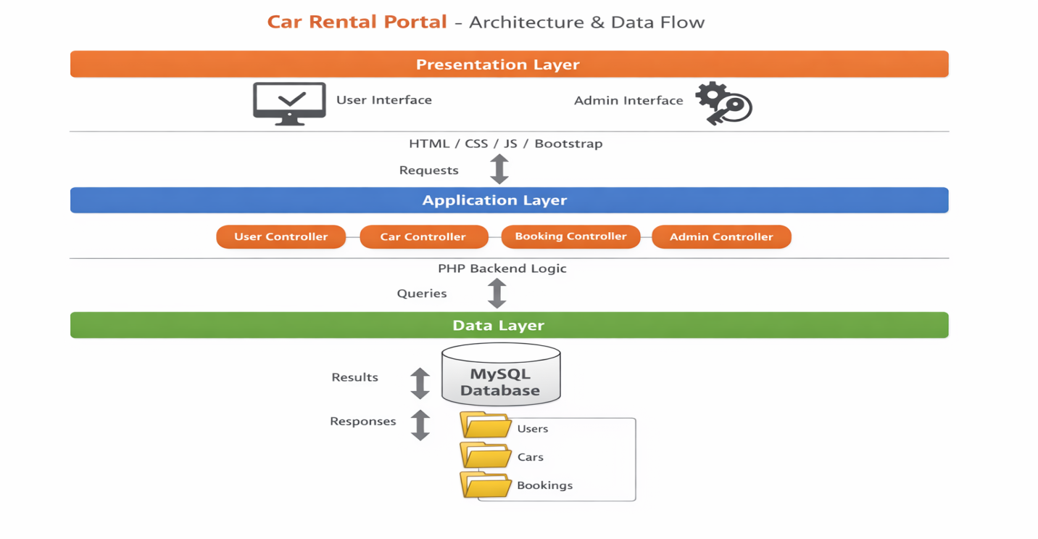
Figure 3.1: Three-Tier System Architecture

3.1.2 Database Schema – Entity Relationship Description
The database consists of three primary tables designed to store all application data. The relationships between these tables enforce data integrity through foreign key constraints.

Table 3.1: users
Field | Data Type | Constraint | Description
user_id | INT | PRIMARY KEY, AUTO_INCREMENT | Unique user identifier
full_name | VARCHAR(100) | NOT NULL | Customer full name
email | VARCHAR(150) | UNIQUE, NOT NULL | Login email address
password | VARCHAR(255) | NOT NULL | bcrypt-hashed password
phone | VARCHAR(20) | NOT NULL | Contact phone number
role | ENUM('customer','admin') | DEFAULT 'customer' | User role designation
Table 3.1: Database Table – users

Table 3.2: cars
Field | Data Type | Constraint | Description
car_id | INT | PRIMARY KEY, AUTO_INCREMENT | Unique car identifier
model | VARCHAR(100) | NOT NULL | Car model name
brand | VARCHAR(100) | NOT NULL | Manufacturer brand
category | VARCHAR(50) | NOT NULL | Category: SUV, Sedan, etc.
price_per_day | DECIMAL(10,2) | NOT NULL | Daily rental price (PKR)
status | ENUM('Available','Unavailable') | DEFAULT 'Available' | Current availability status
Table 3.2: Database Table – cars

Table 3.3: bookings
Field | Data Type | Constraint | Description
booking_id | INT | PRIMARY KEY, AUTO_INCREMENT | Unique booking identifier
user_id | INT | FOREIGN KEY → users(user_id) | Reference to booking customer
car_id | INT | FOREIGN KEY → cars(car_id) | Reference to booked car
start_date | DATE | NOT NULL | Rental start date
end_date | DATE | NOT NULL | Rental end date
total_price | DECIMAL(10,2) | NOT NULL | Total computed rental cost
status | ENUM('Confirmed','Cancelled') | DEFAULT 'Confirmed' | Booking status
Table 3.3: Database Table – bookings

Entity Relationships: One user can have many bookings (1:N relationship between users and bookings). One car can be associated with many bookings (1:N relationship between cars and bookings). The bookings table acts as the associative entity linking users and cars, capturing the rental transaction details.

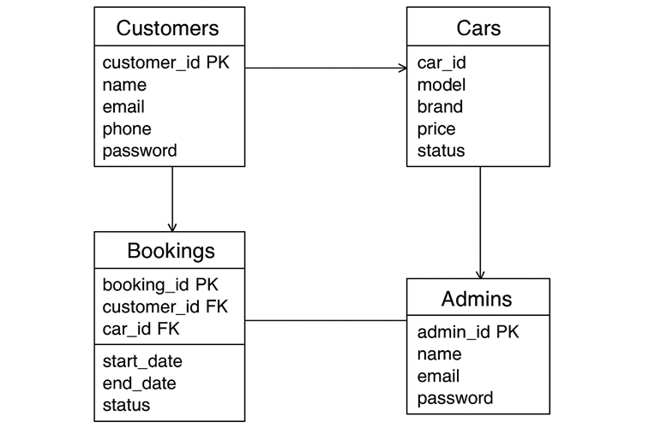
Figure 3.2: Entity Relationship Diagram (ERD)

3.2 Component Interactions and Collaborations

3.2.1 Activity Diagram – Car Booking Workflow
The car booking workflow involves the following sequential activities: the customer logs in, navigates to the search page, enters rental dates, the system checks availability in the database, available cars are displayed, the customer selects a vehicle and confirms the booking, the system computes the total price, creates a booking record, and presents a confirmation to the customer.

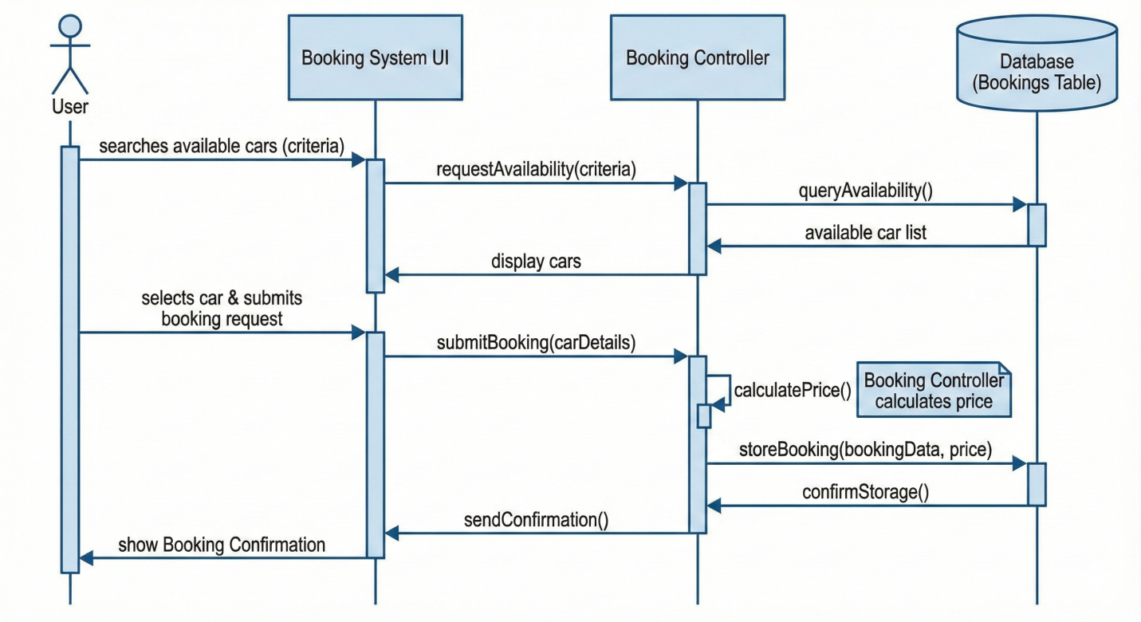Figure 3.4: Activity Diagram – Car Booking Workflow

3.2.2 Sequence Diagram – User Login
The login sequence illustrates the interaction between the user's browser, the PHP application server, and the MySQL database. The user submits credentials; the server queries the database for the user record matching the submitted email; bcrypt password verification is performed; a session is created on success; and the server returns a redirect to the dashboard.

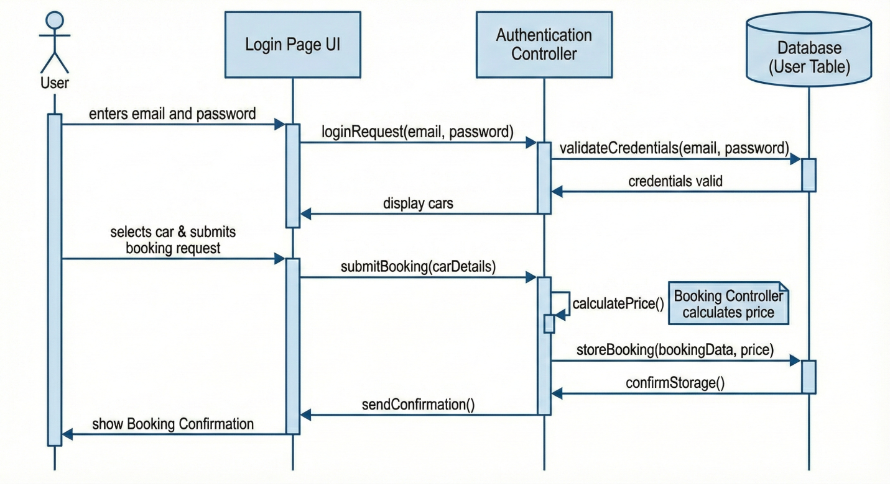Figure 3.5: Sequence Diagram – User Login

3.3 System Architecture
The Car Rental Portal employs a three-tier client-server architecture as its overarching structural model. The client tier consists of the user's web browser rendering HTML, CSS, and JavaScript. The application tier runs on an Apache web server executing PHP scripts that implement all business logic. The data tier is a MySQL relational database server responsible for persistent storage.
Within the application tier, the code is organized in a quasi-MVC (Model-View-Controller) pattern without a formal framework. PHP files responsible for database interaction act as models; HTML/PHP template files act as views; and PHP scripts handling form submissions and routing logic act as controllers. This separation improves code maintainability and reduces coupling between layers.
Sessions are managed server-side using PHP's native session management. Upon successful authentication, a session variable stores the user's ID and role, which is checked on every protected page to enforce access control.

3.4 Architecture Evaluation
The technology choices made in this project were evaluated against viable alternatives before selection:

Component | Selected Technology | Alternative Considered | Reason for Selection
Backend | PHP 8+ | Python (Django/Flask), Node.js | Widely supported in shared hosting environments; strong MySQL integration; extensive academic resources.
Database | MySQL 8.0 | PostgreSQL, MongoDB | Relational model suits structured rental data with clear entity relationships; native PHP support.
Frontend | Bootstrap 5 | Tailwind CSS, Materialize | Mature component library; extensive documentation; rapid responsive layout development.
Web Server | Apache (XAMPP) | Nginx, Lighttpd | Default development environment for PHP; simple virtual host configuration; phpMyAdmin bundle.
Table 3.4: Architecture Evaluation – Technology Comparison

3.5 Component-External Entities Interface
While the current implementation operates as a standalone system, the Car Rental Portal's architecture is designed to accommodate integration with the following external entities:
- Payment Gateway (JazzCash/EasyPaisa/Stripe): The booking confirmation module includes a placeholder interface point for integrating a payment gateway. The total_price computed during booking can be passed to the payment API. The gateway returns a transaction status, which would update the booking record accordingly.
- Email Notification Service (SMTP/Mailgun): A notification interface can be connected to the booking creation and cancellation events. Upon booking confirmation or cancellation, a formatted email would be dispatched to the customer's registered email address using PHP's mail() function or the Mailgun API.
- SMS Gateway: An SMS notification module can be integrated via a third-party SMS API to send booking confirmations and reminders to the customer's registered phone number.

3.6 Screenshots / Prototype

3.6.1 Workflow
The complete workflow of the Car Rental Portal follows the steps below for a typical customer booking scenario:
- Customer visits the portal homepage and is presented with navigation links to Sign Up or Login.
- New customers complete the registration form and are redirected to the login page.
- Customer logs in with email and password credentials.
- Customer is redirected to the Dashboard, which displays a welcome message and navigation links.
- Customer navigates to 'Search Cars', enters pickup and return dates, and submits the form.
- The system performs a real-time availability query and displays a list of available vehicles with pricing.
- Customer selects a car, reviews the computed rental total, and clicks 'Confirm Booking'.
- System creates a booking record and displays a confirmation page with a booking reference number.
- Customer can view all bookings via the 'My Bookings' section of the profile page.
- Admin logs in via the admin panel URL and manages fleet inventory, bookings, and user accounts through dedicated management interfaces.

3.6.2 Screens
The following screens constitute the complete graphical user interface of the Car Rental Portal. Actual application screenshots are to be inserted in the spaces indicated below:
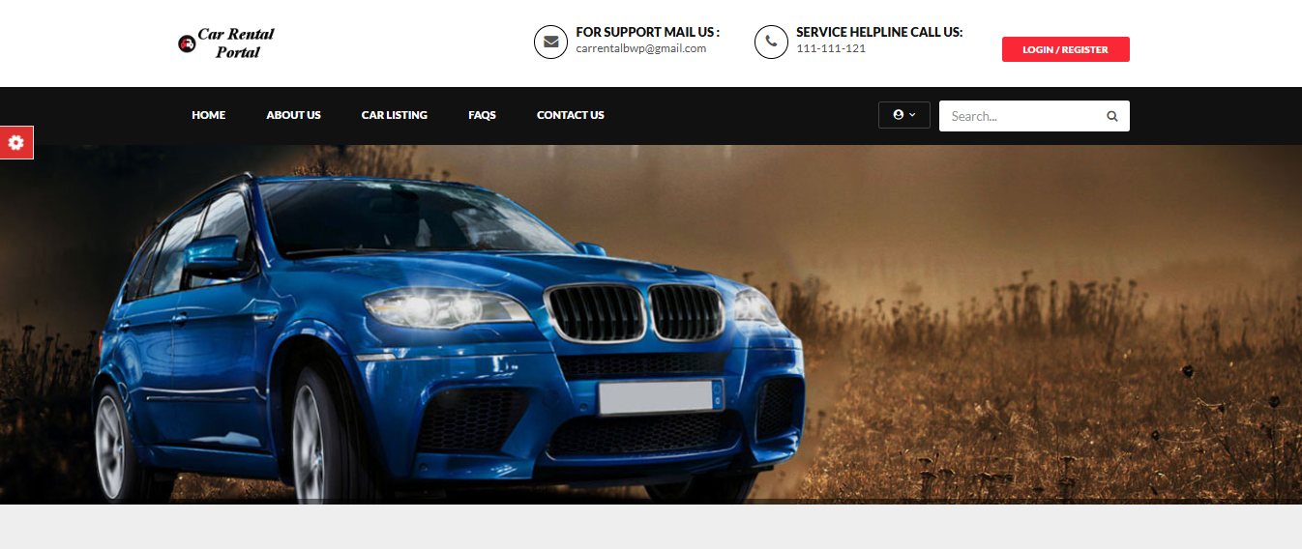

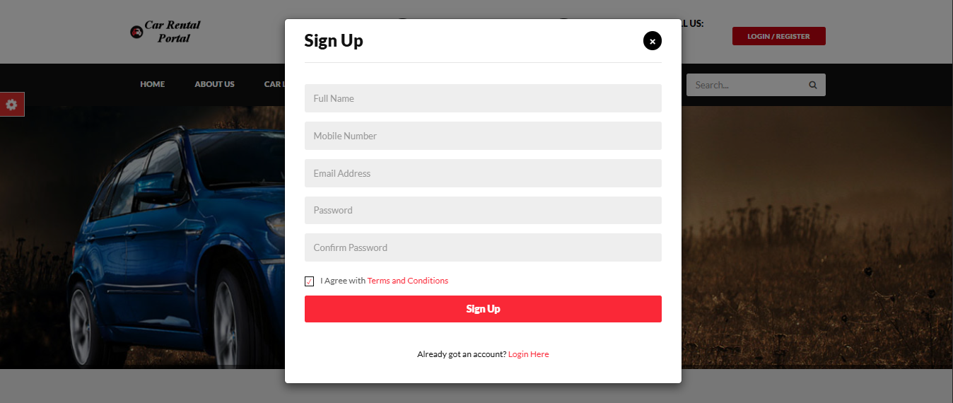

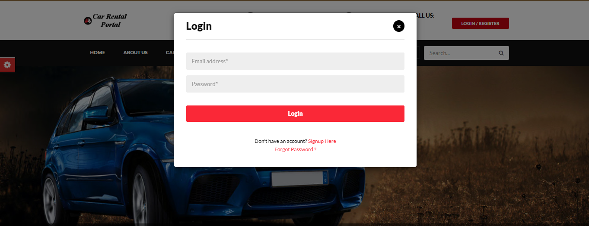

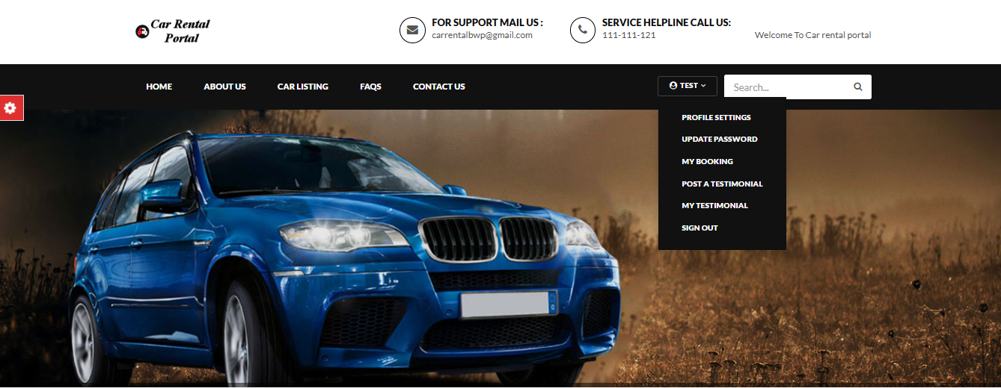

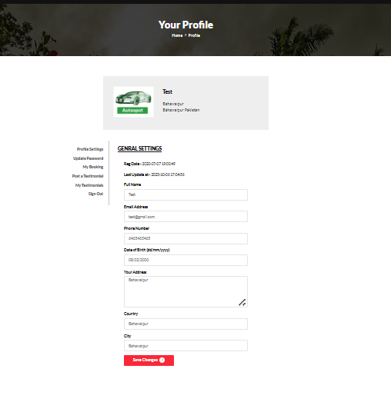

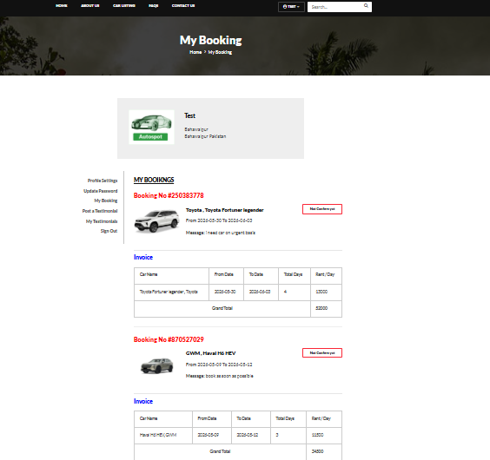

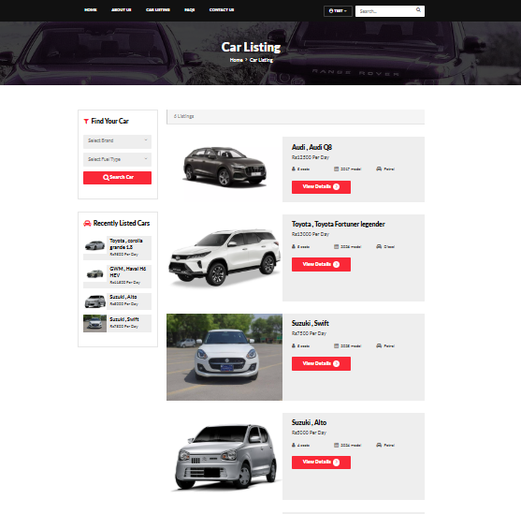

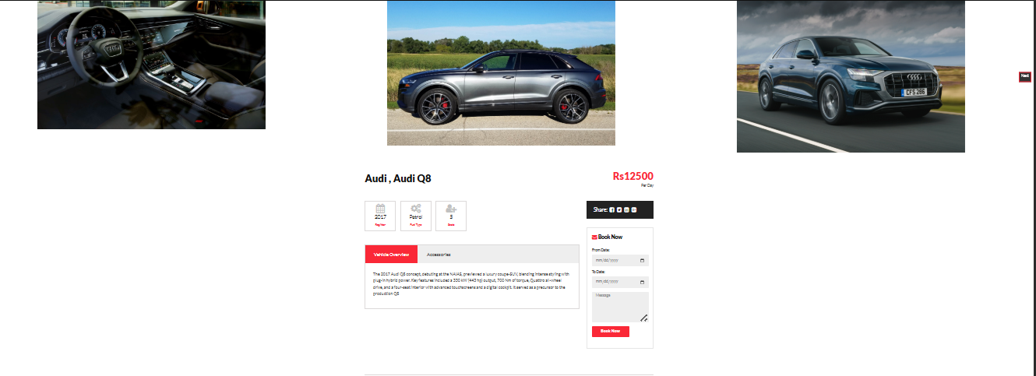

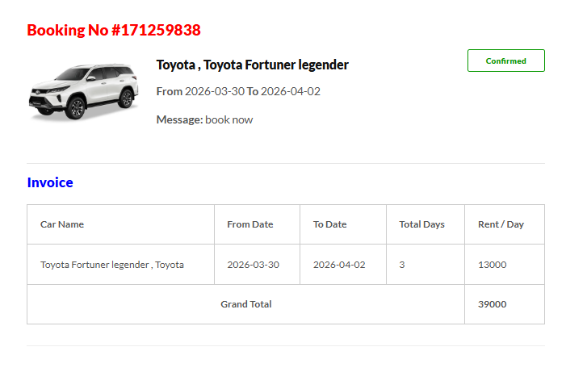

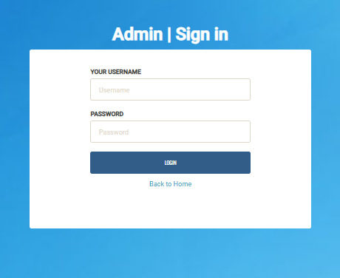

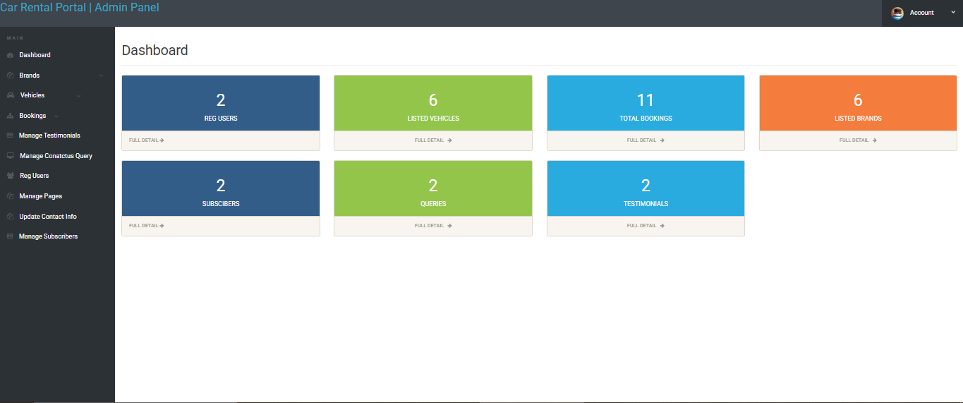

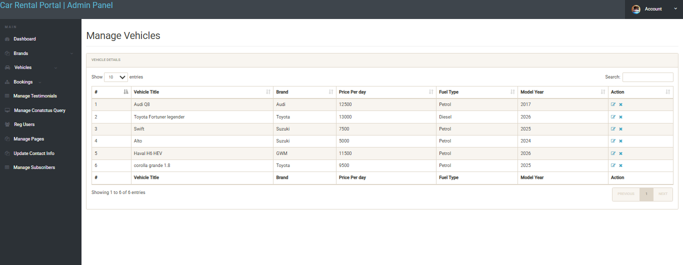

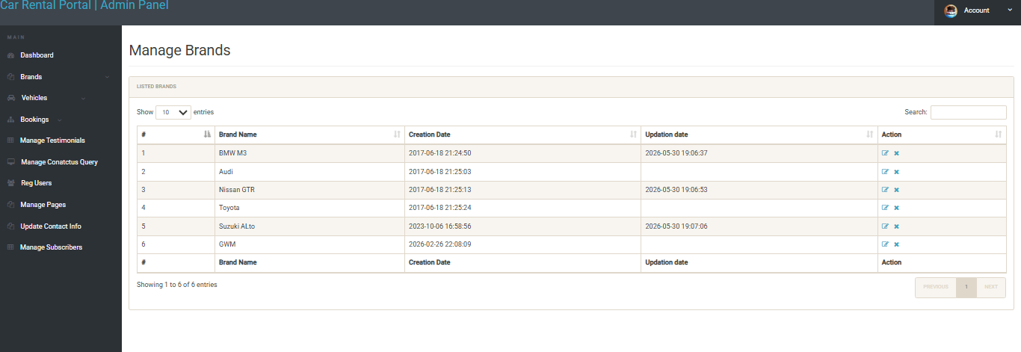

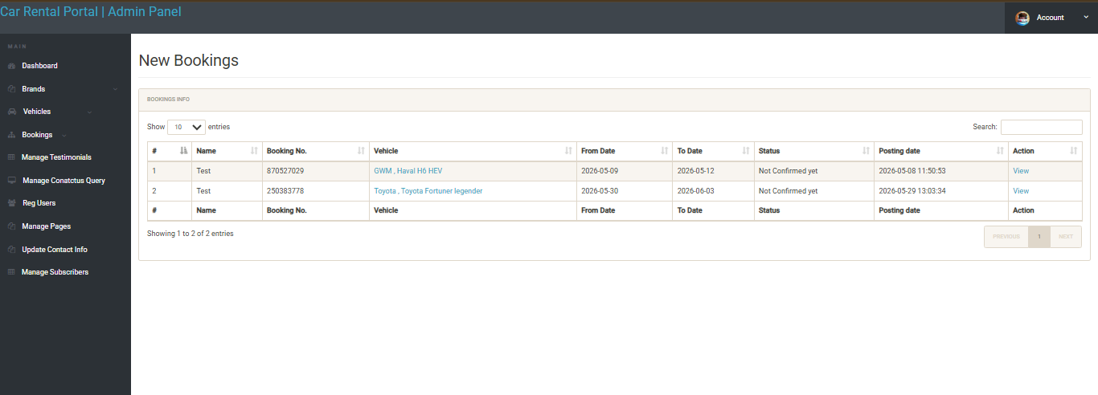

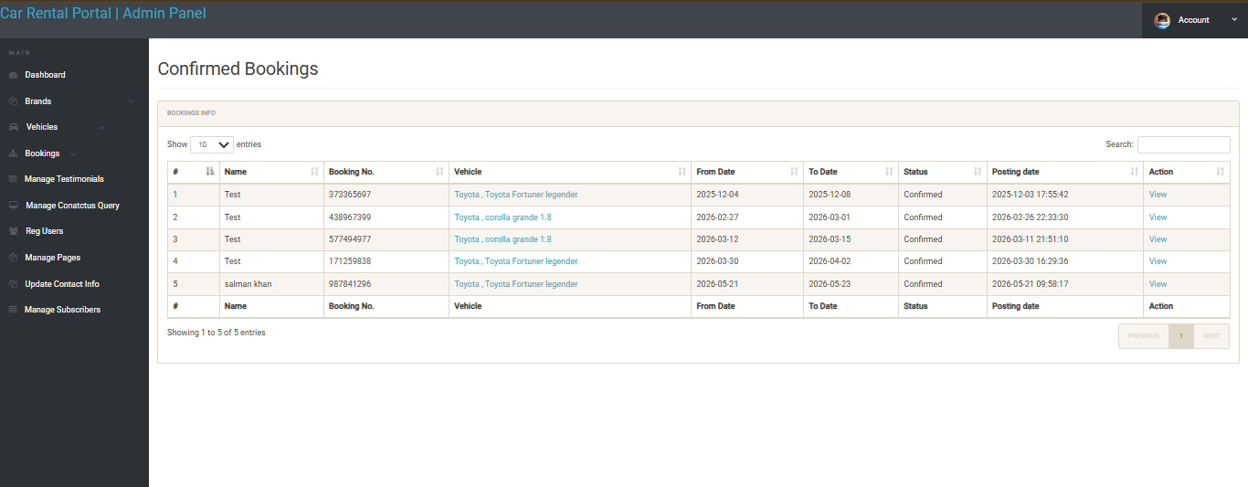

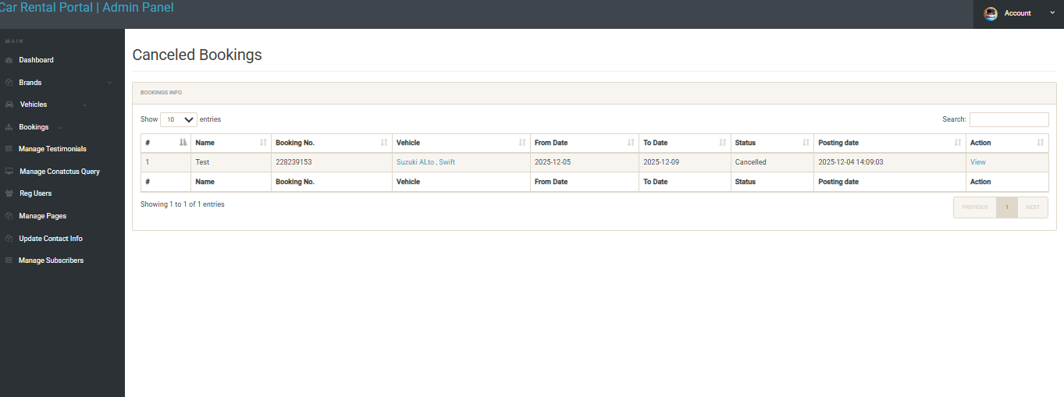

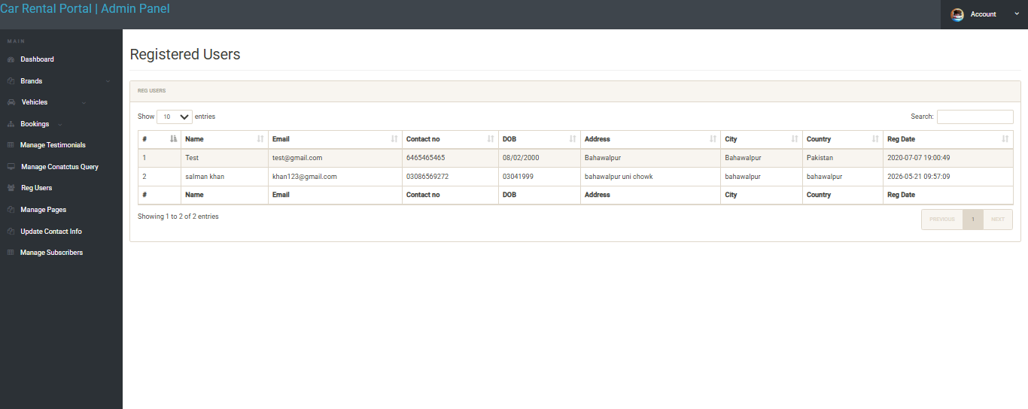

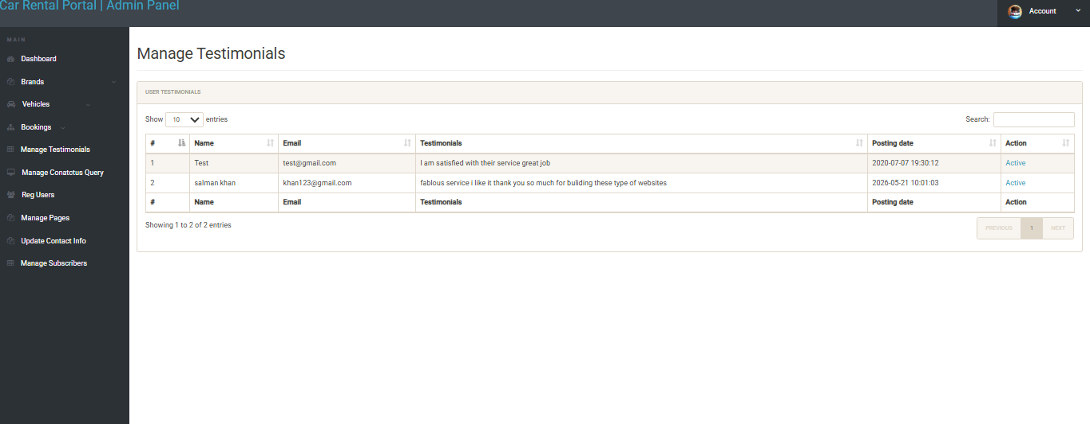

3.7 Other Design Details

3.7.1 Security Implementation Details
Password Security: User passwords are hashed using PHP's password_hash() function with the PASSWORD_BCRYPT algorithm and a cost factor of 10. Password verification is performed using password_verify(). Plaintext passwords are never logged or stored at any stage.
SQL Injection Prevention: All database queries that involve user-supplied data use PHP PDO (PHP Data Objects) with prepared statements and bound parameters. This ensures that user input is never directly interpolated into SQL query strings.
Session Security: PHP sessions use server-side storage. Session tokens are regenerated upon successful login using session_regenerate_id() to prevent session fixation attacks. All session cookies have the HttpOnly flag set.
Input Sanitization: All user input rendered in HTML pages is escaped using htmlspecialchars() to prevent Cross-Site Scripting (XSS) attacks.

3.7.2 Availability Checking Algorithm
The core availability checking query identifies cars with no overlapping confirmed bookings for the requested date range. The SQL query uses a NOT EXISTS subquery pattern to exclude cars that have at least one confirmed booking where the booked date range overlaps with the requested range. A booking overlaps if the existing booking's start_date is before the requested end_date AND its end_date is after the requested start_date.

Chapter 4. Test Specification and Results

4.1 Test Case Specification
The following test cases were designed and executed to verify the functional requirements of the Car Rental Portal. Each test case corresponds to one or more use cases identified in Chapter 2.

Identifier | TC-1
Related Requirement(s) | UC-1 (Sign Up)
Short Description | Verify that a new user can successfully create an account.
Pre-condition(s) | No existing account with the test email. Database connection is active.
Input Data | Full Name: Ali Hassan | Email: ali@test.com | Password: Test@1234 | Phone: 0300-1234567
Detailed Steps | 1. Navigate to Sign Up page. 2. Fill in all required fields with valid data. 3. Click 'Register'.
Expected Result(s) | User account is created in the database. User is redirected to the login page with a success message.
Post-condition(s) | New user record exists in the users table with a bcrypt-hashed password and role='customer'.
Actual Result(s) | User account created. Redirected to login page. Success message displayed.
Test Case Result | PASS
Table 4.1: TC-TC-1

Identifier | TC-2
Related Requirement(s) | UC-2 (Login)
Short Description | Verify that a registered user can log in successfully.
Pre-condition(s) | User account exists with email ali@test.com and a known password.
Input Data | Email: ali@test.com | Password: Test@1234
Detailed Steps | 1. Navigate to Login page. 2. Enter registered email and correct password. 3. Click 'Login'.
Expected Result(s) | User is authenticated and redirected to the Customer Dashboard. Session is created.
Post-condition(s) | User session is active. Dashboard page is displayed.
Actual Result(s) | Login successful. Dashboard loaded with welcome message.
Test Case Result | PASS
Table 4.2: TC-TC-2

Identifier | TC-3
Related Requirement(s) | UC-3 (Search Car)
Short Description | Verify that available cars are correctly displayed for a valid date range.
Pre-condition(s) | User is logged in. At least one car is available for the chosen dates.
Input Data | Pickup Date: 2025-06-10 | Return Date: 2025-06-15
Detailed Steps | 1. Navigate to Search Cars page. 2. Enter valid pickup and return dates. 3. Click 'Search'.
Expected Result(s) | A list of cars with no overlapping confirmed bookings is displayed with pricing.
Post-condition(s) | Available cars are listed. Cars with confirmed overlapping bookings are excluded.
Actual Result(s) | 2 available cars displayed. 1 car with an existing booking for the same dates was excluded.
Test Case Result | PASS
Table 4.3: TC-TC-3

Identifier | TC-4
Related Requirement(s) | UC-4 (Book Car)
Short Description | Verify that a customer can successfully book an available car.
Pre-condition(s) | User is logged in. A specific car (car_id=3) is available for the chosen dates.
Input Data | Car: Toyota Corolla | Pickup: 2025-06-10 | Return: 2025-06-15 | Price/day: PKR 3,000
Detailed Steps | 1. Select car from search results. 2. Confirm pickup and return dates. 3. Click 'Confirm Booking'.
Expected Result(s) | Booking record is created with status='Confirmed'. Total price = 5 days × PKR 3,000 = PKR 15,000. Confirmation page is shown.
Post-condition(s) | New booking record exists in bookings table with correct user_id, car_id, dates, total_price, and status='Confirmed'.
Actual Result(s) | Booking created with ID #007. Total PKR 15,000 displayed on confirmation page.
Test Case Result | PASS
Table 4.4: TC-TC-4

Identifier | TC-5
Related Requirement(s) | UC-6 (Admin – Add Car)
Short Description | Verify that an admin can add a new car to the fleet inventory.
Pre-condition(s) | Admin is logged in with administrator role.
Input Data | Model: Civic | Brand: Honda | Category: Sedan | Price/Day: PKR 3,500
Detailed Steps | 1. Admin navigates to Manage Cars. 2. Clicks 'Add New Car'. 3. Fills in all fields. 4. Clicks 'Save'.
Expected Result(s) | New car record is inserted into the cars table. Car appears in the fleet list with status='Available'.
Post-condition(s) | New record exists in cars table with correct data. Car is visible in the admin fleet list.
Actual Result(s) | New car 'Honda Civic' added successfully. Appears in fleet listing.
Test Case Result | PASS
Table 4.5: TC-TC-5

Identifier | TC-6
Related Requirement(s) | UC-7 (Admin – Cancel Booking)
Short Description | Verify that an admin can cancel an active booking.
Pre-condition(s) | Admin is logged in. A confirmed booking (booking_id=007) exists.
Input Data | Booking ID: 007
Detailed Steps | 1. Admin navigates to Manage Bookings. 2. Locates booking_id=007. 3. Clicks 'Cancel'.
Expected Result(s) | Booking status is updated to 'Cancelled' in the database. Booking no longer appears in active bookings.
Post-condition(s) | Booking record in database has status='Cancelled'. Customer's booking history reflects the cancellation.
Actual Result(s) | Booking #007 status changed to 'Cancelled'. Cancellation reflected in customer's booking history.
Test Case Result | PASS
Table 4.6: TC-TC-6

4.2 Summary of Test Results
The table below provides a summary of test results across all tested modules of the Car Rental Portal:

Module Name | Test Cases Run | Defects Found | Defects Corrected | Defects Remaining
User Registration Module | TC-1 | 1 | 1 | 0
Authentication Module | TC-2 | 0 | 0 | 0
Car Search Module | TC-3 | 1 | 1 | 0
Booking Module | TC-4 | 0 | 0 | 0
Admin – Car Management | TC-5 | 0 | 0 | 0
Admin – Booking Management | TC-6 | 0 | 0 | 0
Complete System | TC-1 to TC-6 | 2 | 2 | 0
Table 4.7: Summary of All Test Results
All identified defects were corrected prior to final release. The two defects found were: (1) a registration form validation bug that allowed duplicate email submission under rapid double-click conditions, corrected by implementing a server-side unique constraint check; and (2) a date comparison error in the car availability query that used >= instead of > for the end_date boundary, corrected to accurately exclude overlapping bookings.

Chapter 5. Conclusion and Future Work

5.1 Project Summary
The Car Rental Portal successfully delivers a comprehensive, web-based solution to the operational challenges faced by manual car rental management systems. The application achieves all stated objectives: it provides an intuitive customer portal for registration, vehicle search, and online booking; an administrative panel for complete fleet and reservation management; real-time availability checking that prevents double-booking; and a security-hardened architecture that protects user data through bcrypt password hashing, prepared statement-based SQL injection prevention, and session-based authentication.
The system was developed using PHP 8+, MySQL 8.0, HTML5, CSS3, JavaScript, and Bootstrap 5, and follows a well-established three-tier architectural pattern. The responsive design ensures accessibility across desktop and mobile platforms. Testing verified that all six primary functional modules operate correctly with zero remaining defects.
The project demonstrates the practical application of software engineering principles—including requirements analysis, system design, iterative development, and structured testing—to produce a production-ready web application. The Car Rental Portal provides a scalable foundation for a digitally-enabled car rental business and can be extended with additional features as outlined in the future work section.

5.2 Problems Faced and Lessons Learned

5.2.1 Problems Faced
- Availability Query Complexity: Implementing a correct date-range overlap detection query proved challenging. An initial implementation using simple date equality checks failed to handle partial overlaps. This was resolved by studying interval intersection theory and implementing the standard NOT EXISTS + overlap condition pattern.
- Session Security: Early versions of the application were vulnerable to session fixation attacks because session IDs were not regenerated after login. This was identified during a security review and corrected by calling session_regenerate_id(true) immediately after a successful authentication check.
- Responsive Design Challenges: Ensuring that the booking table and admin management tables displayed correctly on small screens required additional Bootstrap responsive utility classes and CSS media query overrides.
- Database Design Iteration: The initial schema did not include a role column in the users table, requiring admin status to be tracked separately. This was refactored during the design phase to include ENUM('customer','admin') within the users table, simplifying access control logic.
- Time Management: Balancing the project development workload with academic coursework and examinations required strict weekly planning and scope management to ensure all deliverables were completed on schedule.

5.2.2 Lessons Learned
- Thorough requirements analysis at the outset of the project significantly reduces costly redesign during later development phases.
- Security considerations must be integrated from the beginning of development rather than added as an afterthought.
- Normalization of the database schema to 3NF during design prevents data redundancy issues that are costly to fix post-development.
- Iterative testing at each development milestone catches defects early when they are cheapest to fix.
- Clear documentation of all design decisions, including rationale for technology selections, is invaluable for project review and future maintenance.

5.3 Future Work
The following enhancements are recommended for future versions of the Car Rental Portal:
- Online Payment Integration: Integrate a payment gateway such as JazzCash, EasyPaisa, or Stripe to enable online payment processing at the time of booking confirmation, eliminating the need for in-person payment.
- Email and SMS Notifications: Implement automated email and SMS notifications for booking confirmations, reminders, and cancellations using an SMTP service or a third-party notification API.
- Car Image Gallery: Add support for multiple car images per vehicle to provide customers with a richer browsing experience.
- Rating and Review System: Allow customers who have completed rentals to submit ratings and written reviews for individual vehicles, building trust and aiding future booking decisions.
- GPS and Fleet Tracking: Integrate real-time GPS tracking to allow the admin to monitor the location and status of rented vehicles.
- Mobile Application: Develop a native Android/iOS mobile application to complement the web portal, providing push notifications and an optimized mobile experience.
- Multi-Language Support: Add Urdu language localization to make the platform accessible to a broader range of users in Pakistan.
- Booking Analytics Dashboard: Enhance the admin reporting module with graphical charts and analytics covering revenue trends, vehicle utilization rates, and customer demographics.

References

W3Schools. PHP Tutorial. Retrieved from https://www.w3schools.com/php/
PHP Manual. Password Hashing. Retrieved from https://www.php.net/manual/en/book.password.php
Bootstrap Documentation. Bootstrap 5.0. Retrieved from https://getbootstrap.com/docs/5.0/
MySQL Documentation. MySQL 8.0 Reference Manual. Retrieved from https://dev.mysql.com/doc/
Stack Overflow. PHP, MySQL, and Web Development Resources. Retrieved from https://www.stackoverflow.com

Appendix A –Glossary

Term / Acronym | Definition
PHP | PHP: Hypertext Preprocessor – a server-side scripting language widely used for web development.
MySQL | An open-source relational database management system that uses Structured Query Language (SQL) for data storage and retrieval.
Apache | A widely-used open-source web server software that handles HTTP requests and serves web content.
Bootstrap | An open-source CSS framework for developing responsive and mobile-first websites.
bcrypt | A password hashing function based on the Blowfish cipher, designed to be computationally expensive to resist brute-force attacks.
SRS | Software Requirements Specification – a document that describes the intended purpose, environment, and functional and non-functional requirements of a software system.
SDD | Software Design Document – a document that describes the software architecture and design of a system.
CRUD | Create, Read, Update, Delete – the four basic operations of persistent storage.
SQL Injection | A code injection technique in which malicious SQL statements are inserted into a query, potentially compromising database security.
XSS | Cross-Site Scripting – a security vulnerability that allows attackers to inject malicious scripts into web pages viewed by other users.
PDO | PHP Data Objects – a database abstraction layer providing a consistent interface for accessing multiple database types in PHP.
ERD | Entity Relationship Diagram – a visual representation of database entities and the relationships between them.
API | Application Programming Interface – a set of protocols and tools for building software and enabling communication between different systems.
AJAX | Asynchronous JavaScript and XML – a technique enabling web pages to update content asynchronously without reloading the entire page.
BSIT | Bachelor of Science in Information Technology – the undergraduate degree program at the Department of Information Technology, The Islamia University of Bahawalpur.
FYP | Final Year Project – the capstone project undertaken by undergraduate students in the final year of the BSIT program.
UC | Use Case – a description of how a user interacts with the system to achieve a specific goal.
TC | Test Case – a set of conditions and inputs used to verify that a specific function of the system works as expected.
3NF | Third Normal Form – a database normalization standard that eliminates transitive dependencies and data redundancy.

Appendix B – Deployment / Installation Guide

This guide provides step-by-step instructions for deploying the Car Rental Portal on a local development environment using XAMPP on Windows or Linux.

B.1 Prerequisites
- XAMPP (v8.0 or later) installed: includes Apache 2.4+, PHP 8.0+, and MySQL 8.0+.
- A modern web browser (Google Chrome, Mozilla Firefox, or Microsoft Edge).
- The Car Rental Portal source code archive (CarRentalPortal.zip).

B.2 Installation Steps
- Install XAMPP: Download XAMPP from https://www.apachefriends.org and run the installer. Ensure Apache and MySQL modules are selected for installation.
- Start Services: Open the XAMPP Control Panel and start the Apache and MySQL services.
- Deploy Source Files: Extract the CarRentalPortal.zip archive. Copy the extracted carrentalportal/ folder to the C:\xampp\htdocs\ directory (Windows) or /opt/lampp/htdocs/ (Linux).
- Create Database: Open phpMyAdmin by navigating to http://localhost/phpmyadmin in a browser. Create a new database named car_rental_db.
- Import Schema: In phpMyAdmin, select the car_rental_db database, click the 'Import' tab, and upload the database/schema.sql file from the source code directory. This creates all required tables and inserts sample data.
- Configure Database Connection: Open the file carrentalportal/config/db.php in a text editor. Verify the database credentials: host = localhost, database = car_rental_db, username = root, password = (empty by default in XAMPP).
- Access the Application: Open a browser and navigate to http://localhost/carrentalportal/ to access the customer portal.
- Admin Access: Navigate to http://localhost/carrentalportal/admin/ and log in with the default admin credentials provided in the README.txt file (admin@carrentalportal.com / Admin@1234). Change the admin password immediately after first login.

B.3 Production Deployment Notes
- For production deployment, use a Linux server with Apache, PHP 8+, and MySQL installed (LAMP stack).
- Enable HTTPS using a valid SSL/TLS certificate (e.g., Let's Encrypt) before deploying to a live environment.
- Change all default passwords and remove phpMyAdmin from public access.
- Configure automated daily database backups using mysqldump and a cron job.
- Set PHP error_reporting to E_NONE and turn off display_errors in php.ini for the production environment.

— End of Report —

Car Rental Portal | Final Year Project | BSIT 2022–2026

Department of Information Technology, The Islamia University of Bahawalpur

