FYP ADMINISTRATION SYSTEM REQUIREMENTS

**Abstract**

The Abstract provides a succinct overview of the project, capturing its essence and key objectives. Here's a potential abstract for the Abbottabad University of Science and Technology (AUST):

The management of Final Year Projects (FYPs) constitutes a critical aspect of academic excellence at Abbottabad University of Science and Technology (AUST). In response to the evolving needs of administrators, supervisors, and students, this project endeavors to develop a comprehensive FYP management platform tailored to the unique requirements of our institution.

The proposed platform aims to streamline FYP processes by providing secure user authentication, role-based access control, and a centralized dashboard offering real-time insights into project statistics and progress. Administrators will benefit from customizable reporting tools and project management functionalities, while supervisors will have access to tools for project suggestion, allocation, and progress tracking. Students will enjoy intuitive modules for project selection, communication, and document submission, fostering transparency and collaboration throughout the FYP lifecycle.

Moreover, the platform will feature a robust meeting management system, document repository, and communication tools, ensuring seamless coordination and information sharing among stakeholders. Scalability and security are paramount, with a scalable architecture and stringent data encryption measures safeguarding the platform's integrity and adaptability.

By leveraging technology to optimize FYP management processes, this project aspires to elevate academic excellence at AUST, fostering a culture of innovation, collaboration, and scholarly achievement. Through continuous refinement and stakeholder engagement, the platform aims to serve as a catalyst for academic growth and advancement, empowering students and faculty to realize their full potential in the pursuit of knowledge and discovery.

This abstract encapsulates the project's objectives, methodologies, and potential impact on academic excellence at AUST.

**Introduction**

**Background of Study**

Accessing information in today’s world has taken a leap with the development in technology which given way to online system to be the new management system. The need of online system has increased rapidly during these past years. Online system has been doing a very good task in eliminating the need of hardcopies, spaces, protocols and time. Online system indicates the need of connection between the users and system. As one of the environment that involve a large number of participants, information, and resources, AUST also tend to benefit from the use of a time-efficient online management system. The exchange of information among Final Year Project coordinators, lecturers, supervisors, examiners and students need an effective communication medium to ensure that no misunderstanding or lack of information that will cause delay in the completion of projects. Thus, the FYP Online System (FYPOS) is ideal since it provides the best solutions for the previous FYP management. This system is proposed as the need to enhance the process and management system efficiency. In this project, a web based software solution will be introduced to provide a comfortable environment for FYP management. This system will be developed using software freely distributed and available to the public.

**Problem Statement**

Final Year Project management has been in a more traditional way for all these years. It is done manually where all the registration, allocation and markings are in hardcopies and forms and then managed by FYP coordinators. While the coordinators are doing a great job, this management system has several disadvantages;

* It is time-consuming and requires more man power in running the manual system, hence it is denoted as less efficient
* In communicating with all the participants, the committee also having problems and difficulties because there is no specific medium of interaction and this will cause delays.
* There are also problems aroused in archiving and storage. The previous data are hard to search and tend to be eliminated after some period of time. The manual system also uses much more storage for all the hardcopies.

**Scope of Study**

The scope for FYP Online Management System is very broad in terms of the management system. There are two parts in developing this project. This project will involve the knowledge and experimentation based on

* Web design, setup and development
* Database design and management
* Server design and setup

**Motivation and Scope**

**Motivation:**

The motivation behind this project stems from the recognition of the inherent complexities and inefficiencies prevalent in the management of Final Year Projects (FYPs) within academic institutions. Historically, administrators, supervisors, and students have grappled with fragmented communication channels, cumbersome paperwork, and a lack of centralized systems, leading to challenges in project selection, supervision, and progress tracking. This project seeks to address these pain points by leveraging technology to streamline FYP management processes, thereby enhancing efficiency, transparency, and collaboration.

**Scope:**

The scope of this project encompasses the development of a comprehensive FYP management platform tailored to the specific needs of administrators, supervisors, students, and local users within our academic institution. Key components of the platform include:

**1. User Authentication and Role-Based Access Control:**

* Secure login system with role-based access control to ensure data privacy and confidentiality.

**2. Dashboard and Reporting:**

* Centralized dashboard for administrators with real-time reports on FYP statistics and progress.

**3. Project Selection and Allocation:**

* Tools for students to browse and select FYPs from departmental project lists, with approval workflows for supervisor allocation.

**4. Supervisor Tools:**

* Features for supervisors to suggest projects, manage group allocations, and track project progress.

**5. Student Modules:**

* Modules for students to communicate with supervisors, track project progress, and submit required documents.

**6. Meeting Management:**

* Functionality for scheduling and managing meetings between supervisors and students.

**7. Project Repository:**

* Repository of past FYPs for reference and knowledge sharing among local users.

**8. Scalability and Security:**

* Design of a scalable architecture with robust data security measures to accommodate future growth and ensure data integrity.

The project aims to address the entire FYP lifecycle, from project selection to submission, while fostering collaboration, transparency, and accountability among stakeholders. Through the implementation of advanced features and intuitive interfaces, the platform seeks to revolutionize FYP management within our institution, setting new standards for academic excellence and innovation.

**Requirements**

**Admin:**

* Login with specific credentials.
* View overall reports on dashboard:
* Students doing FYP.
* Total number of FYPs submitted.
* Students remaining for project selection or supervisor allocation.
* Number of students doing department allocated projects.
* Number of students doing their own projects.
* View reports in the form of charts (pie charts, etc.).
* View reports of FYP1 and FYP2 separately.
* Filter results based on progress, program, supervisor, roll number, etc.

**Access project modules to view:**

* Project reports (charts, graphs, progress percentage, meetings attended).
* Group members.
* Project submitted documents.
* Broadcast departmental projects list.
* Access student and supervisor logins and information.

**Supervisor:**

* Login.
* View departmental projects list in real-time.
* Suggest departmental projects with details.
* Accept and reject group allocation requests.
* Access a chat module specific to each group.
* View the number of projects supervised on dashboard.
* Access information of students in supervised groups.
* View own group project progress (documents, progress, chats, etc.).
* View meeting proposal and decide date/time for meetings.

**Student:**

* Login.
* Fill personal information form.
* Select project from departmental projects list.
* Send approval request to related supervisor.

**Upon acceptance, access a module including:**

* Chatting with supervisor.
* Marking project progress.
* Sending meeting requests.
* Submitting meeting logs.
* Submit FYP-related documents.

**Local User:**

* View and download past projects done by university students.
* See number of projects done by university students.

**Goals and Objectives**

**1. Efficient Project Management:**

* **Goal:** Streamline the management of Final Year Projects (FYPs) within the university.
* **Objective:** Develop a platform that facilitates smooth coordination between administrators, supervisors, and students throughout the FYP process.

**2. Transparency and Reporting:**

* **Goal:** Enhance transparency and reporting mechanisms for FYP-related activities.
* **Objective:** Implement a comprehensive reporting system that provides administrators with real-time insights into FYP progress, submissions, and allocations.

**3. Effective Supervision:**

* **Goal:** Improve the supervision process for FYPs to ensure quality outcomes.
* **Objective:** Equip supervisors with tools to monitor and support student progress, facilitate communication, and manage group allocations efficiently.

**4. Enhanced Student Experience:**

* **Goal:** Enhance the overall experience for students participating in FYPs.
* **Objective:** Provide students with user-friendly interfaces for project selection, communication with supervisors, tracking progress, and submitting required documents.

**5. Accessible Project Repository:**

* **Goal:** Establish a repository of past FYPs for reference and knowledge sharing.
* **Objective:** Create a user-friendly interface for local users to access and download past FYPs completed by university students.

**6. Adaptability and Scalability:**

* **Goal:** Develop a system that can adapt to changing requirements and accommodate future growth.
* **Objective:** Design the platform with modular architecture and scalability in mind to support the addition of new features and accommodate increasing user numbers.

**7. Data Security and Privacy:**

* **Goal:** Ensure the security and privacy of sensitive project-related data.
* **Objective:** Implement robust data encryption measures, access controls, and user authentication mechanisms to safeguard confidential information.

**8. User Satisfaction and Feedback:**

* **Goal:** Continuously improve the platform based on user feedback and satisfaction.
* **Objective:** Collect feedback from administrators, supervisors, and students to identify areas for improvement and implement enhancements to enhance user satisfaction.

**Features of the project**

**The features of the FYP (Final Year Project) Administration System:**

1. **User Authentication and Role-Based Access Control:**

**Secure login system with different access levels for Admin, Supervisor, Student, and Local User.**

1. **Dashboard Overview:**

**Admin-exclusive dashboard providing comprehensive reports and statistics regarding FYP progress, submissions, student and supervisor allocations, departmental projects, etc.**

**Visual representation of data through charts (e.g., pie charts) for easy understanding.**

1. **Filtering and Sorting Options:**

**Ability for Admin to filter and sort reports based on various parameters such as progress, program, supervisor, and roll number.**

1. **Project Management:**

**Comprehensive project module displaying project reports, group members, submitted documents, progress tracking (e.g., percentage completion), and meeting attendance.**

1. **Departmental Projects Management:**

**Broadcast capability for Admin to share departmental projects list with Supervisors and Students.**

**Supervisors can suggest departmental projects and view details, which are submitted to the database for Admin's approval.**

1. **Group Allocation Management:**

**Supervisors can accept or reject group allocation requests and engage in group-specific chat modules.**

**Supervisors can view the number of projects supervised and access student information within those groups.**

1. **Meeting Management:**

**Feature for Supervisors to view and respond to meeting proposals, scheduling dates and times for meetings.**

**Students can send meeting requests, submit meeting logs, and track meeting schedules.**

1. **Student Onboarding:**

**Student registration process involving filling a form with personal information.**

**Selection of projects from the departmental projects list.**

**Approval workflow, where Supervisor accepts or rejects the project selection request.**

1. **Document Submission:**

**Students can submit FYP-related documents through the system.**

**10. Past Project Repository:**

**Local User access to view and download past projects completed by university students.**

**Display of the total number of projects completed by university students.**

**11. Security and Data Privacy:**

**Implementation of security measures to protect user data and ensure privacy.**

**Compliance with data protection regulations.**

**12. Notifications:**

**System-generated notifications for important events such as project selection approval, meeting scheduling, document submissions, etc.**

**13. User Profile Management:**

**Ability for users to manage their profiles, update information, and change passwords.**

**14. Scalability and Performance:**

**Design for scalability to accommodate increasing numbers of users and projects.**

**Optimization for performance to ensure smooth system operation even with high user traffic.**

**By incorporating these features, the FYP Administration System will effectively facilitate the management and monitoring of Final Year Projects within the university, streamlining processes for Admins, Supervisors, and Students while providing valuable resources for Local Users.**

**Gantt Chart**

Below is the Gantt chart for the system that show how the SDLC processes are going to occur and at what time.

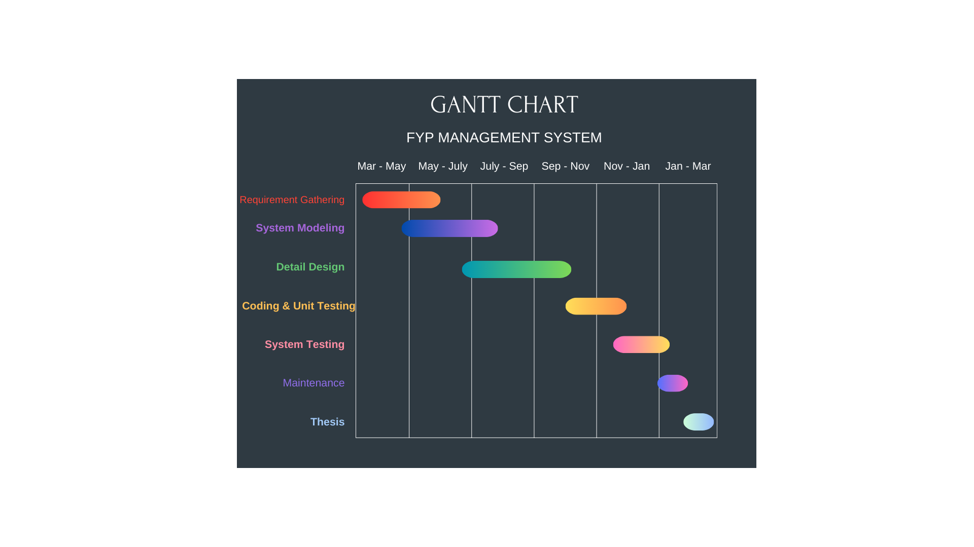

**Architectural Diagram**

**Tools and Technologies**

**IDE**

* Visual Studio Code

**Technologies**

* React JS
* Vite
* React Icons
* Redux Toolkit
* Axios
* React Router DOM
* React Quill
* Formik
* JWT (JSON WEB TOKEN)
* Tailwind CSS
* Node JS
* Multer
* Mongoose
* CORS
* Express JS
* Mongo DB

References