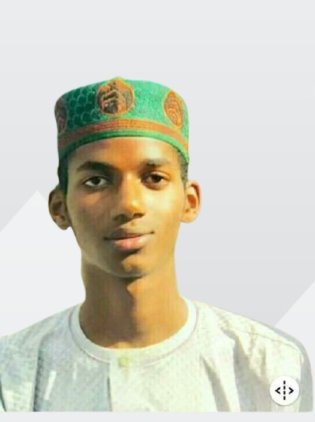
MUBARAK KASIM
Tukur Tukur, Zaria, Kaduna State, Nigeria | 09068500544 | mubarakkasimmaishanu@gmail.com
PROFILE SUMMARY
Resourceful and detail-oriented Computer Science graduate (Distinction) with strong analytical, statistical, and problem-solving skills. Skilled in Excel (advanced), Power BI, Google Data Analytics, web development, and teaching, with proven ability to organize, visualize, and interpret data for decision-making. Experienced in designing dashboards, managing records, and optimizing workflows for SMEs. Eager to contribute to a banking environment through data analysis, reporting, and operational support.
CORE COMPETENCIES
- Data Analysis & Visualization (Excel, Power BI, Google Data Studio)
- Statistical Analysis & Reporting
- Database Management (MySQL, SQL basics)
- Web Development (PHP, CSS, Bootstrap)
- Teaching & Training Delivery
- Report Writing & Documentation
- Strong Interpersonal & Communication Skills
- Process Optimization & Record Management
EDUCATION
National Diploma (ND) in Computer Science — Distinction
Nuhu Bamalli Polytechnic, Zaria | 2024
Professional Diploma in Computer Science
Iya Abubakar Institute of Computing and ICT, Ahmadu Bello University | 2022
CERTIFICATIONS
- Google Data Analytics Professional Certificate (In Progress)
- Excel for Data Analysis — Big Picture Learning (Completed)
- Microsoft Power BI for Business Intelligence (Advanced Level)
- Introduction to Statistics — Microsoft Learn (Completed)
PRACTICAL EXPERIENCE
Senior Master, Chief Typist, Computer & ICT Coordinator, and School Teacher
Nur Light Academy, Zaria | 2020–2023
- Managed and coordinated ICT resources, ensuring effective teaching and learning processes.
- Taught Data Processing and Computer Science, preparing students for WAEC and NECO.
- Designed and typed official school documents, examination papers, and reports.
- Oversaw administrative records and maintained student information systems.
Data & Operations Assistant (Part-Time)
SM Bread Bakery, Zaria | 2025–Present
- Designed and implemented a sales and returns tracking system to monitor daily transactions.
- Developed a simple customer relationship management sheet for better follow-ups.
- Created inventory monitoring templates for raw materials.
Freelance Web Developer & Project Documentation Specialist
2021–Present
- Built and maintained responsive websites using PHP, CSS, and Bootstrap.
- Prepared academic project documentation for health and computer science students.
PROJECT HIGHLIGHTS
- Bakery Operations Dashboard: Created a Power BI dashboard showing daily production, wastage, and revenue trends.
- School Fee Tracker: Excel system tracking payments, outstanding balances, and automated reminders.
- Clinic Stock & Appointment Manager: Spreadsheet-based system to monitor inventory and patient appointments.
TECHNICAL SKILLS
- Software: MS Excel, Power BI, MySQL, PHP, Canva, Google Sheets
- Data Skills: Data Cleaning, Statistical Analysis, Visualization, Dashboard Design
- Languages: PHP, SQL, Python (pandas basics)
STRENGTHS
- Quick learner with strong adaptability
- High attention to detail and accuracy
- Ability to work independently or in a team setting
REFERENCES
Maryam Yusuf – Director, Nur Light Academy | +234 703 700 5509
Mal. Isyaku Dahiru – Former HOD, Department of Computer Science, Nuhu Bamalli Polytechnic, Zaria | +234 803 701 8321
Mal. Sulaiman – School Teacher, Baba Ahmad Memorial College of Higher Islamic and Science Education | [Number Not Provided]

