OOP LAB 9

CODE LAB TASK:
#include <iostream>
#include <string>
using namespace std;

class University;

class Student {
private:
string name;
int marks;
int semester;

public:
Student(const string& n, int m, int s)
: name(n), marks(m), semester(s) {}

friend void display(const Student& s, const University& u);
};

class University {
private:
string universityName;
int ranking;

public:
University(const string& uName, int r)
: universityName(uName), ranking(r) {}

friend void display(const Student& s, const University& u);
};

void display(const Student& s, const University& u) {
cout << "====== Student & University Profile ======" << endl;
cout << "Student Name : " << s.name << endl;
cout << "Marks : " << s.marks << endl;
cout << "Semester : " << s.semester << endl;
cout << "------------------------------------------" << endl;
cout << "University : " << u.universityName << endl;
cout << "Ranking : " << u.ranking << endl;
cout << "==========================================" << endl;
}

int main() {
Student s1("Ali Ahmed", 87, 4);
University u1("Superior University", 12);

display(s1, u1);

return 0;
}

SCREENSHOT:
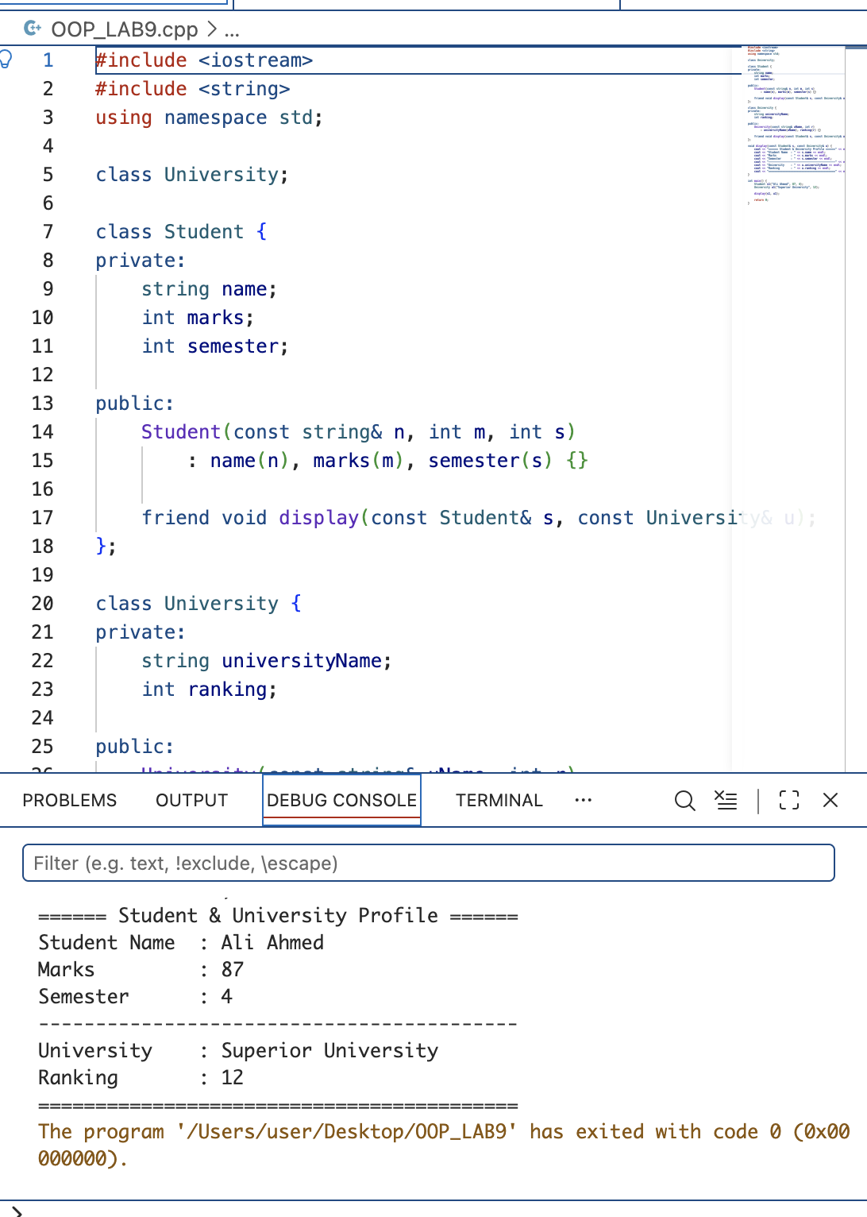

CODE HOME TASK:
#include <iostream>
#include <string>
using namespace std;

class RobotUnit {
private:
string robotName;
int robotID;

static int objectCount;

public:
RobotUnit() : robotName("Unknown"), robotID(0) {
objectCount++;

cout << "[Default Constructor] RobotUnit '"
<< robotName << "' (ID: " << robotID
<< ") created. Count: " << objectCount << endl;
}

RobotUnit(string name, int id) : robotName(name), robotID(id) {
objectCount++;

cout << "[Constructor] RobotUnit '"
<< robotName << "' (ID: " << robotID
<< ") created. Count: " << objectCount << endl;
}

~RobotUnit() {
objectCount--;

cout << "[Destructor] RobotUnit '"
<< robotName << "' destroyed. Count: "
<< objectCount << endl;
}

static int getCount() {
return objectCount;
}

void display() const {
cout << "Robot: " << robotName
<< " | ID: " << robotID << endl;
}
};

int RobotUnit::objectCount = 0;

int main() {
cout << "Objects alive: " << RobotUnit::getCount() << endl;

{
RobotUnit r1("Scout-1", 101);
RobotUnit r2("Carrier-2", 102);
RobotUnit r3;

cout << "Objects alive: " << RobotUnit::getCount() << endl;

RobotUnit* heapBot = new RobotUnit("Heap-Bot", 200);

cout << "Objects alive: " << RobotUnit::getCount() << endl;

delete heapBot;

cout << "Objects alive: " << RobotUnit::getCount() << endl;

cout << "--- Individual Robot Info ---" << endl;
r1.display();
r2.display();
r3.display();

cout << "--- End of main ---" << endl;
}

cout << "Final object count: " << RobotUnit::getCount() << endl;

return 0;
}

SCREENSHOT:
