LAB 5 TASKS OUTPUT
LAB TASK 1:
CODE:
//task 1
#include <iostream>
using namespace std;
struct Book {
int bookId;
float price;
int pages;
};
int main() {
Book myBook;
Book* ptr = &myBook;
cout << "--- Enter Book Details ---" << endl;
cout << "Enter Book ID: ";
cin >> myBook.bookId;
cout << "Enter Price: ";
cin >> myBook.price;
cout << "Enter Number of Pages: ";
cin >> myBook.pages;
int choice;
cout << "\nOptions:" << endl;
cout << "1. Display the price of the most costly book (using pointer)" << endl;
cout << "2. Enter the details again and display the new result" << endl;
cout << "Enter your choice (1 or 2): ";
cin >> choice;
if (choice == 1) {
cout << "\nPrice of the most costly book: Rs" << ptr->price << endl;
} else if (choice == 2) {
cout << "\n--- Enter Book Details Again ---" << endl;
cout << "Enter Book ID: ";
cin >> ptr->bookId;
cout << "Enter Price: ";
cin >> ptr->price;
cout << "Enter Number of Pages: ";
cin >> ptr->pages;
cout << "\n--- Updated Book Record ---" << endl;
cout << "Book ID: " << ptr->bookId << endl;
cout << "Price: Rs" << ptr->price << endl;
cout << "Number of Pages: " << ptr->pages << endl;
} else {
cout << "\nInvalid choice entered." << endl;
}
return 0;
}

Output:
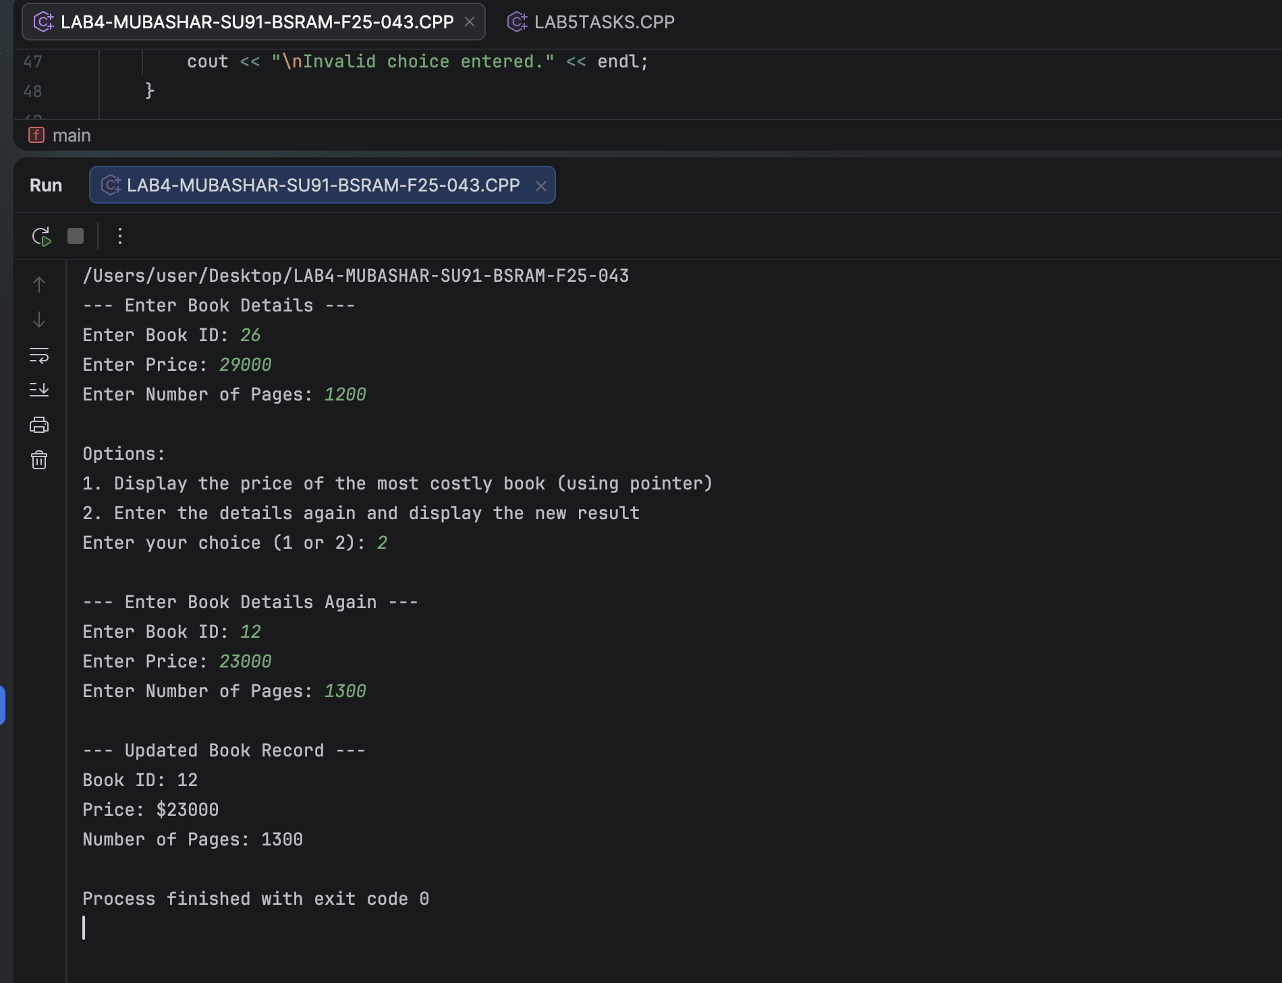

LAB TASK 02:
CODE:
#include <iostream>
using namespace std;
struct Citizen {
long long cnicID;
char name[30];
char city[20];
int age;
};
int main() {
Citizen c;
Citizen *ptr;
ptr = &c;
cout << "Enter CNIC ID: ";
cin >> ptr->cnicID;
cin.ignore();
cout << "Enter Name: ";
cin.getline(ptr->name, 30);
cout << "Enter City: ";
cin.getline(ptr->city, 20);
cout << "Enter Age: ";
cin >> ptr->age;
int choice;
cout << "\nPress 1 to update city of residence, 0 to display record: ";
cin >> choice;
cin.ignore();
if (choice == 1) {
cout << "Enter new city: ";
cin.getline(ptr->city, 20);
cout << "\n--- Updated NADRA Record ---\n";
cout << "CNIC ID : " << ptr->cnicID << "\n";
cout << "Name : " << ptr->name << "\n";
cout << "City : " << ptr->city << "\n";
cout << "Age : " << ptr->age << "\n";
} else {
cout << "\n--- NADRA Record ---\n";
cout << "CNIC ID : " << ptr->cnicID << "\n";
cout << "Name : " << ptr->name << "\n";
cout << "City : " << ptr->city << "\n";
cout << "Age : " << ptr->age << "\n";
}
return 0;
}
OUTPUT SCREENSHOT:
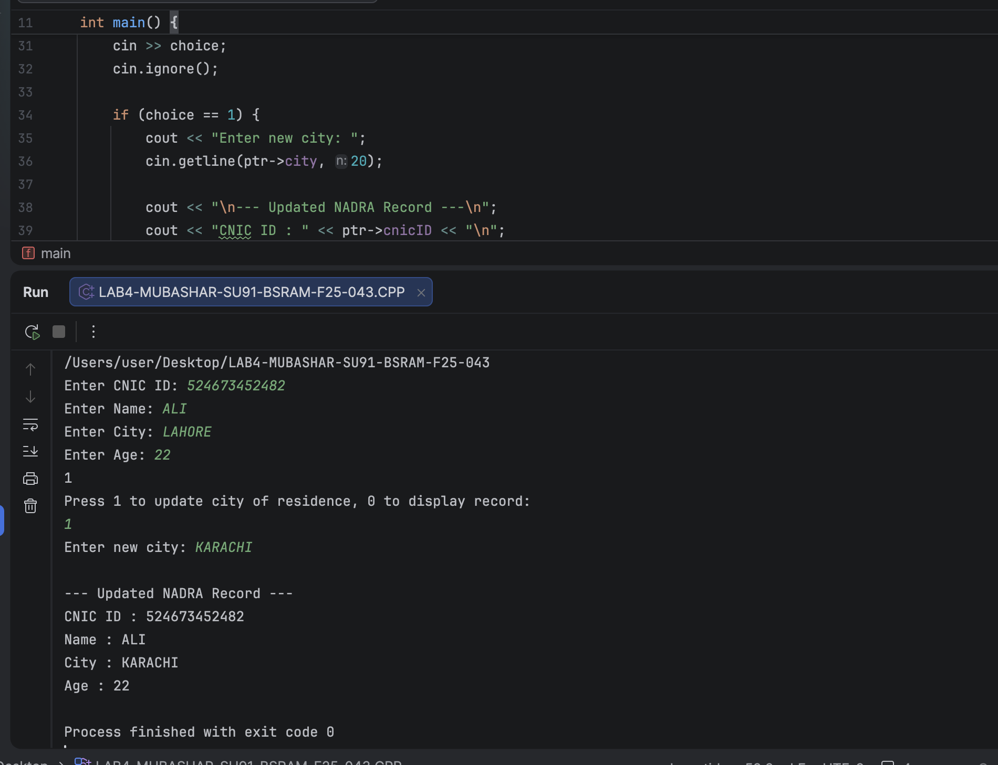

LAB TASK 03:
CODE:
#include <iostream>
using namespace std;
struct PetrolPump {
char name[20];
float pricePerLiter;
int availableLiters;
};
void input(PetrolPump *p) {
cout << "Enter Pump Name: ";
cin >> p->name;
cout << "Enter Price per Liter: ";
cin >> p->pricePerLiter;
cout << "Enter Available Liters: ";
cin >> p->availableLiters;
}
void display(PetrolPump *p) {
cout << "\nPump Name: " << p->name << "\n";
cout << "Price: " << p->pricePerLiter << "\n";
cout << "Stock: " << p->availableLiters << " liters\n";
}
int main() {
PetrolPump p;
input(&p);
display(&p);
return 0;
}

LAB 03: OUTPUT SCREENSHOT
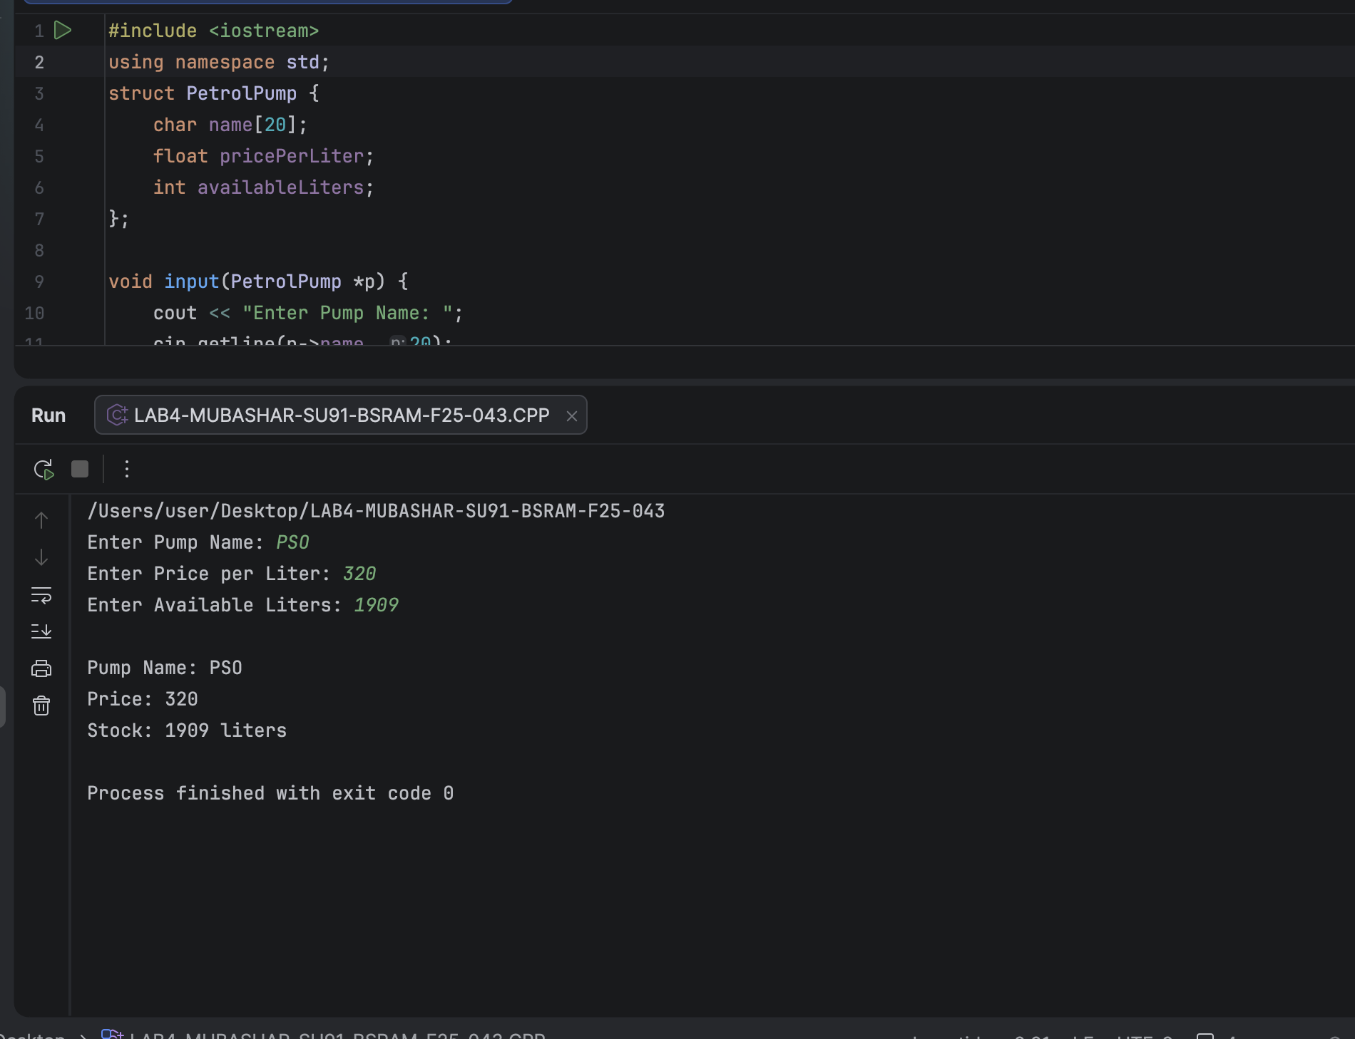

LAB TASK 04:
CODE:
#include<iostream>
using namespace std;
struct Bill {
int accountNo;
char ownerName[30];
int unitsConsumed;
float ratePerUnit;
float totalBill;
};
void inputBill(Bill *b) {
cout << "Enter Account No : ";
cin >> b->accountNo;
cin.ignore();
cout << "Enter Owner Name : ";
cin.getline(b->ownerName, 30);
cout << "Units Consumed : ";
cin >> b->unitsConsumed;
cout << "Rate Per Unit (Rs) : ";
cin >> b->ratePerUnit;
}
void calculateBill(Bill *b) {
b->totalBill = b->unitsConsumed * b->ratePerUnit;
if (b->unitsConsumed > 300) {
b->totalBill += (b->totalBill * 0.15);
}
}
void displayBill(Bill *b) {
cout << "\n========== LESCO Bill ==========\n";
cout << "Account No : " << b->accountNo << "\n";
cout << "Owner Name : " << b->ownerName << "\n";
cout << "Units Used : " << b->unitsConsumed << "\n";
cout << "Rate/Unit : Rs. " << b->ratePerUnit << "\n";
float baseAmount = b->unitsConsumed * b->ratePerUnit;
cout << "Base Amount : Rs. " << baseAmount << "\n";
if (b->unitsConsumed > 300) {
cout << "Surcharge 15%: Rs. " << baseAmount * 0.15 << "\n";
}
cout << "Total Bill : Rs. " << b->totalBill << "\n";
}
int main() {
Bill b;
cout << "=== LESCO Billing System ===\n";
inputBill(&b);
calculateBill(&b);
displayBill(&b);
return 0;
}

LAB 4: OUTPUT SCREENSHOT
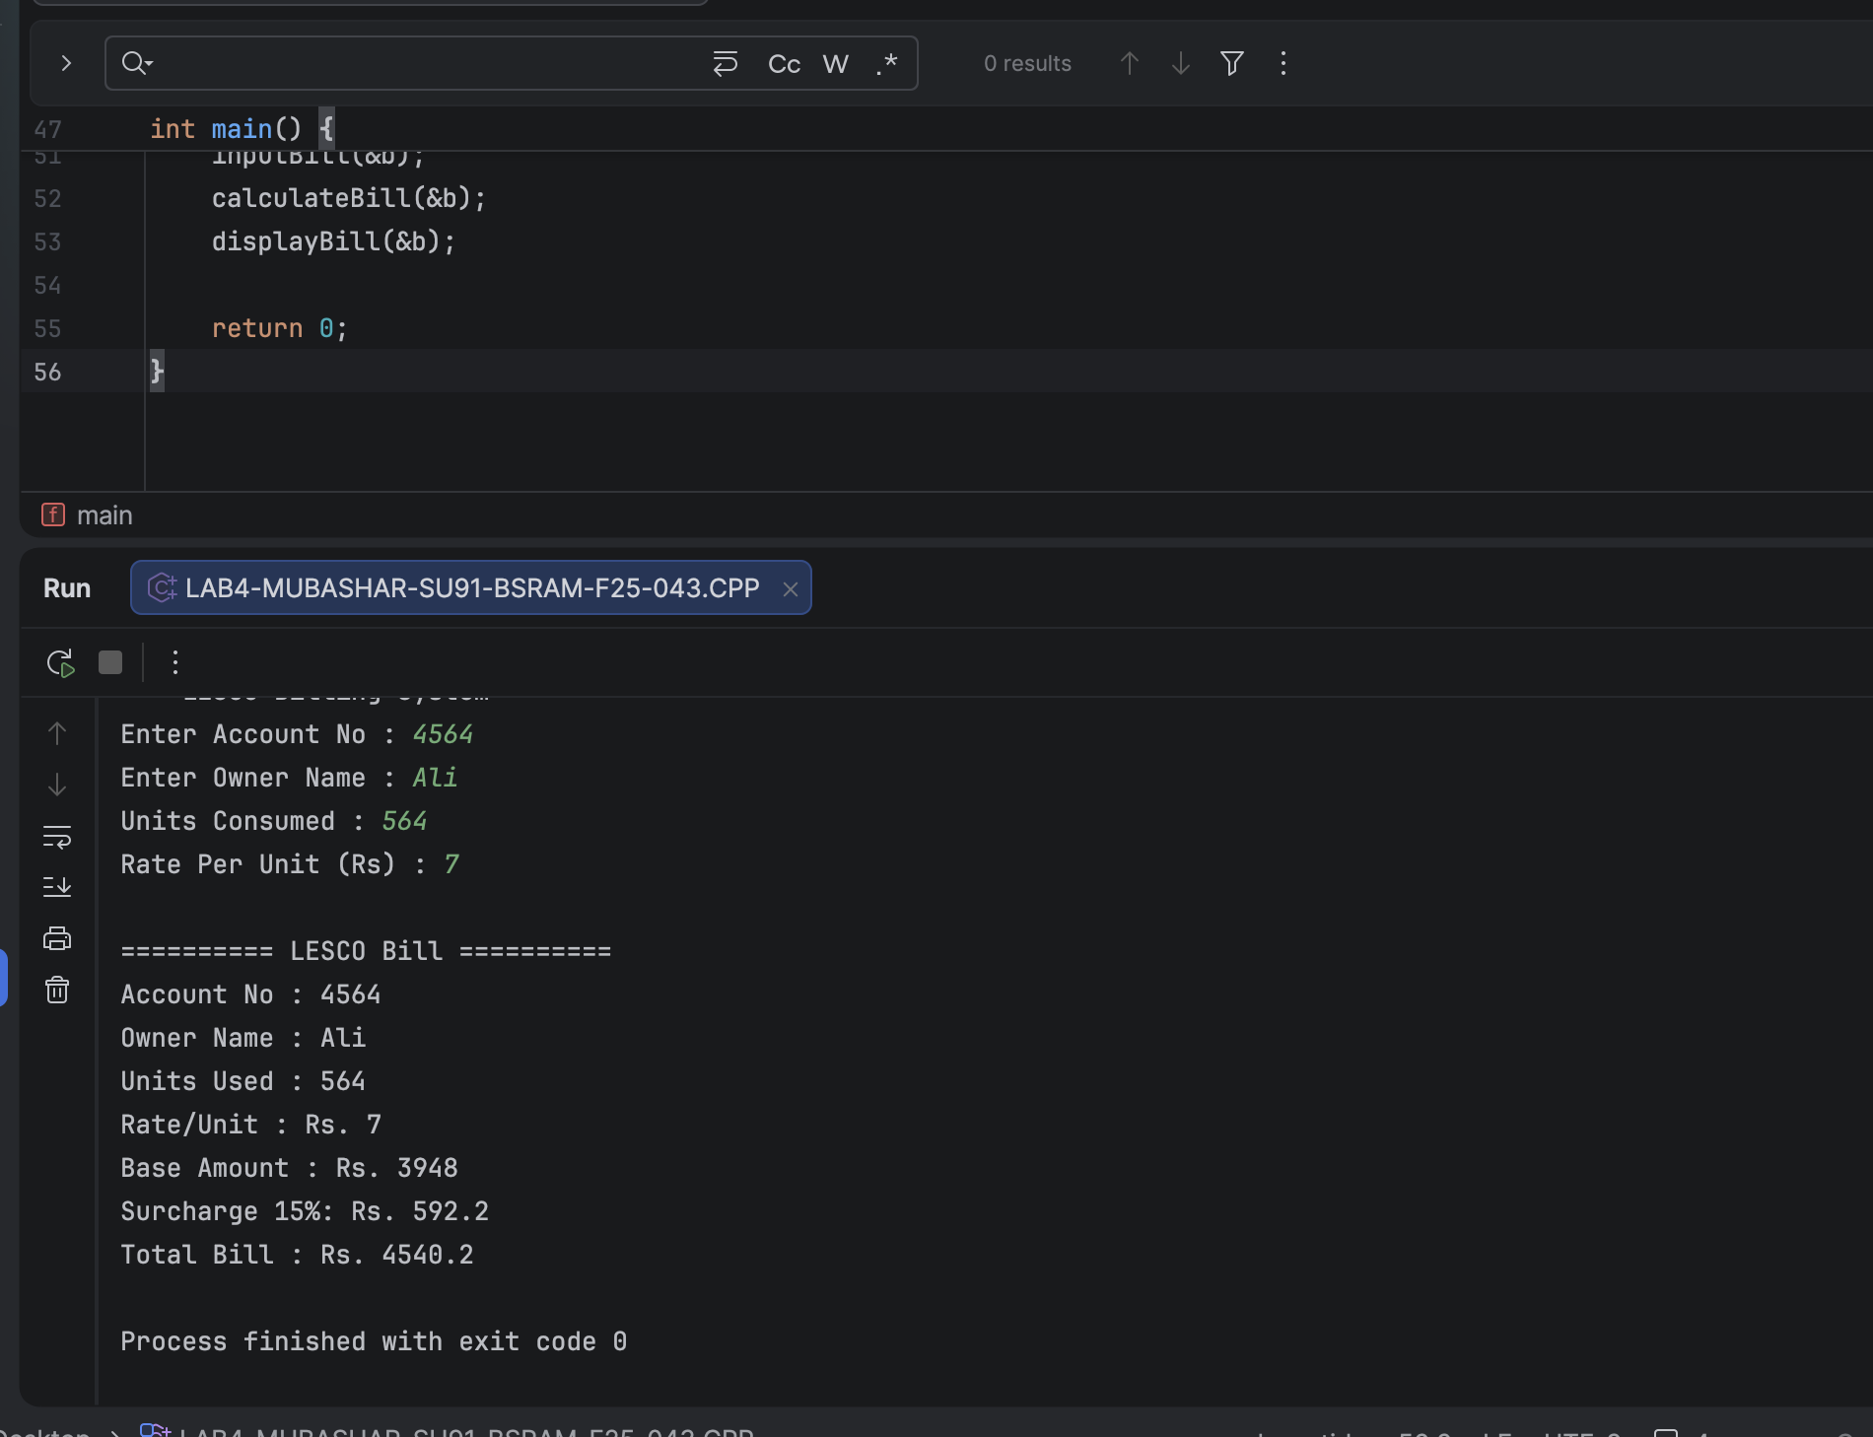

HOME TASK 01:
CODE:
#include <iostream>
using namespace std;
struct Patient {
int patientID;
char name[30];
float temperature;
int severity;
};
Patient* mostCritical(Patient arr[], int n) {
if (n <= 0) return NULL;
Patient* critical = &arr[0];
for (int i = 1; i < n; ++i) {
if (arr[i].severity > critical->severity) {
critical = &arr[i];
}
}
return critical;
}
Patient* findByID(Patient arr[], int n, int id) {
for (int i = 0; i < n; ++i) {
if (arr[i].patientID == id) {
return &arr[i];
}
}
return NULL;
}
void displayPatient(Patient *p) {
cout << "ID : " << p->patientID << "\n";
cout << "Name : " << p->name << "\n";
cout << "Temp : " << p->temperature << " C\n";
cout << "Severity : " << p->severity << "/10\n";
}
void inputPatient(Patient *p, int index) {
cout << "\nPatient " << index + 1 << ":\n";
cout << "ID: ";
cin >> p->patientID;
if (cin.fail()) {
cin.clear();
cin.ignore(10000, '\n');
} else {
cin.ignore(10000, '\n');
}
cout << "Name: ";
cin.getline(p->name, 30);
cout << "Temp: ";
cin >> p->temperature;
if (cin.fail()) {
cin.clear();
cin.ignore(10000, '\n');
}
cout << "Severity: ";
cin >> p->severity;
if (cin.fail()) {
cin.clear();
cin.ignore(10000, '\n');
}
}
int main()
{
int n;
cout << "=== General Hospital - Emergency Triage ===\n";
cout << "Enter number of patients: ";
cin >> n;
if (cin.fail()) {
cin.clear();
cin.ignore(10000, '\n');
n = 0;
}
Patient patients[50];
for (int i = 0; i < n; ++i) {
inputPatient(&patients[i], i);
}
cout << "\n--- Most Critical Patient ---\n";
Patient* critical = mostCritical(patients, n);
if (critical) {
for (int i = 0; i < n; i++) {
if (patients[i].severity == critical->severity) {
cout << "⚠️ ALERT: Immediate Attention Required!\n";
displayPatient(&patients[i]);
}
}
}
char cont = 'y';
while (cont == 'y' || cont == 'Y') {
int updateID;
cout << "\nEnter Patient ID to update (0 to stop): ";
cin >> updateID;
if (cin.fail()) {
cin.clear();
cin.ignore(10000, '\n');
cout << "Invalid input. Please enter a valid ID.\n";
continue;
}
if (updateID == 0) break;
Patient* p = findByID(patients, n, updateID);
if (p) {
cout << "Enter new temperature: ";
cin >> p->temperature;
if (cin.fail()) {
cin.clear();
cin.ignore(10000, '\n');
cout << "Enter new severity : ";
cin >> p->severity;
if (cin.fail()) {
cin.clear();
cin.ignore(10000, '\n');
}
cout << "\n--- Updated Record ---\n";
displayPatient(p);
cout << "\n--- New Most Critical Patient ---\n";
Patient* newCritical = mostCritical(patients, n);
if (newCritical) {
for (int i = 0; i < n; i++) {
if (patients[i].severity == newCritical->severity) {
cout << "⚠️ ALERT: Immediate Attention Required!\n";
displayPatient(&patients[i]);
}
}
}
} else {
cout << "Patient not found.\n";
}
cout << "\nUpdate another patient? (y/n): ";
cin >> cont;
cin.ignore(10000, '\n');
}
cout << "\n=== Final Triage Summary ===\n";
for (int i = 0; i < n; ++i) {
cout << "ID: " << patients[i].patientID
<< " | Name: " << patients[i].name
<< " | Temp: " << patients[i].temperature
<< " C | Severity: " << patients[i].severity << "\n";
}
return 0;
}
}

OUTPUT SCREENSHOT
