OOP LAB 6 TASKS
TASK 1:
CODE:
#include <iostream>
#include <fstream>
#include <sstream>
#include <cmath>
#include <vector>
using namespace std;

struct Waypoint {
int id;
double x, y, z;
double time;
};

double distance3D(Waypoint a, Waypoint b) {
double dx = b.x - a.x;
double dy = b.y - a.y;
double dz = b.z - a.z;
return sqrt(dx * dx + dy * dy + dz * dz);
}

int main() {
ofstream out("path_log.csv");
if (!out) {
cout << "File error\n";
return 1;
}

vector<Waypoint> points;
points.push_back({1, 0, 0, 0, 0});
points.push_back({2, 10, 5, 1, 2});
points.push_back({3, 20, 15, 2, 4});
points.push_back({4, 35, 25, 3, 6});
points.push_back({5, 50, 35, 4, 8});
points.push_back({6, 65, 50, 5, 10});
points.push_back({7, 80, 60, 6, 12});
points.push_back({8, 95, 70, 7, 14});
points.push_back({9, 110, 80, 8, 16});
points.push_back({10, 125, 90, 9, 18});

out << "waypoint_id,x,y,z,timestamp\n";
for (int i = 0; i < points.size(); i++) {
out << points[i].id << "," << points[i].x << "," << points[i].y << "," << points[i].z << "," << points[i].time << "\n";
}
out.close();

ifstream in("path_log.csv");
string line;
getline(in, line);

vector<Waypoint> readPoints;
while (getline(in, line)) {
if (line.size() == 0 || line[0] == '#') continue;
stringstream ss(line);
string temp;
Waypoint w;
getline(ss, temp, ','); w.id = stoi(temp);
getline(ss, temp, ','); w.x = stod(temp);
getline(ss, temp, ','); w.y = stod(temp);
getline(ss, temp, ','); w.z = stod(temp);
getline(ss, temp, ','); w.time = stod(temp);
readPoints.push_back(w);
}
in.close();

double totalDistance = 0;
for (int i = 1; i < readPoints.size(); i++) {
totalDistance += distance3D(readPoints[i - 1], readPoints[i]);
}

double totalTime = readPoints[readPoints.size() - 1].time - readPoints[0].time;
double avgSpeed = totalDistance / totalTime;

vector<int> unsafe;
for (int i = 0; i < readPoints.size(); i++) {
if (readPoints[i].x > 100) {
unsafe.push_back(readPoints[i].id);
}
}

cout << "Total Distance: " << totalDistance << endl;
cout << "Average Speed: " << avgSpeed << endl;
cout << "Unsafe Waypoints: ";
for (int i = 0; i < unsafe.size(); i++) {
cout << unsafe[i] << " ";
}
cout << endl;

ofstream appendFile("path_log.csv", ios::app);
appendFile << "# Summary\n";
appendFile << "# Total Distance," << totalDistance << "\n";
appendFile << "# Average Speed," << avgSpeed << "\n";
appendFile << "# Unsafe Waypoints,";
for (int i = 0; i < unsafe.size(); i++) {
appendFile << unsafe[i] << " ";
}
appendFile << "\n";
appendFile.close();

return 0;
}

OUTPUT:
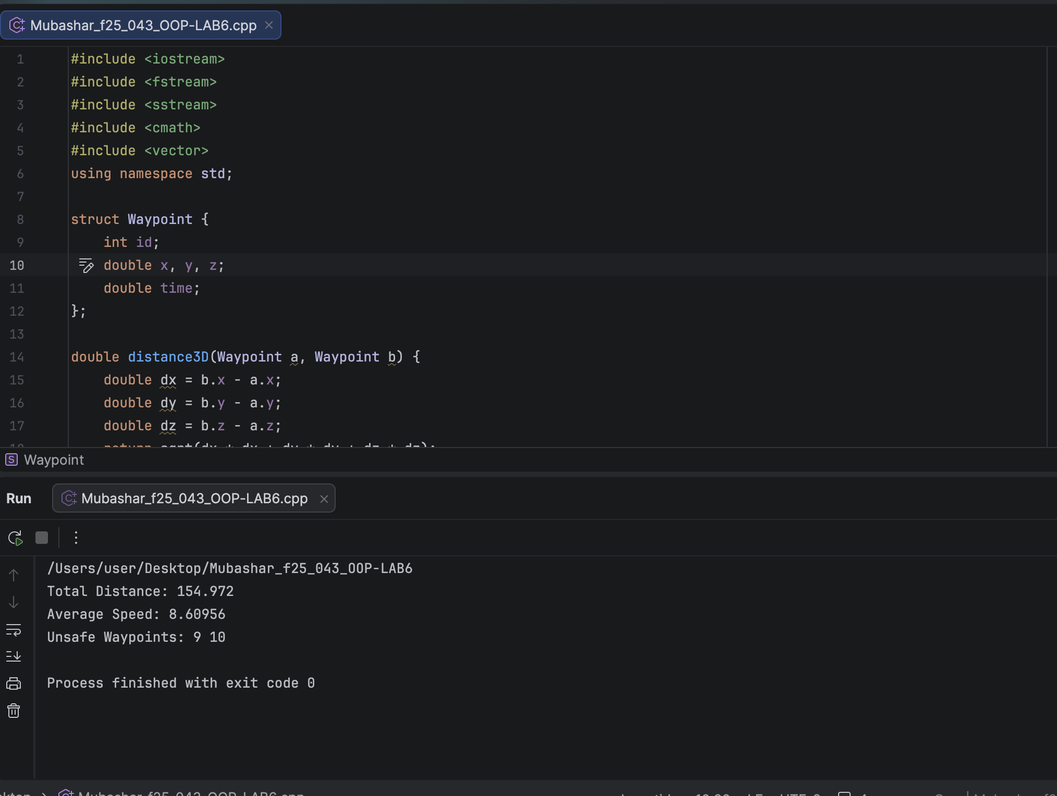

TASK 02:
CODE:
// TASK 02
#include <iostream>
#include <fstream>
using namespace std;

struct Layer {
int neurons;
float weights[10];
float bias;
};

int main() {
Layer* layers = new Layer[3];

layers[0].neurons = 4;
layers[0].bias = 0.1f;
for (int i = 0; i < 10; i++) layers[0].weights[i] = i * 0.1f;

layers[1].neurons = 6;
layers[1].bias = 0.2f;
for (int i = 0; i < 10; i++) layers[1].weights[i] = i * 0.2f;

layers[2].neurons = 2;
layers[2].bias = 0.3f;
for (int i = 0; i < 10; i++) layers[2].weights[i] = i * 0.3f;

ofstream out("model_weights.bin", ios::binary);
if (!out) {
cout << "File error\n";
delete[] layers;
return 1;
}
out.write((char*)layers, sizeof(Layer) * 3);
out.close();

Layer* loaded = new Layer[3];
ifstream in("model_weights.bin", ios::binary);
if (!in) {
cout << "File error\n";
delete[] layers;
delete[] loaded;
return 1;
}
in.read((char*)loaded, sizeof(Layer) * 3);
in.close();

for (int i = 0; i < 3; i++) {
cout << "Layer " << i + 1 << endl;
cout << "Neurons: " << loaded[i].neurons << endl;
cout << "Weights: ";
for (int j = 0; j < 10; j++) {
cout << loaded[i].weights[j] << " ";
}
cout << endl;
cout << "Bias: " << loaded[i].bias << endl;
cout << endl;
}

delete[] layers;
delete[] loaded;
return 0;
}

OUTPUT:
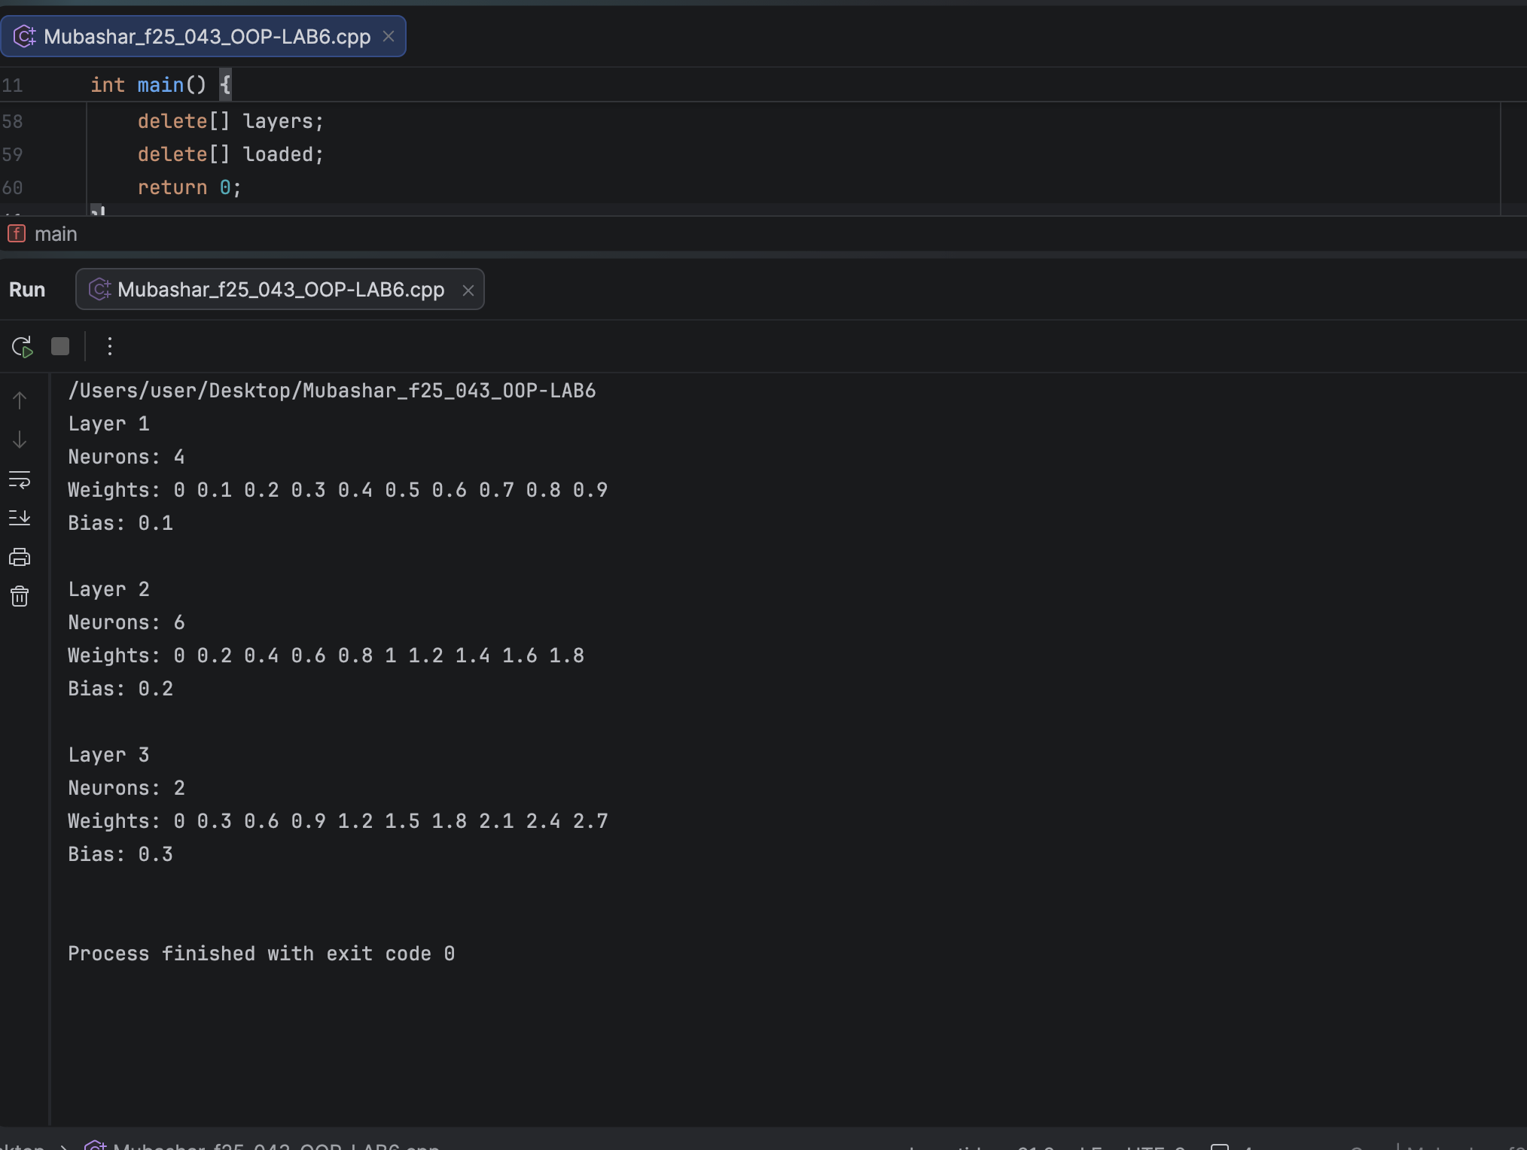

TASK 03:
CODE :
// TASK 3
#include <iostream>
#include <fstream>
#include <sstream>
#include <vector>
#include <algorithm>
#include <cstdio>
using namespace std;

struct Reading {
int robotID;
float temperature;
float battery;
};

void createLog(string filename, int id, float temp[], float battery[]) {
ofstream out(filename.c_str());
out << "RobotID,Temperature,Battery\n";
for (int i = 0; i < 5; i++) {
out << id << "," << temp[i] << "," << battery[i] << "\n";
}
out.close();
}

void readLog(string filename, vector<Reading>& all) {
ifstream in(filename.c_str());
string line;
getline(in, line);
while (getline(in, line)) {
stringstream ss(line);
string temp;
Reading r;
getline(ss, temp, ','); r.robotID = stoi(temp);
getline(ss, temp, ','); r.temperature = stof(temp);
getline(ss, temp, ','); r.battery = stof(temp);
all.push_back(r);
}
in.close();
}

int main() {
float t1[5] = {30, 31, 32, 33, 34};
float b1[5] = {90, 85, 80, 75, 70};

float t2[5] = {35, 36, 37, 38, 39};
float b2[5] = {50, 40, 30, 18, 10};

float t3[5] = {28, 29, 30, 31, 32};
float b3[5] = {95, 90, 85, 80, 75};

createLog("robot1_log.txt", 1, t1, b1);
createLog("robot2_log.txt", 2, t2, b2);
createLog("robot3_log.txt", 3, t3, b3);

vector<Reading> all;
readLog("robot1_log.txt", all);
readLog("robot2_log.txt", all);
readLog("robot3_log.txt", all);

sort(all.begin(), all.end(), [](Reading a, Reading b) {
return a.robotID < b.robotID;
});

ofstream out("fleet_log.txt");
out << "RobotID,Temperature,Battery,Status\n";
for (int i = 0; i < all.size(); i++) {
out << all[i].robotID << "," << all[i].temperature << "," << all[i].battery << ",";
if (all[i].battery < 20)
out << "CRITICAL";
else
out << "OK";
out << "\n";
}
out.close();

remove("robot1_log.txt");
remove("robot2_log.txt");
remove("robot3_log.txt");

cout << "fleet_log.txt created successfully\n";
return 0;
}

OUTPUT:
