
The Superior University, Lahore
Department of Robotics & Artificial Intelligence

Object Oriented Programming
Lab Report # 08
Constructors and Destructors

Submitted To: | Ms. Eisha Nawaz
Submitted By: | Mubashar
Roll No.: | F25-043
Subject: | Object Oriented Programming
Semester: | 2nd
Section: | ________________
Department: | Robotics & Artificial Intelligence
Date of Submission: | ________________

Lab 8 — Constructors and Destructors
Lab Task 1: Servo Motor Class
Objective: Default constructor, parameterized constructor (initializer list), destructor, rotate() with clamping, and display(). Observe LIFO destruction order.
Source Code (servo_motor.cpp)
#include <iostream>
using namespace std;

class ServoMotor {
private:
int servoID;
float currentAngle;
float maxAngle;

public:

ServoMotor() {
servoID = 0;
currentAngle = 0.0f;
maxAngle = 180.0f;
cout << "[Default Constructor] Servo-0 initialized." << endl;
}

ServoMotor(int id, float angle, float maxAng)
: servoID(id), currentAngle(angle), maxAngle(maxAng) {
cout << "[Param Constructor] Servo-" << servoID
<< " initialized at " << currentAngle << " deg." << endl;
}

~ServoMotor() {
cout << "[Destructor] Servo-" << servoID << " powered off." << endl;
}

void rotate(float newAngle) {
if (newAngle > maxAngle) newAngle = maxAngle;
if (newAngle < 0) newAngle = 0;
currentAngle = newAngle;
cout << "Servo-" << servoID << " rotated to " << currentAngle << " deg." << endl;
}

void display() const {
cout << "Servo[" << servoID << "] Angle: " << currentAngle
<< " / Max: " << maxAngle << endl;
}
};

int main() {
cout << "--- Creating servos ---" << endl;
ServoMotor s1;
ServoMotor s2(2, 30.0f, 270.0f);
ServoMotor s3(3, 90.0f, 180.0f);

cout << "--- Rotating servos ---" << endl;
s1.rotate(45.0f);
s2.rotate(300.0f); // should clamp to 270
s3.rotate(-10.0f); // should clamp to 0

cout << "--- Status ---" << endl;
s1.display();
s2.display();
s3.display();

cout << "--- End of main ---" << endl;
return 0;
}
Output
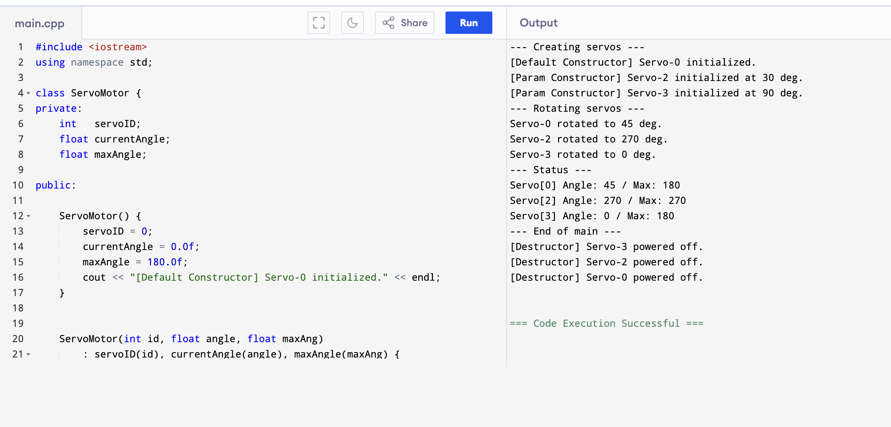
Lab Task 2: Dynamic Sensor Log
Objective: Dynamic memory allocation in the constructor, a deep-copy copy constructor, and safe release with delete[] in the destructor.
Source Code (sensor_log.cpp)
#include <iostream>
using namespace std;

class SensorLog {
private:
string sensorID;
float* data;
int capacity;
int count;

public:

SensorLog(string id, int cap) : sensorID(id), capacity(cap) {
count = 0;
data = new float[capacity];
for (int i = 0; i < capacity; i++) data[i] = 0.0f;
cout << "[Constructor] Log '" << sensorID << "' created. Capacity: "
<< capacity << endl;
}

SensorLog(const SensorLog& other) {
sensorID = other.sensorID + "_copy";
capacity = other.capacity;
count = other.count;
data = new float[capacity]; // NEW independent array
for (int i = 0; i < capacity; i++) data[i] = other.data[i];
cout << "[Copy Constructor] Log '" << sensorID << "' cloned." << endl;
}

~SensorLog() {
delete[] data;
cout << "[Destructor] Log '" << sensorID << "' memory freed." << endl;
}

void addReading(float val) {
if (count >= capacity) {
cout << "Log '" << sensorID << "' full. Cannot add." << endl;
} else {
data[count] = val;
count++;
cout << "Log '" << sensorID << "' recorded: " << val << endl;
}
}

void display() const {
cout << "Log [" << sensorID << "] (" << count << "/" << capacity << "): ";
for (int i = 0; i < count; i++) cout << data[i] << " ";
cout << endl;
}
};

int main() {
SensorLog log1("Ultrasonic-01", 4);
log1.addReading(12.5f);
log1.addReading(33.1f);
log1.addReading(45.8f);
log1.addReading(22.0f);
log1.addReading(99.9f);

cout << "--- Copy log ---" << endl;
SensorLog log2(log1);
log2.display();

cout << "--- Display original ---" << endl;
log1.display();

cout << "--- Heap log ---" << endl;
SensorLog* log3 = new SensorLog("LiDAR-01", 2);
log3->addReading(5.0f);
log3->display();
delete log3;

cout << "--- End ---" << endl;
return 0;
}
Output
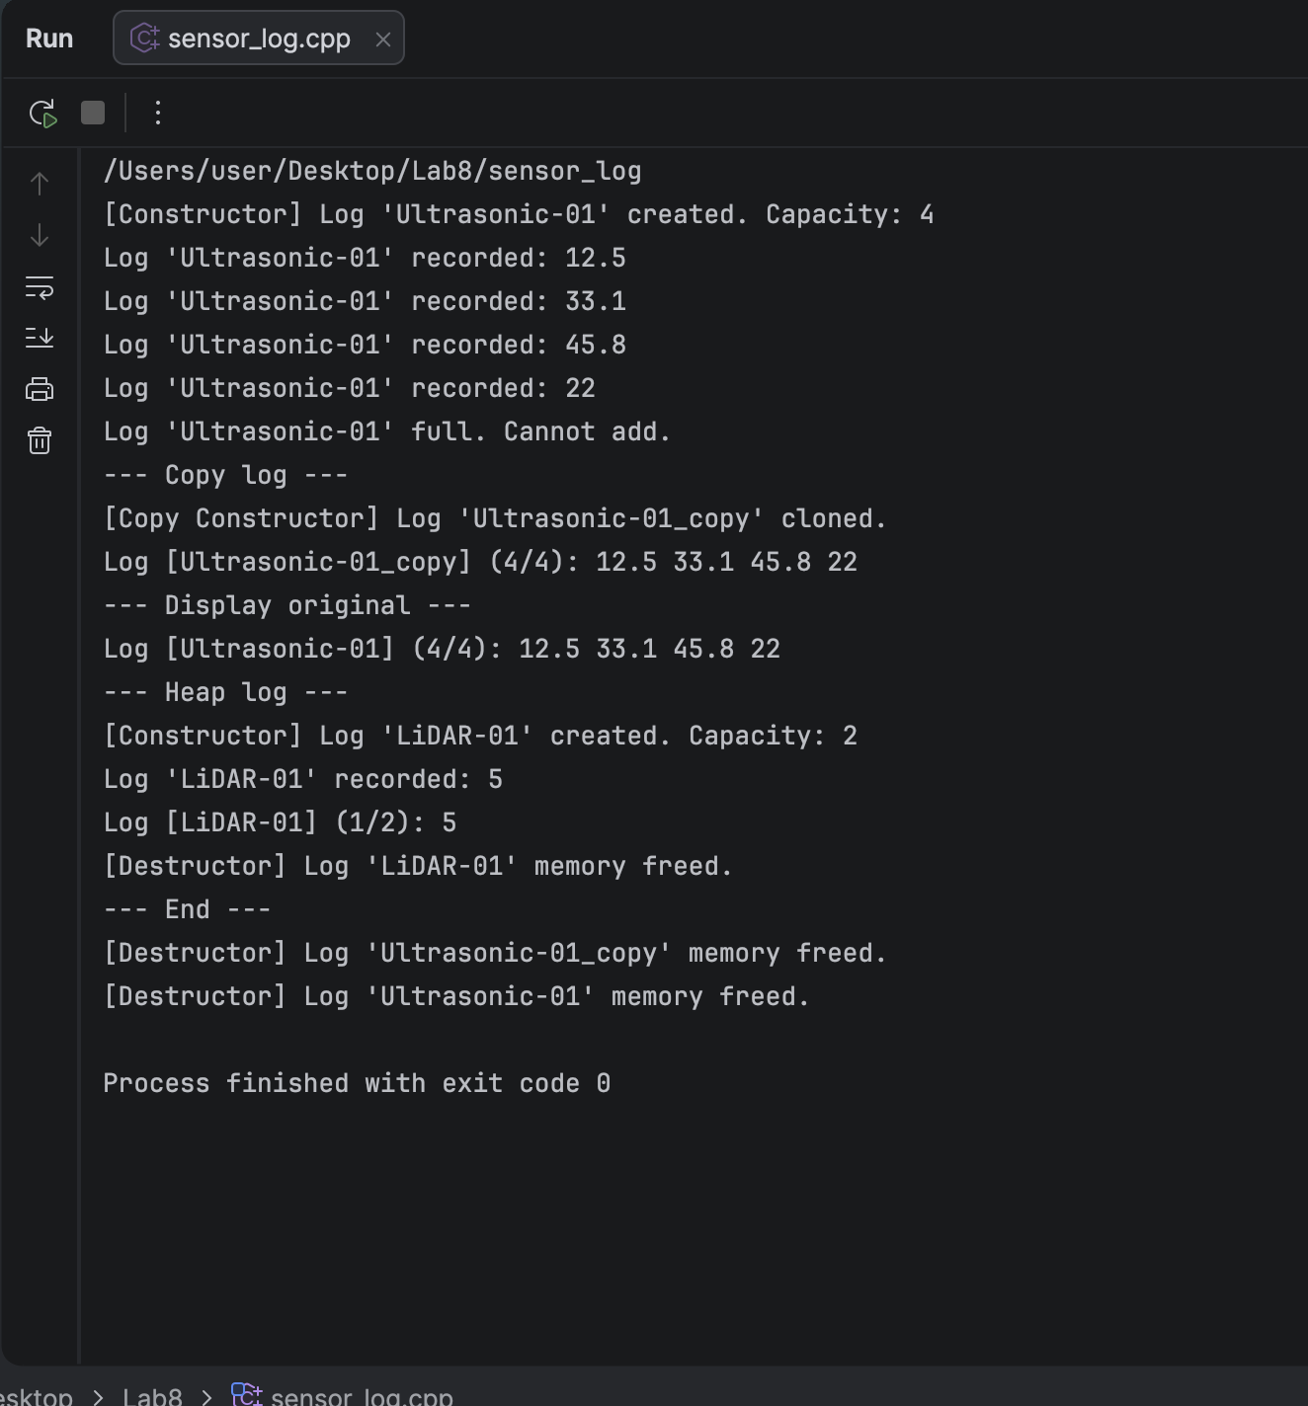
Home Task: Robot Arm Class
Objective: A multi-joint RobotArm managing two dynamically allocated arrays (joint names and angles). Default + parameterized + deep-copy constructors, destructor, setAngle(), displayArm(), totalAngle(), plus a deep-copy correctness test.
Source Code (robot_arm.cpp)
#include <iostream>
#include <iomanip>
using namespace std;

class RobotArm {
private:
string armName;
int numJoints;
string* jointNames;
float* jointAngles;
float maxReach;
public:

RobotArm() {
armName = "DefaultArm";
numJoints = 3;
maxReach = 50.0f;
jointNames = new string[numJoints];
jointAngles = new float[numJoints];
jointNames[0] = "J1";
jointNames[1] = "J2";
jointNames[2] = "J3";
for (int i = 0; i < numJoints; i++) jointAngles[i] = 0.0f;
cout << "[Default Constructor] " << armName
<< " created. Joints: " << numJoints << endl;
}

RobotArm(string name, int n, string names[], float reach) {
armName = name;
numJoints = n;
maxReach = reach;
jointNames = new string[numJoints];
jointAngles = new float[numJoints];
for (int i = 0; i < numJoints; i++) {
jointNames[i] = names[i];
jointAngles[i] = 0.0f;
}
cout << "[Param Constructor] " << armName
<< " created. Joints: " << numJoints << endl;
}

RobotArm(const RobotArm& other) {
armName = other.armName + "_copy";
numJoints = other.numJoints;
maxReach = other.maxReach;
jointNames = new string[numJoints]; // NEW independent arrays
jointAngles = new float[numJoints];
for (int i = 0; i < numJoints; i++) {
jointNames[i] = other.jointNames[i];
jointAngles[i] = other.jointAngles[i];
}
cout << "[Copy Constructor] " << armName
<< " cloned. Joints: " << numJoints << endl;
}

~RobotArm() {
delete[] jointNames;
delete[] jointAngles;
cout << "[Destructor] " << armName << " shut down. Memory freed." << endl;
}

void setAngle(int jointIndex, float angle) {
if (jointIndex < 0 || jointIndex >= numJoints) {
cout << "Invalid joint index " << jointIndex << "." << endl;
return;
}
if (angle > 180.0f) angle = 180.0f;
if (angle < 0.0f) angle = 0.0f;
jointAngles[jointIndex] = angle;
cout << armName << " Joint[" << jointIndex << "] "
<< jointNames[jointIndex] << " set to " << angle << " deg." << endl;
}

void displayArm() const {
cout << "Arm: " << armName << " | Max Reach: " << maxReach << " cm" << endl;
for (int i = 0; i < numJoints; i++) {
cout << " Joint[" << i << "] " << left << setw(8) << jointNames[i]
<< " : " << right << setw(2) << jointAngles[i] << " deg" << endl;
}
}

float totalAngle() const {
float sum = 0.0f;
for (int i = 0; i < numJoints; i++) sum += jointAngles[i];
return sum;
}
};

int main() {

RobotArm defaultArm;

string deltaJoints[4] = {"Shoulder", "Elbow", "Wrist", "Gripper"};
RobotArm delta("Arm-Delta", 4, deltaJoints, 120.0f);

delta.setAngle(0, 45.0f);
delta.setAngle(1, 90.0f);
delta.setAngle(2, 30.0f);

RobotArm deltaCopy(delta);

cout << "--- Arm-Delta Status ---" << endl;
delta.displayArm();
cout << "Total angle: " << delta.totalAngle() << " deg" << endl;

cout << "--- Arm-Delta_copy Status ---" << endl;
deltaCopy.displayArm();
cout << "Total angle: " << deltaCopy.totalAngle() << " deg" << endl;

// Deep-copy correctness test: change the copy, original must stay the same
cout << "--- Deep copy test: change copy's Shoulder to 10 ---" << endl;
deltaCopy.setAngle(0, 10.0f);
cout << "Original Arm-Delta (unchanged):" << endl;
delta.displayArm();

cout << "--- End of main ---" << endl;
return 0;
}
Output
