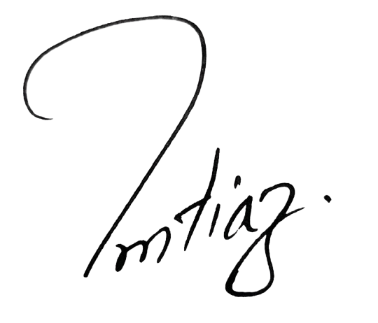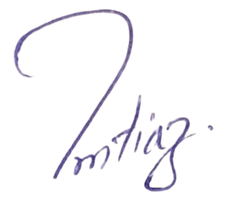
Muhammad Imtiaz ul Hassan
CEO Hammad Rahim Filling station

This is computerized generated bill Errors and Emission are accepted

HAMMAD RAHIM FILLING STATION
Muzafar Garh Road Ada Ghyl Pur District Jhang
+92301-7221831 +92300-0989192 hammadrahimfs@gmail.com
Invoice No:__________________ Dated:__________________

