Screen # 1
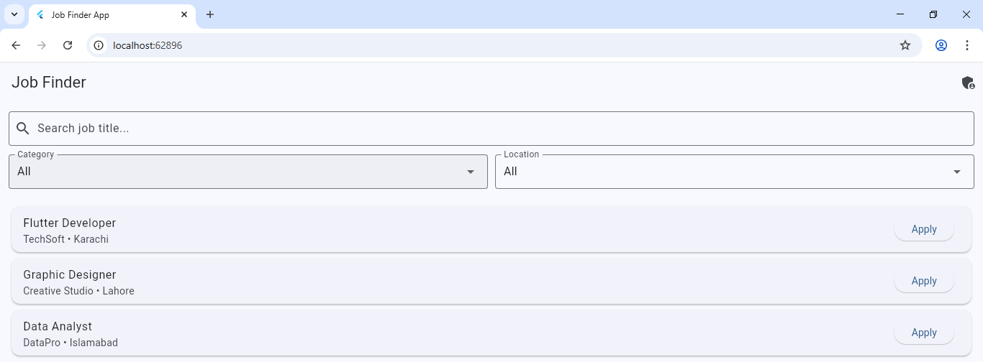Selecting categories from drop down
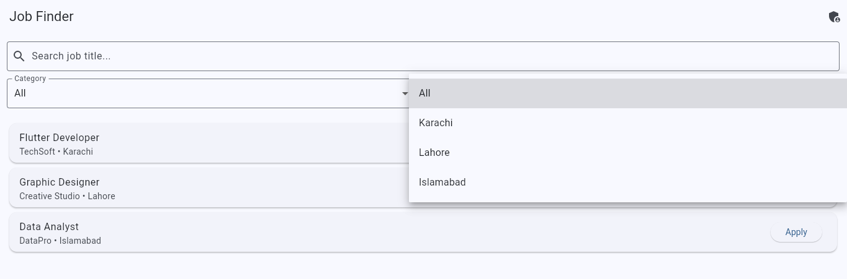
Checking the Job description
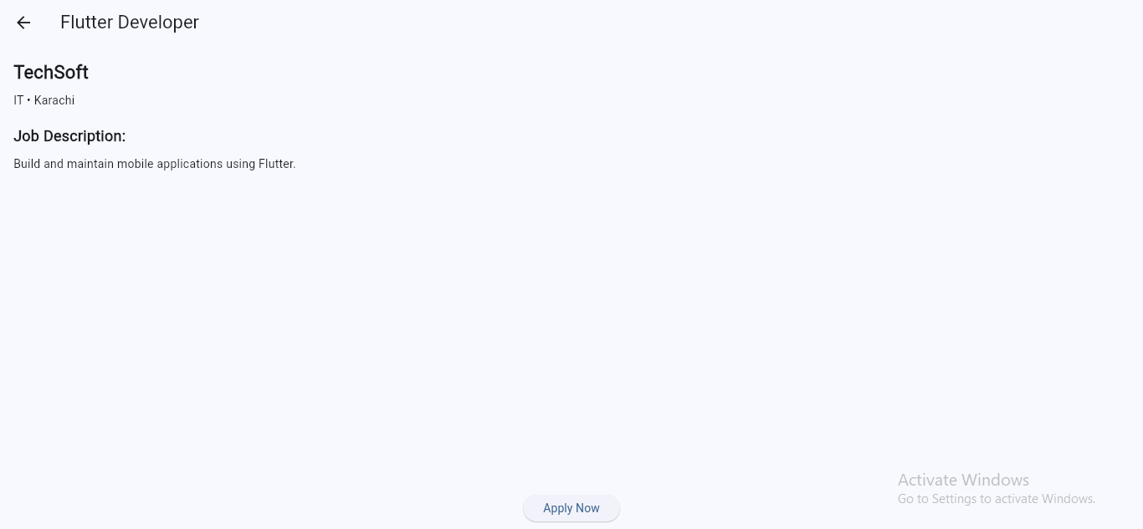
The popup at bottom of screen shows that job application is submitted Successflly

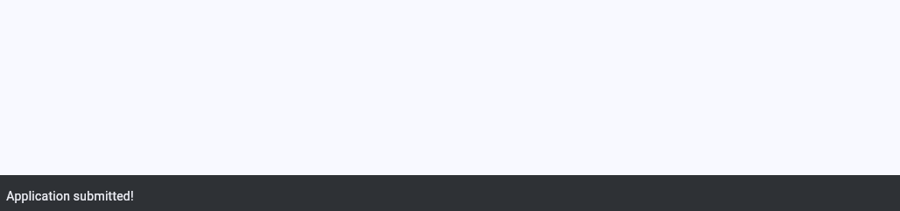
Admin is posting the job
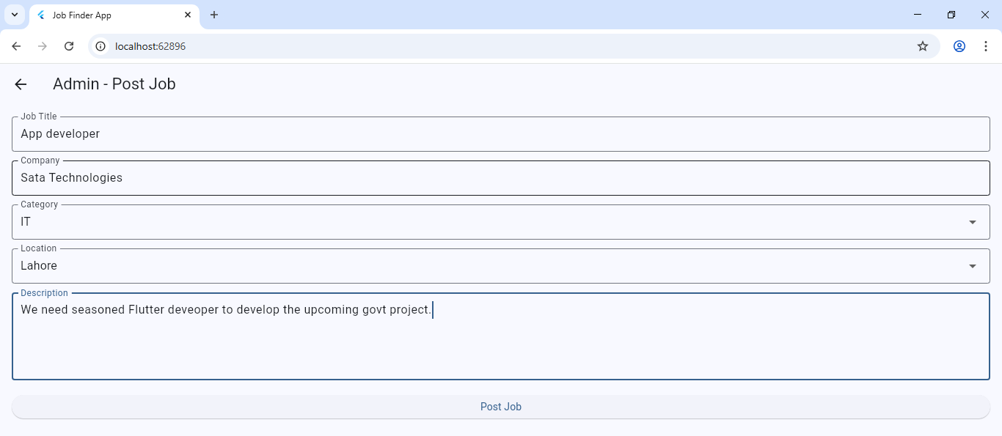
Admin is selecting the category of the Job from drop down
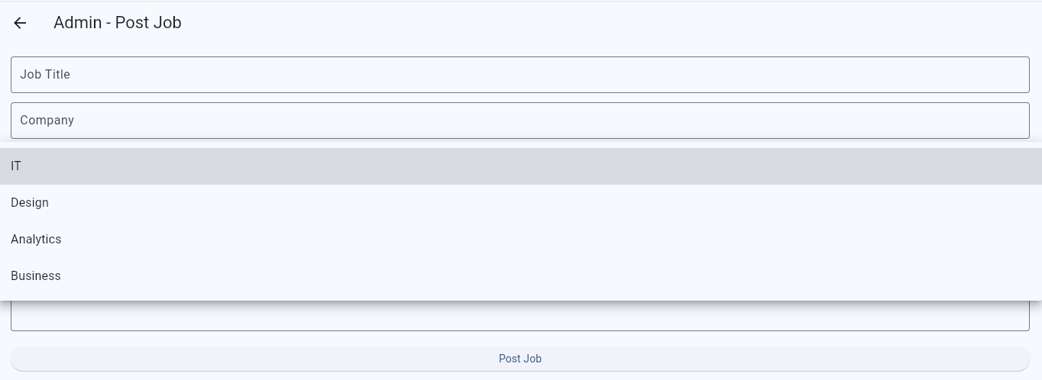
The pop up at bottom of screen shows that job is posted successfully.
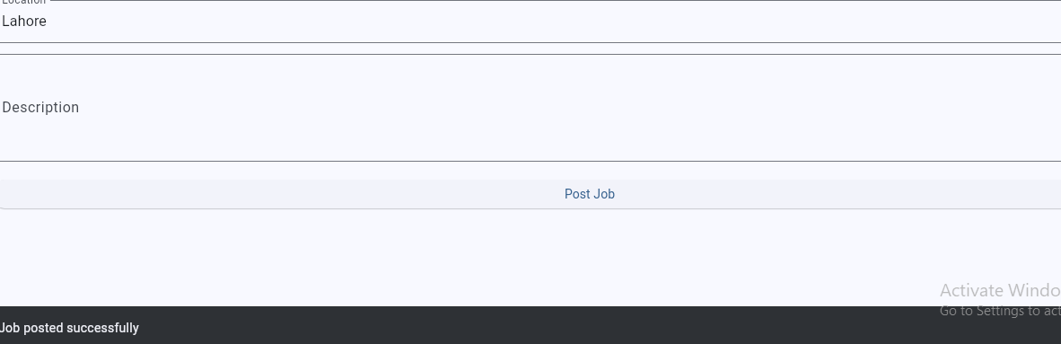
Link of Repository
https://github.com/muntazirabbas460/Job-Finder-App/commit/412a43336b3496e984eaddd43a0d35e016a4f972

PROJECT REPORT — Job Finder App

1. Project Title & Abstract
Project Title: Job Finder App Using Flutter

Abstract:
The Job Finder App is a mobile application developed using Flutter that enables users to search, filter, and apply for jobs based on category, location, and keywords. It also provides an Admin Panel, allowing administrators to post new jobs into the system. The app includes a job listing page, job detail view, and job application feedback through notifications. This project demonstrates core Flutter concepts such as state management, navigation, UI design, and CRUD operations on an in-memory data model.

2. Problem Statement & Objectives

Problem Statement:
Job seekers often face difficulty finding relevant jobs quickly due to scattered job listings and inefficient filtering. Similarly, small organizations lack simple tools to post job opportunities without complex systems. A simple, user-friendly mobile app is needed to bridge this gap.

Objectives:
- To develop a mobile application that allows users to browse and search job listings.
- To implement category-wise and location-wise filtering for relevant job discovery.
- To allow administrators to easily post new jobs.
- To display job details with an option to apply.
- To demonstrate Flutter App UI design and stateful widget implementation.

3. System Design & Architecture

Architecture Overview:
- Frontend: Flutter UI
- Backend: In-memory mock database using a List<Job> model
- Navigation: Page-based navigation using Navigator.push()
- State Management: Basic setState() within Stateful Widgets

Main Components:
Component | Description
Home Page | Search, filter, view jobs, navigate to detail page
Job Model | Data structure for storing job information
Job Details Page | Shows job description and apply button
Admin Page | Admin can post a new job dynamically

System Workflow:
- User opens the app → Home Page loads all jobs
- User applies filters (category/location) → Jobs update
- User clicks job → Navigates to Job Detail Page
- Admin enters job info → New job added to list

4. Tools and Technologies Used
Tool / Technology | Purpose
Flutter | Cross-platform UI toolkit
Dart | Programming language
Material UI 3 | Modern UI components
Android Studio / VS Code | App development IDEs
Hot Reload | Fast UI testing

5. Implementation Details

Key Features Implemented:
- Search jobs by title
- Filter jobs by category and location
- Admin adds new jobs dynamically
- Navigation between pages
- Snackbars for user feedback

Important Code Snippets:

Job Model
dart
Copy code
class Job { String title; String company; String category; String location; String description; Job({ required this.title, required this.company, required this.category, required this.location, required this.description, }); }

Filtering Logic
dart
Copy code
List<Job> filteredJobs = jobs.where((job) { bool matchesCategory = selectedCategory == "All" || job.category == selectedCategory; bool matchesLocation = selectedLocation == "All" || job.location == selectedLocation; bool matchesSearch = job.title.toLowerCase().contains(searchQuery.toLowerCase()); return matchesCategory && matchesLocation && matchesSearch; }).toList();

Admin Adding New Jobs
dart
Copy code
jobs.add(Job( title: titleCtrl.text, company: companyCtrl.text, category: category, location: location, description: descCtrl.text, ));

6. Testing & Results

Testing Performed
Test Case | Expected Output | Result
Search job title | Shows matching jobs only | ✔ Passed
Filter by category | Displays only selected category jobs | ✔ Passed
Filter by location | Displays selected location jobs | ✔ Passed
Admin posts job | Job appears in Home Page list | ✔ Passed
Apply Job | Snackbar “Applied!” appears | ✔ Passed
Empty admin field | Shows warning via Snackbar | ✔ Passed

Screenshots (Add from your mobile / emulator):
- Home Page
- Filters
- Job Detail Page
- Admin Panel
- Apply Button Snackbar

7. Conclusion & Future Work

Conclusion:
The Job Finder App successfully fulfills its purpose of helping users search, filter, and apply for jobs efficiently. The admin functionality allows easy posting of new jobs. The project demonstrates the effective use of Flutter UI, state management, and navigation.

